Pipe Stand User Guide
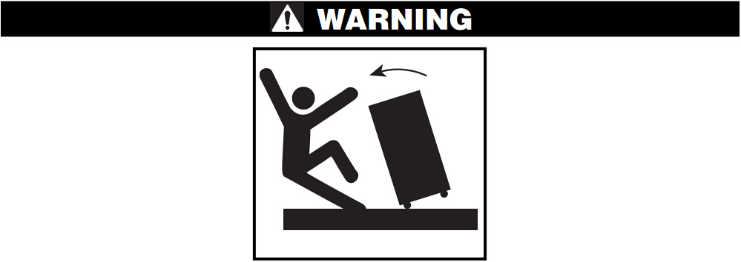
Read the warnings and instructions for all equipment being used before operating this tool to reduce the risk of serious personal injury
• Properly support pipe. Failure to properly support pipe can cause stand tipping, falling pipe and serious injury.
•Use appropriate safety equipment. Always wear proper eye and foot protection. Dust mask, face shield, hearing protection or other equipment may be needed to reduce the risk of injury.

Description
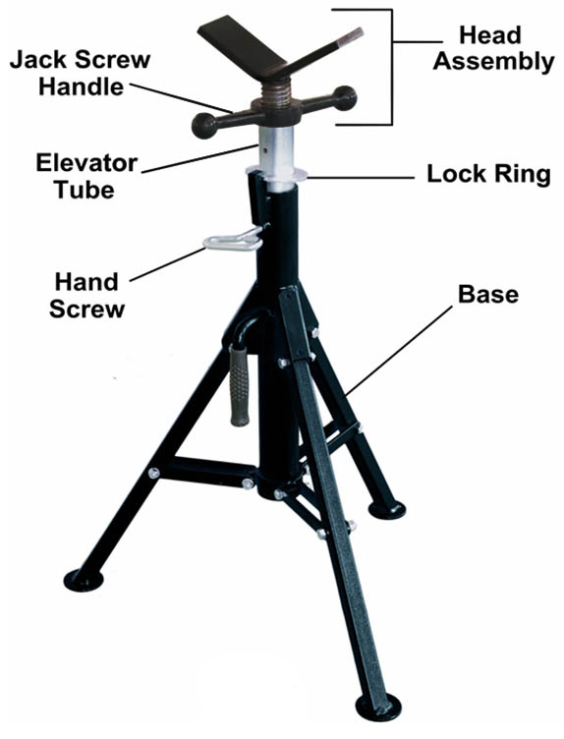
Pipe Stands.
Inspection/Maintenance
Clean the stand to aid inspection and improve control. Inspect the stand before each use for proper assembly, wear, damage, modification or other issues that could affect safe use. Install any required parts, such as the hand screw. If any problems are found, do not use until corrected.
Lubricate all moving parts/joints as needed with light lubricating oil. Wipe up excess oi.
Set Up/Operation
1. Make sure all equipment is inspected and set up per its instructions
2. Locate a clear, level, stable location for the stand, other equipment and the operator
3. Make sure the legs are fully open and the feet sit squarely on the floor.
4. Height Adjustment:
Do not exceed stand rating. Stands are equipped with a lock ring: Securely grip head assembly. Loosen hand screw. Raise lock ring to disengage elevator tube. Move head assembly to desired height and lower lock ring to engage elevator tube. Do not raise the elevator tube past the hand screw. Make sure lock ring engages elevator tube and securely tighten the hand screw.
Models equipped with jack screw for fine adjustment: Hold the head assembly stationary and turn the jack screw handle to position as desired. Do not force the jack screw handle, this can allow the screw to come loose from the stand.
5. Place stands to properly support the pipe. Generally pipe should be supported in at least two places. The number and placement of stands depend on the specific circumstances, including pipe size, length and weight.
6. Carefully place the pipe on the stands. Make sure that the pipe is properly centered on the stands to reduce the risk of tipping. Do not drop the pipe onto the stands. Do not exceed the stand ratings. Make sure pipe is stable and secure. Always stay clear of supported loads.

