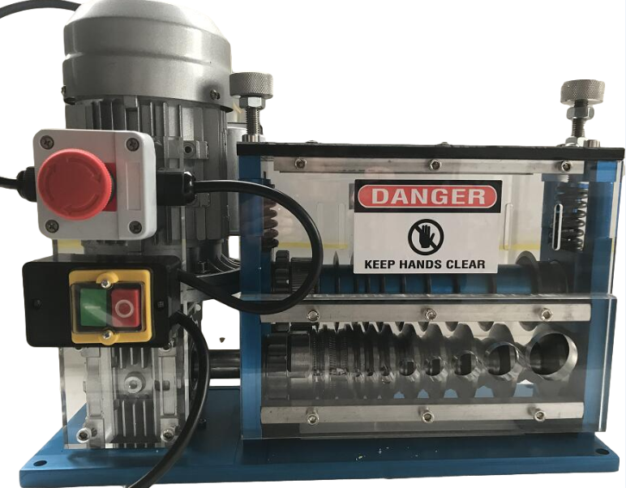

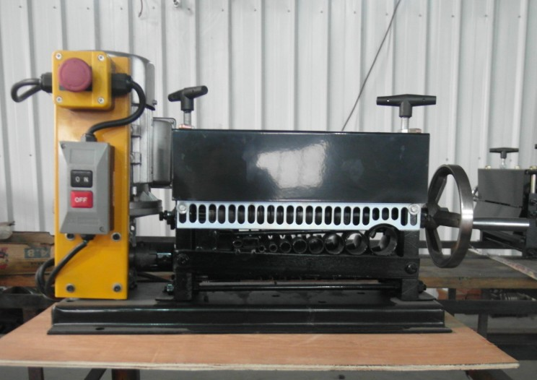
Wire Stripper Manual
Wire Stripping range: Φ1.5mm~ 38mm
This machine is easy to operate and convenient to carry,can process single core copper wire,twin cores copper wire.
Measurement:L44cm×W30.5cm×H36cm
Weight：25.5kg
1.Comparing the cables/wires’diameters with the feeding holes on the machine,feeding the cables/wires one off the head of the cables/wires,to avoid gaps caused to the blades.
2.On the output side,if the cuts on the cables/wires are too deep,please check below points:
- Please adjust the handles on the input side, screw down or loose them. (M12 handles)
- Check whether the cables/wires on the right position as you feeding them.
- Make sure the blades are sharp,if not,polish them with the oil stone
3.On the output side,if you find the plastic(PVC)has been stripped,but the copper wires can not been disgorged,please check below 4 points:
① polish The axis of the upside with the oil stone

②Check whether the springs are loose,if yes, screw down to make them tighten
③The diameter of the cables/wires are too small,please adjust the space between the two axises to 0.3-0.6mm.
④If the cables/wires you want to strip are hot,also can not get the copper wires stripped out.
4.If the cables/wires were blocked in the axises,please check below points:
  - If the springs on the press wheels are too tight,loose them.
  - There are too much oil on the cables/wires,please wipe it.
5.If see the blades tilted :
①Check whether the center adjuster was loosed.
②centering adjustment and adjust the screws of two sides of it.
Make sure the cables/wires’diameter are similar with the feeding holes ,large cables/wires in large feeding holes,small cables/wires in small feeding holes,flat cables/wires in flat feeding holes.

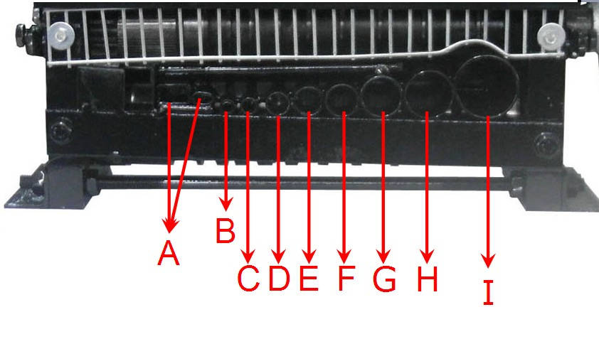
A：Flat cables/wires feeding hole
B：Diameter 1.5-6.0mm cables/wires’ feeding hole
C：Diameter 6.0-9.0mm cables/wires’ feeding hole
D：Diameter 9.0-13.0mm cables/wires’ feeding hole
E：Diameter 13.0-16.0mm cables/wires’ feeding hole
F：Diameter 16.0-19.0mm cables/wires’ feeding hole
G：Diameter 19.0-24.0mm cables/wires’ feeding hole
H：Diameter 24.0-28.0mm cables/wires’ feeding hole
I：Diameter 28.0-38.0mm cables/wires’ feeding hole

