Digital Heated Magnetic Stirrer User’s Manual
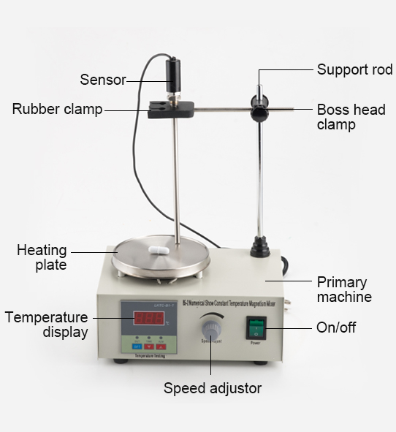
1 Sensor 2 Rubber clamp 3 Support rod 4 Boss head clamp
5 Primary machine 6 Heating plate 7 Temperature display
8 Button to set temperature and other values 9 Button to decrease temperature
10 Button to increase temperature 11 Speed adjusting knob 12 On/off
Introduction
Equipped with premium AC motor, our heated magnetic stirrer is a reliable equipment with stepless adjustable spinning speed. It has not only a stable stir efficiency, but also has reliable digital temperature adjustment function. In addition, via the temperature control knob, as well as an external temperature sensor, users can obtain a more accurate temperature performance. SH-4C Is an economical, practical, accurate and durable magnetic stirrer. It is a high-quality equipment that every laboratory should set up one.
Specifications
Power: AC 50HZ 220V+/-10V
Wattage: 200W
Speed range: 0-2,400 RPM
Heating range: room temperature to 100℃
Stirring capacity: 1,000ml/33.8 fl oz.
Instructions
Sc: Press and hold SET button for 3 seconds to enter specification adjusting mode, SC is the error calibration value which is the difference between the set and actual temperature, and is set to 0.0. If you want to adjust it, please press the SET button and the numbers will flash, you can adjust the value between -9.9 to 9.0 using the up or down buttons.
E: press SET button to enter the next specification, it will display E, which is the critical value before the magnetic stirrer enters into slow heating speed (set to 0.5), it requires the same steps to adjust it as the SC
P: press SET button again to enter the next specification setting, it will display P, which equals the set value minus (10/P). For example, if it is set to 50 degrees when P equals 10, then it means it it will start to control the heating speed once it reaches 49 degrees, when P equals 4, then it will start to control the heating speed once it reaches 47.5 degrees. Please decrease P value if the temperature is in huge disparity, please increase P value if the temperature is rising too slowly or just cannot reach your desired temperature.
Notes:
When P equals 0, the magnetic stirrer will enter into the mode under which PID will NOT work. It will not start heating up unless the set temperature is higher than the actual temperature.
C: press SET button to set C. This is a default value, it is not recommended to adjust it.(set to 20)
Press SET button to go back to normal operative mode.
TIPS:
If the stirrer is not working, please power off to check if the breaker is placed appropriately. And please make sure the voltage is between 100V to 120V.
Please make sure not to use the magnetic stirrer for extended period of time to lengthen service life.
Please set speed to medium if you need the stirrer to work for a long time, please take breaks if you set the speed to high.
Please unplug the stirrer if not in operation.
Maintenance
The stirrer is built for long, trouble-free, dependable service. It needs no user maintenance beyond keeping the surfaces clean. The unit should be given the care normally required for any electrical appliance. Avoid wetting or unnecessary exposure to fumes. Spills should be removed promptly after the unit has cooled down. Do not use a cleaning agent or solvent on the front panel or top plate which is abrasive or harmful to plastics, nor one which is flammable. Always ensure the power is disconnected from the unit prior to any cleaning. If the unit ever requires service, contact your VWR representative.
Package list
1x magnetic stirrer 1x pole 1x boss head clamp

1x clamp 1x fuse 1x instructions manual

