

Technical Support and E-Warranty Certificate [www.vevor.com/support](https://www.vevor.com/support" \t "_blank)

**Stud Welder Dent Repair Kit**

**Model:3402**

We continue to be committed to provide you tools with competitive price.

"Save Half", "Half Price" or any other similar expressions used by us only represents an estimate of savings you might benefit from buying certain tools with us compared to the major top brands and does not necessarily mean to cover all categories of tools offered by us. You are kindly reminded to verify carefully when you are placing an order with us if you are actually saving half in comparison with the top major brands.



**Stud Welder Dent Repair Kit**

**Safety Warning Signs**



Operate this protection with working conditions common sense Before installing and operating the welder, look at the following safety precautions

 

Read the instructions 1. before the operation of the machine, free to read the product brochures in detail. 2.please use the original parts and accessories.

To prevent electric shock: 1.Do not use the skin and wet clothes contact welding machine. 2.Do not turn off the power supply, and do not let the cable around the operator who wear a thick bottom insulation shoes 3. Ground and work directly connected.

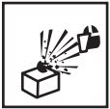 

When using the machine,wear a mask to avoid problems with parts exploding will cause harm.

In the workplace, due to welding will produce toxic gases, pay attention to ventilation, so as not to poison. (Prohibited in the closed container welding)

 

Static electricity can damage the machine's circuit board

1. connected to a good ground, to prevent electricity.2. in the movement and storage to use anti-static items covered,So as to avoid damage to the machine.

1. splash of sparks and arc will cause damage to 2. please wear a mask or with the edge of the glasses

 

Do not touch the hot workpieces by hand during welding.

To prevent the explosion: flammable, explosive products away from the welding area.

 

1. the electromagnetic field can affect the operator'sheart, such as the heart there Install the pacemaker, please stay away from the machine.2.such as the need to operate the machine, free advice advice for life.

Be careful not to be crushed and bruised while moving.

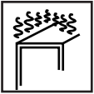 

Please do not work for too long, will cause the machine part of the zero parts overheating, damage the life of the machine.

Prohibit welding at high..



Prevent fire Welding is completed, check the welding area with or without overheating spatter and hot metal to prevent fire.

Note: Welder self-protection! Focus on others safe! Focus on plant safety! Pay attention to equipment maintenance!

**Installation**

**1.Specifications and parameters**

|  |  |
| --- | --- |
| Model | 3402 |
| Input voltage（V） | AC200-240V |
| Output voltage（V） | AC1-7V |
| Input power（KW） | 3KW |
| Instantaneous maximum output current（A） | 3500A |
| Input the maximum current（A） | 20A |
| Way of working | Automatic/manually |
| Regular working hours | Automatic mode |
| Work stalls | One-button mode 5 types (Triangular pieces, round gaskets, long gaskets, wavy lines, hot pressing flat) |
| Welding thickness（mm） | 0.6-1.2 |
| Vacuum suction（kg） | 180kg |
| Dimensions（mm） | 505\*320\*350mm |
| Weight（kg） | 25kg |

|  |  |  |  |  |
| --- | --- | --- | --- | --- |
| Aisle | coding | Name | Power | Time |
|  | 1 | Triangle sheet welding | \_\_\_\_\_ | 0.01-0.50S |
|  | 2 | Gasket welding | \_\_\_\_\_ | 0.01-0.50S |
|  | 3 | OT gasket welding | \_\_\_\_\_ | 0.01-0.50S |
|  | 4 | Waveline spot welding | \_\_\_\_\_ | 0.01-0.50S |
|  | 6 | Carbon rod heating | 45%-85% | \_\_\_\_\_ |

**2.The work cycle and overheating protection**

The working cycle of the machine is the use of repeated cycle of work, the welding cycle time for the load time and no load time and.

In addition, the machine is equipped with overheating protection, when the temperature reaches the critical, the welding machine will automatically stop working, to be cooled, you can continue to operate, as shown in the specific situation.

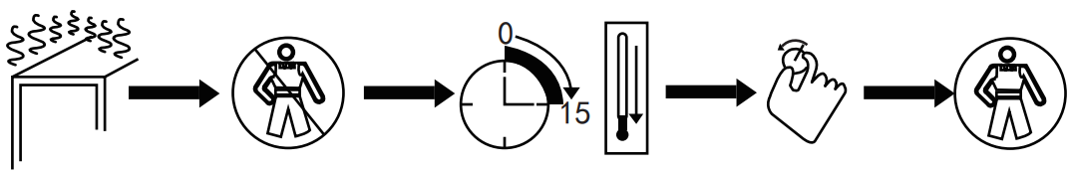

Machine

overheating

Stop working

Rest for a while, wait for the machine to drop

Re-adjust the machine

Continue to use

**3.The installation of the machine**

1). Customers receive the machine, the first package will open, find the product brochures.

2). According to the instructions in the packing list on the items and the number of checks to check the type of machine accessories and the number is correct.

3). According to the machine's appearance picture, the machine is installed, and check the machine whether there are other problems, if any questions, please consult the dealer or service solution.

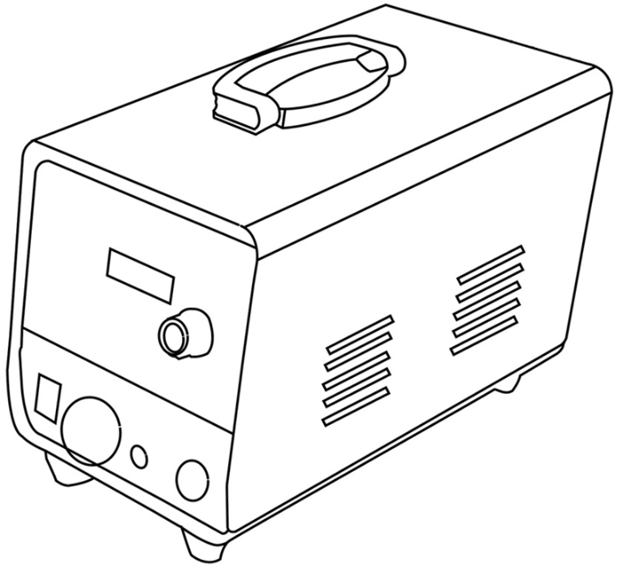

**4.Move and place the machine's attention**

1).After the installation of the machine if no other problems, we must choose the right place to put.

2).The length of the input power cord is determined according to the operating distance, and the power cord must not be less than 4 mm copper cable.

3).When placed in the machine, can not be tilted around, to be stable on the ground to avoid damage to the machine.

4).When moving the machine, use a pulley with a pulley or move it with the wheels of the machine. Do not drag the machine or pull the cable to move the machine. Otherwise, it will damage the machine or break the cable and cause inconvenience to the later work.

As shown:

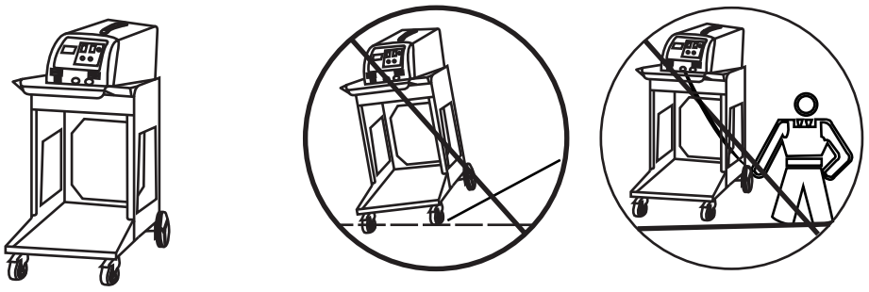

**5.Enter the connection method of the power supply**

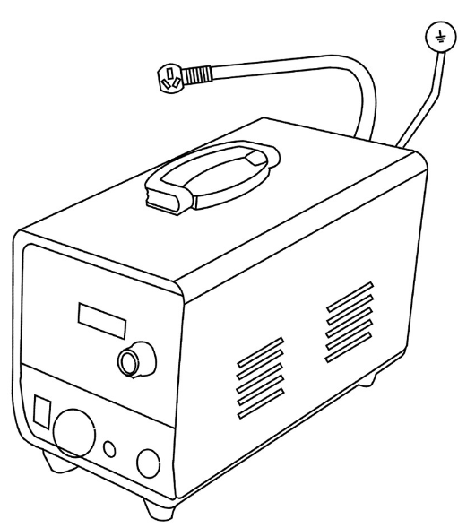

**Insert the plug into the appropriate socket according to the plug supplied with the unit. Be sure to check the voltage.**

**Operating**

**1.Operation panel guidelines**

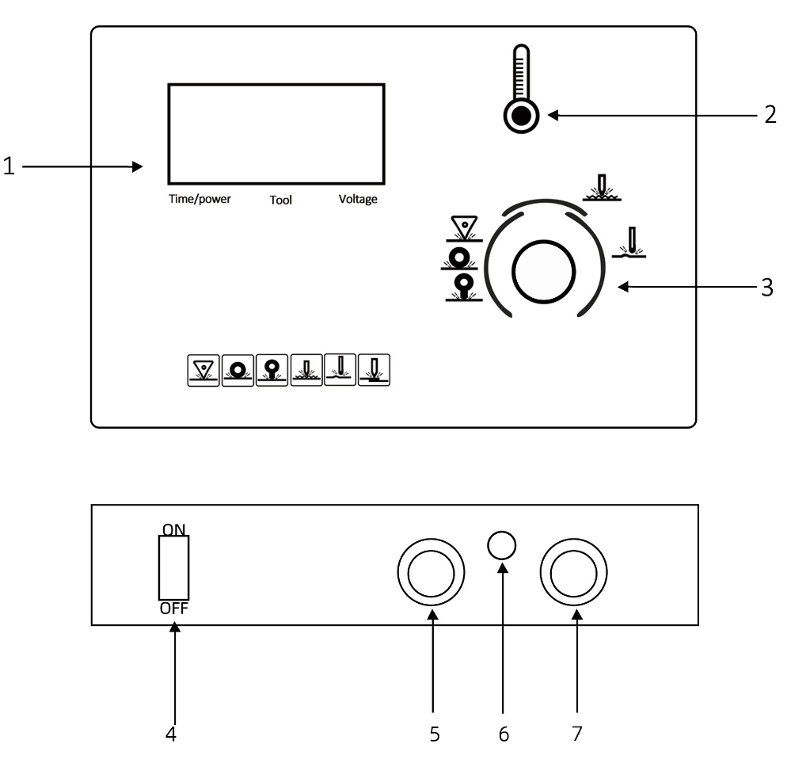

1..Display 2.Overheat protection indicator

3.Tools and Time Adjustment 4.ON/OFF

5.Torch wire 6.Signal line

7.Ground wire

Note:

Machine overload work will enter the protection state, until the machine cooling, and then work

**2.Welding torch and connector**

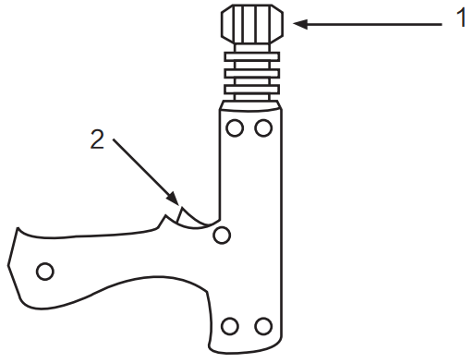

**1.Locking head**

**2.Torch switch**

Application of single - sided spot welding gun

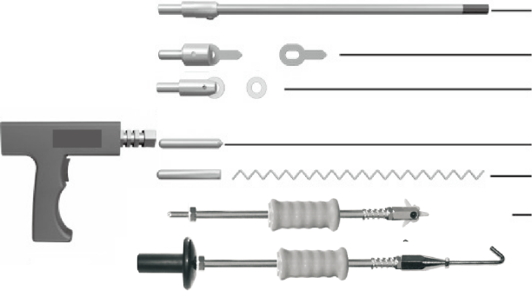

Carbo Rod Shrinking

OT Washer Welding

Washer Welding

Hot pressing

Wave form Wire Welding

Pulling Spot Hammer

Connection of negative wire

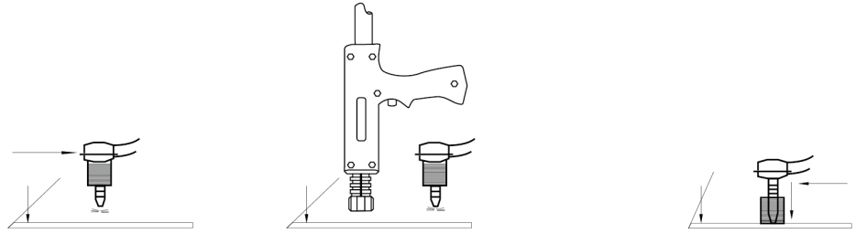

1.Place the wire on the

sheet metal section that

needs to be repaired,as

close towelding area as

possible.

2.the welding torch in the vicinity of the machine near the

automatic welding machine.

3.Fixed ground

**For the negative connection, the code can be selected as 1 and the power can be selected as 6. The power can be increased, granting a higher number of welds to dissolve the plating on the negative tip.**

**3.Method of operation**

a.Gasket welding

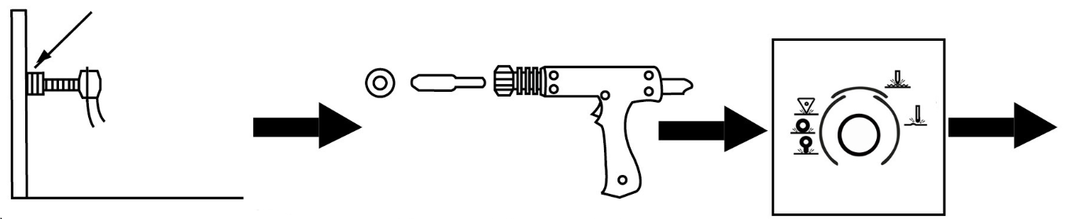

The negative line fixed to the polished clean and remove the paint on the workpiece, the closer the operating surface the better .

Connect the gasket connector to the torch and lock it with a gasket.

Point the spin button to the corresponding tool range.

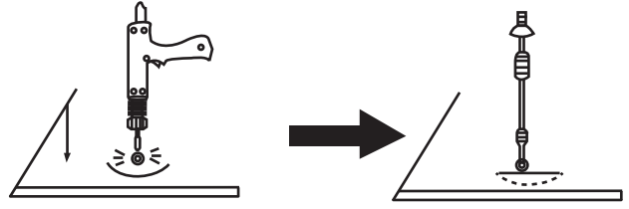

The welding torch light pressure to the body of the depressed parts of the machine automatically welding.

Remove the welding torch, with a strong pull hammer to the gasket in the opposite direction to pull the gasket, the depression out.

OT gasket welding, same as Gasket welding, code 3, power priority 5, other steps same as Gasket welding.

Note:

1. Before doing this, please test on other workpieces to avoid damage to the surface of the vehicle due to excessive current or too long damage.

2.According to the body plate thickness, select the appropriate gear, the machine will automatically match the welding time with the current.

3.After doing this, you can continue with other functional operations. If you do not continue to work, turn off the power and cut off the main switch, finishing the various accessories for the next use.

b.Triangular pieces of welding

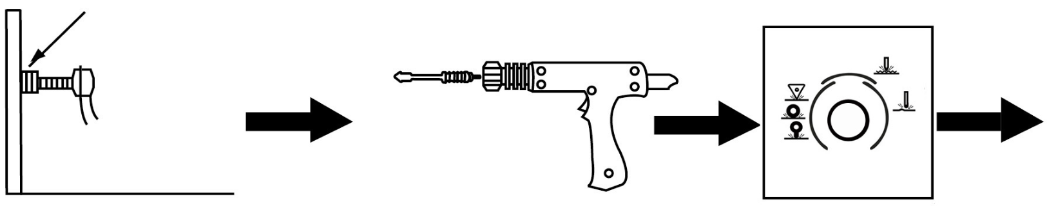

The negative line fixed to the polished clean and remove the paint on the workpiece, the closer the operating surface the better .

Connect the connected triangular pull hammer to the torch and lock it.

Point the spin button to the corresponding tool range.

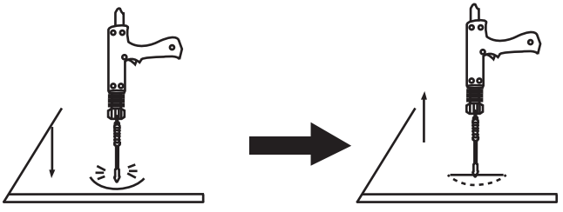

The welding torch light pressure to the body of the depressed parts of the machine automatically welding.

Pull the recessed parts directly in the opposite direction of the hammer welding.

Note:

1. before doing this operation, please try the other parts in order to avoid the current is too large or too long to damage the body to repair the surface.

2. according to the body plate thickness, select the appropriate gear, the machine will automatically match the welding time with the current.

3. triangular pieces of welding before the replacement of the meson repair, it can be directly after the welding part of the depression pulled out.

4. after doing this operation, you can continue to other functional operation, if you do not continue to work, please turn off the power and cut off the main switch, the various accessories finishing for the next use.

c. carbon rod heating

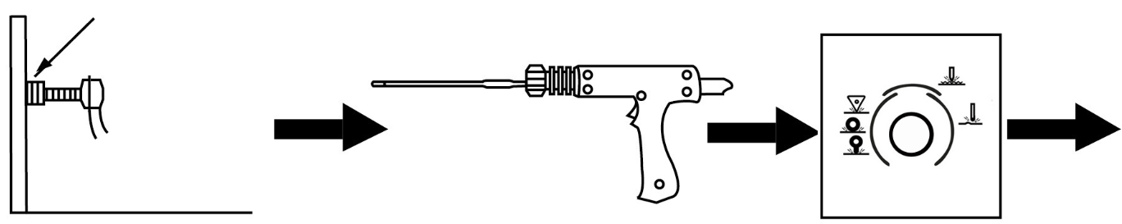

The negative line fixed to the polished clean and remove the paint on the workpiece, the closer the operating surface the better .

Connect the connected triangular pull hammer to the torch and lock it.

Point the spin button to the corresponding tool range.

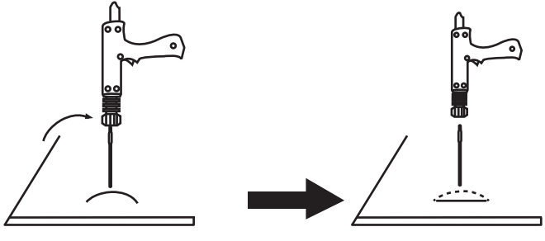

The carcass is heated in a clockwise direction.

With cold water or wet cloth placed just to the location of the use of thermal expansion and contraction of the prominent part of the tightening, to return to normal.

Note:

1. before doing this operation, please try the other parts in order to avoid the current is too large or too long to damage the body to repair the surface.

2. according to the body plate thickness, select the appropriate gear, the machine will automatically match the welding time with the current.

3. after doing this operation, you can continue to other functional operation, if you do not continue to work, please turn off the power and cut off the main switch, the various accessories finishing for the next use.

d.wave line welding

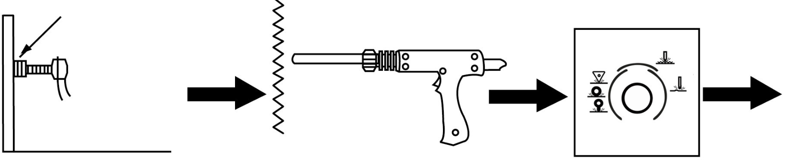

The negative line fixed to the polished clean and remove the paint on the workpiece, the closer the operating surface the better .

Connect the connected triangular pull hammer to the torch and lock it.

Point the spin button to the corresponding tool range.

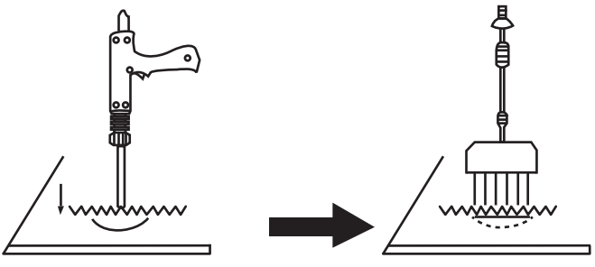

Place the waveform line upright in the car body and place the welding head on the upright waveform line. The machine will automatically weld .

With a claw pull hook and hammer set in the waveform line, the car body depression out.

Note:

1.before doing this operation, please first test on the other parts, so as to avoid the current is too large or too long damage to repair Body surface.

2. according to the body plate thickness, select the appropriate gear, the machine will automatically match the welding time with the current.

3. after doing this operation, you can continue to other functional operation, if you do not continue to work, turn off the power and cut off the main switch,Will be a variety of accessories finishing, for the next use.

e.The use of sucker

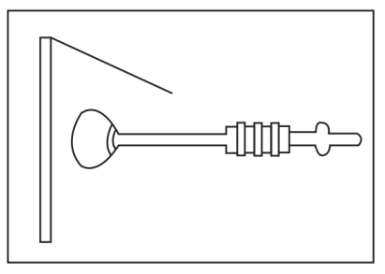

Use of manual sucker:

1. the sucker and pull hammer connected
2. the sucker forced to no dead angle of the depression

3.with the hammer in the opposite direction to pull out the depression

**Maintenance and repair**

**Failure and exclusion**

|  |  |  |
| --- | --- | --- |
| **Trouble** | **Reason** | **Remedy** |
| **No welding output** | **1.Connected power supply incorrectly.**  **2.Power switch in off position** | **1.Connect power supply according to manufacturer's instructions.**  **2.Place power switch in “on” position.** |
| **Trigger not working** | **1.Trigger damaged.**  **2.Gun control wire broken.**  **3.Control wire plug loosen.**  **4.Mode switch in incorrect position.** | **1.Replace trigger.**  **2.Connect again or replace if necessary.**  **3.Connect control wire plug again.**  **4.Place Mode switch in correct position.** |
| **Poor weld** | **1.Aamperage too low**  **2.lnput power cord did not meet the requirement.**  **3.Ground clamp bad contact.** | **1.lncrease amperage setting**  **2.Replace input power cord.**  **3.Change ground clamp location.** |
| **Piercing workpiece** | **1.output amperage too high**  **2.Bad contact of electrode tip or**  **washer with workpiece.** | **1.Reduce amperage setting**  **2.)Remove coating from material**  **reduce added pressure.** |
| **Carbon rod workingunstable** | **1.Carbon rod or workpiece is dirty.**  **2.Incorrect amperage and time**  **setting.** | **1.Polish carbon rod and workpieces**  **2. Set amperage and time according to**  **workpiece thickness** |
| **Unit stop workingwhile operation** | **1.Trigger plug loosen.**  **2.Gun control wire broken.**  **3.Over heating.** | **1.Check gun control wire andtrigger plug.**  **2.Wait for temperature cool down** |

Packing List

|  |  |  |
| --- | --- | --- |
| Part name | Quantity | Remarks |
| Mainframe | 1 |  |
| Tool Box | 1 |  |
| Pulling Hammer | 1 |  |
| Pulling gun | 1 |  |
| Wavy wire | 10 |  |
| meson head | 1 |  |
| Carbon Rod Head | 1 |  |
| Spot Welding Head | 1 |  |
| Carbon Rods | 2 |  |
| Wrench | 1 |  |
| Pull Hook | 1 |  |
| Six-jawed Hook | 1 |  |
| Triangle Tabs | 10 |  |
| Long shims (OT) | 10 |  |
| Round Spacer | 20 |  |
| Suction Cups | 1 |  |

****

**Technical Support and E-Warranty Certificate**

**[www.vevor.com/support](https://www.vevor.com/support" \t "_blank)**