

Technical Support and E-Warranty Certificate [www.vevor.com/support](https://www.vevor.com/support" \t "_blank)

**Tow Bar**

**Model: FF-T809**

We continue to be committed to provide you tools with competitive price.

"Save Half", "Half Price" or any other similar expressions used by us only represents an estimate of savings you might benefit from buying certain tools with us compared to the major top brands and does not necessarily mean to cover all categories of tools offered by us. You are kindly reminded to verify carefully when you are placing an order with us if you are actually saving half in comparison with the top major brands.

1677836647625

**TOW BAR**

**MODEL: FF-T809**

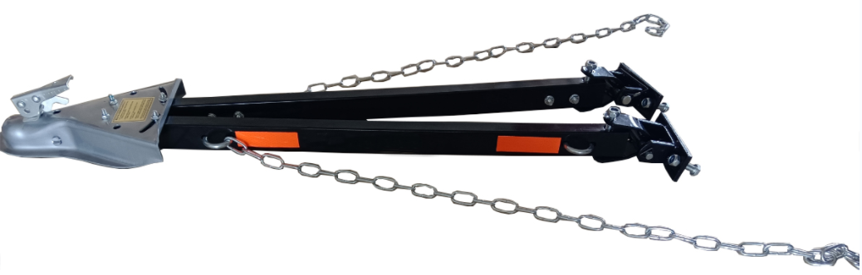

Have product questions? Need technical support? Please feel free to contact us:

**Technical Support and E-Warranty Certificate**

**www.vevor.com/support**

**NEED HELP? CONTACT US!**

This is the original instruction, please read all manual instructions carefully before operating. VEVOR reserves a clear interpretation of our user manual. The appearance of the product shall be subject to the product you received. Please forgive us that we won't inform you again if there are any technology or software updates on our product.

**SAFETY INSTRUCTIONS**

Failure To Follow These Instructions May Result In A Hazardous Towing Condition1674973508886.

1. Total weight of the towed vehicle must not exceed 5500 lbs.

2. Towing vehicle must weigh more than towed vehicle.

3. Install per the instructions provided.

4. Follow towed vehicle manufacturer's towing recommendations. Transmission must be neutral. The parking brake must be released. Some vehicles with power steering may "follow" better with the engine idling.

5. Steering wheel of towed vehicle must be free to turn.

6. Do not allow passengers to ride in towed vehicles.

7. Towed vehicle's taillights, turn signals, and brake lights should function when being towed. Otherwise, the vehicle should be fitted with a temporary lighting system.

8. Added weight of the towed vehicle will increase the stopping distance. Allow for this in your driving.

9. When making turns begin by rolling straight forward, then turn the wheel.

10. Do not exceed 45 miles per hour.

11. Do not back up with the vehicle in tow.

12. Check all connections, including hitch and ball, before towing and often during your trip.

13. Remove the tow bar when not towing.

14. Use only a 2" ball rated for at least 5500 lbs.

15. Properly connect safety chains from the tow bar to towing and towed vehicles.

16. Read and follow the label on the side of the tow bar. Coupler and instructions before towing.

**USAGE NOTES**

1. Never exceed the lowest rating of any part of your towing system.
2. Use this tow bar to tow only vehicles in good condition. Do not tow vehicles with damaged steering or surension systems.
3. Inflate the tires of the towed vehicle to the maximum pressure recommended by the tire manufacturer.
4. Towng mirrors on both sides of towing vehicle add to safety by increasing rear visibility and are required by state laws.
5. Allow more time for accelerating, stopping, and maneuvering. Slow down well before sharp curves, obstacles, or lane changes and before starting down hills.
6. If the vehicle combination sways or seems unstable, gradually slow down, pull off the road to a safe location, and inspect all connections. Instability increases with speed, and you may have to tow at a lower speed. Discontinue towing if instability persists. A combination that is stable and easy to control at a low speed may be unstable at a higher speed. Stability decreases when going downhill. Start downhill slowly and maintain a low speed.
7. Do not make sharp turns from a complete stop.
8. Reduce speeds on rough roads.

**Special Instructions for using a Pickup Truck or Van as the Towing Vehicle:**

1. Pickup or van must weigh 1-1/2 times as much as the towed vehicle. Example: to tow 3000lb. Car, pickup, or van must weigh at least 4500 Ib.

2. If towing vehicle does not weigh enough, weight must be added to prevent a dangerous towing combination. Instability can lead to loss of control and/or a "jackknife" condition.

3. Some step bumpers restrict turning. Use extra caution. Turning too sharply can damage the tow bar, the hitch ball, and the bumper.

**MODEL AND PARAMETERS**

|  |  |
| --- | --- |
| **Model** | FF-T809 |
| **Max. Towing Capacity** | 5500lbs |
| **Opening And Closing Width** | 39.4'' Max |
| **Coupler** | 2'' |

5

2

**STRUCTURE DIAGRAM AND COMPONENTS**



9

8

7

6

4

3

1

|  |  |  |
| --- | --- | --- |
| **No.** | **Name** | **Qty** |
| 1 | Coupler(2'') | 1 |
| 2 | Tow Bar | 2 |
| 3 | Reflective Sticker | 4 |
| 4 | Safety Chain(1.2m) | 2 |
| 5 | Bolt (φ12\*80mm) | 2 |
| 6 | Bolt (φ12\*45mm) | 4 |
| 7 | U-bolt | 2 |
| 8 | U-shaped Connector | 2 |
| 9 | Mounting Bracket | 2 |
| 10 | User Manual | 1 |

**INSTALLATION NOTES**

1. This tow bar will be installed by a professional installer/fabricator experienced in selecting vehicle attachment areas with adequate strength.
2. Park vehicles on level ground for installation.
3. The coupler must be level within 5°when the attachment is complete, as shown. Must be level within 5°.

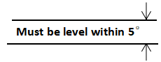

4. Bumper attachments should be reinforced, as shown below.

5. Attachments to the towed vehicle should be bolted, not welded.

6. Keep the mounting surface of brackets as close to being flush with the front of the bumper as possible to allow free vertical travel.

7. Attach the tow bar to properly mounted brackets with pins and secure it with the attached wire.

8. Adjust the coupler for proper fit to the ball; see coupler adjustment.

9. Avoid suspension and brake components with attachments.

**TOWED VEHICLE ATTACHMENT**

A structure must be fabricated to allow the tow bar to be attached to the frame of the towed vehicle. Some typical frame attachment structures are shown below.

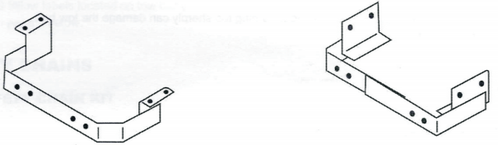

If the bumper is used for support, it must be reinforced with frame attachments. A typical way of reinforcing a bumper is shown below.

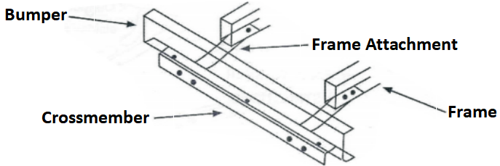

These frame attachments should be attached within 2'' of the tow bar brackets to be connected. These frame attachments should be made from at least 1/2" x 2" flat bar stock. Never attaches through plastic fascia covering a bumper. With customer approval, this fascia must be trimmed to provide a secure attachment.

**COUPLER**

**COUPLER ADJUSTMENT:**

1. With the coupler locked onto a 2" dia. ball, tighten the locknut until all parts are clamped solid.

**NOTE:** DO NOT OVERTIGHTEN. JUST TIGHTEN ENOUGH TO FULLY COMPRESS HELICAL SPRING.

1. Back locknut off 1/2 to 3/4 turn.

3. Check for proper couple/uncouple operation.

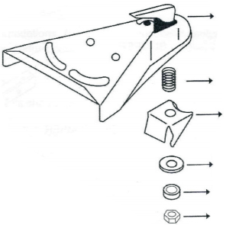

Locknut

Helical Spring

Hardened Washer

Ball Clamp

Papered Coil Spring

Locking Lever Assembly

**INSTALLATION**

1. Center the tow bar on the attachment surface, spreading side arms to at least 24", and mark the tow bar bracket centerlines.

2. Using the tow bar bracket as a template, drill two 1/2" holes into the attachment surface on each side.

3. Attach tow bar brackets to the attachment surface using the 1/2 x 1-3/4 Gr5 bolts supplied with the tow bar.

****NOTE:****IF LONGER BOLTS ARE NEEDED, USE 1/2-13 Gr5 BOLTS.

4. Fasten the tow bar brackets with flat washers and locknuts, as shown below.

5. Tighten these 1/2" fasteners to 75 lb-ft..

**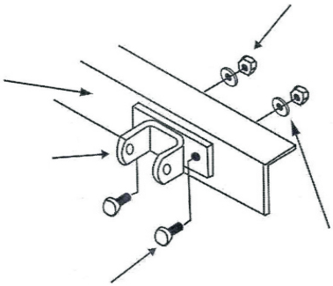**

Attachment Surface

Flat Washer (4 Places)

1/2 x 1-3/4 GR5 BOLT (4 Places)

**HOOK-UP**

1. Attach the tow bar to the tow bar brackets with two wire lock pins.

2. Attach the tow bar coupler to the 2" ball of the towing vehicle.

3. Center coupler on tow bar side arms so that the tow bar is symmetrical about the centerline of the vehicles.

4. Tighten the nuts which attach the tow bar side arms to the coupler to 31 lb-ft.

5. Install the safety chains as described in the next section.

6. Connect an adequate wiring harness so that stoplights, turn signals, and taillights operate on a towed vehicle in conjunction with towing vehicle's lights.

7. Read and follow labels located on the tow bar.

USE SAFETY CHAIN :

1. Connect safety chains to both vehicles and the tow bar itself.

2. Attach chains to the tow bar with U-bolts and flanged locknuts.

3. Tighten each flanged locknut until U-bolt threads extend past locknut.

4. Cross two chains under the coupler and connect to the chair bracket on the hitch or to the frame of towing vehicle allowing only enough slack to permit turning.

Connect To Chain Bracket On Hitch

Or to Frame of Towing Vehicle

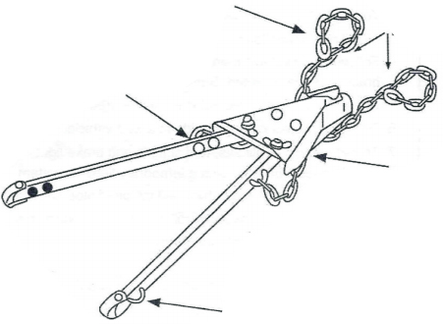

Cross Chains

Under Coupler

Quick Link

Flanged Locknut

(8 Places)

U-Bolt

1. Check bolts and safety pins regularly .

**MAINTENANCE**

2. Do not overload.

****

**Technical Support and E-Warranty Certificate**

**[www.vevor.com/support](https://www.vevor.com/support" \t "_blank)**