1

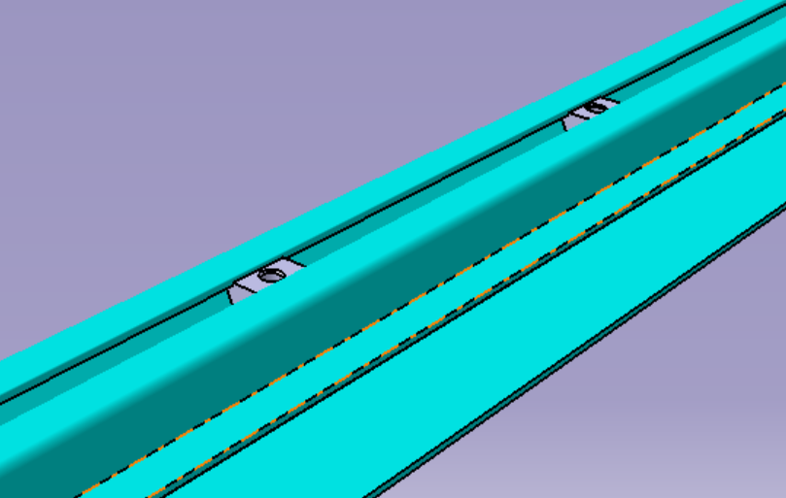

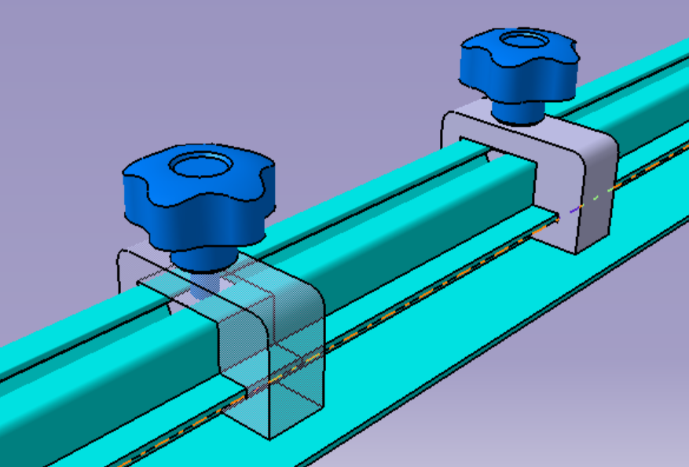

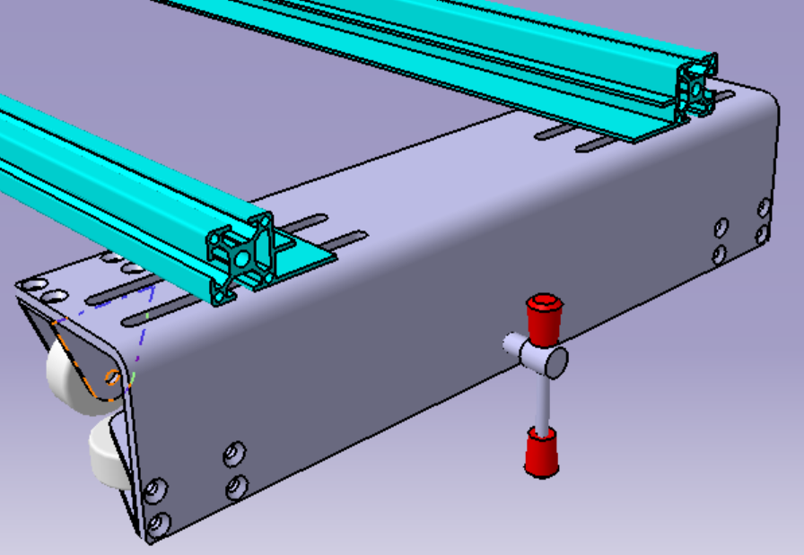

1. Put two moving nuts into the sliding groove of an aluminum profile as shown in the figure, and four moving nuts into the sliding groove on the reverse side. The second aluminum profile is only installed in the chute on the reverse side with four swimming.

2. Put the two locking blocks on the aluminum profile in the direction shown in the figure, insert the five-star bolts through the holes on the locking blocks and align them with the moving nut blocks installed in the chute in the first step and tighten them. The trimming machine pallet is placed between two locking blocks to control the lateral movement of the trimming machine.

3. Align the nut block in the chute on the reverse side of the aluminum profile with the long hole on the roller bracket and lock it with bolts, adjust the relative position of the aluminum profile and the roller bracket, so that the pallet of the trimming machine can be placed between the two aluminum profiles. It slides flexibly in between, and makes the roller press just on the edge of the worktable.

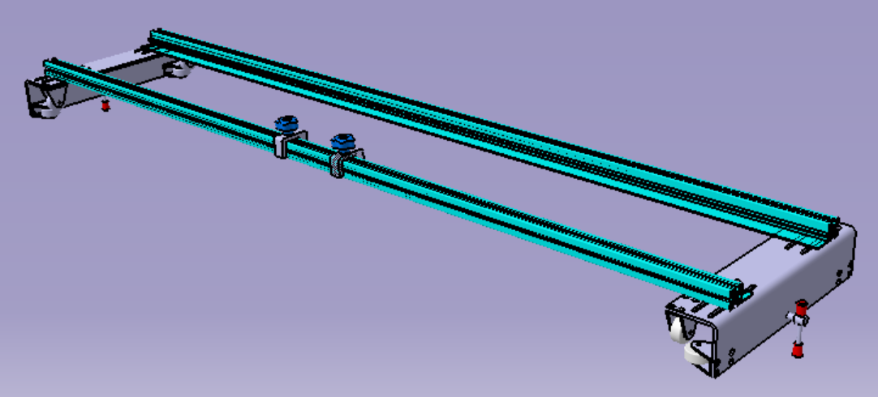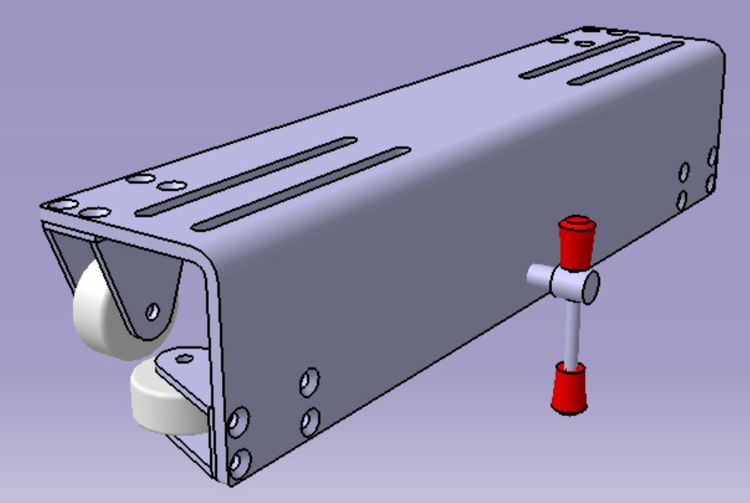

5. When you need to fix the front and back direction of the trimming machine, you can tighten the handle as shown in the figure to make the front end of the handle press against the edge of the worktable.

4. The assembled state

