## Arm intravenous injection model

1、 Product function:

1. The eight main venous systems distributed on the arm can be used for puncture training such as intravenous injection, infusion (blood), and blood drawing.

2. It can be injected into deltoid muscle.

3. The upper limb can be rotated 360 degrees, which can imitate the human arm, which is convenient for puncture practice.

4. The needle has obvious sense of falling into the air, and there is blood return when puncturing correctly.

5. The same puncture site of vein and skin can withstand hundreds of repeated puncture without leakage.

6. The annular holster provides multiple training points for intradermal injection, which is put on the model arm. If the liquid injection is correct, a hillock will appear on the skin. After the liquid is drawn out, the hillock will disappear.

2、 Installation method:

1. Take out the silicone upper limb model and adjusting infusion stand from the packing box.

2. Screw the fixing nut to firmly fix the hanging infusion bottle bracket on the jack position of the model support plate.

3. Blood simulation with a small amount of blood powder and water configuration.

3、 Training steps:

1. Blood was drawn from forearm vein of elbow

Step 1: 50 ml disposable syringe was connected with the upper rubber tube of the plastic upper limb model, and the simulated blood was injected and filled with blood vessels. As shown in the figure:

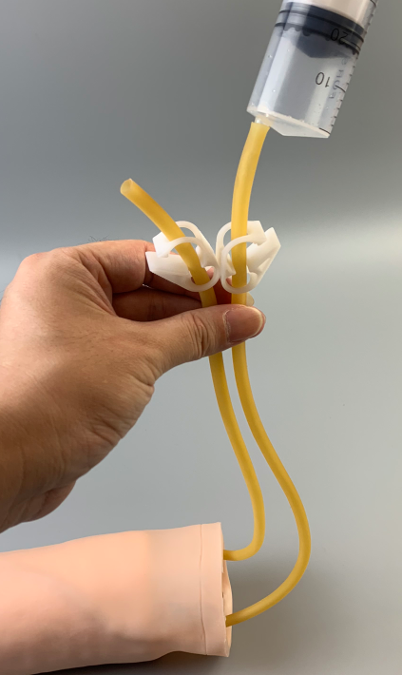

**Two clips released**

**The blood vessels were filled with simulated blood**

**(after a head of water overflows, it is necessary to continue to irrigate water to drain the air in the blood vessel. The air in the blood vessel will affect the blood return.)**

**One end clamp of blood vessel**

**Place the arm model horizontally**

**The other end clamp is released**

**The hand vessel is higher than the arm model**

**Venipuncture can produce blood returning effect**

**Warm tips: when injecting water, do not clamp the clamp. Both clamps must be released and filled with water. Otherwise, the blood vessel with needle eye may leak. It is recommended to use tap water directly for the first operation, and blood powder can be used to simulate blood and water operation (improper blood and water operation can easily contaminate the model)**

Step 2: routine disinfection of elbow and forearm skin.

Step 3: select the suitable vein, puncture the vein with 5 ml syringe, and draw 2 ml venous blood (blood simulation solution).

2. Intravenous injection or intravenous infusion through elbow forearm:

Intravenous injection or intravenous infusion is to inject liquid medicine into the vein under pressure. The common veins are cephalic vein and basilic vein,

Purpose: A: rescue or treatment of patients, through intravenous pressure injection of glucose solubilized liquid or blood patients, increase the blood volume of coronary artery and carotid artery, so as to improve the blood flow of heart and brain, and recover blood pressure through reflex to rescue or treat patients. B: It is used to perform some special examinations, etc. C: For chemotherapy.

3. Intravenous injection or intravenous infusion operation training:

Step 1: (the same as step 1 of blood drawing through elbow forearm vein), using injection plate, suitable syringe, No. 6-8 needle, medicine, sandbag, sterile gloves and sterile treatment towel, etc. In case of neonatal patients can choose radial vein, blood disease patients contraindicated this method of injection, in order to avoid bleeding.

Step 2: disinfect the skin of elbow and forearm routinely, wear sterile gloves and lay sterile hole towel.

Step 3: fix the selected vein with the left index finger and middle finger, the other hand with a syringe (50ml syringe, No. 6-8 needle) with the liquid extracted, and stab into the vein vertically at 40 ° angle. When the red liquid enters the syringe, clamp the upper rubber tube clamp to block the upper rubber tube, loosen the lower rubber tube clip, fix the puncture needle with one hand, and at the same time, use the other hand to fix the puncture needle Push the liquid medicine as fast as possible with one hand, so that the liquid medicine in the syringe flows through the pipeline system in the model, and the liquid medicine enters the waste liquid bottle through the lower rubber tube. After the injection, quickly pull out the needle. When there is red liquid entering the syringe, release the upper rubber pipe clamp and adjust the dripping speed of the intravenous infusion set, so that the red blood simulation liquid in the infusion bottle flows through the pipeline system in the model, and enters into the waste liquid bottle through the lower rubber tube, and the puncture needle is fixed.

4. Transfemoral blood transfusion through elbow forearm

Step 1: the same as step 1 of drawing blood through elbow forearm vein.

Step 2: routine disinfection of elbow and forearm skin.

Step 3: select a suitable vein and puncture the vein with an injection needle. When the red liquid enters the vein, adjust the dropping speed of the venous transfusion set to make the red blood simulation liquid in the infusion bottle flow through the pipeline system in the model and enter the waste liquid bottle through the lower rubber tube.