

Technical Support and E-Warranty Certificate [www.vevor.com/support](https://www.vevor.com/support" \t "_blank)

**Manual Gear Chain Hoists**

**User's Manual**

We continue to be committed to provide you tools with competitive price.

"Save Half", "Half Price" or any other similar expressions used by us only represents an estimate of savings you might benefit from buying certain tools with us compared to the major top brands and doses not necessarily mean to cover all categories of tools offered by us. You are kindly reminded to verify carefully when you are placing an order with us if you are actually saving half in comparison with the top major brands.



**Manual Gear Chain Hoists**

**Model: HC0.5-3，HC1-3，HC1-6，HC2-3，HC3-3**

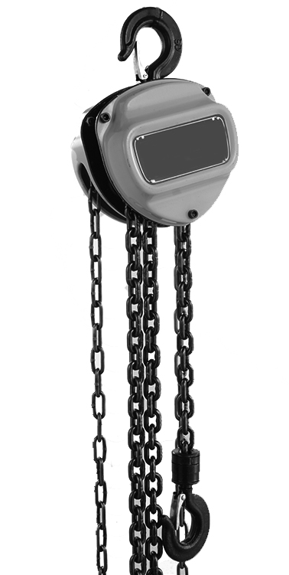

Have product questions? Need technical support? Please feel free to contact us:

**[CustomerService@vevor.com](mailto:CustomerService@vevor.com)**



**NEED HELP? CONTACT US!**

This is the original instruction, please read all manual instructions carefully before operating. VEVOR reserves a clear interpretation of our user manual. The appearance of the product shall be subject to the product you received. Please forgive us that we won't inform you again if there are any technology or software updates on our product.

**SAFE INSTRUCTIONS**

警示WARNING:

Before use, check if the machine parts are intact, the transmission part and lifting chain are well lubricated, the idling condition is normal, and the braking is reliable.

**The following rules must be strictly observed during use.**

1.It is forbidden to use two or more hoists to lift a heavy object at the same time.

2.Do not hang heavy objects that exceed the max. lifting capacity.

3.It is forbidden to lift heavy objects at the tip of the hook and bind heavy objects with lifting chains.

4.The lifting and lowering of heavy objects shall not exceed the limit of the upper and lower movable distance.

5.It is not allowed to pull the weight diagonally and horizontally.

6.It is forbidden to roll the lower hook frame of 2t and 3t products with double-row lifting chains in the double-row chains.

7.The chain shall not be used when it is twisted.

8.It is strictly forbidden for personnel to work or walk under the lifted load.

9.If the hand pull force is greater than the normal hand pull force, stop using it immediately and check it. Do not pull hard, let alone add people to pull hard.

10.Don't throw the hoist.

警示CAUTION: Carefully read instructions and procedures for safe operations.

**Product Introduction**

Model

|  |  |  |  |  |  |
| --- | --- | --- | --- | --- | --- |
| SPEC. | **HC0.5-3** | **HC1-3** | **HC1-6** | **HC2-3** | **HC3-3** |
| **Max. Lifting Capacity** | 0.5t | 1t | 1t | 2t | 3t |
| **Max. Lifting Height** | 10ft | 10ft | 20ft | 10ft | 10ft |
| **Material** | Alloy Steel | Alloy Steel | Alloy Steel | Alloy Steel | Alloy Steel |
| **Load Chain Size** | 6\*18mm  G80 | 6\*18mm  G80 | 6\*18mm  G80 | 6\*18mm  G80 | 8\*24mm  G80 |
| **Hand Chain Size** | 4.6\*25mm | 4.6\*25mm | 4.6\*25mm | 4.6\*25mm | 4.6\*25mm |
| **Normal Hand Pull Force** | 200N | 320N | 320N | 365N | 385N |

Package Content

|  |  |  |  |  |  |
| --- | --- | --- | --- | --- | --- |
| Model  Parts | **HC0.5-3** | **HC1-3** | **HC1-6** | **HC2-3** | **HC3-3** |
| **Manual Gear Chain Hoists** | **1** | **1** | **1** | **1** | **1** |
| **User's Manual** | **1** | **1** | **1** | **1** | **1** |

**Product Diagram**

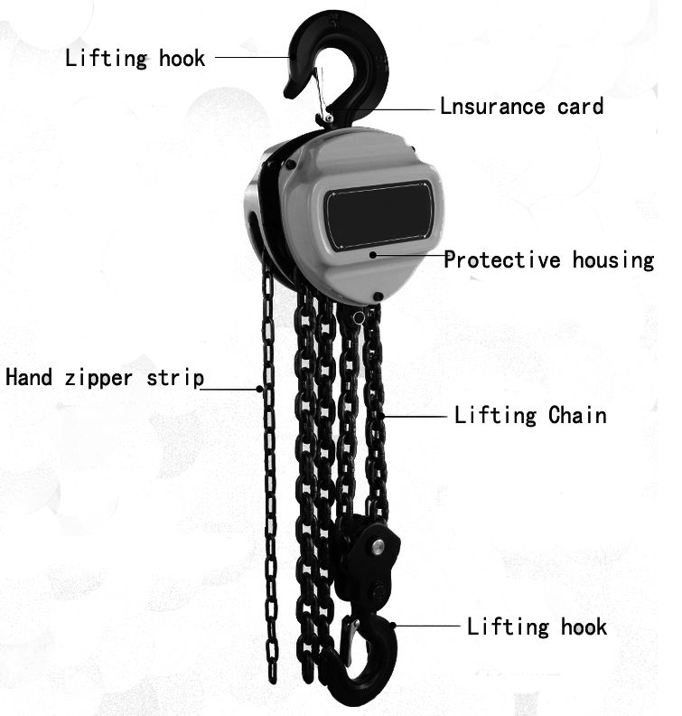

3

4

5

2

1

**L**

**Fig. 1**

1. Upper Hook 2. Hand Chain 3. Protective Housing

4. Load Chain 5. Lower Hook

**Installation Instruction**

The chain hoist is a simple and portable manual lifting machine, which is applicable to factories, mines, construction sites, agricultural production, wharves, docks, warehouses, etc. as installation machines for lifting goods and loading and unloading vehicles, especially for open-air and non-power operations.

1.First of all, ensure that the hoist is firmly suspended and reliable.

2.The suspension rod load must be greater than the weight of the weight and hoist combined,so as to avoid personal injury or accidents.

3. It is strictly prohibited to use the Manual Gear Chain Hoists with overload.

4.It is forbidden to operate with forces other than manpower.

5. Before use, make sure that the parts are intact, the transmission part and the lifting chain are well lubricated, and the idling condition is normal.

6. Before lifting, check whether the upper and lower hooks are fastened. The lifting chain shall be hung vertically, and there shall be no chain link with wrong twist. The lower hook frame of the double chain shall not be overturned.

7. The operator should stand in the same side as the hand chain wheel and pull the hand chain, so that the hand chain wheel rotates clockwise to make the weight rise; Pull the handle chain in the reverse direction, and the weight can fall slowly.

8. When lifting heavy objects, it is strictly forbidden for personnel to do any work or walk under the heavy objects to avoid personal injury or accidents.

9. In the process of lifting, no matter the weight rises or falls, when dragging the hand chain, the force should be even and gentle, not too strong, so as to avoid personal injury or parts damage.

10. If the operator finds that the hand tension is greater than the normal tension, he shall immediately stop using it. Prevent damaging the internal structure to prevent falling objects.

11. After the heavy object has landed safely and stably, remove the lower hook .

12. After use, handle it gently, place it in a dry and ventilated place, apply lubricating oil and put it away.

**TROUBLESHOOTING MAINTENANCE, AND REPAIR**

1.The chain is kinked, and the fault is usually caused by not combing the chain when hanging it. The solution is to comb it and hang it again.

2.The failure reason of the chain jumping is that the chain and sprocket are not in the same working face . The solution is to keep the chain and sprocket in the same working face when operating.

3. Hand chain stuck, the solution is to pull the hand chain in reverse.

1.After use, the hoist shall be cleaned and coated with anti-rust oil and stored in a dry place.

2.Maintenance and overhaul shall be carried out by those familiar with the hoist mechanism to prevent those who do not understand the performance principle of the mechanism from being removed at will.

3. After cleaning and maintenance, the hoist shall be subject to no-load and heavy-load tests, and can be delivered for use only when it is confirmed that the hoist works normally and the brake is reliable.

4. The friction surface of the brake must be kept clean, and the brake part should be checked regularly to prevent brake failure. Self-falling of heavy objects occurs.

**Importer:** WAITCHX

**Address:** 250 bis boulevard Saint-Germain 75007 Paris

**Importer:** FREE MOOD LTD

**Address:** 2 Holywell Lane, London, England, EC2A 3ET

**Manufacturer：**Daimler(Hebei) Hoisting Machinery Manufacturing Co., Ltd

**Add:** Donglu Industrial Park,Qingyuan District,Baoding City,Hebei Pronvince

**REP**

**UK**

EUREP UK LTD

UNIT 2264, 100 OCK STREET, ABINGDON

OXFORDSHIRE ENGLAND OX14 5DH

**REP**

**EC**

EUREP GmbH

Unterlettenweg 1a, 85051

Ingolstadt, Germany

**Made In China**

****

**Technical Support and E-Warranty Certificate**

**[www.vevor.com/support](https://www.vevor.com/support" \t "_blank)**