

Technical Support and E-Warranty Certificate [www.vevor.com/support](https://www.vevor.com/support" \t "_blank)

**Dock Ladder**

**User's Manual**

We continue to be committed to provide you tools with competitive price.

"Save Half", "Half Price" or any other similar expressions used by us only represents an estimate of savings you might benefit from buying certain tools with us compared to the major top brands and doses not necessarily mean to cover all categories of tools offered by us. You are kindly reminded to verify carefully when you are placing an order with us if you are actually saving half in comparison with the top major brands.



**Dock Ladder**

**Model:ZT-C03，ZT-C04，ZT-C05**

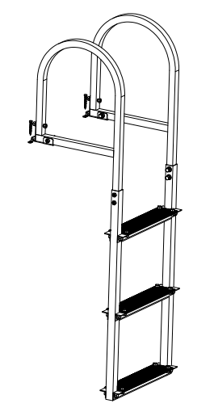 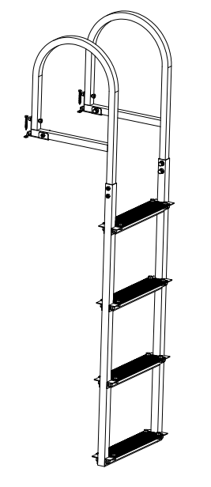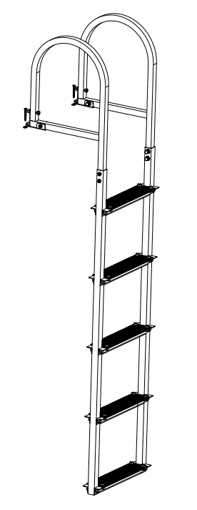

Have product questions? Need technical support? Please feel free to contact us:

**[CustomerService@vevor.com](mailto:CustomerService@vevor.com)**



**NEED HELP? CONTACT US!**

This is the original instruction, please read all manual instructions carefully before operating. VEVOR reserves a clear interpretation of our user manual. The appearance of the product shall be subject to the product you received. Please forgive us that we won't inform you again if there are any technology or software updates on our product.

**SAFE INSTRUCTIONS**

**WARNING:**

Carefully read instructions and procedures for safe operations. and SAVE THESE INSTRUCTIONS

Do not modify the ladder / platform design.

• Do not move a ladder / platform while standing on it.

• Do not use in bad weather, such as wind, rain, snow and so on；It is recommended to use the ladder in clear weather.

**Before Use**

1. Ensure that you are fit enough to use a ladder. Certain medical conditions or medication, alcohol or drug abuse could make ladder use unsafe;

2. When transporting ladders on roof bars or in a truck, ensure they are suitably placed to prevent damage;

3. Inspect the ladder after delivery and before first use to confirm condition and operation of all parts;

4. Visually check the ladder is not damaged and is safe to use at the start of each working day when the ladder is to be used;

5. For professional users, regular periodic inspection is required;

6. Ensure the ladder is suitable for the task;

7. Do not use a damaged ladder. Before using the ladder, ensure that the ladder is securely installed to prevent personal injury and accidents;

8. Remove any contamination from the ladder, such as wet paint, mud, oil or snow;

9. Before using a ladder at work, a risk assessment should be carried out respecting the legislation in the country of use;

10. When using the ladder, do not overload the ladder to avoid personal injury or accidents;

11. Do not use the ladder for two or more people at the same time;

12. Minors should only use ladders under the guidance of their guardians;

13. When using a ladder, climb up or down slowly to avoid personal injury or accidents caused by falling or bumping the ladder;

14. Before using a ladder after placing it for a long time, check whether the ladder is loose to prevent personal injury or accidents;

15. Before installing the ladder, ensure that the dock mounting plate is solid and ready for use;

16. To avoid personal injury, do not install a ladder if the dock mounting plate is rotten;

**Positioning and Erecting the Ladder**

1. Ladder shall be erected at the correct position, such as the correct angle for a leaning ladder;

2.Ladder shall be on an even, level and unmoveable base;

3.Leaning ladder should lean against a flat nonfragile surface and should be secured before use, e.g. tied or use of a suitable stability device;

4.Ladder shall never be repositioned from above;

5.When positioning the ladder, consider the risk of collision with the ladder e.g. from pedestrians, vehicles or doors. Secure doors (not fire exits) and windows where possible in the work area;

6.Identify any electrical risks in the work area, such as overhead lines or other exposed electrical equipment;

7.Ladder shall be stood on its feet, not the rungs or steps;

8.Ladders shall not be positioned on slippery surfaces (such as ice, shiny surfaces or significantly contaminated solid surfaces) unless additional effective measures are taken to prevent the ladder slipping or ensuring contaminated surfaces are sufficiently clean.

**Using the Ladder**

1.Do not exceed the maximum total load for the type of ladder;

2.Do not overreach; user should keep their belt buckle (navel) inside the stiles and both feet on the same step/rung throughout the task;

3.Do not step off a leaning ladder at a higher level without additional

security, such as tying off or use of a suitable stability device;

4.Do not stand on the top three steps/rungs of a leaning ladder;

5.Do not stand on the top two steps/rungs of a standing ladder without a platform and hand/knee rail;

6.Do not stand on the top four steps/rungs of a standing ladder with an extending ladder at the top;

7.Ladders should only be used for light work of short duration;

8.Use non-conductive ladders for unavoidable live electrical work;

9.Do not use the ladder outside in adverse weather conditions, such as strong wind;

10.Take precautions against children playing on the ladder;

11.Secure doors (not fire exits) and windows where possible in the work area;

12.Face the ladder when ascending and descending;

13.Keep a secure grip on the ladder when ascending and descending;

**Product Introduction**

**Model**

|  |  |  |  |
| --- | --- | --- | --- |
| **SPEC.** | **ZT-C03** | **ZT-C04** | **ZT-C05** |
| Steps | 3 | 4 | 5 |
| Step Spacing | 300mm | 300mm | 300mm |
| Step Size( L\*W) | 350\*80mm | 350\*80mm | 350\*80mm |
| Load Capacity | 500Lbs | 500Lbs | 500Lbs |
| Material | Aluminum | Aluminum | Aluminum |

**Product Diagram**

**（Take ZT-C03 as an example）**

1

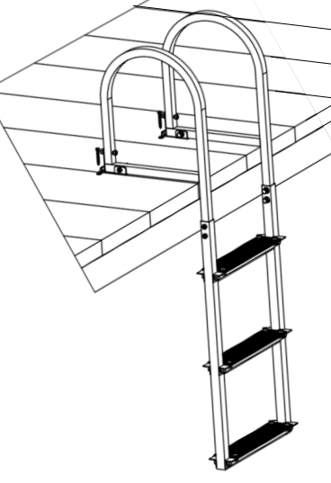

2

3

4

1. Handrail 2.Frame 3. Step 4. Clasp

**COMPONENTS**

|  |  |  |  |  |  |
| --- | --- | --- | --- | --- | --- |
| **NO.** | **Name** | **Picture** | **Q’ty of ZT-C03** | **Q’ty of ZT-C04** | **Q’ty of ZT-C05** |
| 1 | A |  | 4 | 4 | 4 |
| 2 | B |  | 8 | 8 | 8 |
| 3 | C |  | 12 | 16 | 20 |
| 4 | D |  | 12 | 16 | 20 |
| 5 | E |  | 2 | 2 | 5 |
| 6 | F |  | 2 | 2 | 2 |
| 7 | G |  | 3 | 4 | 5 |
| 8 | H |  | 3 | 4 | 5 |
| 9 | I |  | 2 | 2 | 2 |
| 10 | J |  | 2 | 2 | 2 |

**INSTALLATION INSTRUCTION**

1. Two or more people to move and assemble the workbench.
2. Please prepare a carpet or mat to protect your floor you need to spread out all the accessories.
3. Please prepare gloves to avoid being scratched by sharp parts that may occur during installation.
4. Please open all the boxes to check if the accessories are complete and in good condition.
5. If you need to use power tools to install this product, please set the speed to low speed in advance.
6. When installing please align all the holes and do not tighten all the screws first, otherwise, it may make the installation difficult.

**Installation:**

**STEP 1:** Install non-slip mat(G) on the steps(H).

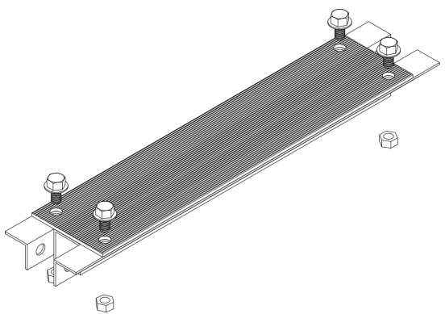

G

G

D

H

**STEP 2:** Install the steps.

C

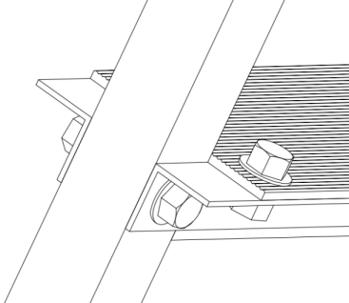 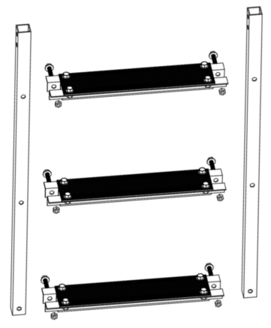

I

I

**STEP 3:** Install two handrails(J) as shown.Note that pass the bolts through the mounting holes from inside out.

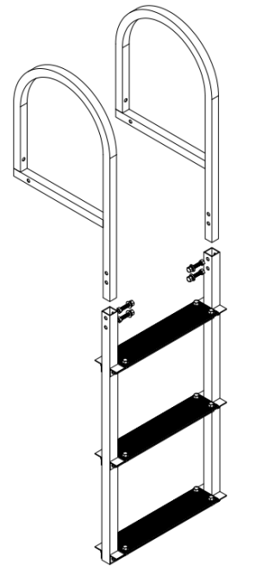

J

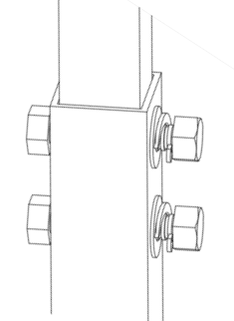

B

**STEP 4:** Install the clasps(F).Note that pass the bolts through the mounting holes from inside out.

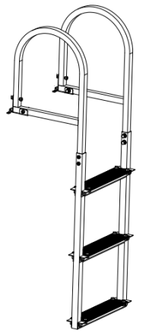

B

F

B

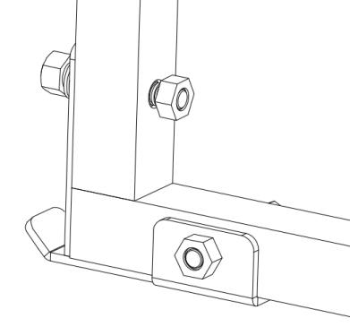

**STEP 5:** Make sure all parts are locked again. Install the clasp rack(E) on the dock mounting plate,and then hook the ladder.

(This product only provides accessories for wooden dock mounting plates. Other installation methods need to purchase additional accessories)

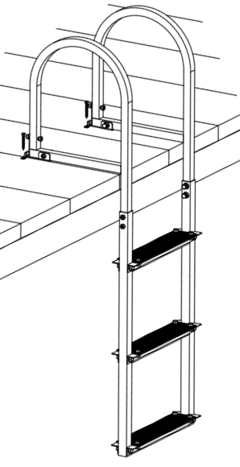

E

A

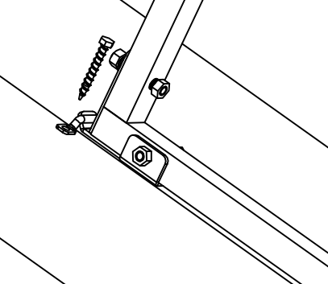

**Note:**

1. For a wooden dock mounting plate,the recommended thickness is

greater than 50mm. Place the ladder at the appropriate position of the mounting plate and match the clasp rack ,then mark the installation holes,remove the ladder and lock the clasp rack with the self-tapping nails,finally hook the ladder.

1. For a concrete dock mounting plate,the recommended thickness is

greater than 80mm. Place the ladder at the appropriate position of the mounting plate and match the clasp rack,then mark the installation holes,remove the ladder and drill holes 8mm in diameter and 70mm in depth at the marks,then fix the M6\*60 expansion bolts in the hole,install the clasp rack on the expansion bolt and lock the nut,finally hook the ladder.

1. For an iron dock mounting plate,the recommended thickness is greater

than 5mm. Place the ladder at the appropriate position of the mounting plate and match the clasp rack,then mark the installation holes,remove the ladder and drill through holes 8mm in diameter at the marks,then use stainless steel M6 long bolts and nuts to lock the clasp rack on the mounting plate,finally hook the ladder.

**Above is the ZT-C03 installation,and the installation of the ZT-C04，ZT-C05 is the same as that of ZT-C03**.

**CLEANING,MAINTENANCE AND TROUBLESHOOTING**

1.Before use, please make sure that the dock ladder is installed firmly.

2.Before use,make sure the dock ladder is firmly fixed.

3.When assembling ladders, do not tighten all the screws first; Lock them completely after the installation.

4.When checking the ladder, if some parts are slightly deformed, it can be corrected with a mallet or other tools.

5.Do not overload the ladder when it is used.

6.If the ladder wobbles, stop using it, check whether it is loose, and tighten it again.

7.After each use, remove sand and dirt from the dock ladder and rinse it off with water.

8.If the ladder is not used for a long time, you are advised to disassemble and store it.

9.If some parts of the ladder are seriously damaged. Stop using the ladder and replace them.

Before storing ladders, clean and dry them and store them in a dry, ventilated environment.

**Manufacturer:** HONGXIANG TECHNOLOGY CO.，LTD

**Add:** # 2 factory building, Canal Small and medium enterprise park, Xiangshui County Canal Town, Yancheng, Jiangsu province, China

**Made In China**

****

**Technical Support and E-Warranty Certificate**

**[www.vevor.com/support](https://www.vevor.com/support" \t "_blank)**