**VEVOR Pipe Stand**

**Operating Instructions and Parts Manual**

Please read and save these instructions. Read through this owner's manual carefully before using product. Protect yourself and others by observing all safety information, warnings, and cautions. Failure to comply with instructions could result in personal injury and/or damage to product or property. Please retain instructions for future reference.

**Description**

Design to support pipes for a variety of uses. Do not exceed the maximum capacity of the product.

Inspection/Maintenance

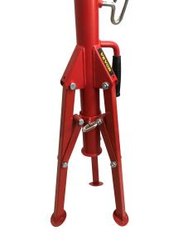Carefully inspect the stand prior to each use for proper assembly (such as the hand screw), wear, damage, or other issues that may affect safe usage. If any problems are found, stop to use until the stand is repaired. Keep the stand clean and all moving parts lightly lubricated to aid in operation.

Operating Instructions and Parts Manual

**General Safety Information**

**WARNING** Read the warnings and instructions for all equipment being used before operating to reduce the risk of serious personal injury.

**WARNING**  Failure to properly support the pipe may result in tipping of the stand, dropping of the pipe, or serious injuries.

**WARNING**  Use the appropriate safety equipment for the intended job such as eye protection,hearing protection, feet protection, dusk masks, face shields, etc to reduce the risk of injuries.

Installation and Operation

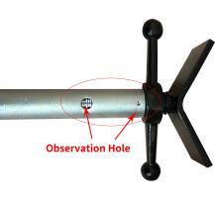1. Make sure that all equipment is inspected and set up accordingly.

2. Make sure that the ground below the pipe stand is clear, stable, and level.

3.The legs of the pipe stand should be fully open and the feet placed squarely on the floor.

4. if the stand is equipped with rollers, ensure the rollers are properly adjusted for the pipe size

5. Fasteners on the pipe stand should be evaluated and ensure that they are secured

6. To adjust the height. Grip head assembly, loosen the hand screw, and raise the lock ring to disengage the elevator tube. Move the head assembly to the desired height. Next, lower the lock ring until it engages the elevator tube, and securely tighten the hand screw. Do not raise the elevator tube past the hand screw or past the unit specifications. The jack screw can be used for fine adjustments to height. Do so by holding the head of the assembly station and carefully turning the jack screw handle to the desired height. Do not force the jack screw handle, as it may cause the screw to come loose from the stand.

7. Position the stand(s) to properly support the pipe. The pipe should be supported in at least two places at all times. The number and placement of stands depends on the size, length, and weight of the pipe length.

8. Carefully place the pipe on the stands. Make sure the pipe is properly centered on the stands to reduce the risk of tipping. Always stay clear of the supported load.

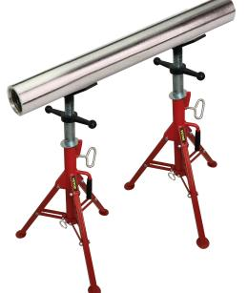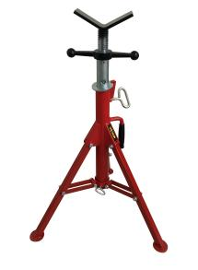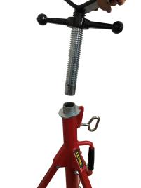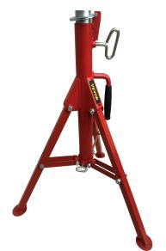

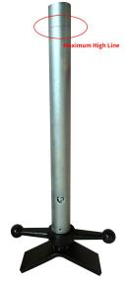**Attention**：

Tighten the safety nut can be more security

Do not exceed the maximum line of the inner tube.

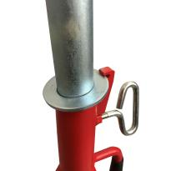

Make sure you can always see the screw through the observation holes.

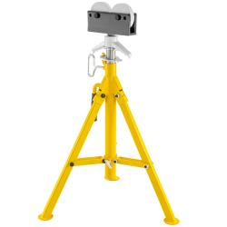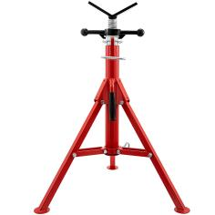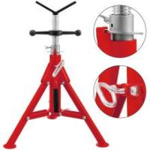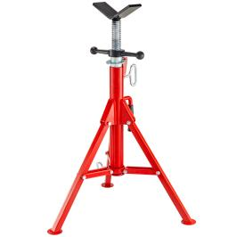

[Pipe Jack Stand Pipe Jack Stand Pipe Jack Stand Pipe Jack Stand Pipe Jack Stand](https://www.ebay.com/itm/123750426938?2592693)

[With V-Head](https://www.ebay.com/itm/123750426938?2592693) With V-Head With V-Head With V-Head With Roller-Head

**1107 1107B 1107C 1107S 1109**

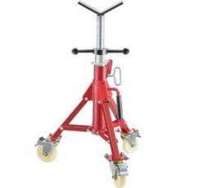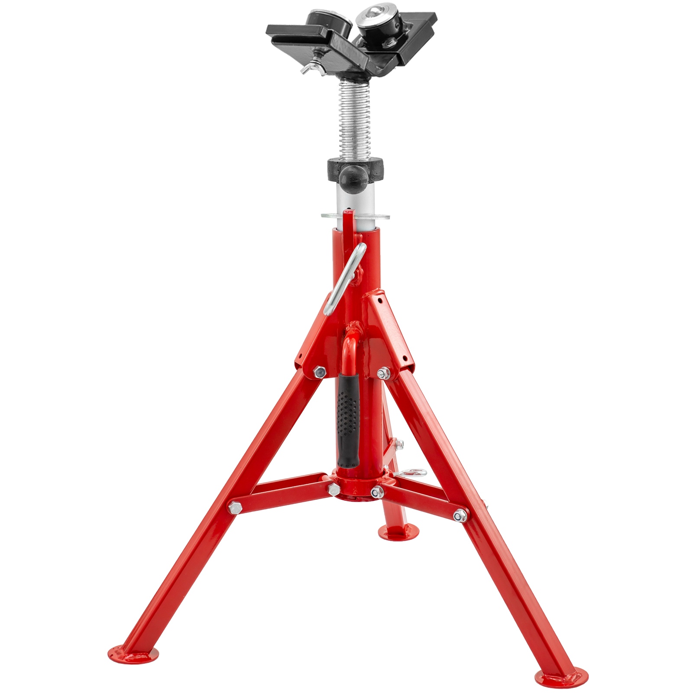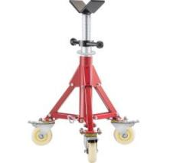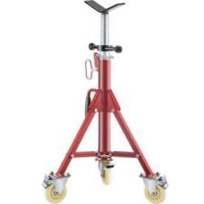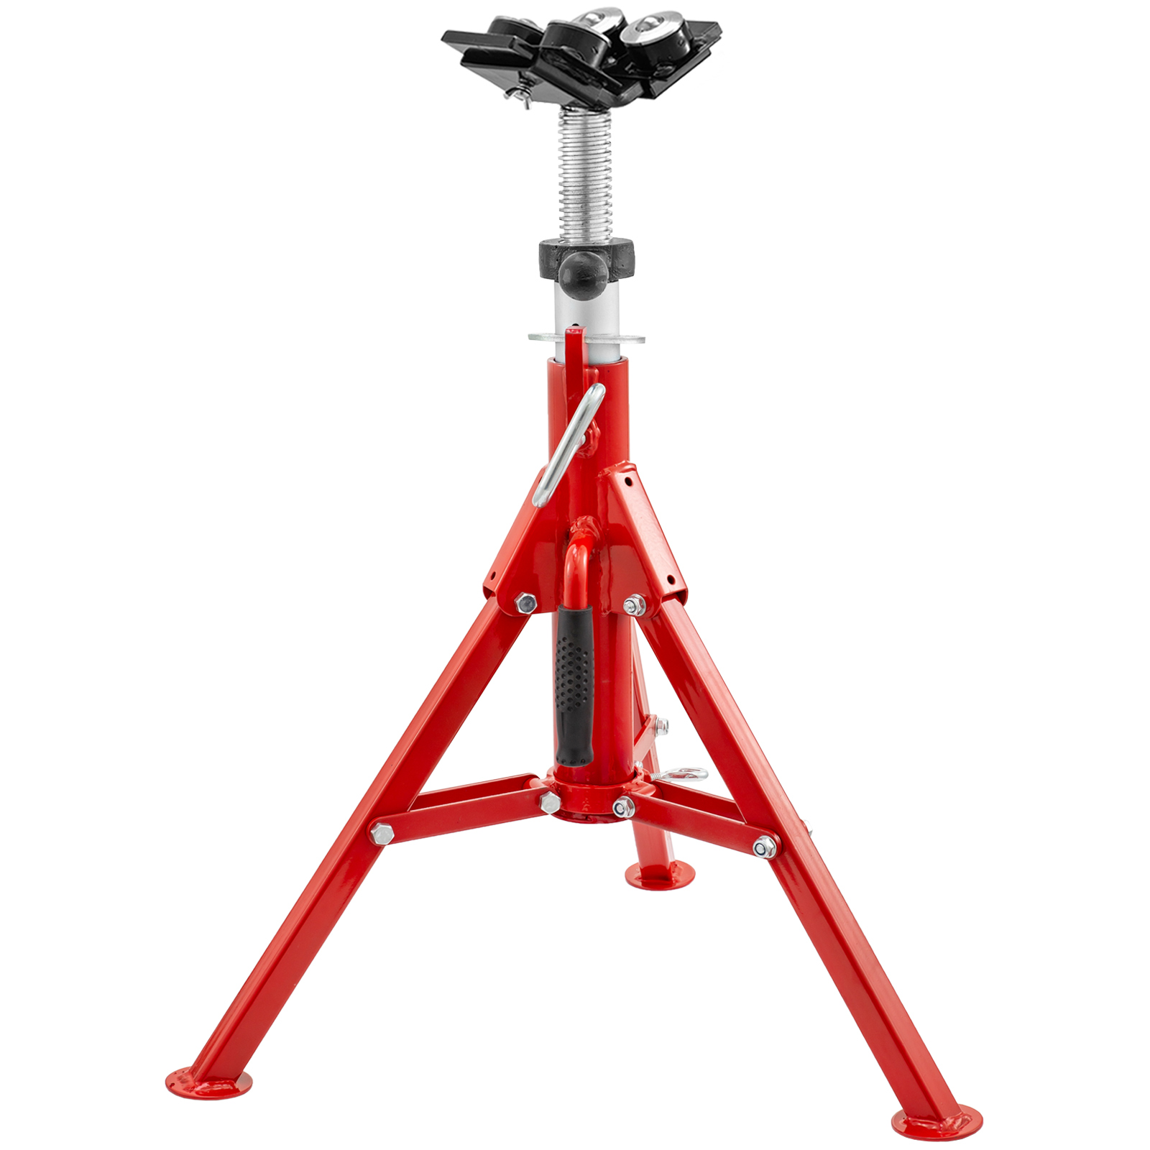[V-Head Pipe V-Head Pipe V-Head Pipe V-Head](https://www.ebay.com/itm/124804282706?6213567" \t "https://vi.vipr.ebaydesc.com/ws/_blank) [Pipe](https://www.ebay.com/itm/124189101683?3983954) [V-Head](https://www.ebay.com/itm/124804282706?6213567" \t "https://vi.vipr.ebaydesc.com/ws/_blank) [Pipe](https://www.ebay.com/itm/124189101683?3983954)

[Jack Stand](https://www.ebay.com/itm/124804282706?6213567" \t "https://vi.vipr.ebaydesc.com/ws/_blank)  Jack Stand Jack Stand Jack Stand Jack Stand

with Casters with Casters with Casters With 4-Ball With 2-Ball

**1107AV 1107BV 1107CV 1107B4-BALL** **1107C2-BALL**

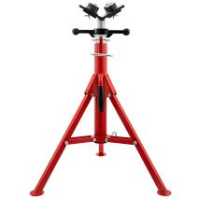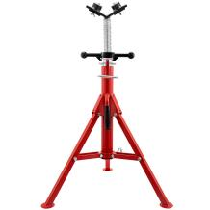V-Head [Pipe V-Head Pipe V-Head](https://www.ebay.com/itm/124680436710?3988960) [Pipe](https://www.ebay.com/itm/124189101683?3983954)  [V-Head](https://www.ebay.com/itm/124680436710?3988960) [Pipe](https://www.ebay.com/itm/124189101683?3983954)  [V-Head](https://www.ebay.com/itm/124680436710?3988960) [Pipe](https://www.ebay.com/itm/124189101683?3983954)

[Jack Stand Jack Stand Jack Stand Jack Stand Jack Stand](https://www.ebay.com/itm/124680436710?3988960)

[With 2-Ball With 4-Ball With 2-Ball With 4-Ball With 2-Ball](https://www.ebay.com/itm/124680436710?3988960) **[1107S2-BALL 1107S4-BALL 1107A2-BALL 1107A4-BALL 1107B2-BALL](https://www.ebay.com/itm/124680436710?3988960)**

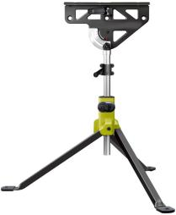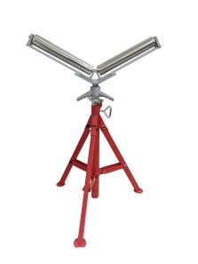

V-Head [Pipe Jack](https://www.ebay.com/itm/124189101683?3983954)  V- Roller Head Mul-Function

Stand With 2-Ball Pipe Stand Jaw Stand

**1107C4-BALL 1106 1108**

**Part Number Pipe Capacity(In.) Max Weight Capacity Overall Height (In.)**

1107 1/8 To 12 2500 lbs 28” To 52”

1107A2-BALL 1/8 To 12 1300lbs 28” To 52”

1107A4-BALL 1/8 To 12 1500lbs 28” To 52”

1107B 1/8 To 12 2500lbs 24” To 42”

1107B2-BALL 1/8 To 12 1300lbs 24” To 42”

1107B4-BALL 1/8 To 12 1500lbs 24” To 42”

1107C 1/8 To 12 2500lbs 20” To 37”

1107C2-BALL 1/8 To 12 1300lbs 20” To 37”

1107C4-BALL 1/8 To 12 1500lbs 20” To 37”

1107S 1/8 To 12 2500lbs 28” To 52”

1107S2-BALL 1/8 To 12 1300lbs 28” To 52”

1107S4-BALL 1/8 To 12 1500lbs 28” To 52”

1109 1/8 To 12 2500lbs 32” To 55”

1106 1/8 To 24 3000lbs 28” To 52”

1108 300lbs 32” To 45”