

Technical Support and E-Warranty Certificate [www.vevor.com/support](https://www.vevor.com/support" \t "_blank)

**Access door**

**Model: M-2320713**

**M-22B2213**

We continue to be committed to provide you tools with competitive price.

"Save Half", "Half Price" or any other similar expressions used by us only represents an estimate of savings you might benefit from buying certain tools with us compared to the major top brands and doses not necessarily mean to cover all categories of tools offered by us. You are kindly reminded to verify carefully when you are placing an order with us if you are actually saving half in comparison with the top major brands.



**Access door**

**Model: M-2320713**

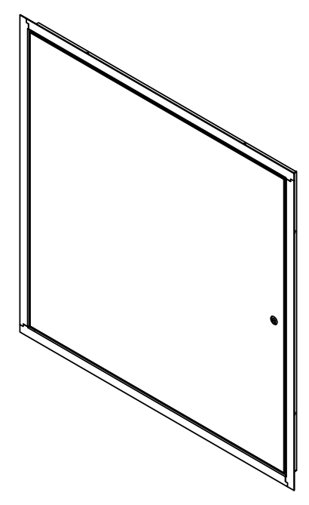 **M-22B2213**

Note: the quantity of parts shown in the manual is the actual usage and the unused parts are spare parts.

Have product questions? Need technical support? Please feel free to contact us:

**[CustomerService@vevor.com](mailto:CustomerService@vevor.com)**



**NEED HELP? CONTACT US!**

This is the original instruction, please read all manual instructions carefully before operating. VEVOR reserves a clear interpretation of our user manual. The appearance of the product shall be subject to the product you received. Please forgive us that we won't inform you again if there are any technology or software updates on our product.

|  |  |
| --- | --- |
|  | Warning-To reduce the risk of injury, user must read instructions manual carefully. |

**IMPORTANT SAFEGUARDS**

Thank you for using this product. In order to make sure that you can operate the machine correctly, read this instruction carefully before operation and keep it properly for future reference. Please be sure to read the precautions and safety rules in this page to ensure your safe use.

This manual will outline safety warnings and precautions, operating, maintenance and cleaning. The warnings and instructions reviewed in this manual cannot cover all possible conditions and situations that may occur. Caution and common sense are not built into this product, since we believe that the uses will comply with these codes.

**Please read ALL the instructions before using your machine.**

1. Do not let children and minors get close to or touch the product.

2. Do not immerse the appliance in water or any other liquid.

3. Using any accessories or attachments that are not provided or recommended by the manufacturer may cause injury.

4. Do not apply this unit to any other purposes than the indicated usage.

5. Do not use it outdoor or for commercial purposes.

7. Never leave it unattended while in use.

8. This appliance can not be used by children aged from 8 years and above and persons with reduced physical, sensory or mental capabilities or lack of experience and knowledge if they have been given supervision or instruction concerning use of the appliance in a safe way and understand the hazards involved. Children shall not play with the machine alone. Cleaning and user maintenance shall not be made by children without supervision.

**PRODUCT PARAMETERS**

|  |  |  |  |
| --- | --- | --- | --- |
| **Model No.** | **Product Size** | **Access Hole Size** | **Door Open Size** |
| M-2320713 | 17.71x17.71x1 inch  (450x450x25.6 mm) | 16.26x16.26 inch  (413x413 mm) | 15.35x16.18 inch  (390x411 mm) |
| M-22B2213 | 25.78x25.78x1 inch  (655x655x25.6 mm) | 24.25x24.25 inch  (616x616 mm) | 23.22x24.8 inch  (590x630 mm) |

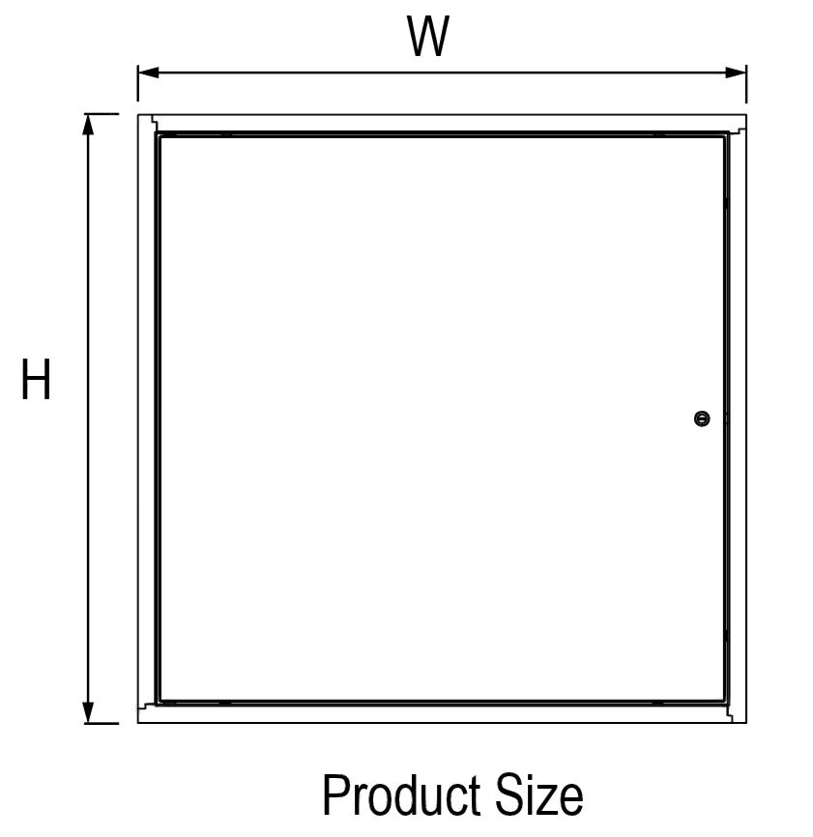

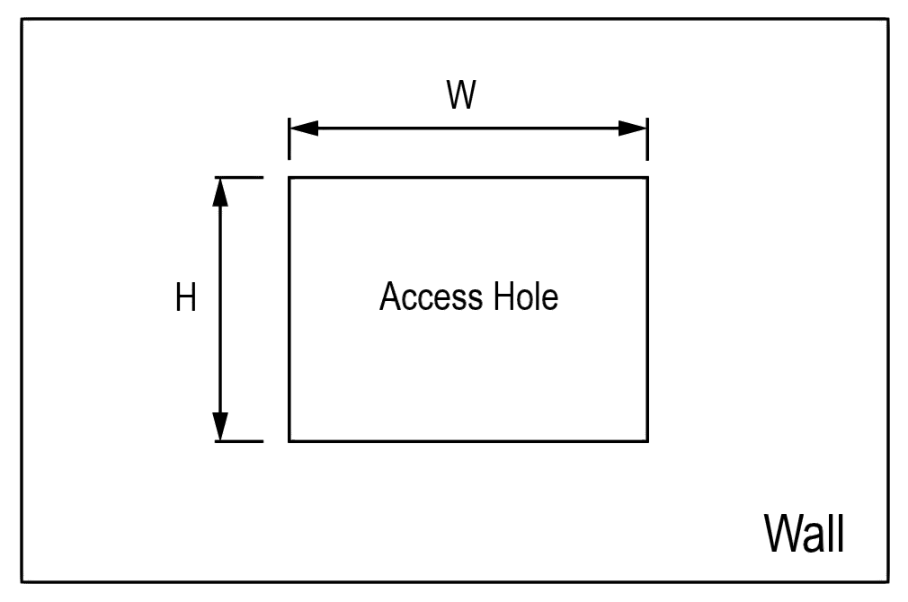

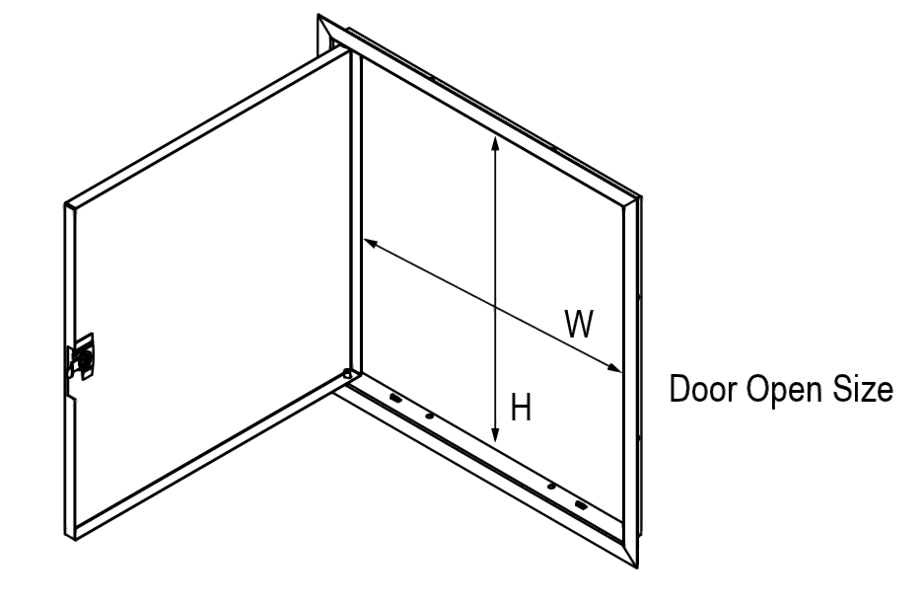

**PRODUCT COMPONENTS**

**ATTENTION!**

1. Check all parts for completeness before beginning assembly.
2. To avoid accidents or sharp edges injuries please assemble and use carefully.
3. Please wear safety protective equipment:gloves and goggles.
4. Check the installation size of the corresponding model of the access hole, and select the access door consistent with or close to the installation size for Installation.

**OPERATING INSTRUCTIONS**

Before using the appliance for the first time, peel off any promotional materials and packaging materials, and check that the cooking plates are clean and free of dust. If necessary, wipe them over with a damp cloth. Spread over with an absorbent kitchen towel and wipe off any excess oil.

**ATTENTION!**



**WARNING!** Keep children and pets away.

**WARNING!** Remove all packaging materials and keep them for future use.Packaging materials are not a toy.

**WARNING!** Don't let children play with the packaging materials. If they swallow the packaging materials, they will suffocate!

**CLEAING MAINTENANCE AND STORAGE**

1. For cleaning, wipe the surface with a damp (not wet) cloth or wipe dry with a clean lint free cotton cloth.
2. Window cleaning liquid or a similar cleaning liquid can be used to clean the surface.
3. Store the appliance in a dry and clean area.

**TIPS**

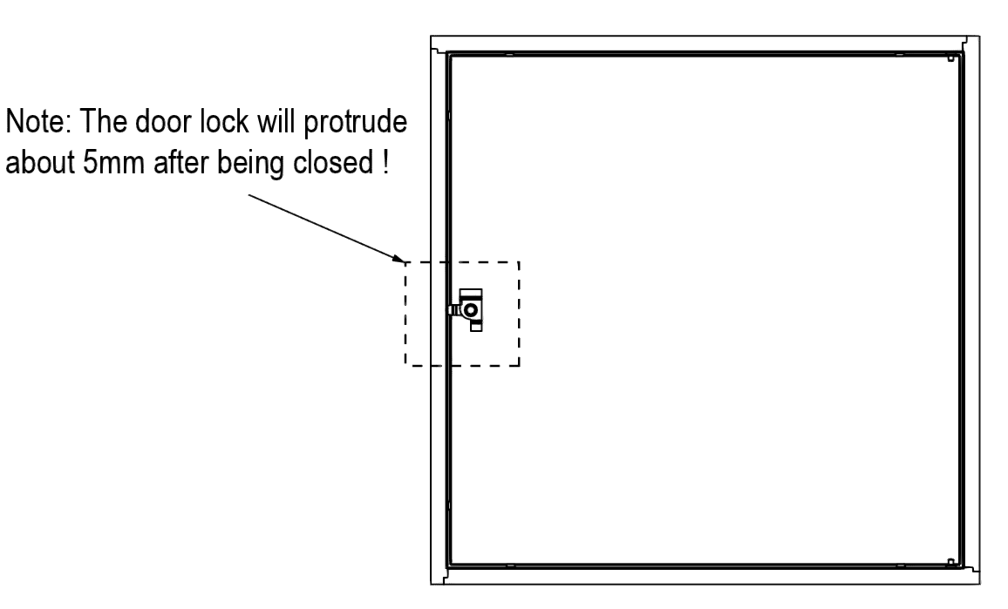

****

**Support and E-Warranty Certificate**

**[www.vevor.com/support](https://www.vevor.com/support" \t "_blank)**

**Made in China**