

Technical Support and E-Warranty Certificate [www.vevor.com/support](https://www.vevor.com/support" \t "_blank)

**Solar street light**

**Model:---------**

We continue to be committed to provide you tools with competitive price.

"Save Half", "Half Price" or any other similar expressions used by us only represents an estimate of savings you might benefit from buying certain tools with us compared to the major top brands and doses not necessarily mean to cover all categories of tools offered by us. You are kindly reminded to verify carefully when you are placing an order with us if you are actually saving half in comparison with the top major brands.



**Solar street light**

**Model:---------**

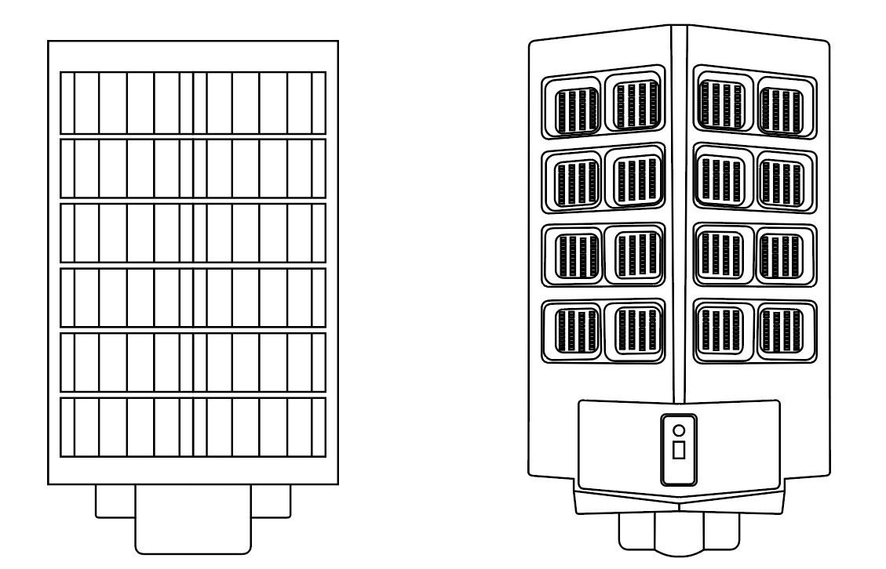

Have product questions? Need technical support? Please feel free to contact us:

**Technical Support and E-Warranty Certificate**

**www.vevor.com/support**

**NEED HELP? CONTACT US!**

This is the original instruction, please read all manual instructions carefully before operating. VEVOR reserves a clear interpretation of our user manual. The appearance of the product shall be subject to the product you received. Please forgive us that we won't inform you again if there are any technology or software updates on our product.

**Product Overview**

Solar light is an electric lamp which converts light energy into electricity by solar panels. The advantage of the product is no wiring, easy to installation and without electricity. In the day, solar panel absorbs the sun's light and convert to electricity and store in batteries. At night, the light will turn on automatically.

**Key Instructions of Remote Control**

**Three Brightness Modes**

(The remote control has memory function, you can set only once.)

1.AUTO mode.AUTO mode means radar mode for all night. This mode is the brightest and the discharging time is more than 5 days.

2.Switch to radar mode after constant light mode. The buttons“2+X”,

“3+X”means switching to radar mode after 2 or 3 hours constant

lighting. The brightness ofthis mode is 70% of radar mode for all night.

3. Always mode. Always mode means constant lighting for all light. The brightness of this mode is 70% of radar mode for all night.

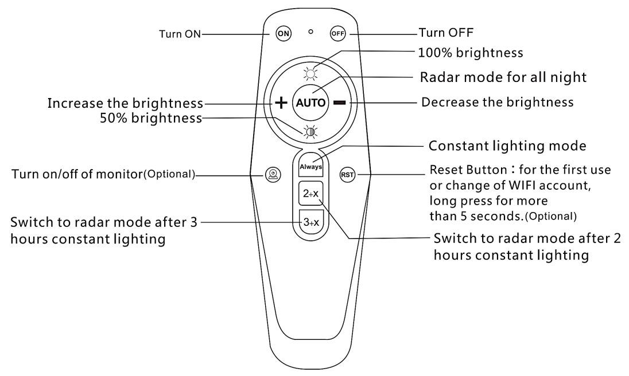

Tips:

1. Pressing the key “AUTO” the light will automatically turn on in the dark

and turn off to charge in the day.

2. The remote control has memory function, you can set according to your

preference.

3. The brightness is 70% of radar mode during in constant lighting mode,

2 hours constant lighting mode, 3 hours constant lighting mode.

**Operating Instruction**

|  |  |  |
| --- | --- | --- |
| 1.Lamp | 2.Screws | 3.Metal Plate |
| 4.Remote Control | 5.Operating Manual |  |

**Installing**

**Light-control Detection.**

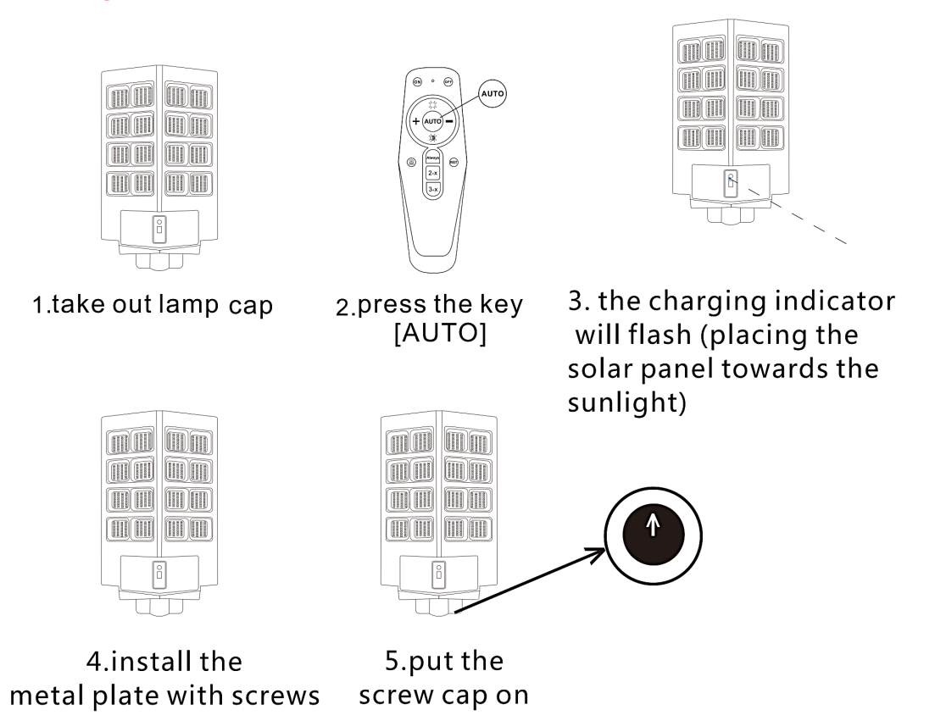

**Installing**

1.Insert the lamp arm into the lamp body and tighten the screw.

2.Make sure the solar panel is installed towards the south and it isn't blocked by obstacles.

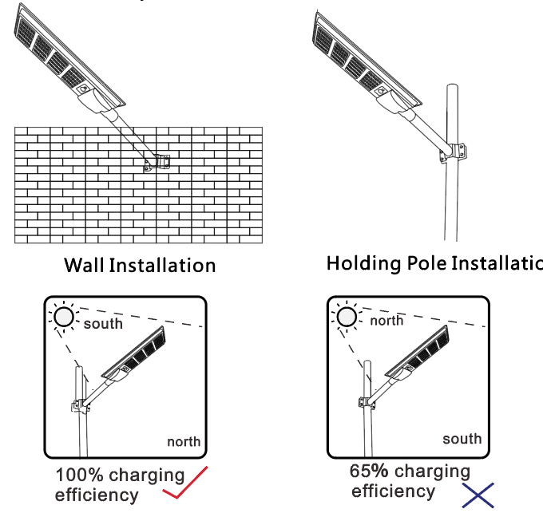

**(A diagram for how the orientation impacts on power generation efficiency)**

**Tips:**

1.Installation direction of the solar panel is 5-10 degrees south to west, an angle of 35 degrees with the horizontal place.

2.Please install the solar panel in the sun direction to avoid affecting the power generation efficiency.

3.Please ensure the installation is stable.

**Address：**Baoshanqu Shuangchenglu 803long 11hao 1602A-1609shi Shanghai

**Imported to AUS:** SIHAO PTY LTD, 1 ROKEVA STREETEASTWOOD NSW 2122 Australia

**Imported to USA:** Sanven Technology Ltd., Suite 250, 9166 Anaheim Place, Rancho Cucamonga, CA 91730

**REP**

**UK**

Pooledas Group Ltd

Unit 5 Albert Edward House, The Pavilions Preston, United Kingdom

**REP**

**EC**

SHUNSHUN GmbH

Römeräcker 9 Z2021, 76351 Linkenheim-Hochstetten, Germany

**Made In China**

****

**Technical Support and E-Warranty Certificate**

**[www.vevor.com/support](https://www.vevor.com/support" \t "_blank)**