

Technical Support and E-Warranty Certificate [www.vevor.com/support](https://www.vevor.com/support" \t "_blank)

**Garment Racks**

**User manual**

**Model:YC0002**

We continue to be committed to provide you tools with competitive price.

"Save Half", "Half Price" or any other similar expressions used by us only represents an estimate of savings you might benefit from buying certain tools with us compared to the major top brands and doses not necessarily mean to cover all categories of tools offered by us. You are kindly reminded to verify carefully when you are placing an order with us if you are actually saving half in comparison with the top major brands.



**Garment Racks**

**Model:YC0002**

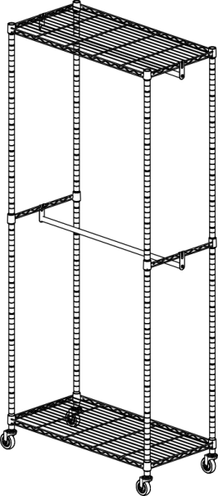

Have product questions? Need technical support? Please feel free to contact us:

**[CustomerService@vevor.com](mailto:CustomerService@vevor.com)**



**NEED HELP? CONTACT US!**

This is the original instruction, please read all manual instructions carefully before operating. VEVOR reserves a clear interpretation of our user manual. The appearance of the product shall be subject to the product you received. Please forgive us that we won't inform you again if there are any technology or software updates on our product.

**SAFETY INSTRUCTIONS**

**WARNING:**

**Read this material before using this product. Failure to do so can result in serious injury.**

**Assembly precautions**

1. Assemble only according to these instructions. Improper assembly can create hazards.
2. Wear ANSI-approved safety goggles and heavy-duty work gloves during assembly.
3. Keep the assembly area clean and well-lit.
4. Keep bystanders out of the area during assembly.
5. Do not assemble when tired or when under the influence of alcohol, drugs or medication.
6. The product capabilities apply to properly and completely assembled products only.
7. Assemble on a flat, level, hard and smooth surface capable of safely supporting the Garment Racks.
8. For additional information regarding the parts listed in the following pages, please refer to the Assembly Diagram of this manual. Unwrap and separate all parts in a clean work area.

**Use precautions**

1. DO NOT SIT OR STAND ON THIS ITEM.
2. This product is not a toy Do not allow children to play with or near this item.
3. Do not exceed weight capacities.
4. Use only on a flat, level, hard and smooth surface capable of safely supporting a fully loaded Garment Racks.
5. Use as intended only.
6. Inspect before every use; do not use if parts are loose or damaged.

**SAVE THIS MANUAL**

**PARTS LIST**

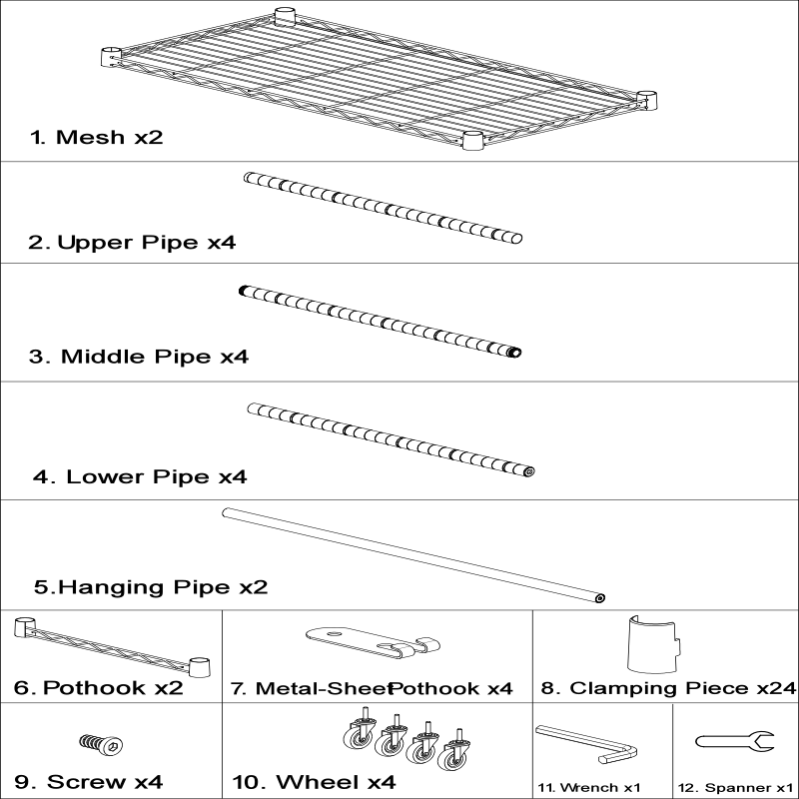

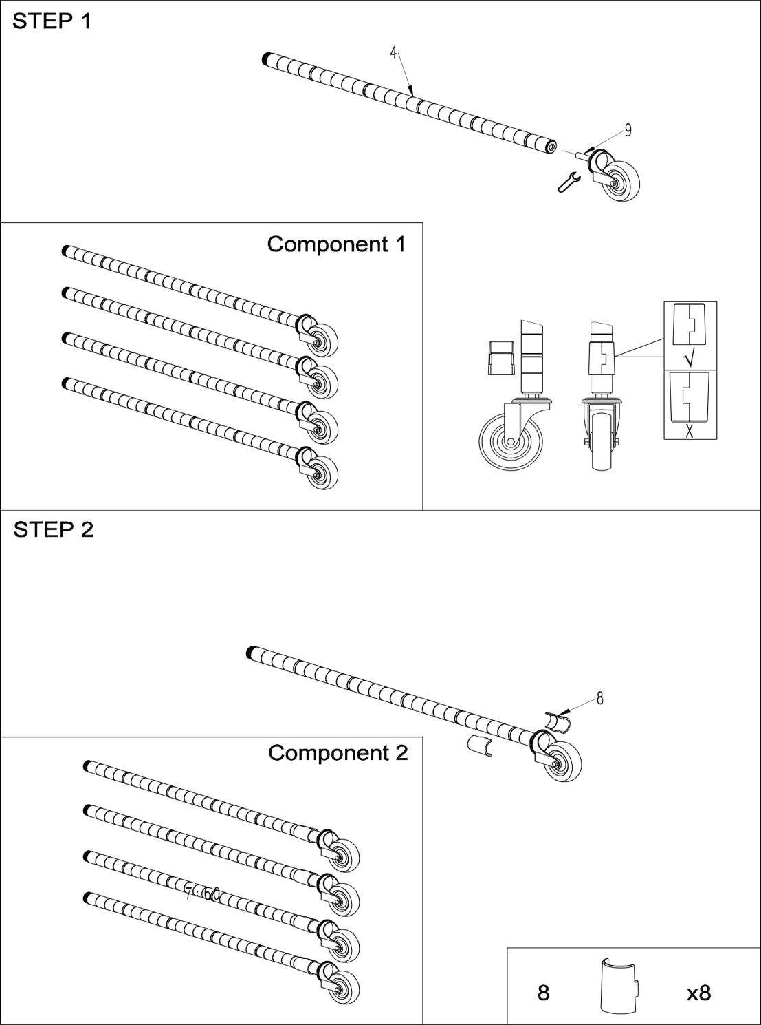

**ASSEMBLY STEP**

**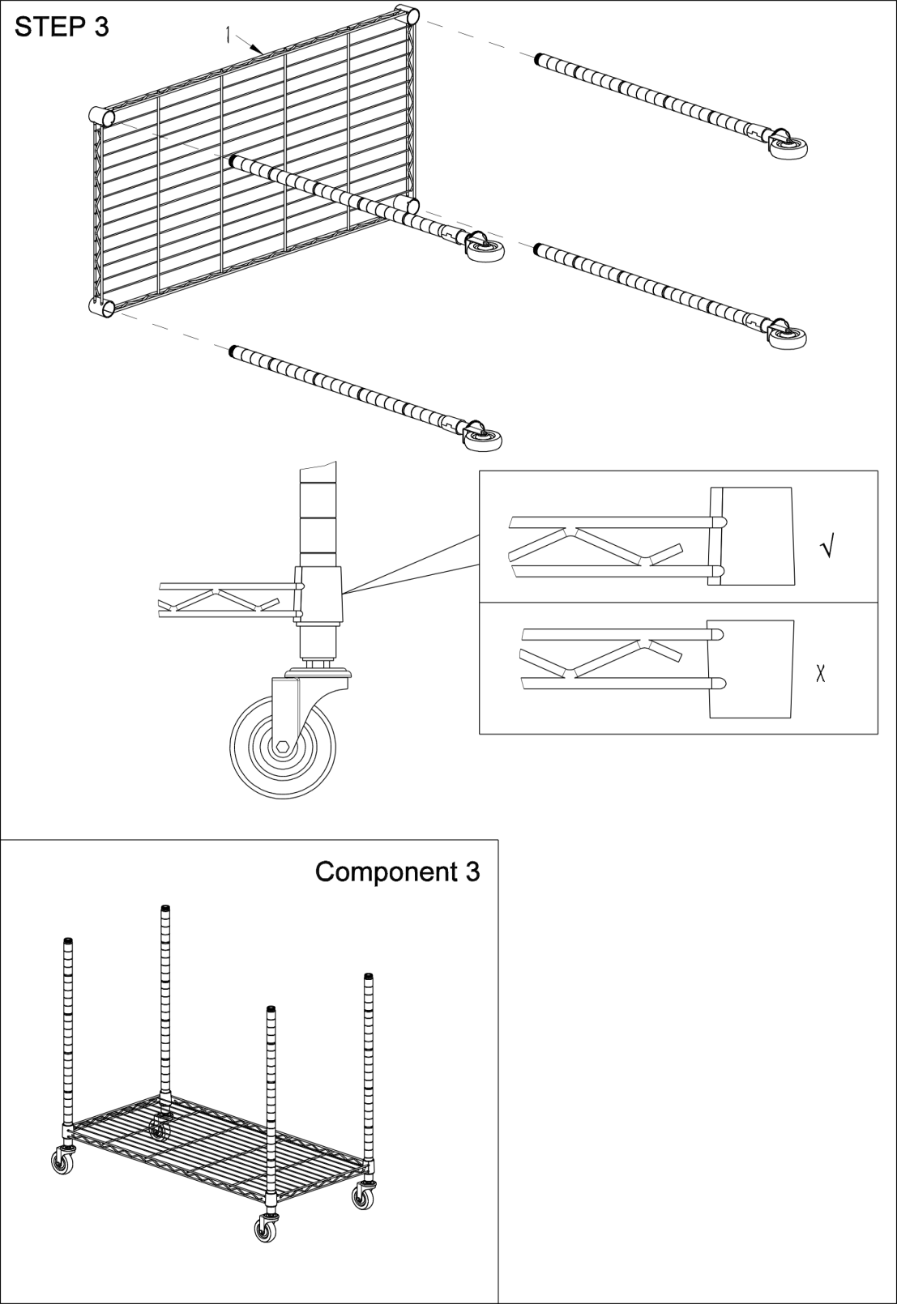**

**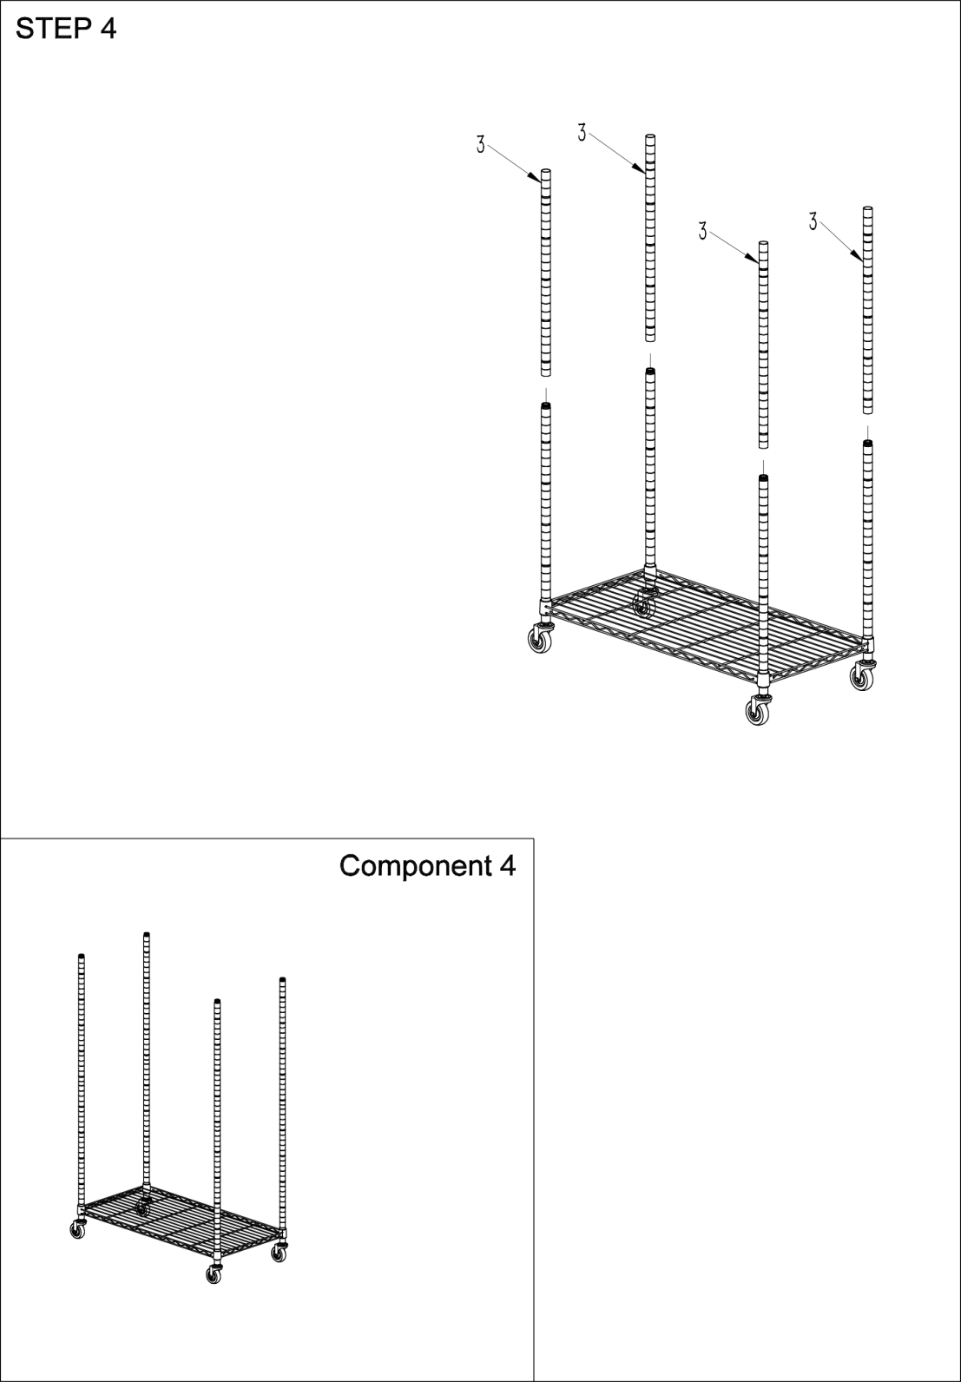**

**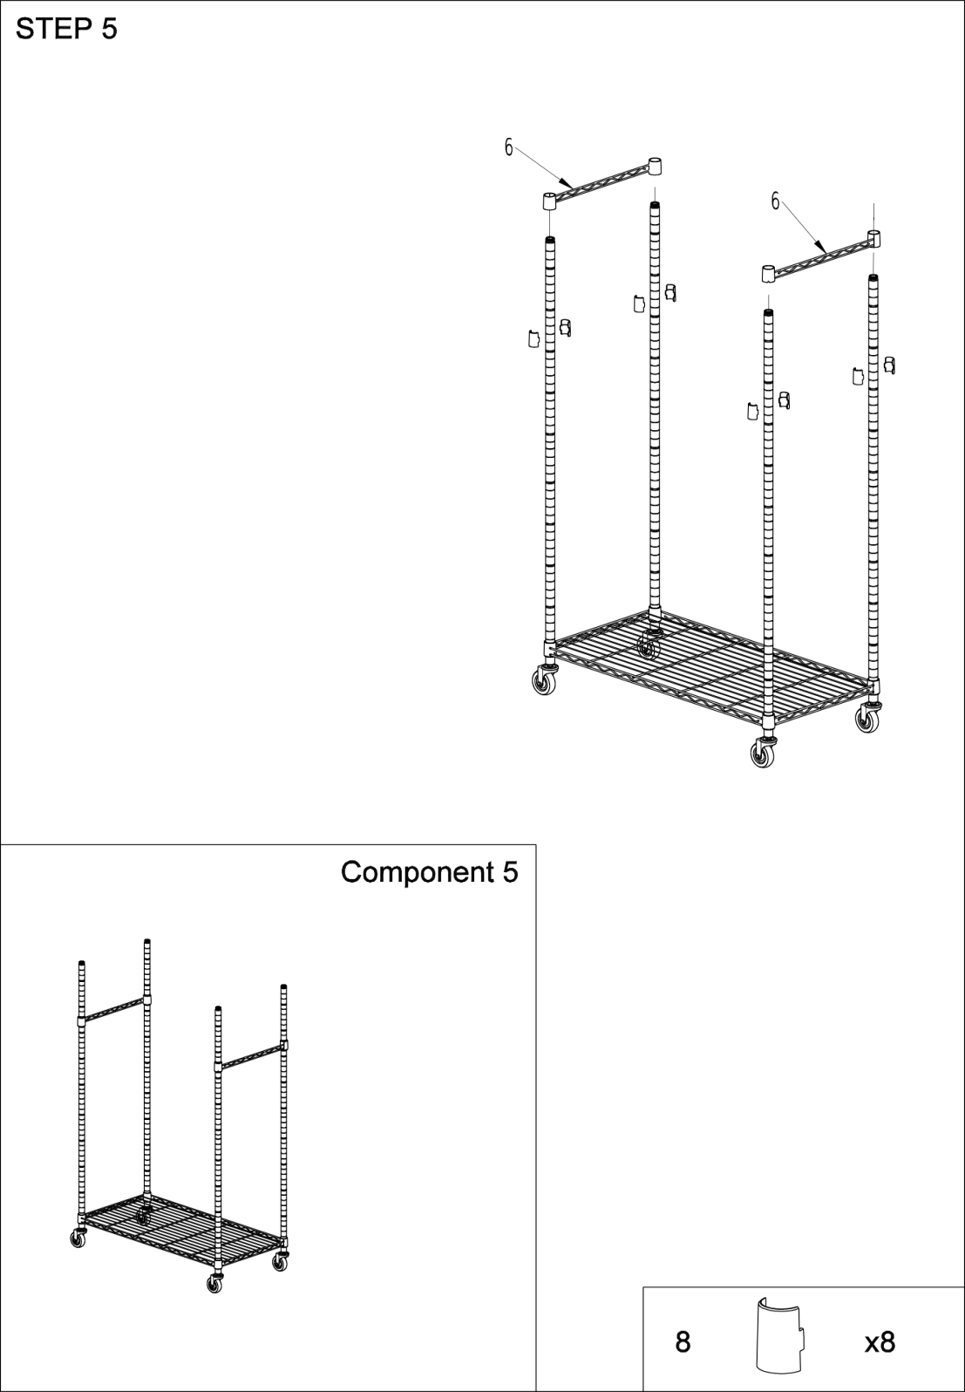**

**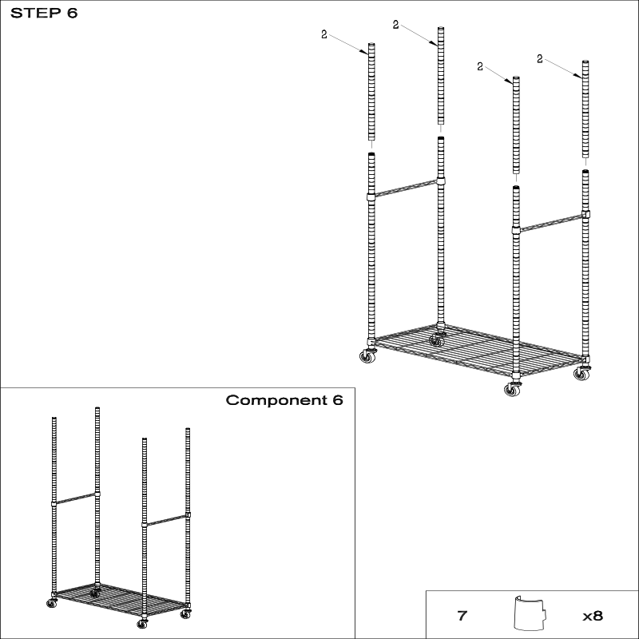**

**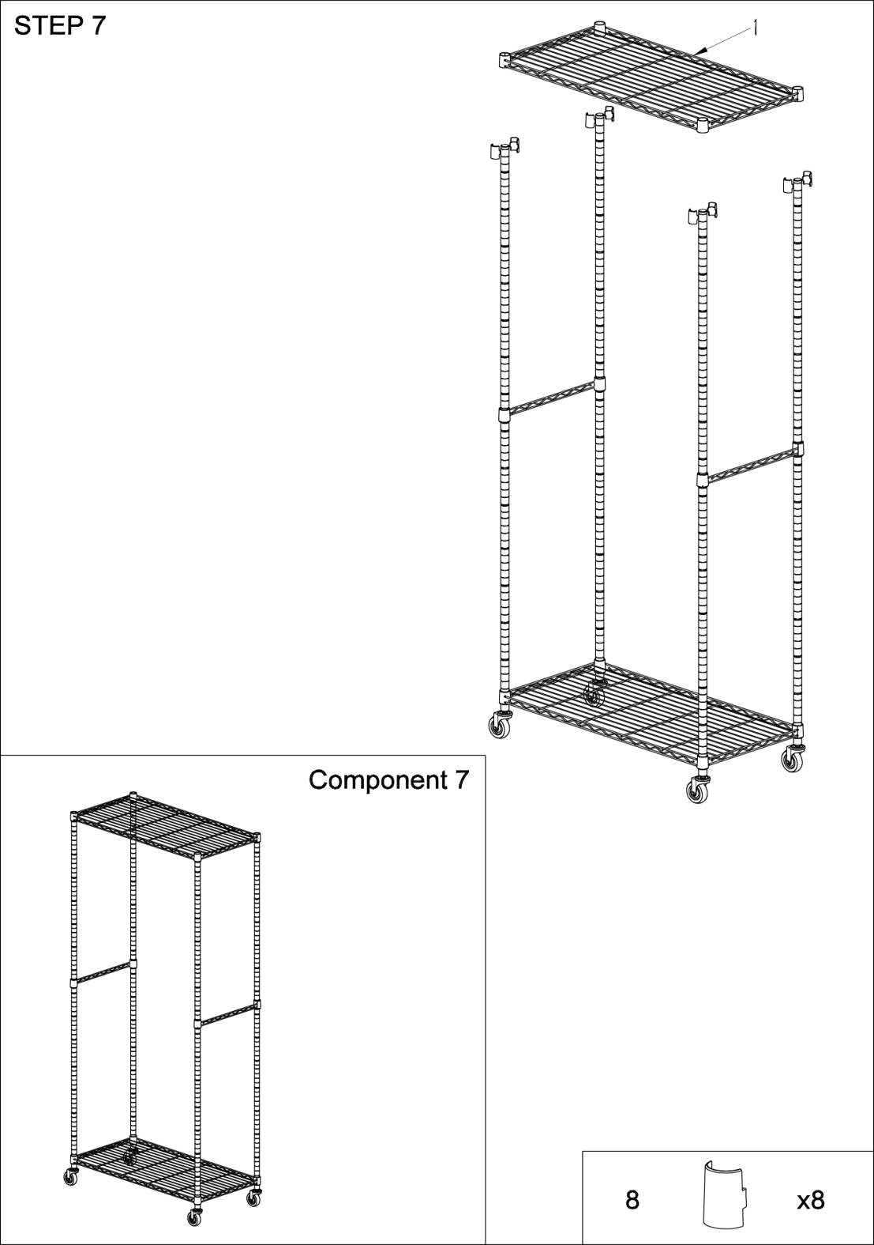**

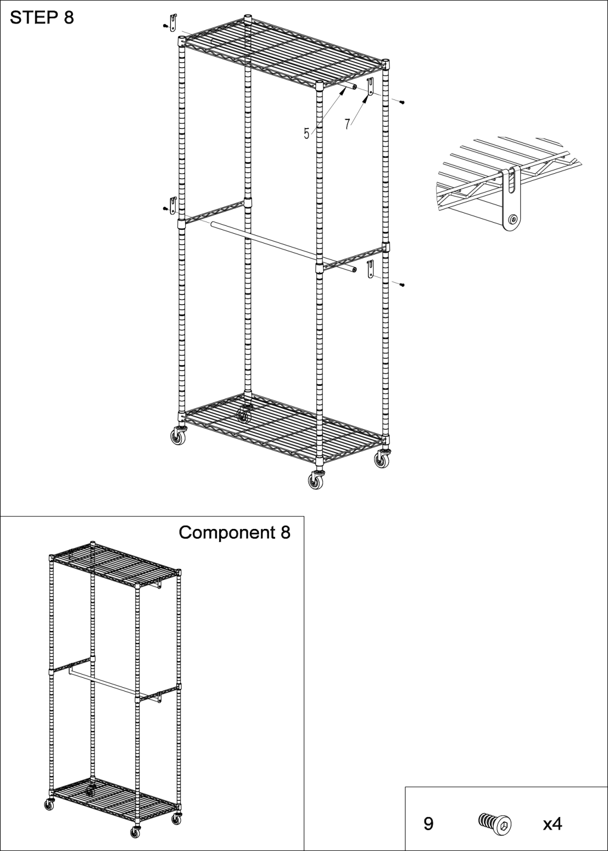

**COMPLETION**

|  |
| --- |
| 资源 9  **30kg/Each Side，Even Distribution**  **60kg，Even Distribution** |

**[Product Parameter](javascript:;)**

|  |  |
| --- | --- |
| Model | YC0002 |
| Safe Bearing | 120 kg |
| Product Size | 915\*450\*2040 mm |
| Net Weight | 9.7 kg |

**Address:** Baoshanqu Shuangchenglu 803long 11hao 1602A-1609shi Shanghai

**Imported to AUS:** SIHAO PTY LTD, 1 ROKEVA STREETEASTWOOD NSW 2122 Australia

**Imported to USA:** VEVOR STORE INC, 9448 RINCHMOND PL #E RANCHO CUCAMONGA, California, 91730 United States of America

**REP**

**EC**

SHUNSHUN GmbH

Römeräcker 9 Z2021,76351 Linkenheim-Hochstetten,Germany Germany

**REP**

**UK**

Pooledas Group Ltd

Unit 5 Albert Edward House, The Pavilions Preston, United Kingdom

**Made In Chin**

****

**Technical Support and E-Warranty Certificate**

**[www.vevor.com/support](https://www.vevor.com/support" \t "_blank)**