

Technical Support and E-Warranty Certificate [www.vevor.com/support](https://www.vevor.com/support" \t "_blank)

**Tow Chain**

**User Manual**

We continue to be committed to provide you tools with competitive price.

"Save Half", "Half Price" or any other similar expressions used by us only represents an estimate of savings you might benefit from buying certain tools with us compared to the major top brands and doses not necessarily mean to cover all categories of tools offered by us. You are kindly reminded to verify carefully when you are placing an order with us if you are actually saving half in comparison with the top major brands.



**Tow Chain**

**Model:ZG⅜-02，ZG5⁄16-02，ZG5⁄16-01，ZG⅜-01**

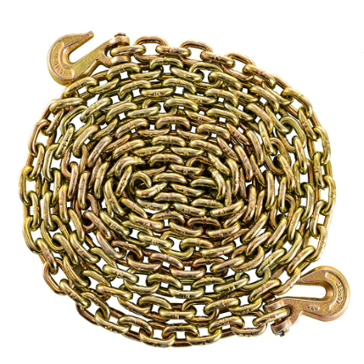

Have product questions? Need technical support? Please feel free to contact us:

**[CustomerService@vevor.com](mailto:CustomerService@vevor.com)**



**NEED HELP? CONTACT US!**

This is the original instruction, please read all manual instructions carefully before operating. VEVOR reserves a clear interpretation of our user manual. The appearance of the product shall be subject to the product you received. Please forgive us that we won't inform you again if there are any technology or software updates on our product.

**SAFETY INSTRUCTIONS**

 **WARNING:**

1.Read this material before using this product. Failure to do so can result in serious injury.

2.The bridle chain sling must be used flexibly, and it is strictly prohibited to use it compulsorily when individual connections are inflexible.

3. Do not exceed WLL (working load limit) for bridle chain sling. Not approved for overhead lifting.

4. After use, please dry before storage to avoid rusting of bolts affecting use.

5. Procedures not specifically explained in this manual must be performed only by a qualified technician. **To prevent serious injury from tool failure,do not use When it is damaged:**

1) Please check the overall condition of the product before each use.

Does the opening of the hook widen?

Is the bridle chain deformed?

Whether there are cracks in all parts.

Before each use, check whether the bridle chain works properly before actual use. If the bridle chain doesn’t work properly, please follow the inspection instructions to see if the problem occurs.

2) To prevent serious injury,be carefully when troubleshooting the faulty bridle chain , solve all problems before use. If the solution provided in the troubleshooting guide cannot be solved problem, please ask qualified technicians to check the bridle chain before use.

3) Make sure that the bridle chain is safe enough to continue to use it. Wish that the bridle chain can bring you convenience at work.

** CAUTION:**

1. **Carefully read instructions and procedures for safe operations.**
2. **Carefully INSPECTIONS:**
3. Before each use: Each time the bridle chain is used, a visual

inspection should be carried out to determine whether there are abnormal conditions, such as cracking,bending,deformation,etc.

1. After each use: After each use,if the bridle chain is strained

abnormally, the manufacturer or the supplier’s authorized maintenance personnel should be advised to check immediately.

**Suggestions for Safe Use of The Bridle Chain**

* Do not knot the chain when using the bridle chain.
* When using the bridle chain,make sure that the bridle chain is straight without folding and twisting.
* Due to the shipping(handing) or transportation, the bridle chain may have knots at the connection between the ring and the hook . Please smooth the them before use.
* NO one is allowed to stand below when hoisting goods by bridle chain.
* When using the bridle chain, please confirm whether the goods can be lift with the chain and whether the hardness of the chain will damage your goods.

**Save This Manual**

**MODEL AND PARAMETERS**

**Model**

|  |  |  |  |  |
| --- | --- | --- | --- | --- |
| **SPEC.** | **ZG⅜-02** | **ZG5⁄16-02** | **ZG5⁄16-01** | **ZG⅜-01** |
| Material | Alloy Steel | Alloy Steel | Alloy Steel | Alloy Steel |
| Surface Treatment | Galvanization | Galvanization | Galvanization | Galvanization |
| Chain Working Load Limit | 7100lbs  G80 | 4900lbs  G80 | 4900lbs  G80 | 7100lbs  G80 |
| Chain Size | 3/8inch | 5/16inch | 5/16inch | 3/8inch |
| Chain Length | 20ft | 20ft | 20ft | 20ft |

**Package Content**

|  |  |  |  |  |
| --- | --- | --- | --- | --- |
| **Model**  **PARTS** | **ZG⅜-02** | **ZG5⁄16-02** | **ZG5⁄16-01** | **ZG⅜-01** |
| Tow Chain | 2 | 2 | 1 | 1 |
| User's Manual | 1 | 1 | 1 | 1 |

**STRUCTURE DIAGRAM**

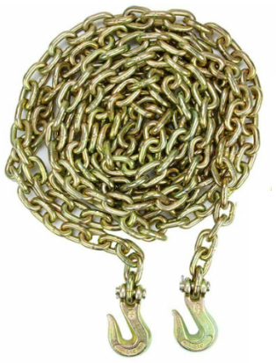

1

2

1. Chain 2. Hook

**INSTRUCTIONS**

**This product is often used with ratchet binder. The following examples illustrate.**

1.Used for binding.

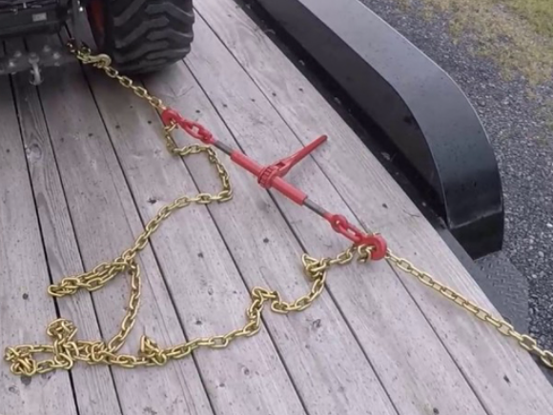

1. The tow chain hooks to the anchor point, as shown below.

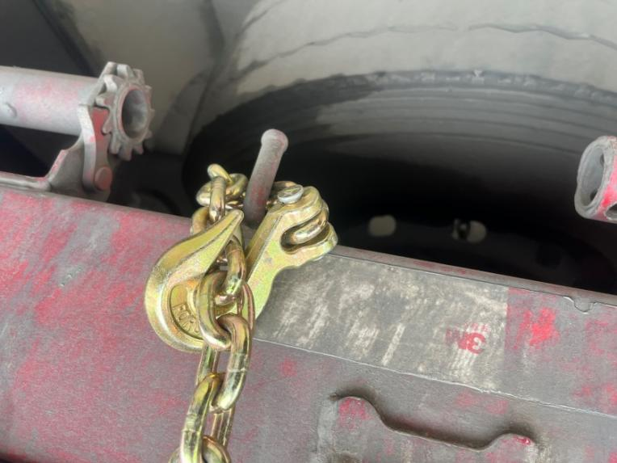

3.The ratchet binder hooks the tow chain, as shown below.

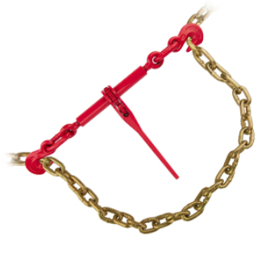

**MAINTENANCE**

* Do not exceed WLL (working load limit) .
* After use, Please clean and dry the product and store in a dry ventilated place.

**Imported to AUS:** SIHAO PTY LTD, 1 ROKEVA STREETEASTWOOD NSW 2122 Australia

**Imported to USA:** VEVOR STORE INC, 9448 RINCHMOND PL #E RANCHO CUCAMONGA, California, 91730 United States of America

**REP**

**UK**

Pooledas Group Ltd

Unit 5 Albert Edward House, The Pavilions Preston, United Kingdom

**REP**

**EC**

SHUNSHUN GmbH

Römeräcker 9 Z2021, 76351 Linkenheim-Hochstetten, Germany

**Made In China**

****

**Technical Support and E-Warranty Certificate**

**[www.vevor.com/support](https://www.vevor.com/support" \t "_blank)**