

Technical Support and E-Warranty Certificate [www.vevor.com/support](https://www.vevor.com/support" \t "_blank)

**FLOOR sweeper**

**User manual**

**Model:FD-13**

We continue to be committed to provide you tools with competitive price.

"Save Half", "Half Price" or any other similar expressions used by us only represents an estimate of savings you might benefit from buying certain tools with us compared to the major top brands and doses not necessarily mean to cover all categories of tools offered by us. You are kindly reminded to verify carefully when you are placing an order with us if you are actually saving half in comparison with the top major brands.



**FLOOR sweeper**

**Model:FD-13**

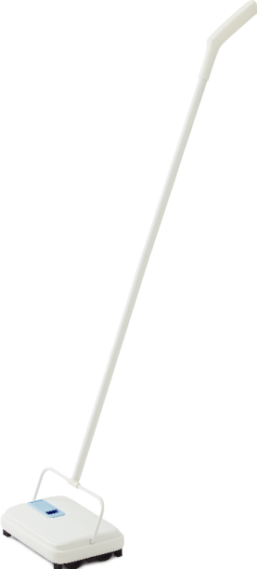

Have product questions? Need technical support? Please feel free to contact us:

**[CustomerService@vevor.com](mailto:CustomerService@vevor.com)**



**NEED HELP? CONTACT US!**

This is the original instruction, please read all manual instructions carefully before operating. VEVOR reserves a clear interpretation of our user manual. The appearance of the product shall be subject to the product you received. Please forgive us that we won't inform you again if there are any technology or software updates on our product.

**SAFETY INSTRUCTIONS**

**WARNING:**

**Read this material before using this product. Failure to do so can result in serious injury.**

**Assembly precautions**

1.Assemble only according to these instructions. Improper assembly can create hazards.

2. Wear ANSI-approved safety goggles and heavy-duty work gloves during assembly.

3.Keep assembly area clean and well lit.

4.Keep bystanders out of the area during assembly.

5.Do not assemble when tired or when under the influence of alcohol, drugs or medication.

**Use precautions**

1.Please do not put it near flammable materials, Keep away from fire.

2.Over load is strictly prohibited.

3.Don't move too fast when passing potholes areas.

4.This product is not a toy. Do not allow children to play with or near this item.

5.Do not lift while loaded.

6.Use as intended only.

7.Inspect before every use; do not use if parts are loose or damaged.

8. Do not wash products or put it in any damp place.

**WARNING: KEEP AWAY FROM MATERIAL SAND COMPONENTS THAT CAN BE DAMAGED BY EXPOSURE TO MAGNETS. INDIVIDUALS WITH PACE MAKER SHOULD CONSULT PHYSICIAN BEFORE USING THIS PRODUCT.**

**SAVE THESE INSTRUCTIONS**

**[Product Parameter](javascript:;)**

|  |  |
| --- | --- |
| Model | FD-13 |
| Sweeper Width | 200mm |
| Rubbish Bin Capacity | 300ml |
| Drive Type | Hand Push |
| Product Size | 1120\*230\*160mm |
| Net Weight | 0.8 kg |

**PARTS LIST**

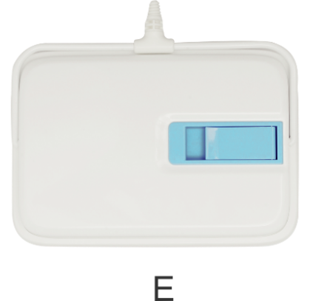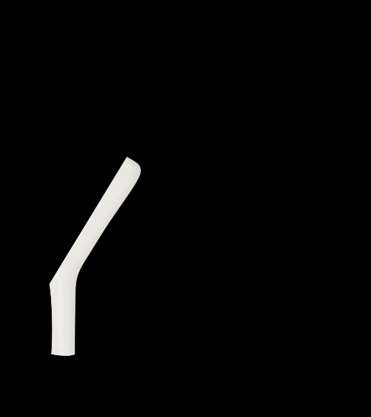

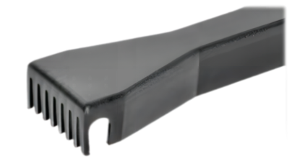

Cleaning Comb

**ASSEMBLY STEP**

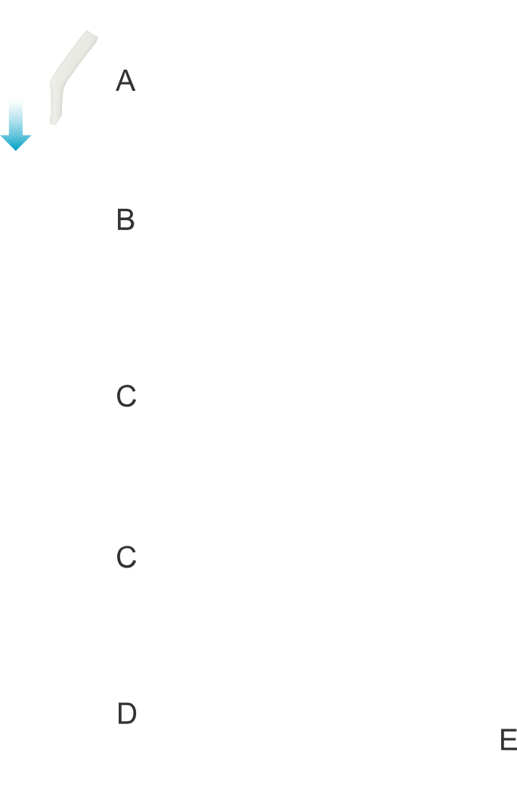

1. Take out the components.
2. Assemble components A,B,C,D,and E separately.(as shown)

**instructions**

**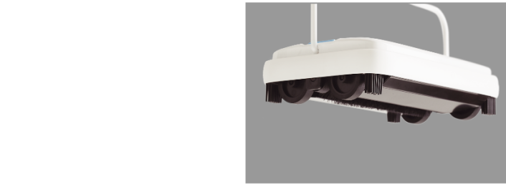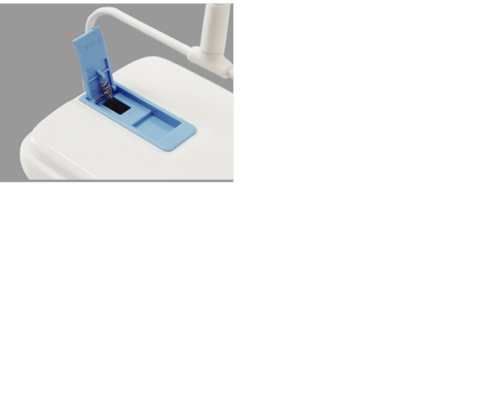**

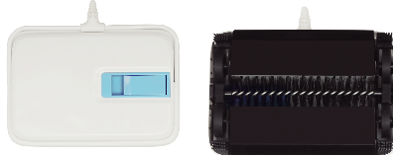

Front

Back

\*This sweeper is manual, no electricity or batteries required.

1. Easily push back and forth for effective pick up. (as shown)

2. Put the product above the garbage bin with the snap button up, you can easy to empty the garbage. (as shown)

**Address：**Baoshanqu Shuangchenglu 803long 11hao 1602A-1609shi Shanghai

**REP**

**UK**

Pooledas Group Ltd

Unit 5 Albert Edward House, The Pavilions Preston, United Kingdom

**REP**

**EC**

SHUNSHUN GmbH

Römeräcker 9 Z2021, 76351 Linkenheim-Hochstetten, Germany

Imported to AUS: SIHAO PTY LTD, 1 ROKEVA STREETEASTWOOD NSW 2122 Australia

Imported to USA: VEVOR STORE INC, 9448 RINCHMOND PL #E RANCHO CUCAMONGA, California, 91730 United States of America

**Made In China**

****

**Technical Support and E-Warranty Certificate**

**[www.vevor.com/support](https://www.vevor.com/support" \t "_blank)**