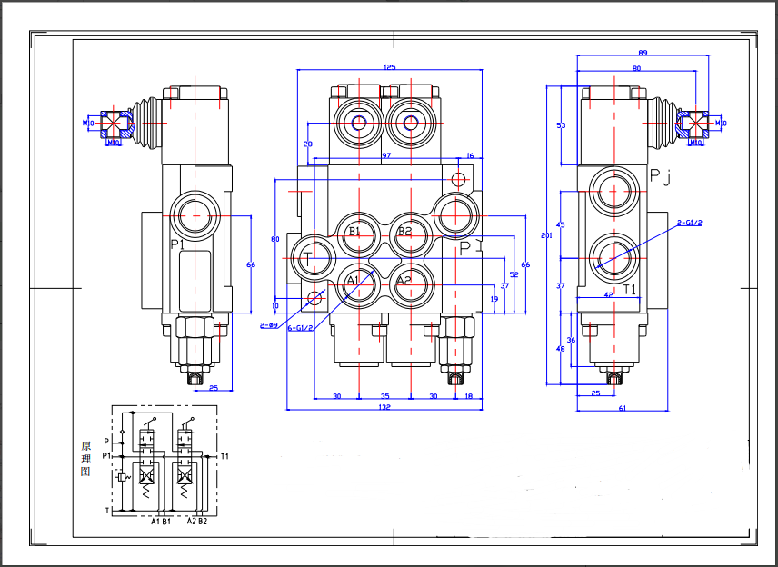

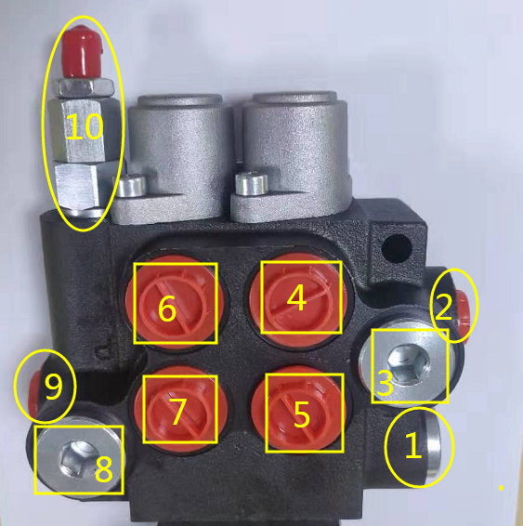

port P connects to oil hose

Port T connects to oil return pipe

Port A,B connect to working oil pipe

1,2,3 are spared port T (oil return port)

4,5,6,7, corresponding on the drawings, A1, B1, A2, B2, (working oil port)

8,9 are referred to P and P1, oil inlet

10 is regulating valve