

Technical Support and E-Warranty Certificate [www.vevor.com/support](https://www.vevor.com/support" \t "_blank)

**Voltage converter**

**Universal Instruction Manual**

We continue to be committed to provide you tools with competitive price.

"Save Half", "Half Price" or any other similar expressions used by us only represents an estimate of savings you might benefit from buying certain tools with us compared to the major top brands and doses not necessarily mean to cover all categories of tools offered by us. You are kindly reminded to verify carefully when you are placing an order with us if you are actually saving half in comparison with the top major brands.



**Voltage converter**

**Model:SV-500VA/SV-1000VA/SV-2000VA/SV-3000VA/SV-5000VA**

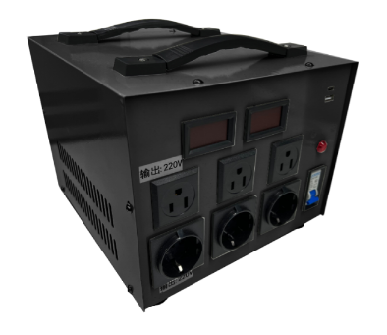

Have product questions? Need technical support? Please feel free to contact us:

**[CustomerService@vevor.com](mailto:CustomerService@vevor.com)**



**NEED HELP? CONTACT US!**

This is the original instruction, please read all manual instructions carefully before operating. VEVOR reserves a clear interpretation of our user manual. The appearance of the product shall be subject to the product you received. Please forgive us that we won't inform you again if there are any technology or software updates on our product.

|  |  |
| --- | --- |
| **Symbol** | **Symbol Description** |
|  | Warning - To reduce the risk of injury, user must read instructions manual carefully. |
|  | Danger! Risk of personal injury or environmental damage! Risk of electric shock! Risk of personal injury by electric shock! |
|  | Note |
|  | This symbol, placed before a safety comment, indicates a kind of precaution, warning, or danger. Ignoring this warning may lead to an accident. To reduce the risk of injury, fire, or electrocution, please always follow the recommendation shown below. |
|  | Correct Disposal :  This product is subject to the provision of European Directive 2012/19/EC. The symbol showing a wheelie bin crossed through indicates that the product requires separate refuse collection in the European Union. This applies to the product and all accessories marked with this symbol. Products marked as such may not be discarded with normal domestic waste, but must be taken to a collection point for recycling electrical and electronic devices |
|  | FCC statement:  This device complies with Part 15 of the FCC Rules. Operation is subject to the following two conditions:(1)This device may not cause harmful interference, and (2)this device must accept any interference received, including interference that may cause undesired operation. |

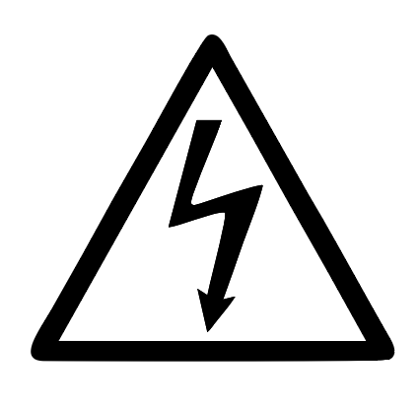**WARNING:**

**ELECTRICAL SHOCK AND FIRE HAZARD!** Fallure to comply with this instruction could result in an electrical failure, fire and electrocution.

**WARNING:**

This equipment is a high voltage device, please do not attempt to disassemble this equipment at any time to avoid danger. After a device failure, if the external switch fails to restart the device, please contact your reseller for handling.

**ATTENTION**

The voltage input range of this product can be selected by toggle switch, please check that the voltage of the mains and the switching voltage of the product should be consistent before powering on.

1. **PRODUCT PARAMETERS**

|  |  |  |  |  |  |
| --- | --- | --- | --- | --- | --- |
| **Model** | **SV-500VA** | **SV-1000VA** | **SV-2000VA** | **SV-3000VA** | **SV-5000VA** |
| Input voltage | AC110V±15% or AC 220V±15% | | | | |
| Output voltage | Out 1: AC110-120V 60Hz Out 2: AC220-240V 50Hz | | | | |
| Output power | 500VA | 1000VA | 2000VA | 3000VA | 5000VA |
| Overload protector | 5A | 10A | 18A | 28A | 45A |
| Operating temperature | -30℃~55℃ | | | | |
| relative humidity | 5%~95% | | | | |

**[II] Instructions for use of the product**

Set the input toggle switch of the product to a position consistent with the mains voltage.(As shown in the figure below).

1.Set the input toggle switch of the product to a position consistent with the mains voltage.(As shown in the figure below).

The input voltage is 220V-240V rule Switch to position 220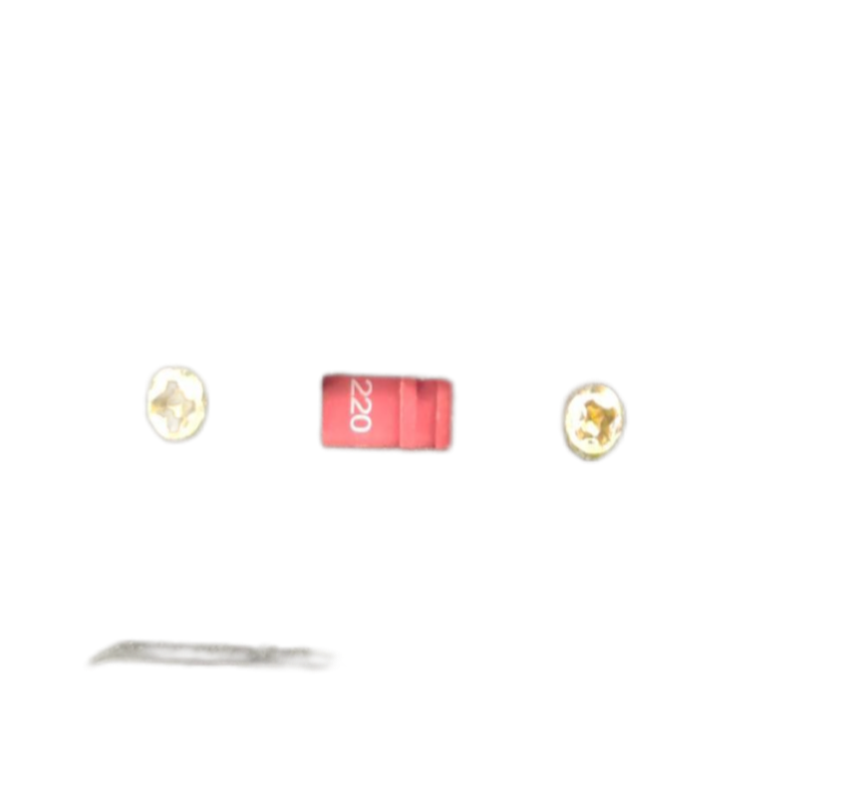

The input voltage is 100V-120V rule Switch to position 110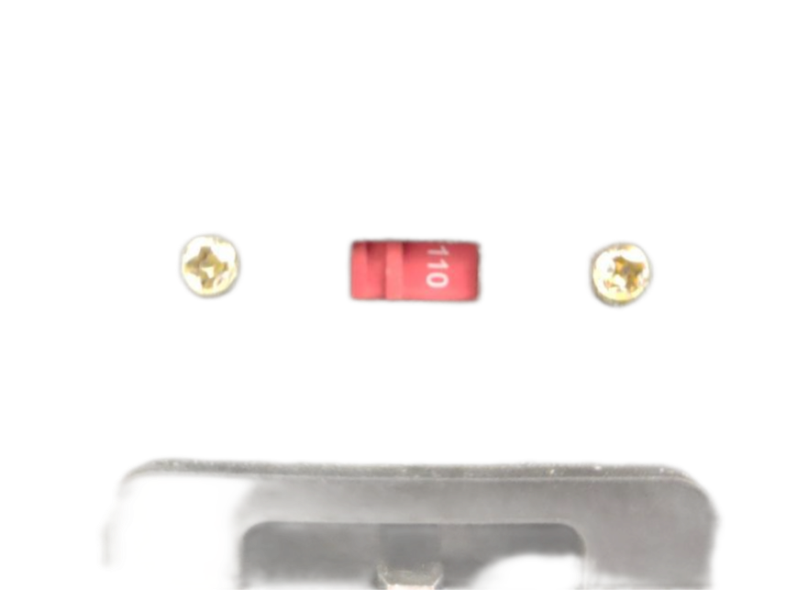

2.Insert the input power cord into the end of the product, and then insert the plug of the power cord into the mains outlet.

✮Note:Before plugging in the mains, please check whether the position of the input voltage transfer switch is consistent with the mains voltage.

3.Please use the load according to the voltage of the panel output socket, the load power must be less than the nominal power of the device, and the recommended load power is 80% of the rated power.

✮Because the equipment itself has a certain loss, the load use power must be less than the nominal power of the equipment, otherwise there is a risk of damage to the equipment.

4.The panel USB output port outputs 5V/1.5A DC as an emergency to charge other smart devices.

**Notes:**

1.This equipment is equipped with an overcurrent fuse (SV-500VA or SV2000VA), which will blow when the load exceeds the load of the equipment. When you find that there is no output, check the replacement fuse.

2.This equipment has an overload protection switch, when the load exceeds the load of the equipment, the overload protection switch will automatically spring up and disconnect the output; When the load overload is solved, you can press the overload protection by hand to open it and resume work.

3.This equipment is equipped with an air switch, when the load is overloaded for a long time, or the load is short-circuited, the air switch will immediately turn off the output, thereby protecting the equipment from damage. When the load fault is lifted, close the air again and open it, and it can work normally.

**Device panel：**

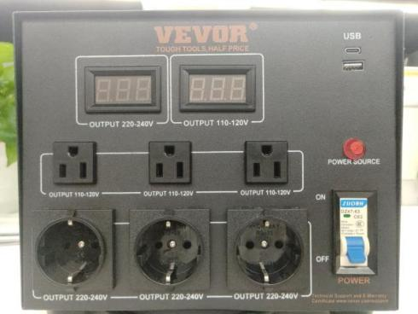

Power switch（Air switch）

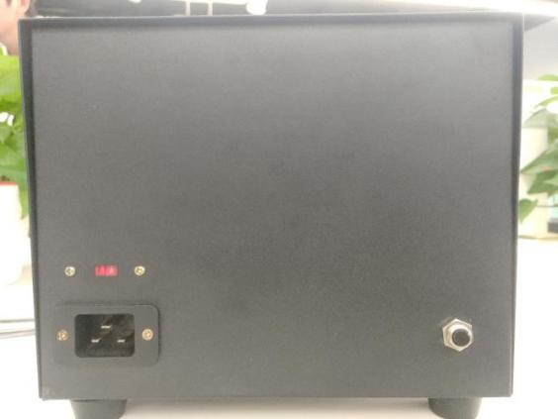

Input transfer switch

Overload protection switch

**List of accessories**

1.Instruction manual \*1

2.Adapter plug \*1

3.Power cord \*1

**Made In China**

****

**Technical Support and E-Warranty Certificate**

**[www.vevor.com/support](https://www.vevor.com/support" \t "_blank)**