

Technical Support and E-Warranty Certificate [https://www.vevor.com/support](https://www.vevor.com/support" \t "_blank)

**Watch Winder**

**USER MANUAL**

**MODEL NO.: G450VS+**

We continue to be committed to provide you tools with competitive price.

"Save Half", "Half Price" or any other similar expressions used by us only represents an estimate of savings you might benefit from buying certain tools with us compared to the major top brands and doses not necessarily mean to cover all categories of tools offered by us. You are kindly reminded to verify carefully when you are placing an order with us if you are actually saving half in comparison with the top major brands.



**Electric Paper Cutter**

MODEL NO.: G450VS+

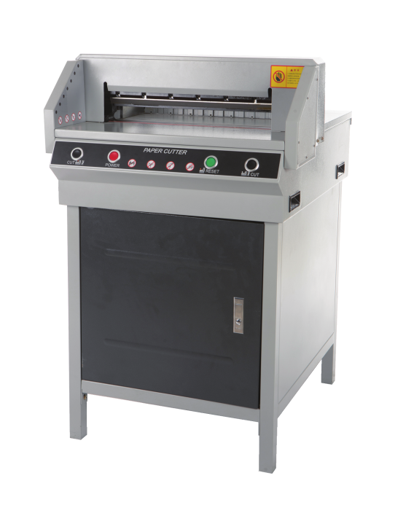

Have product questions? Need technical support? Please feel free to contact us:

**Technical Support and E-Warranty Certificate**

**www.vevor.com/support**

**NEED HELP? CONTACT US!**

This is the original instruction, please read all manual instructions carefully before operating. VEVOR reserves a clear interpretation of our user manual. The appearance of the product shall be subject to the product you received. Please forgive us that we won't inform you again if there are any technology or software updates on our product.

**IMG_256WARNING:**

**Please read this manual carefully before using the product. Failure to do so may result in serious injury. SAVE THIS MANUAL**

****Warning:this kind machine is allowed to cut printed paper or

books or soft leathers only.It is forbidden to cut any metal sheets or other hard objects do harm to the machine’s quality.

****

Forbid children to operate the machine

****

Keep hand from underneath the blade

****

Do not extract or transport the blade without protection



Do not cut hand or splintery materials

****

Must use socket with ground wire connected

Note:

In order to have more usage information on the Numerical-controlled Paper Cutting Machine, you have to read this specification carefully first. This will help you improve your working efficiency, and realize the machine’s Property, then the machine will have the best cutting effects. This will also be good for the maintenance of the machine and can prolong the service life of the maintenance of the machine, and can prolong the service life of the machine.

**Safety caution**

1. Open the box and check

When you open the package of the machine,firstly you should check the machine and relevant accessories. Please contact the seller or company if there is any damage or shortage.

|  |
| --- |
| ●Main unit one set ●Machine chassis one set ●Specification one piece |
| ●Tools one set ●Rubber under chassis two pieces ●Certificate one piece |
| ●Stick one piece ●Screw stem four pieces ●Warranty receipt one piece |

1. Settlement of the machine

◆Open the wooden crate ,take out the machine casing,and discharge fourM8 screws

on the main machine;

◆The machine casing needs to assembly,and the screws shouldbe fixed firmly;

◆The main unit should be put on the machine casing correctly;

◆Check all parts of the machine,and clean them;

◆Turn on the power and test.

1. Operating environment

◆The machine should be placed in clean working environment,keep away from direct sunlight and wind;

◆Temperature of the operating environment keep 10~30℃，cannot higher than32℃；

◆Humidity level of the operating environment:50~80%

◆Connect the ground wire correctly.

1. Special hints

◆Remember that only one professional operator is allowed to work on the machine;

◆When you cut,you should operate buttons by both of your hands;

◆Please don’t dismantle the safety covering;

◆When you put your hands or other things into the cutting area,you must cut the power firstly;

◆When you change knife blades, you should strictly abide the blade-changing instructions;

◆You are not allowed to re-equip the inner construction and circuit of the machine by yourself.

**TECHNICAL SPECIFICATIONS**

|  |  |
| --- | --- |
| Model | G450VS+ |
| Rating(s) | AC120V, 60Hz, 500W |
| Max cutting length | 450mm |
| Cutting thickness | 40mm |
| Product Dimensions  (LxWxH) | 650\*770\*1003.5mm |
| Packing Size  (LxWxH) | 730\* 820\* 710mm |
| Net Weight (kg) | 80 |
| Gross Weight (kg) | 120.5 |

**Parts description**

**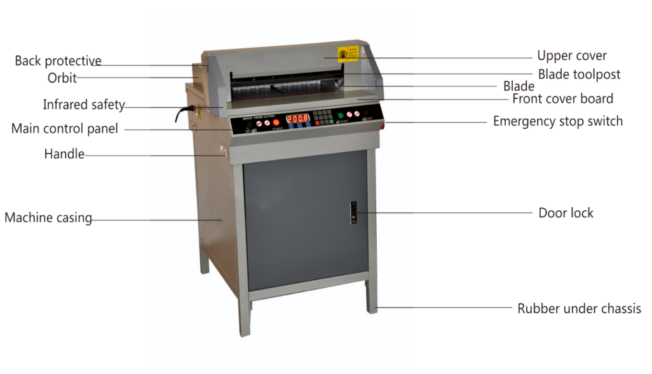**

**Operation panel**

◆Operating panel

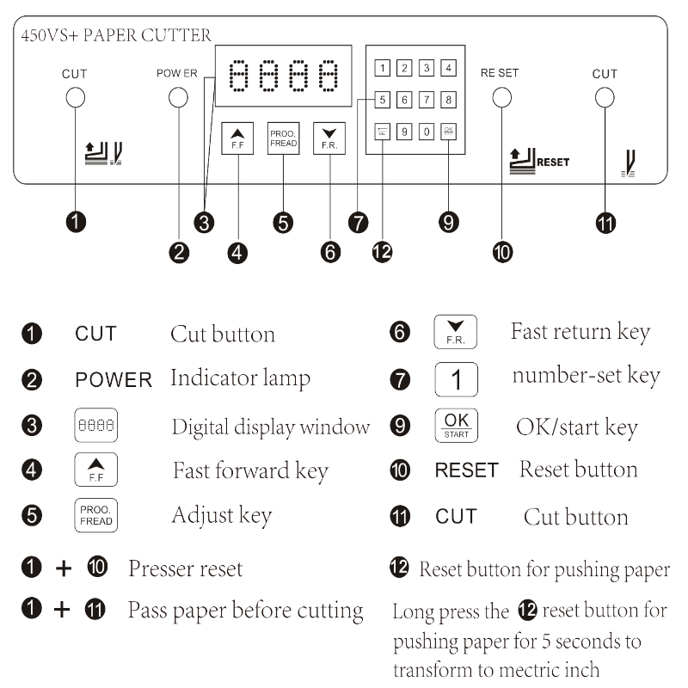

**Basic operation and adjustment**

1. basic operation

Before operating,please review contents described before carefully.Then you can operate the machine as below.

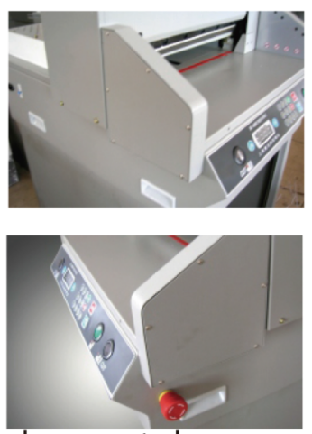**1-1 Start the machine**

◆Insert the power plug into socket.

◆Turn the protective switch to 'On' position.Turn on the power switch,the liquid crystal displays and indicative wiring of knife position light, that means electricity connection is normal.

◆Indication appears on display window,When knife indication light turns on,it means the electrical power is properly connected.

**1-2 Paper Pushing**

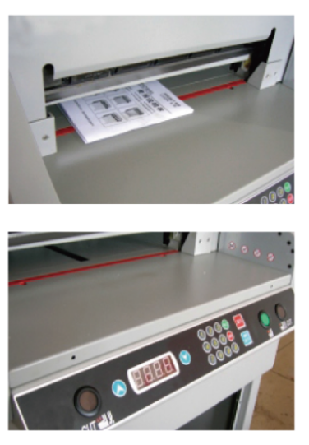◆Push paper or book to be cut to the left side trimming with the gauge strip.Push buttons  or , the paper pusher will advance or retreat to required paper cutting position .

◆The display dimension digits shall be identical to the gaugegraduation dimension.

◆Press numeric button to input the numeric. Then press button  and the paper will move to the required paper cutting dimension automatically.

Note;Press  Hold it in cutting dimension is properly mm/inch mode.

**1-3 Cutting paper**

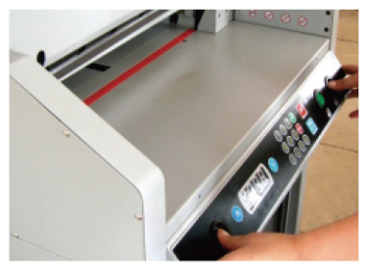◆Get ready for cutting after cutting dimension is properly adjusted.

◆LED turn red after pressing reset button.Then the light for indicating knife position is on.

◆Operation of one-way paper press reference for operating panel.

◆Follow operating before Cutting.

◆If it is found that the last piece of paper is not cut apart, please adjust according to the method of Cutting Knife Adjustment.

**Basic adjustment**

◆Dimension check and adjustment

Cut the electricity power;

Check whether there are any other things on the guiding rod;Pull out the front covering strip,and check stepping motor,to see whether the synchronous pulley and you synchronous belt are fixed normal;Adjust the support chip on the screw,and you can move it back and forth until digita display dimension matches measuring scale dimension,then lock the upper cover firmly;

◆Blade adjustment

Cut off the electricity power;

Disassemble retaining screws on both sides of the upper cover,and then take the upper cover away;

Loosen screws M6 fasten screws on the blade which is on blade carrier,and adjust screws of adjusting blade depth on blade carrier,until the blade cuts into cutting stick about 0.3-0.5mm;

Tighten screws on blade carrier,put on the upper cover,then fix up ;Choose one piece of paper to have a try. If it cannot be cut completely. you can readjust according to the processes above.

◆Blade replacement

Loosen the notched fasten screw on the blade carrier,revolve the two screws clockwise,and then fix up and lock firmly;

Open the upper cover;

Take away other fasten screws on the blade carrier;

Revolve the two screws anticlockwise 180°,then tack out the lade.Please wear gloves or use cotton cloth to wrap the blade to avoid being scratched;

When you install the blade,you should loosen the screw to adjust blade depth on the blade carrier ,After that,make screw stems,and fix up the blade carrier.After that,make screw stems,and fix up one by one,then adjust according to cutting depth adjustment method;Blade sharpening needs to be done in a professional factory,so that to ensure the sharpened quality.

Note:To avoid any injury,you must be more careful when you change the blade.

◆Cutting stick adjustment

One cutting stick can be used for 8 times;

When the slash on the shim is too deep,you should adjust or change knife strip ;

Cutting stick can be taken out by screw ,and should be assembled onto the cutting desk flatly when it needs to be set back.

Cutting stick should lean to left side;

Note: When cutting stick is being changed,the blade itself also needs to be adjusted.lf the blade cuts too deep ,the cutting stick will be damaged easily,and the blade will abrade rapidly.

Note:the cutting will be stopped if something black the infrared laser or there is something is in the cutting area.

**Lubrication and maintenance**

1. **Lubrication**

Every three month,you should open the brace plate of the brace plate of the machine,check,clean and tighten parts,and use lubricating oil to lubricate parts.When you machine,you should be careful to avoid lubricating oil dripping on the wires or electrical parts. The speed reduction box needs to be cleaned and lubricated once a year.

1. **Maintenance**
2. When the machine is working,other objects are forbidden to put on the machine.Because the blade when cutting.
3. After everyday work,you should wipe the machine,remove junk,wax the blade and cut the power.
4. **Attached drawings**

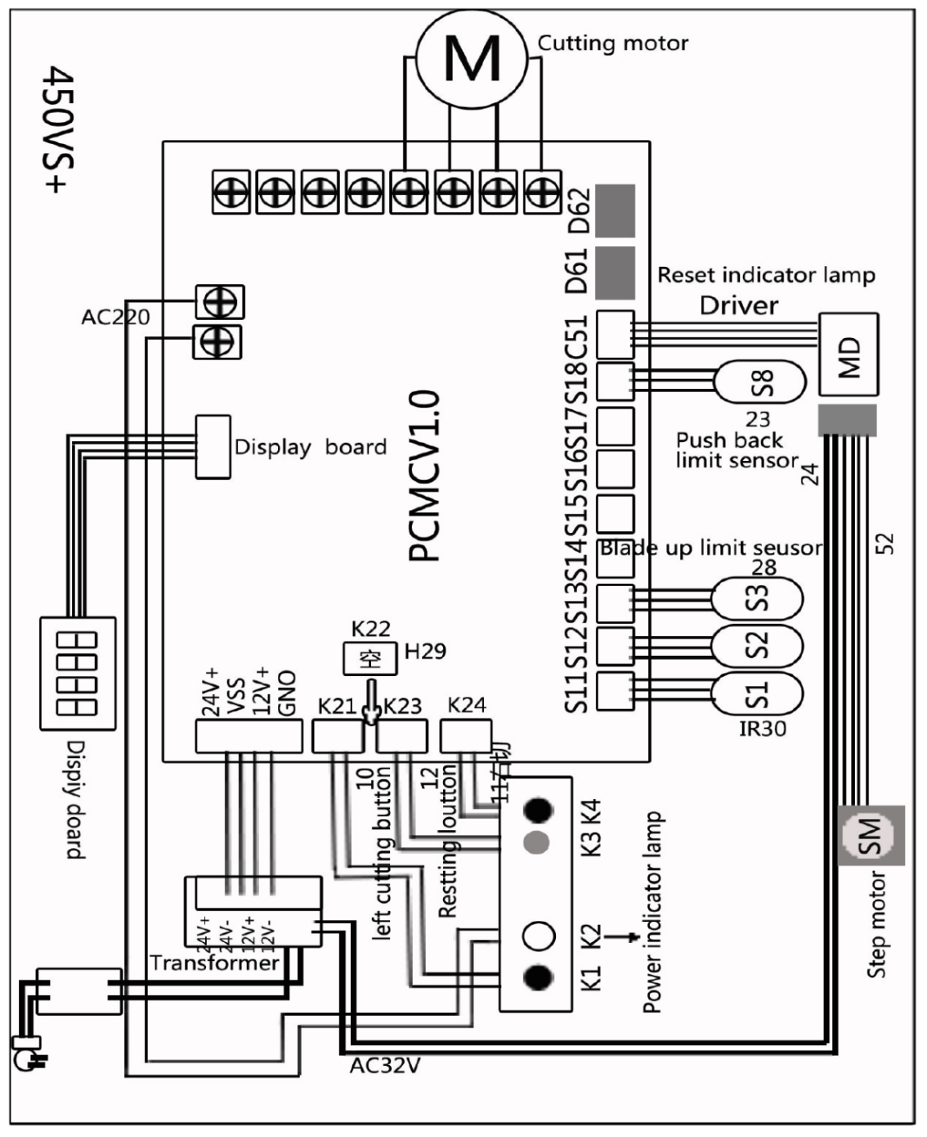

**Common error and elimination**

|  |  |  |
| --- | --- | --- |
| **Error** | **Phenomena** | **Solution** |
| No power source display | Indicating light is off | 1. Check the power source plug 2. Check main switch 3. The power source wire is bed |
| Incomplete cutting | Paper can't be cut completely | 1. The blade abrades badly 2. The knife position is too high. Revolve the screw of adjusting blade Revolve the screw of adjusting bladedepth on the blade carrier downward to make the knife position lower. |
| Too deep cutting | Slash on the knife strip it too deep | The knife position is too low.Revolve the screw of adjusting blade depth on the blade upward to have the knife position higher. |
| Dull blade | Paper cant be cut complete or cutting becomes difficult | 1. Sharpen the blade: Use whetstone to sharpen or ask professional 2. Change a new blade |
| Capacitor of electrical motor damaged | The knife work up and down slowly or powerlessly | Change Capacitor |
| Paper cutting is not even or the cutting size is not accurate | The cut paper has one side wide and the other side narrow , or has big deviation on dimensions | Loosen tighten screw, and use a ruler to adjust the angle between measuring scale and paper-pushing plate |
| The knife can't reset or works up and down continuously | The button is invalid.The Blade works up and down without stopping | 1. The sensor is displaced or damaged. 2. Circuit main panel is damaged |
| The window can't display or display wrong or display wrong or can't proofread | Power buttons are  invalid | 1. Check stepping motor, driver 2. Check whether the circuit of main board is damaged. |
| Digital-controllled Circuit damaged | Paper-pushing part can't work | Check display board,main board of the electrical equipment, and circuit parts |
| If can not cut (only for cover series) | The front cover lock is unlocked or front cover dose not cover well | 1. Check steeping motor,driver 2. 2.Check whether the circuit of main board is cover well |
| The platform has other things and alarm(only for safety guage series) | Button is not available | 1. Check if the safety IR guage is good 2. Check if the main board is damaged |

**Address:** Baoshanqu Shuangchenglu 803long 11hao 1602A-1609shi Shanghai

**Imported to AUS:** SIHAO PTY LTD. 1 ROKEVA STREETEASTWOOD NSW 2122 Australia

**Imported to USA:** Sanven Technology Ltd. Suite 250, 9166 Anaheim Place, Rancho Cucamonga, CA 91730

**REP**

**EC**

SHUNSHUN GmbH

Römeräcker 9 Z2021,76351 Linkenheim-Hochstetten,Germany Germany

**REP**

**UK**

Pooledas Group Ltd

Unit 5 Albert Edward House, The Pavilions Preston, United Kingdom

**Made In China**

****

**Support and E-Warranty Certificate**

**[www.vevor.com/support](https://www.vevor.com/support" \t "_blank)**