

Technical Support and E-Warranty Certificate

[www.vevor.com/support](http://www.vevor.com/support)

**Steel Wire Shelf**

**USER MANUAL**

We continue to be committed to provide you tools with competitive price.

"Save Half", "Half Price" or any other similar expressions used by us only represents an estimate of savings you might benefit from buying certain tools with us compared to the major top brands and doses not necessarily mean to cover all categories of tools offered by us. You are kindly reminded to verify carefully when you are placing an order with us if you are actually saving half in comparison with the top major brands.



**Steel Wire Shelf**

**I6V0**

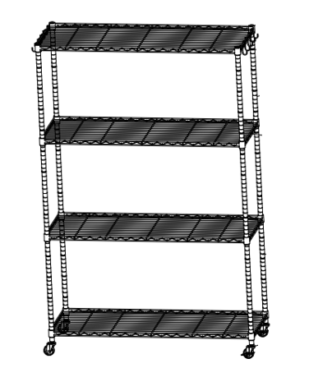

Have product questions? Need technical support? Please feel free to contact us:

**[CustomerService@vevor.com](mailto:CustomerService@vevor.com)**



**NEED HELP? CONTACT US!**

This is the original instruction, please read all manual instructions carefully before operating. VEVOR reserves a clear interpretation of our user manual. The appearance of the product shall be subject to the product you received. Please forgive us that we won't inform you again if there are any technology or software updates on our product.

**Important Safety Instructions**

|  |  |
| --- | --- |
| 1675144569414_F0630884-BE5F-4868-BD1D-9B32B2F7D91D | Warning - To reduce the risk of injury, user must read instructions manual carefully. |
|  | This symbol, placed before a safety comment, indicates a kind of precaution, warning, or danger. Ignoring this warning may lead to an accident. To reduce the risk of injury, fire, or electrocution, please always follow the recommendation shown below. |
| 1675144636845_862401FE-AD7D-47af-8BC6-6C3B9486534A | Warning- Be sure to wear eye protectors when using this product. |
| 1675144700345_CE9EFE48-3CFA-481c-9860-9DE68DE1CFAD | Warning- Be sure to wear gloves when using this product. |

****

1. Keep this manual for the safety warnings and precautions. The manual offers important information on how to assemble, use and maintain this product.
2. The maximum load bearing capacity is obtained by placing the weights equally on this product.
3. Do not place all the weights on the same layer .
4. The placement time under the maximum load bearing capacity shall not exceed 1 hour !
5. Please be sure to keep any parts and/or packing material in the package away from infants/toddlers/small children during the process of assembling this steel wire shelf.

**ASSEMBLY PRECAUTIONS**

1. Please assemble the product in strict accordance with the instructions. Incorrect assembly could be hazardous.
2. Please wear safety goggles and work gloves properly during assembly.

3.Do not try to assemble the product when feeling tired or when under the influence of alcohol, drugs or medication.

4.Load bearing capacity and other product parameters are applied to the properly and completely assembled product only.

**USE PRECAUTIONS**

1.This product is not a toy. Do not allow children to play with or get access to this item.

2.Follow the intended uses only. Do not sit or stand on the shelf.

3.Check carefully before use. Do not use if parts get loosened or damaged.

4.Use on flat, level, and hard surfaces only.

5.Do not exceed the listed load bearing capacity. Tighten all the knobs securely before placing weights on. Be aware of the dynamic load bearing capacity! Sudden load changes may temporarily cause excessive load, resulting in product failure.

**SAVE THESE INSTRUCTIONS**

**Product Parameters**

1. Name: Steel Wire Shelf
2. Model: I6V0
3. G.W.: 16.0kg
4. Package Size: 1225x468x175mm
5. Total dynamic load limit: 175lbs
6. Total static load limit: 450lbs (without wheels: 700lbs)
7. Static load limit for each layer:112.5lbs( without wheels: 175lbs )

**Part list**

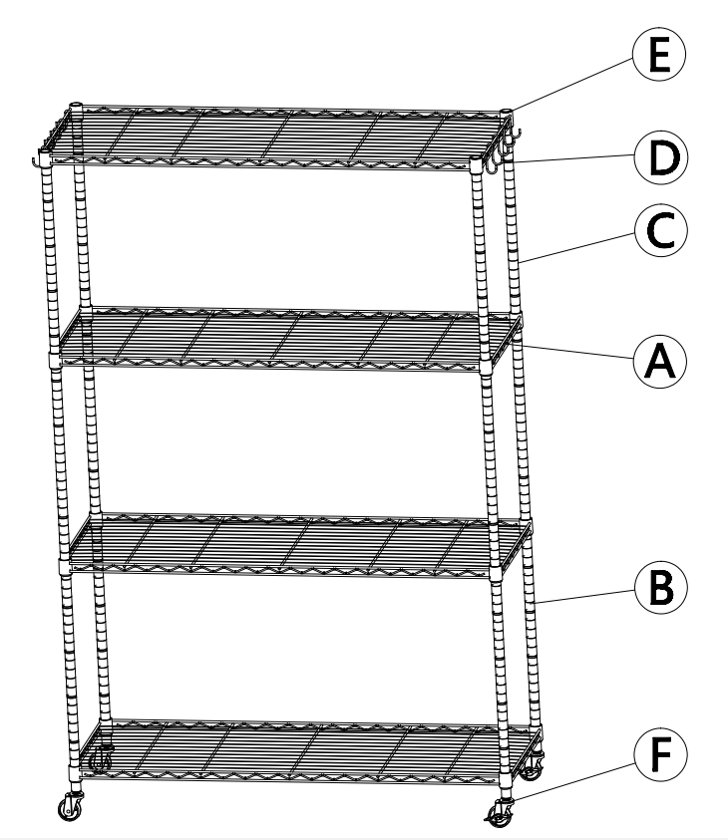

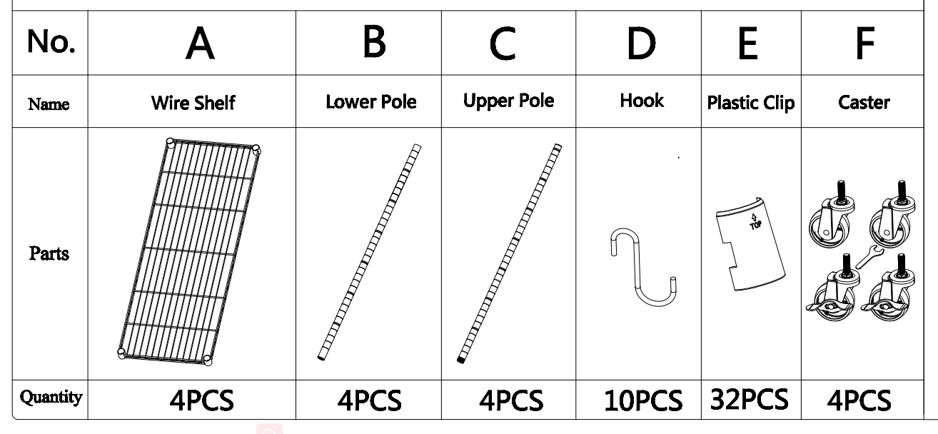

**Attention:**

For additional information regarding the parts listed below, please refer to the Assembly Diagram of this manual. Unwrap and separate all parts in a clear work area.

**Assembly step**

1. Screw the caster(F)into the bottom of each lower poles(B)And snap the plastic clips(E) onto the grooves of each lower poles at the same position.Please make sure that the allow on the plastic clips all should be pointed up.

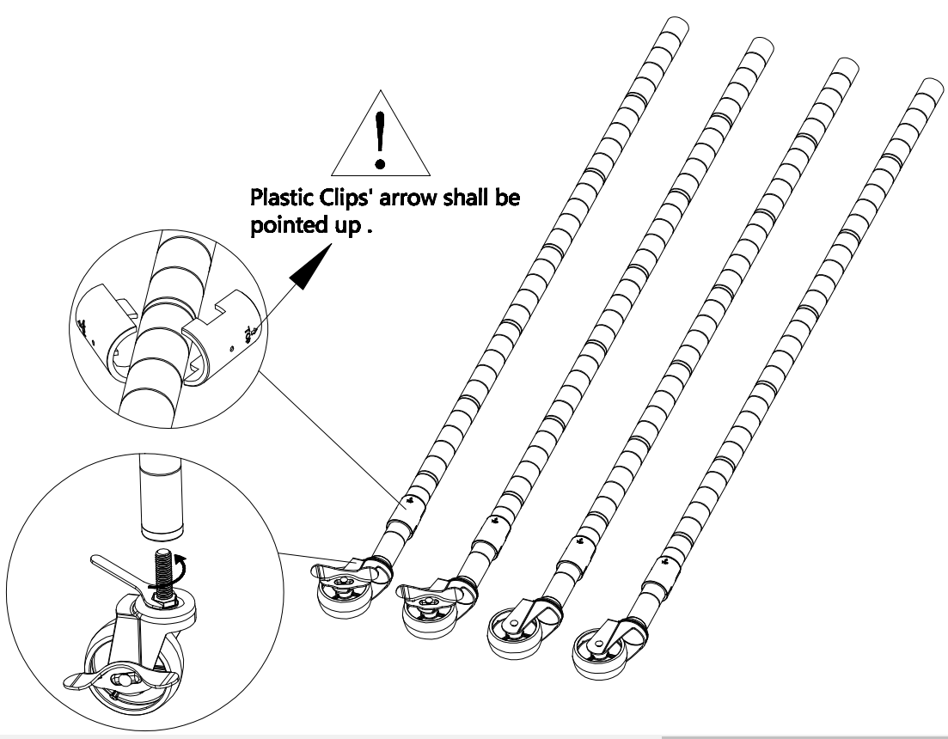

1. Please make sure that you have the wire shelf(A) the correct way up,hold the wire shelf on it's side and slide the top of four poles through the bottom of the wire shelf at it's corner until there is a snug fit,and then set the wire shelf upright.

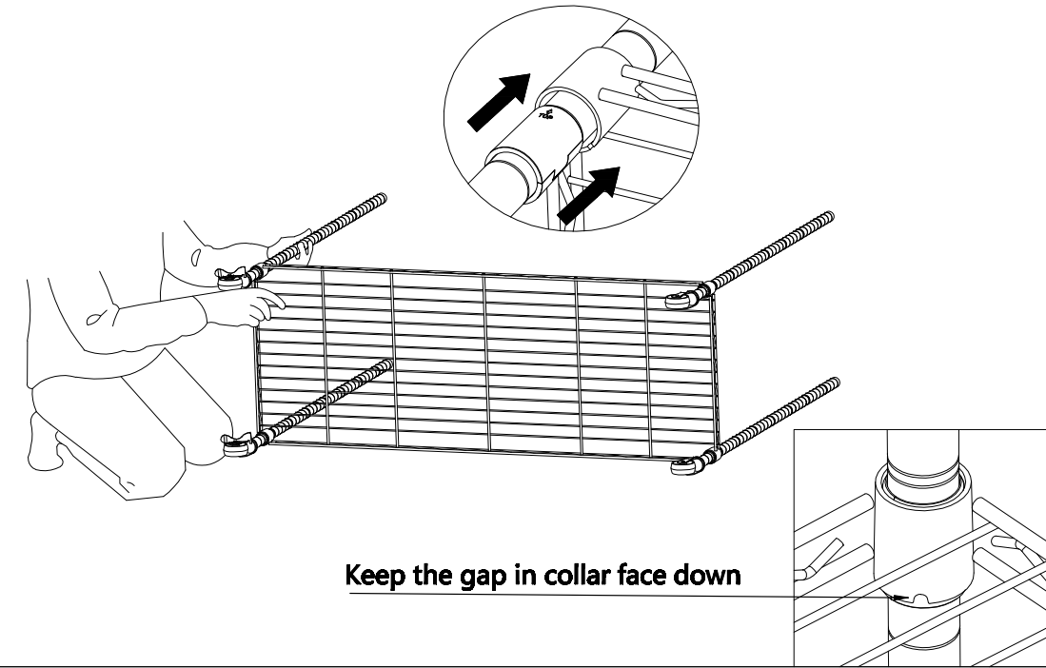

1. Snap plastic clips into the pole groove at your desired position for next wire shelf.Slide down the shelf from top down onto the plastic clips.

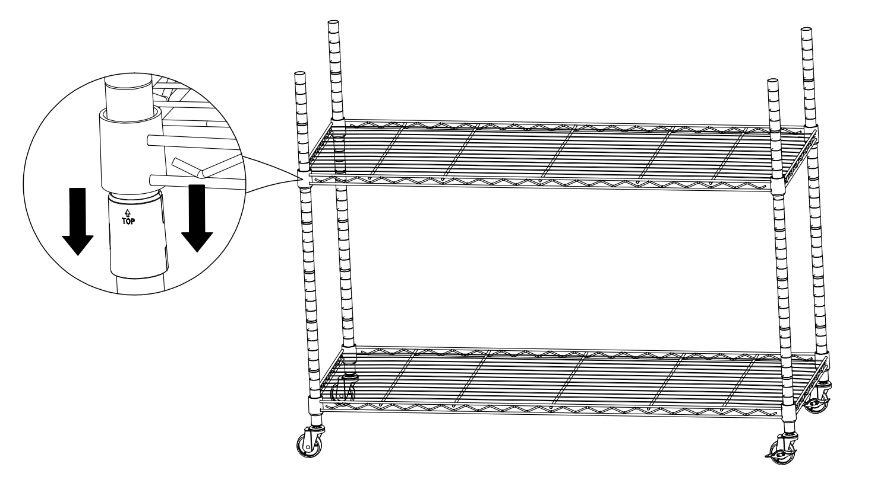

1. Screw upper poles(C) into the lower poles by screw connection which are already assembled onto the middle and upper poles.

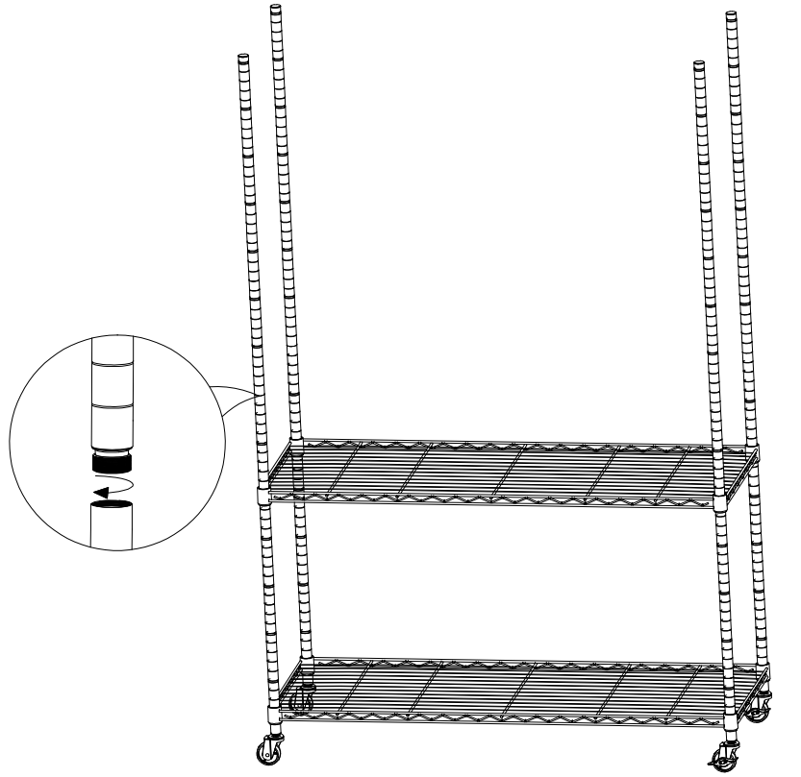

1. Refer to step(3to assemble the other wire shelves.After finishing assemble,pushing firmly down on every wire shelf at its corners by rubber mallet(Not include) to make sure all the wire shelf in a place over the plastic clips.

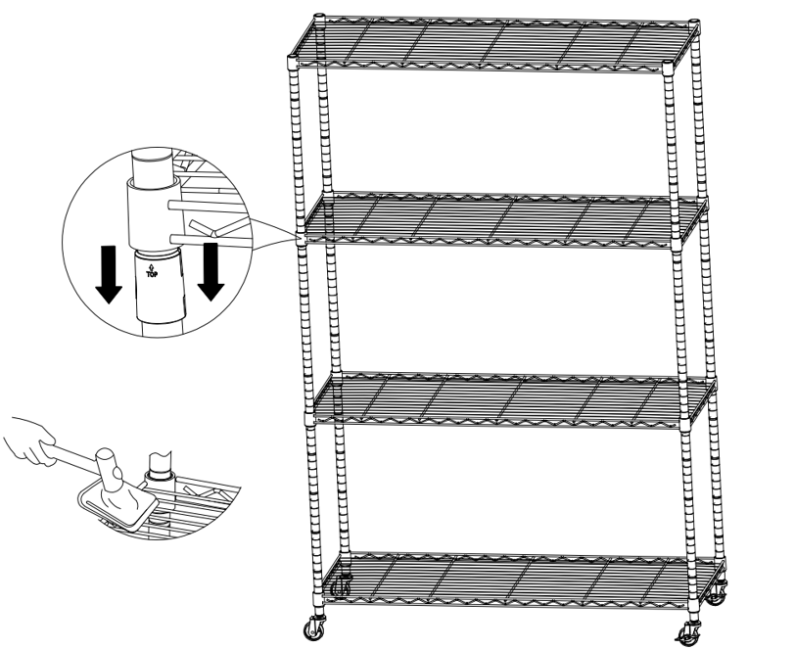

1. Hang the hook (D) over the edge of the shelf as the picture show.

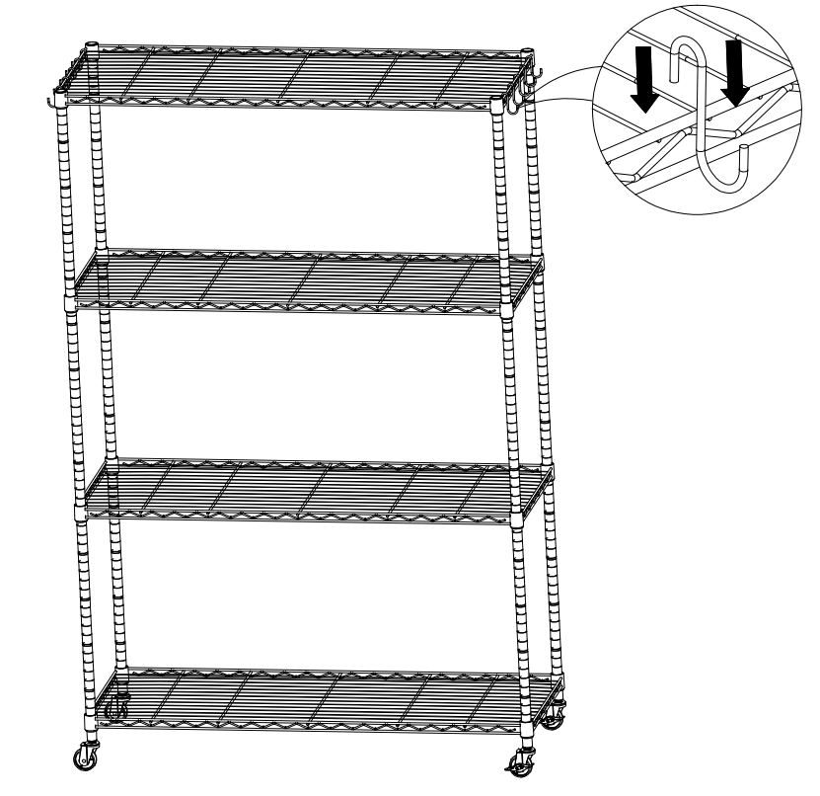

**Address：**Baoshanqu Shuangchenglu 803long 11hao 1602A-1609shi Shanghai

**Imported to AUS:** SIHAO PTY LTD, 1 ROKEVA STREETEASTWOOD NSW 2122 Australia

**Imported to USA:** VEVOR STORE INC, 9448 RINCHMOND PL #E RANCHO CUCAMONGA, California, 91730 United States of America

**Made In China**



Technical Support and E-Warranty Certificate

www.vevor.com/support