# VEVOR Wood Chisel Sets 8pcs Lathe Chisels 7INCH/17CM Woodworking Chisels 9INCH Wood Lathe Tools Wood Chisels Lathe Tools Wood Tool Box for Wood Carving Root Carving Furniture Carving Lathes Red

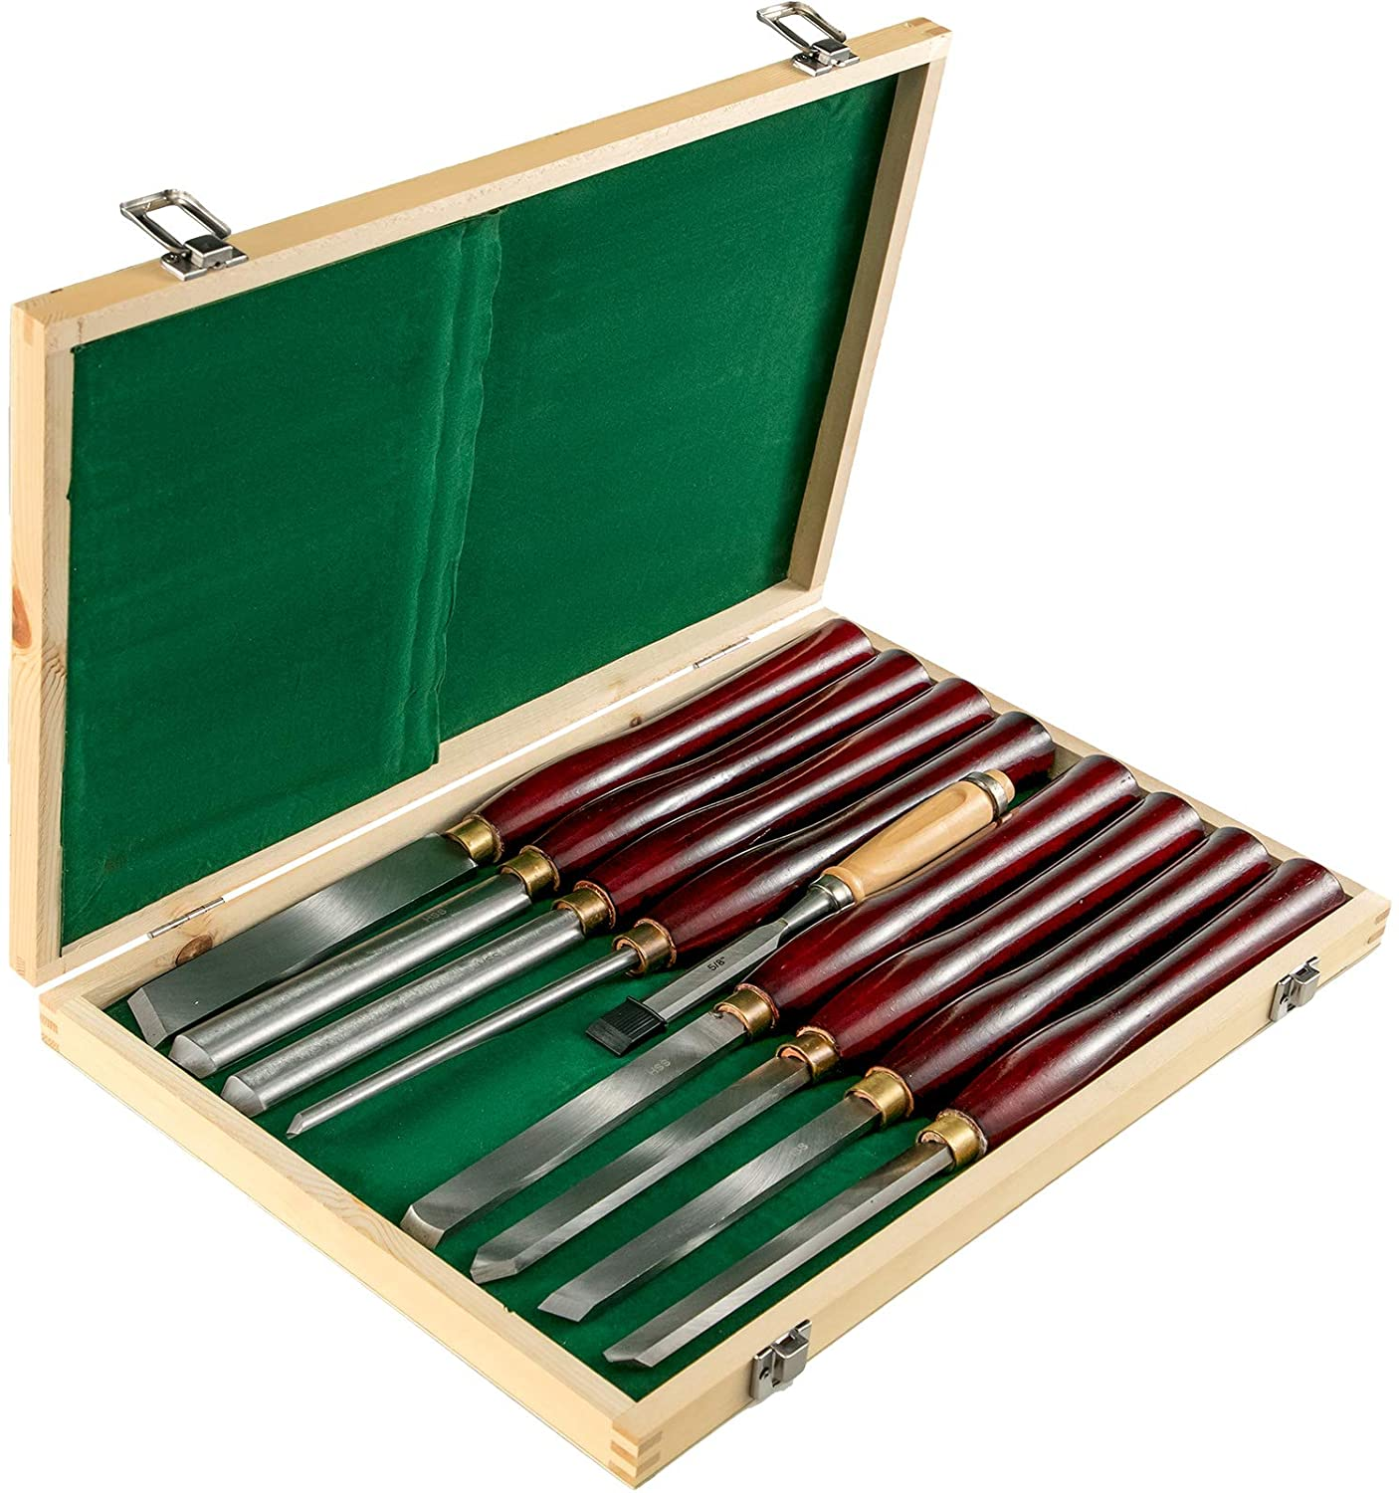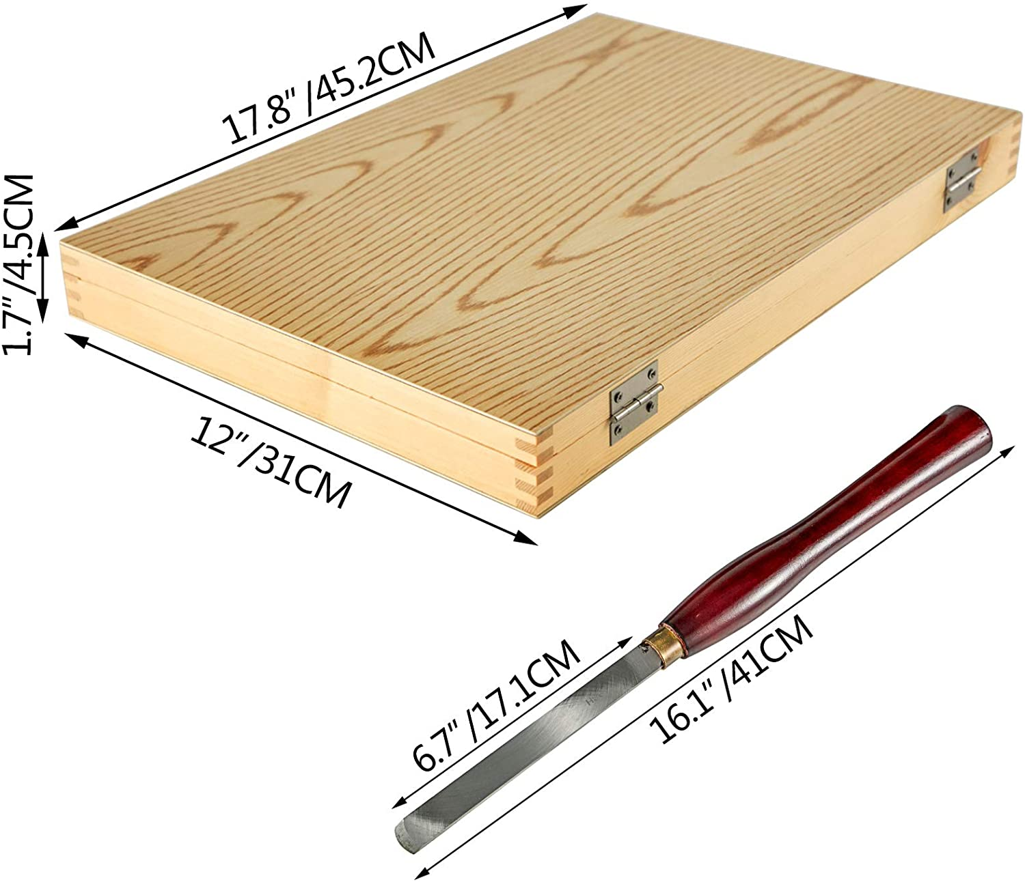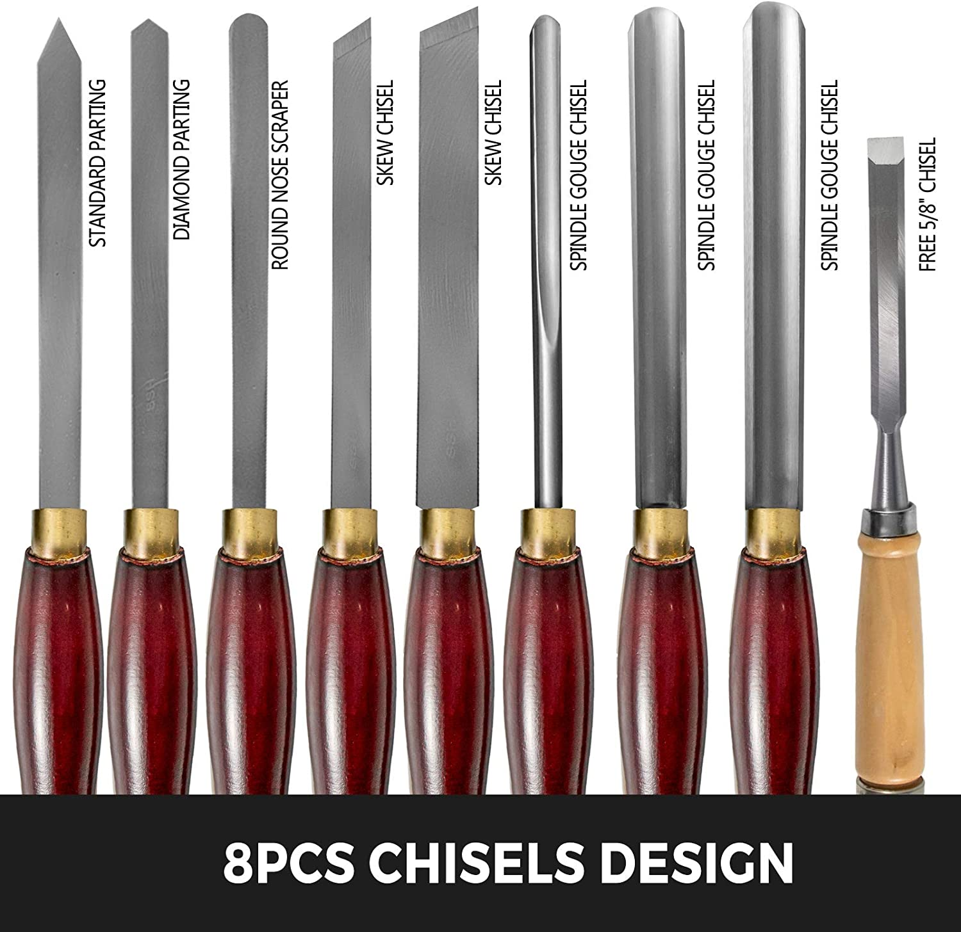

* Solid Blades Design: The lathe chisels are made from high speed steel(HSS), featuring shrill edge and fine grinding. Our entire shank has been heat treated, it can be used after grinding.This knife is an arc shape milled with a 10mm round bar CNC milling machine.
* 8 pcs Chisels Set: Chisels range in overall length is about 16.14" (41cm). The lathe tools includes 8 essential chisels: 3 x Gauge Chisel, 2 x Skew Chisel, 1 x Round Nose Scraper, 1 x Standard Parting and 1 x Diamond Parting. One free 5/8" chisel for you. Blades is about about 6.89" (17.5cm) in length.
* Safe Brass Ferrules: High speed steel(HSS) blades are tightly connected to the handle by durable brass ferrules, easuring chisels' safety and reliability while working.
* Reliable & Sturdy: Solid wood material handles(Red eucalyptus). Ergonomics design offers it more comfortable while doing turning job. Each tool handle is beautifully turned hardwood that are approximately 9.06"(23cm) long.
* Attractive Wood Tool Box: A wooden case for easy storage and transportation. Foam bases to protect wood chisel sets from any damage. Box Size(LxWxH): 17.72" x 12.20" x 1.57" / 45 x 31 x 4 cm.

## **Product description**

Wood Chisel Sets Mini Wood Lathe Wood Turning Tools Bowl Gouge Wood Chisels  
Introduction  
HSS Lathe Chisel Set 8 Piece For Wood Turning The Wood Lathe tools are designed for wood working, lathes, carving projects, etc, easy and safe to use.  
The handles are made with quality polished wood for comfortable grip and the blades are made from high speed steel.  
Chisels range in overall length is about 16.14" (41cm). Compact design with durable case, the wood turning tools are easy storage and transportation.  
High Speed Steel  
Shrill edge, fine grinding, durable. Blade Length: about 6.89" (17.5cm).  
8 Pcs Chisels Design  
Eight blades in different shapes avaliable, sturdy and durable, compact design and easy to use. One 5/8" chisel for free.  
Durable Brass Ferrules  
Connect blades and handles tightly, high safety assured.  
Stained Hardwood Handles  
Ergonomic design principle, smooth surface, comfortable to push, 9.06"(23cm).  
Wooden Case For Storage  
Closable wooden case for easy storage and transportation. Box Size(LxWxH): 17.72" x 12.20" x 1.57" / 45 x 31 x 4 cm.  
Universal Applications  
Ideal kit for wood working, carving projects of wood carving, root carving, furniture carving, lathes, etc.  
  
Specifications  
Blade Material: High Speed Steel(HSS)  
Handle Material: Red Eucalyptus  
Blade Processing: Heat Treated  
Blade Length: about 6.89" (17.5cm)  
Handle Length: 9.06"(23cm)  
Chrisle Length: 16.14" (41cm)  
Box Size(LxWxH): 17.72" x 12.20" x 1.57" / 45 x 31 x 4 cm  
Featured Refinements:Lathe Chisel  
Original/Reproduction: Vintage Original  
Package List  
3 x Gauge Chisel  
2 x Skew Chisel  
1 x Round Nose Scraper  
1 x Standard Parting  
1 x Diamond Parting  
1 x Free 5/8" Chisel