

Technical Support and E-Warranty Certificate  [www.vevor.com/support](https://www.vevor.com/support" \t "_blank)

MANUAL TRAILER MOVER

**User Manual**

**Model:QYC1000**

We continue to be committed to provide you tools with competitive price.

"Save Half", "Half Price" or any other similar expressions used by us only represents an estimate of savings you might benefit from buying certain tools with us compared to the major top brands and doses not necessarily mean to cover all categories of tools offered by us. You are kindly reminded to verify carefully when you are placing an order with us if you are actually saving half in comparison with the top major brands.



MANUAL TRAILER MOVER

**MODEL: QYC1000**

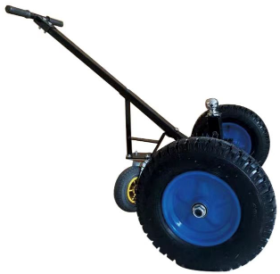

Have product questions? Need technical support? Please feel free to contact us:

**[CustomerService@vevor.com](mailto:CustomerService@vevor.com)**



**NEED HELP? CONTACT US!**

This is the original instruction, please read all manual instructions carefully beforeoperating. VEVOR reserves a clear interpretation of our user manual. The appearance of the product shall be subject to the product you received. Please forgive us that we won't inform you again if there are any technology or software updates on our product.

**SAFETY INSTRUCTIONS**

bw10pt**WARNING**: Read and understand all instructions. Failure to follow all instructions listed below may result in **serious injury**.

1. **Check whether the tire has enough gas before use. If the tire gas is not enough, please inflate the tire before use.**
2. **Check whether the screw part is loose, if yes, please tighten it.**
3. **Do not overload.The maximum load is 1000lbs.**
4. **Ensure the trailer ball is securely connected to avoid falling off while working.**

bw10pt**CAUTION**:Please read the instructions for safe operation carefully.

**Assembly Precautions**

1.Assemble only according to these instructions. Improper assembly can create hazards.

2. Wear ANSI-approved safety goggles and heavy-duty work gloves during assembly.

3.Keep assembly area clean and well lit.

4.Keep bystanders out of the area during assembly.

5.Do not assemble when tired or when under the influence of alcohol, drugs or medication.

6.Weight capacity and other product capabilities apply to properly and completely assembled product only.

7.Assemble on a flat, level, hard and smooth surface capable of safely supporting a fully loaded MANUAL TRAILER MOVER.

**Use Precautions**

TO PREVENT SERIOUS INJURY AND DEATH FROM TIPPING:

1. Do not sit,stand or climb on this item.

2. This product is not a toy. Do not allow children to play with or near this item.

3. Do not lift while loaded.

4. To prevent tipping, push/pull using supplied handle only.

5. Use as intended only.

6. Inspect before every use; do not use if parts are loose or damaged.

7. After use, please dry before storage to avoid rusting of bolts affecting use.

**Special Attention:**

The swivel caster must be straightened before use,and the accessories will bend after the force is not straightened !

**SAVE THESE INSTRUCTIONS**

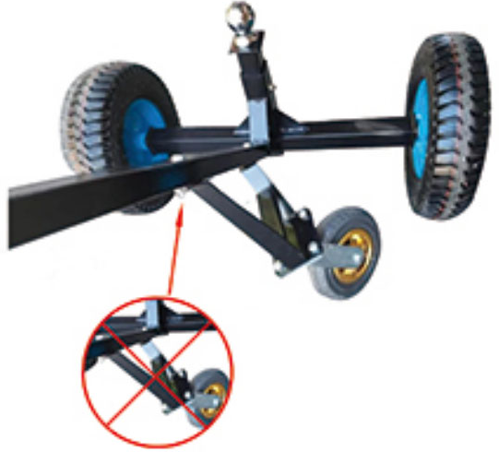

**MODEL AND PARAMETERS**

|  |  |
| --- | --- |
| Model | QYC1000 |
| Maximum Load | 1000lbs |
| Product Size | LxWxH=123x87x90 cm |
| Wheel | 16" Pneumatic Tire  8" Swivel Caster |
| Hitch Ball | Diameter:2" |
| Adjustable Height | 48-65cm |
| Material | Steel |

**STRUCTURE DIAGRAM**



4

3

2

1

1.Handle 2.Hitch Ball 3.Swivel Caster  4.Pneumatic Tire

**COMPONENTS**

|  |  |  |
| --- | --- | --- |
| 1676358104189(1)  ×1 | a13f31bee3545a5bf4ee4f3c01cd2f51676358426625  ×8  （Ф10） | 1676358266748  ×1 |
| 1676358290542  ×1 | 1676358315003  ×2 | **1676358351917(1)**  ×1 |
| 1676358392701  ×1 | 1676358426625  ×4  （Ф20） | 1676018946527  ×2  （M20） |
| 1676358476151(1)  ×4  （M10\*45） | 1676358556268  ×1 | 1676018901275  ×4  （M10\*20） |
| 1676358668419  ×1 | 1676018721373  ×8  （M10） |  |

**Note:**Before leaving the factory, some accessories have been installed on the main body.

**ASSEMBLY**

|  |
| --- |
| Tools needed |
| 1676007653854  Socket Wrench |

**Step 1:** Connect ⑥ to ⑦ with ⑫+ ⑭+②

**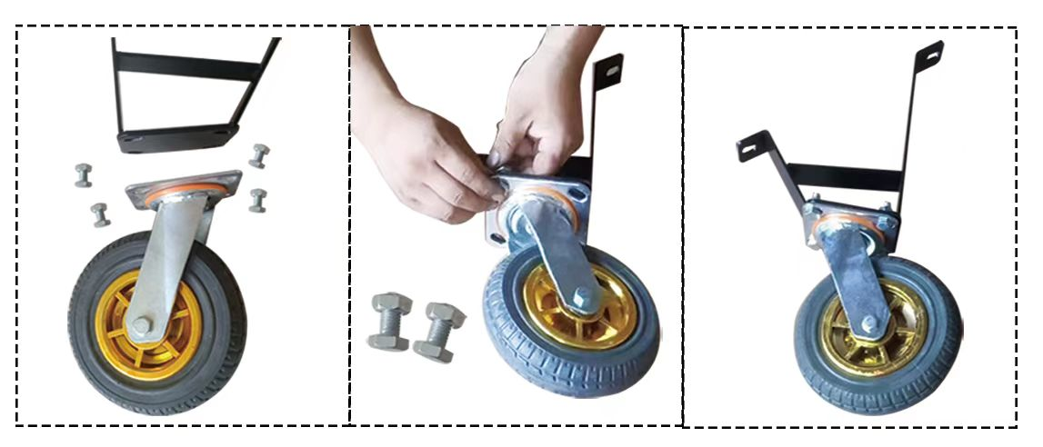**

7

6

**Step 2:** Connect with ①+⑦+⑩+⑭+②

1

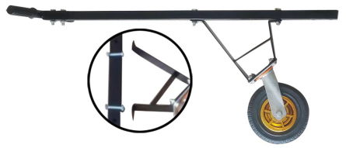

7

**Step 3:** Connect with ③+⑤+⑧+⑨

**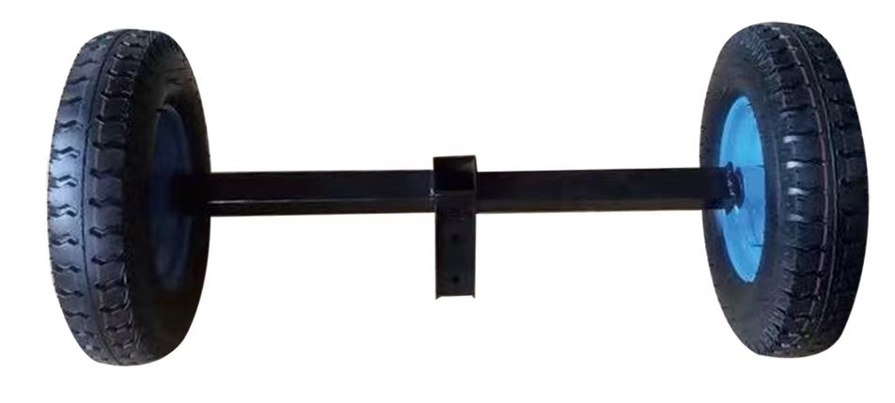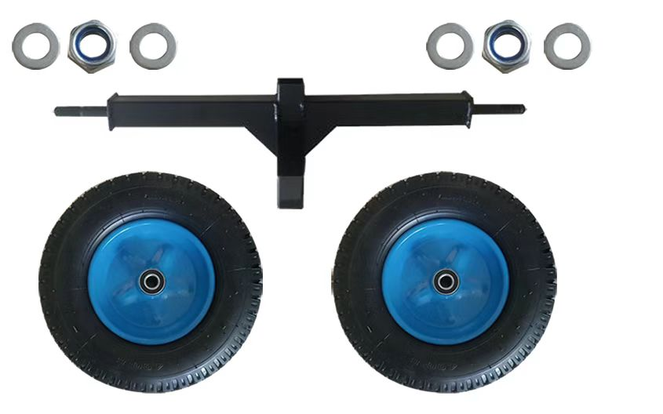**

3

5

**Step 4:** Connect with ①+③+⑩+⑭

1

**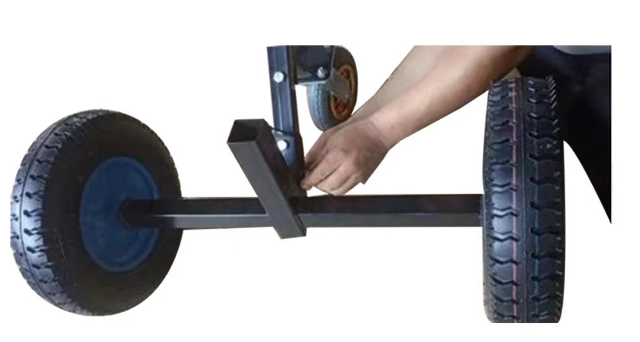 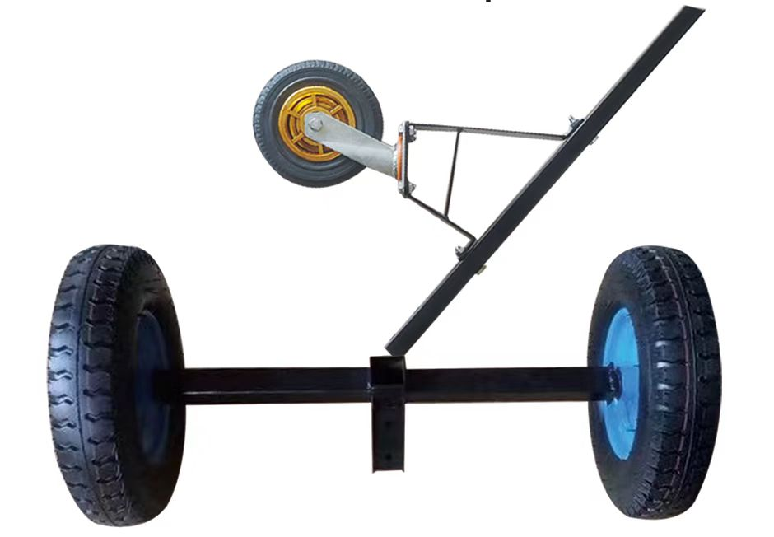**

3

**Step 5:** Connect with ③+④+⑪+⑬

**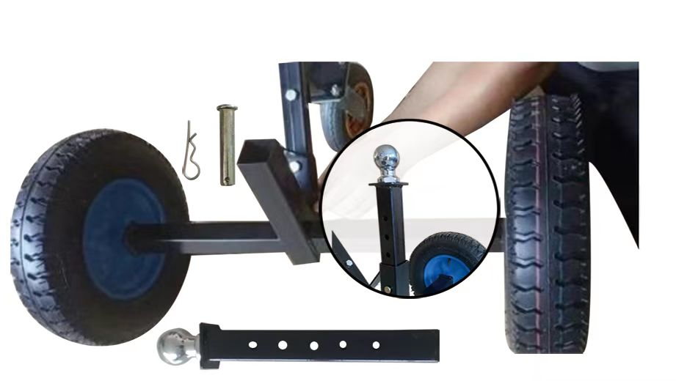**

3

4

**Step 6:** Re-confirm that all parts are locked,and the installation is complete.

**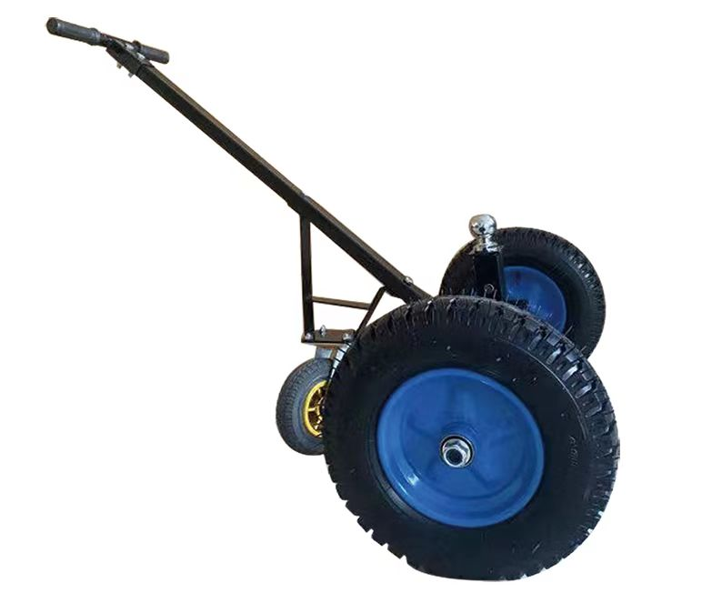**

**Step 7:** Before use,please inflate the tires to a pressure of 27KPa.

NOTE that do not exceed the prescribed tire pressure to avoid bursting.

MAINTENANCE

* Do not overload.
* After use, please dry before storage to avoid rusting of bolts affecting use.
* Check your tires regularly for air and loose bolts.

EU Importer: WAITCHX, 250 bis boulevard Saint-Germain 75007 Paris



UK Importer: FREE MOOD LTD, 2 Holywell Lane, London, England, EC2A 3ET



Manufacturer：Wuqiang Xintianhong Tool Manufacturing Co., LTD

Add:Beiche Village, Wuqiang County, Hengshui City, Hebei Province

**Made in China**

****

**TechnicalSupport and E-Warranty Certificate**

**[www.vevor.com/support](https://www.vevor.com/support" \t "_blank)**