

Technical Support and E-Warranty Certificate  [www.vevor.com/support](https://www.vevor.com/support" \t "_blank)

**Garage wall shelving**

**Model: ML2448**

We continue to be committed to provide you tools with competitive price.

"Save Half", "Half Price" or any other similar expressions used by us only represents an estimate of savings you might benefit from buying certain tools with us compared to the major top brands and doses not necessarily mean to cover all categories of tools offered by us. You are kindly reminded to verify carefully when you are placing an order with us if you are actually saving half in comparison with the top major brands.



**Garage wall shelving**

**MODEL:ML2448**

**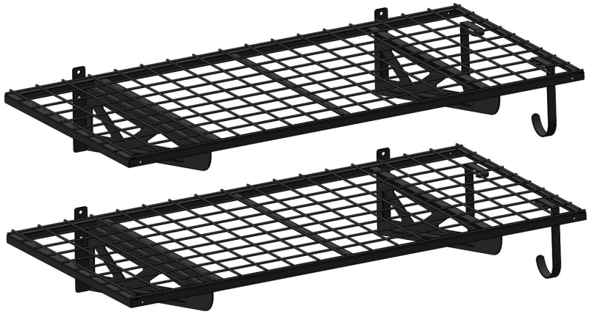**

Have product questions? Need technical support? Please feel free to contact us:

**[CustomerService@vevor.com](mailto:CustomerService@vevor.com)**



**NEED HELP? CONTACT US!**

This is the original instruction, please read all manual instructions carefully beforeoperating. VEVOR reserves a clear interpretation of our user manual. The appearance of the product shall be subject to the product you received. Please forgive us that we won't inform you again if there are any technology or software updates on our product.

**SAFETY INSTRUCTIONS**

**WARNING:This product contains small parts. If swallowed, it will pose a choking hazard. Keep these small parts away from children !**

1. Before installation, take protective measures to avoid personal injury!

****

**EYE PROTECTION**  **FOOT PROTECTION DUST MASK PROTECTION WEAR**

1. The product must be installed on a wooden or concrete wall. Before installation, ensure that the bearing capacity of the wall does not exceed the maximum bearing capacity ! Please strengthen the structure of the wall in time to consolidate the bearing capacity of the wall ! Otherwise, the product may be damaged or personal injury may occur !
2. This product is for indoor use only. Outdoor use may cause product damage or personal injury.
3. Please check and confirm whether the screws are loose every two months.
4. At least two people to complete the installation.
5. Ensure that you have read the instructions and fully understood how to install. If you do not understand any of the installation steps, contact a professional installation personnel.

7. Do not overload ! Maximum capacity : 251 lbs **/**per layer**（evenly distributed）**

**Installation Preparation:**

**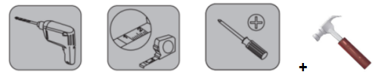**

**MODEL AND PARAMETERS**

|  |  |
| --- | --- |
| **Model** | **ML2448** |
| Number of Layers | 2 |
| Shelving Surface Size | 48x24 inch |
| Maximum Bearing Capacity | 251 lbs /per layer（502lbs in total） |
| Material | Steel |
| Color | Black |

**STRUCTURE DIAGRAM**

1

2

****

3

1.Brackets 2.Shelf 3.Hooks

**COMPONENTS**

|  |  |  |  |
| --- | --- | --- | --- |
| **No.** | **Picture** | **Name** | **Qty** |
| 1 | 1678190410902 | Left Bracket | 2 |
| 2 | 1678190440838 | Right Bracket | 2 |
| 3 | 1678245946760 | Shelf | 2 |
| 4 | 1677836119391 | Hook | 4 |
| 5 | 1677836049510 | L-shaped Wrench | 1 |
| 6 | 1678190519460 | Positioning Paper | 1 |
| 7 | **1677835434254** | Micro Level Vial | 1 |
| 8 | 1677835307555 | Expansion Plug-8\*58 | 12 |
| 9 | 1678071710167 | Washer-8.5 | 12 |
| 10 | 1677834985544 | Hexagon Self-tapping Screw-8\*60 | 12 |
| 11 | 1677834109907 | Cable Ties-12\*250 | 8 |
| 12 | 1678257606869 | User Manual | 1 |

**ASSEMBLY**

**STEP 1-A : Installation on Solid Concrete Walls**

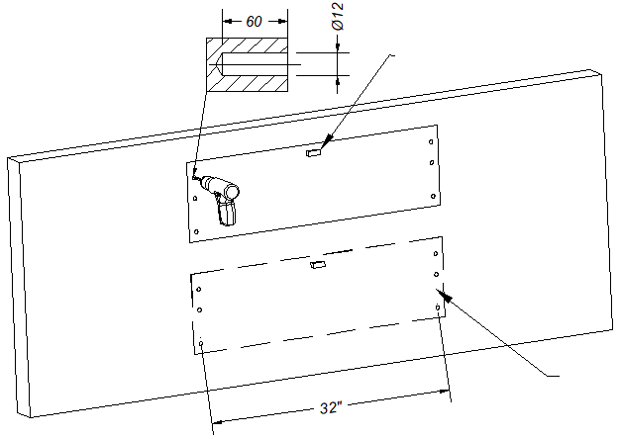

Positioning Paper

Micro Level Vial

1. Paste the positioning paper to the appropriate height, glue the Micro level vial to adjust the level, and then use the jackhammer to lightly drill out the anchor points.
2. Remove the positioning paper and drill holes(Φ12x60mm) into the wall. (The positioning paper should be reused 2 times.)

Expansion Plug-8\*58

**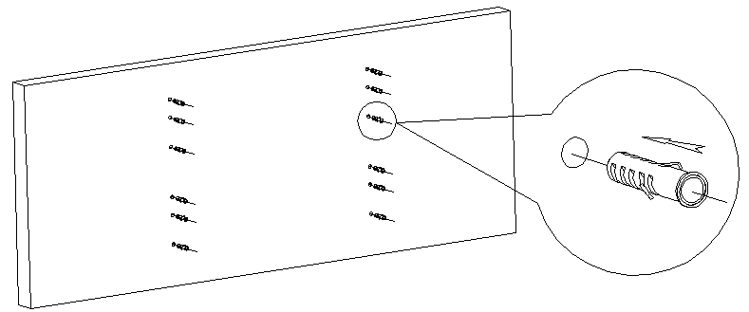**

1. After clearing the residual soil in the hole, tap the expansion plug into the hole completely.

Washer-8.5

Hexagon Self-tapping Screw-8\*60

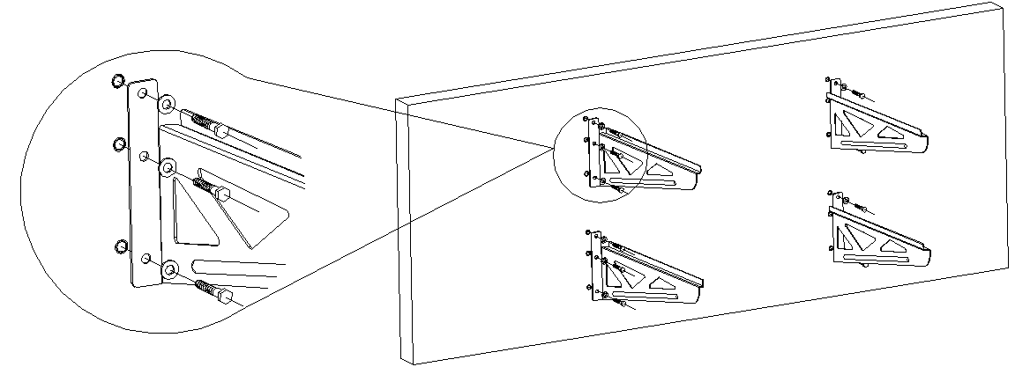

1. Install and fix the left and right bracket. The screw must be screwed in completely and press tightly !

**STEP 1-B : Installation on Wooden Wall Post**

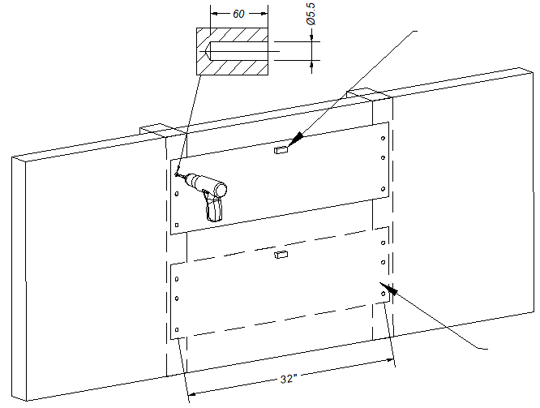

Positioning Paper

Micro Level Vial

1. Paste the positioning paper to the appropriate height, glue the Micro level vial to adjust the level, and then use the jackhammer to lightly drill out the anchor points.
2. Remove the positioning paper and drill holes(Φ5.5x60mm) into the wall.(The positioning paper should be reused 2 times.)

**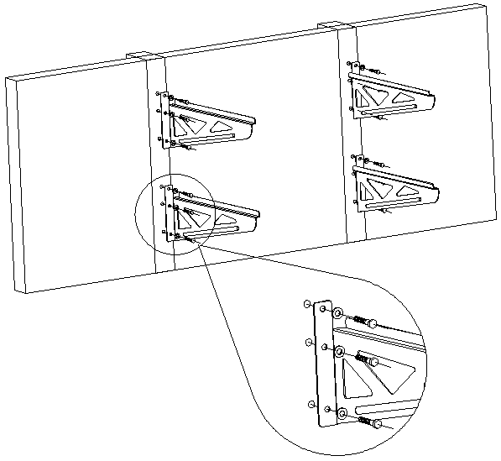**

Hexagon Self-tapping Screw-8\*60

Washer-8.5

1. Install and fix the left and right bracket. The screw must be screwed in completely !

**STEP 2 : Installation of The Shelf**

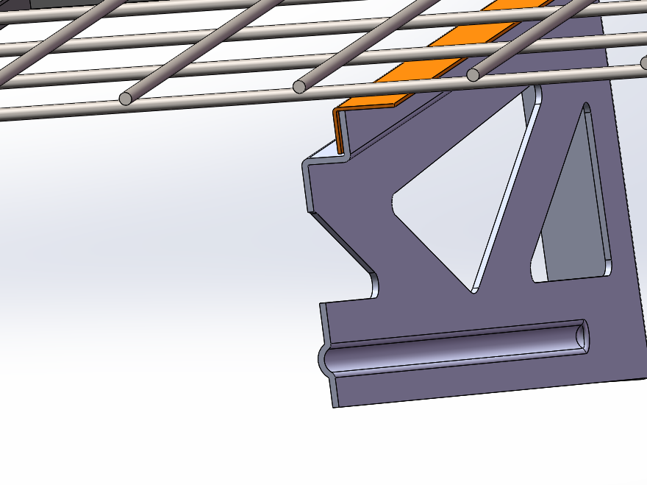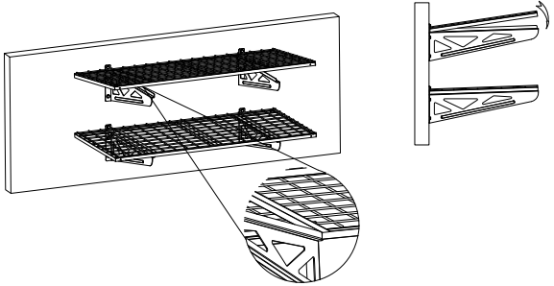

The bracket should be stuck inside the strengthening Angle iron.

**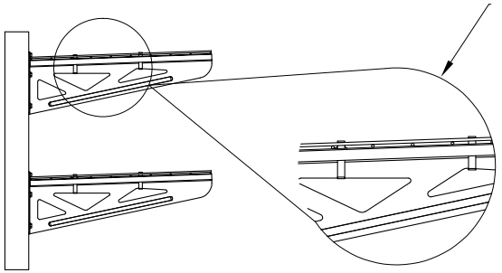**

Use 2 cable ties to fix the grid and bracket.

**STEP 3 : Mounting Hook**

**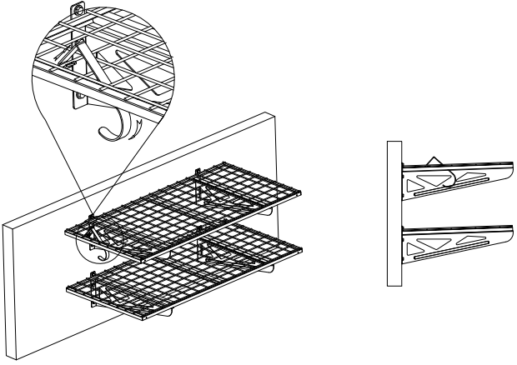**

**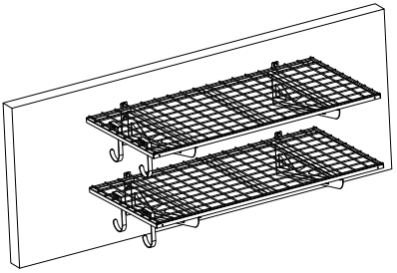**

**MAINTENANCE**

1. Do not overload.
2. Please try to avoid putting wet items on shelves. Keep the warehouse not too wet.
3. Please check and confirm whether the screws are loose every two months.
4. Dust off regularly with a clean rag, and arrange items neatly on shelves.

**VEVOR STORE INC**

**9448 RINCHMOND PL #E RANCHO CUCAMONGA, California, 91730 United States of America**

****

**TechnicalSupport and E-Warranty Certificate**

**[www.vevor.com/support](https://www.vevor.com/support" \t "_blank)**