

Technical Support and E-Warranty Certificate www.vevor.com/support

Gas Hedge Trimmer
USER MANUAL

We continue to be committed to provide you tools with competitive price.
"Save Half","Half Price" or any other similar expressions used by us only represents an estimate of savings you might benefit from buying certain tools with us compared to the major top brands and does not necessarily mean to cover all categories of tools offered by us. You are kindly reminded to verify carefully when you are placing an order with us if you are actually saving half in comparison with the top major brands.


Gas Hedge Trimmer
F43-C
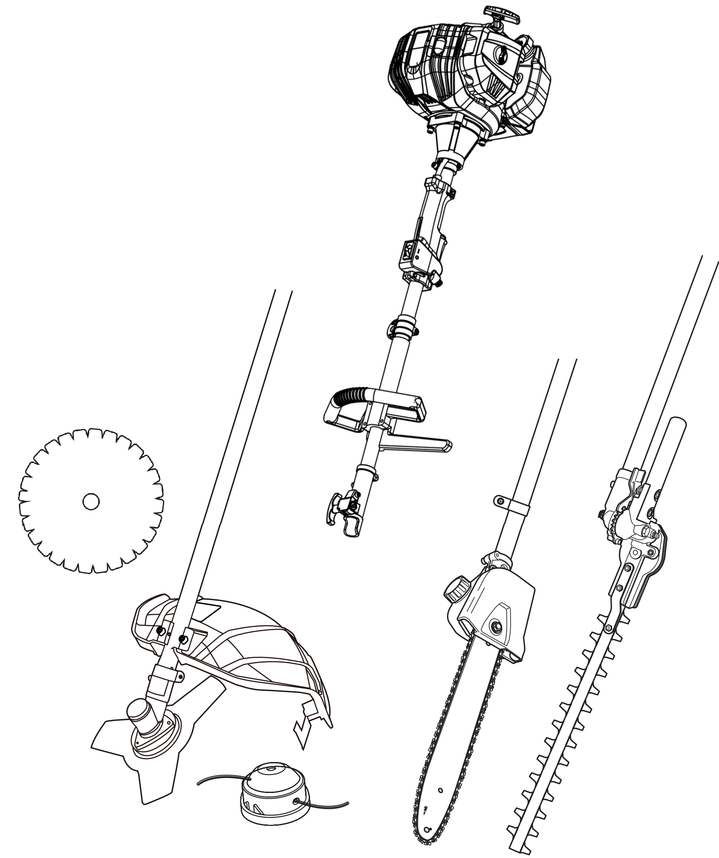
Have product questions? Need technical support? Please feel free to contact us:
Technical Support and E-Warranty Certificate
www.vevor.com/support

NEED HELP? CONTACT US!
This is the original instruction,please read all manual instructions carefully before operating. VEVOR reserves a clear interpretation of our user manual. The appearance of the product shall be subject to the product you received. Please forgive us that we won't inform you again if there are any technology or software updates on our product.

IMPORTANT
READ CAREFULLY BEFORE USE.
KEEP FOR FUTURE REFERENCE.
Training
1. Read the instructions carefully. Be familiar with the controls and the proper use of the product.
2. Never allow children or people unfamiliar with these instructions to use the product. Local regulations can restrict the age of the operator.
3. Never operate the product while people, especially children, or pets are nearby.
4. Keep in mind that the operator or user is responsible for accidents or hazards occurring to other people or their property.
5. The product must not be used by persons under the influence of alcohol, drugs or medication.
6. Do not operate the product if you are tired.
7. Do not operate the product without guards or if it is damaged.
8. Never use the product indoors.
9. This product produces toxic exhaust fumes when the engine is started.
10.During operation this product may generate dust, fumes and smoke containing chemicals that affect your health. So be careful when using your product and protect yourself properly.
11.Also avoid breathing exhaust fumes voluntarily; always hold the product properly during operation.
12.Wear gloves and keep hands warm.

Preparation
1. This product can cause serious injuries. Read the instructions carefully for the correct handling, preparation, maintenance, starting and stopping of
the product. Become familiar with all controls and the proper use of the product.
2. Avoid operating while people, especially children, are nearby.
3. Dress proper clothing! Do not wear loose clothing or jewellery, which can be caught in moving parts. Use of sturdy gloves, non-skid footwear and safety glasses is recommended.
4. Store the product in a dry, clean place protected from direct sunlight only after the fuel tank has been emptied and the product is cleaned. The product must be stored inside only under these conditions.
5. If the cutting attachment strikes any foreign object or the product starts making any unusual noise or vibration, shut off the power source and allow the product to stop. Disconnect the spark plug connector from the spark plug and take the following steps:
• inspect for damage,
• check for, and tighten, any loose parts,
• have any damaged parts replaced or repaired with parts having equivalent specifications.
6. Check the cutting attachment stops turning when the engine idles.

Operation
1. This product should not be used for any other purpose than described. National regulations can restrict the use of the product.
2. While operating, always wear substantial footwear and long trousers. Do not operate the product when barefoot or wearing open sandals. Wear
protective glasses or goggles.
3. Ensure the area to be worked is clear from stones, sticks, wire etc. or other objects that could damage the product.
4. Thoroughly inspect the area where the product is to be used and remove all objects which can be thrown by the product.
5. Before using the product and after any impact, check for signs of wear or damage and repair as necessary.
6. Never operate the product with damaged guards or without the guards in place.
7. Keep hands and feet away from the cutting attachment at all times and especially when switching on the engine.
8. Never allow children or people unfamiliar with the instructions to use the product.
9. Stop using the product while people, especially children, or pets are nearby.
10.Only use the product in daylight or good artificial light.
11.Keep your body upright during operation. Do not lean forward. Make regular breaks and change your working position to stay concentrated.
12.Keep firm footing and balance during operation. Always use the harness, if provided.
13.Stop the engine before
• cleaning or when clearing a blockage,
• checking, carrying out maintenance or working on the product,
• adjusting the working position of the cutting attachment,
• leaving the product unattended,
14.Ensure that the product is correctly located in a designated working position before starting the engine.
15.While operating the product, always ensure that the operating position is safe and secure.
16.Do not operate the product with a damaged or worn cutting attachment.
17.Keep the engine and silencer free of debris, leaves and excessive lubricant to reduce fire hazards.
18.Always ensure that all handles and guards are fitted when using the product. Never attempt to use an incomplete product or one fitted with an
unauthorised modification.
19.Always use two hands to operate a product fitted with two handles.
20.Always be aware of your surroundings and stay alert for possible hazards of which you may not be aware due to the noise of the product.
21.Be careful when handling any cutting attachment / sharp edge fitted for trimming the filament line length. Ensure a new filament trimming line is
installed correctly before turning the product on.
22.Always ensure that air vents are kept clear of debris.
23.Only use cutting attachments as listed in the technical data within these instructions. The use of other attachments leads to hazards resulting in
personal injuries and property damage.
24.Never carelessly touch the product, you can burn yourself. While the product is in operation or shortly thereafter, its parts such as the exhaust pipe, engine, and other surfaces are extremely hot! Pay attention to the markings on the product.
Maintenance and storage
1. Follow the maintenance and repair instructions for this product. Never carry out any modifications to the product.
2. When the product is stopped for servicing, inspection or storage, shut off the power source, disconnect the spark plug connector from the spark plug and make sure all moving parts have come to a stop. Allow the product to cool before making any inspections, adjustments, etc.
3. Maintain and inspect your product regularly. Check for misalignment or binding of moving parts,breakage of parts and any other condition that may
affect the product’s operation. If damaged, have the product repaired before use. Many accidents are caused by poorly maintained products.
4. Improper maintenance will lead to malfunction/ failure of the product.
5. Inspect the product before each use, after dropping the product or exposing to other impacts to identify significant defects. Check for loose fasteners, fuel leaks and damaged parts, such as cracks in the cutting attachment.
6. Never change the preset rotary speed or the engine and product settings. Information about maintenance and repair is provided in this instruction manual.
7. Store the product where the fuel vapour will not reach an open flame or spark. Always allow the product to cool down before storing.
8. When not in use, store the product out of the reach of children.
9. Use only manufacturers recommended replacement parts and accessories.
10.Secure the product during transport to prevent loss of fuel, damage and injury.
11.Clean and maintain the product as described in these instructions before storage. Always use guards on cutting attachments when storing.
12.Make sure that the air intake of the combustion engine is clear. Keep the air intake free of dust, dirt particles, gases and fumes.
13.Make sure that air circulation is adequate and good. The product must be easily accessible from all sides.
14.Attach the transportation cover for the metal cutting attachment during transport and storage.
Additional safety warnings for pole saw
1. Interrupt your work when you feel tired. Make regular breaks to regenerate. A moment of inattention while operating the product may result in serious personal injury.
2. Keep all parts of the body away from the saw chain. Do not remove cut material or hold material to be cut when saw chain is moving. Make sure the product is switched off when clearing jammed material. A moment of inattention while operating the product may result in serious personal injury.
3. Hold the product by insulated gripping surfaces only, because the saw chain may contact hidden wiring. Saw chains contacting a “live” wire may make exposed metal parts of the product “live” and could give the operator an electric shock.
4. Keep all parts of the body away from the saw chain when the product is operating. Before you start the product, make sure the saw chain is not contacting anything. A moment of inattention while operating products may cause entanglement of your clothing or body with the saw chain.
5. Always hold the product with both hands on the handles. Holding the product with only one hand or on parts not intended for that increases the
risk of personal injury and should never be done.
6. Wear safety glasses and hearing protection. Further protective equipment for head, hands, legs and feet is recommended. Adequate protective clothing will reduce personal injury by flying debris or accidental contact with the saw chain.
7. Do not operate a product in a tree. Operation of a product while up in a tree may result in personal injury.
8. Always keep proper footing and operate the product only when standing on a fixed, secure and level surface. Slippery or unstable surfaces such as ladders may cause a loss of balance or control of the product.
9. When cutting a limb that is under tension be alert for spring back. When the tension in the wood fibers is released the spring-loaded limb may strike the operator and/or throw the product out of control.
10.Use extreme caution when cutting brush and saplings. The slender material may catch the saw chain and be whipped toward you or pull you off balance.
11.Carry the product by the handles/poles with the product switched off and away from your body. When transporting or storing the product always fit the guide bar cover. Proper handling of the product will reduce the likelihood of accidental contact with the moving saw chain.
12.Follow instructions for lubricating, chain tensioning and changing accessories. Improperly tensioned or lubricated chain may either break or increase the chance for kickback.
13.Keep handles dry, clean, and free from oil and grease. Greasy, oily handles are slippery causing loss of control.
14.Cut wood only. Do not use product for purposes not intended. For example: do not use product for cutting plastic, masonry or non-wood building materials. Use of the product for operations different than intended could result in a hazardous situation.
15.Pay attention to national and local regulations. National and local regulations may restrict the use of this product.
16.Only use replacement guide bars and saw chains specified by the manufacturer or equivalent replacements. Using non-approved cutting attachments can result in personal injuries and damage to property.
17.Before using the product and after any impact or dropping, check for signs of wear or damage and repair as necessary.
18.Never remove or modify any guard or safety component. Ensure that guards and other safety components necessary for machine operation are
in position, in good working condition and properly maintained to avoid injuries.
19.Remove branches in sections.
20.Beware of dangerous operating positions as well as of the risk of being struck by falling branches or by those that rebound after hitting the ground.
21.Beware of overhead power lines. Do not use the product in any position that causes any part to come within 10 m of overhead electrical lines.
22.Never cut in areas where the cutting attachment is out of sight.

Causes and operator prevention of kickback
• Kickback may occur when the nose or tip of the guide bar touches an object, or when the wood closes in and pinches the saw chain in the cut.
• Tip contact in some cases may cause a sudden reverse reaction, kicking the guide bar up and back toward the operator.
• Pinching the saw chain along the top of the guide bar may push the guide bar rapidly back towards the operator.
• Either of these reactions may cause you to lose control of the saw which could result in serious personal injury. Do not rely exclusively upon the safety devices built into your saw. As a product user, you should take several steps to keep your cutting jobs free from accident or injury.

Kickback is the result of tool misuse and/or incorrect operating procedures or conditions and can be avoided by taking proper precautions as given below:
1. Maintain a firm grip, with thumbs and fingers encircling the product handles, with both hands on the saw and position your body and
arm to allow you to resist kickback forces.
Kickback forces can be controlled by the operator, if proper precautions are taken. Do not let go of the product.
2. Do not overreach. This helps prevent unintended tip contact and enables better control of the product in unexpected situations.
3. Only use replacement bars and chains specified by the manufacturer. Incorrect replacement bars and chains may cause chain breakage and/or kickback.
4. Follow the manufacturer’s sharpening and maintenance instructions for the saw chain.Decreasing the depth gauge height can lead to increased kickback.

Additional safety warnings for pole hedge trimmer
1. Keep all parts of the body away from the cutter blade. Do not remove cut material or hold material to be cut when blades are moving.
Make sure the switch is off when clearing jammed material. A moment of inattention while operating the hedge trimmer may result in serious personal injury.
2. Carry the hedge trimmer by the handle with the cutter blade stopped. When transporting or storing the hedge trimmer always fit the cutting
device cover. Proper handling of the hedge trimmer will reduce possible personal injury from the cutter blades.
3. Hold the product by insulated gripping surfaces only, because the cutter blade may contact hidden wiring. Cutter blades contacting a “live” wire may make exposed metal parts of the product “live” and could give the operator an electric shock.
4. Check the hedge for foreign objects before operation, e.g. wire fences. Take care that the cutting device does not come into contact with wire or other metal objects.
5. Hold the product properly with both hands. Loss of control can cause personal injury.

Fuel handling
1. Always switch the product off, disconnect the spark plug connector and let the product cool down, before refueling it. Fuel and fuel vapor are highly flammable. Take care when handling fuel. Never smoke when you are refueling the product. Do not refuel the product, if there is an open fire in the vicinity!
2. Always use suitable aids such as funnels and filler necks. Do not spill any fuel on the product or its exhaust system. There is a risk of ignition. Remove spilled fuel carefully from all parts of the product.
Any residue that may be present must have been completely volatilized before the product is put into operation!
3. Never refuel indoors.
4. Never use the product in environments where there is a risk of explosion. Exhaust gases and fuel fumes are noxious. Fuel fumes can ignite.
5. Never breathe in any fuel fumes, when you are refueling the product. Never fill the tank in enclosed spaces, such as basements or sheds.
There is a risk of poisoning and explosion!
6. Avoid skin contact with petrol.
7. Do not eat or drink, while you are refueling the product. If you have swallowed petrol or oil, or if petrol or oil has got into your eyes, then seek the advice of a doctor immediately.
8. Close the tank lid immediately after filling the tank. Make sure that it is properly closed.
9. Never use the product without an air filter.
10.Fuel vapour pressure may build up inside the fuel tank depending on the fuel used, weather conditions and the tank venting system. To reduce
the risk of burns and other personal injuries, remove the fuel cap carefully to allow any pressure build up to release slowly.
11.Be aware of fire risks, explosion and inhalation risks.
12.Do not smoke while operating the product, handling fuel or near fuel.
13.Ensure the spark plug lead is secured, a loose lead may cause electrical arcing that could ignite combustible fumes and cause a fire or explosion.
14.Check regularly for leaks from the fuel cap and fuel lines.
15.Use caution when handling fuel. To avoid any accidental fires, move the product at least 3 metres (10’) from the fuelling point before starting the
engine.
16.Tighten the fuel cap thoroughly after refilling the fuel tank.
17.Do not operate the product if it is leaking fuel. Do not remove the fuel tank cap while the engine is running.
18.Use only an approved container.
19.Do not store cans of fuel or refill the fuel tank in any place where there is a boiler, stove, wood fire, electrical sparks, welding sparks, or other sources of heat or fire which might ignite the fuel.
20.If any fuel spillage occurs during refueling, use a dry rag to wipe up spills and allow remaining fuel to evaporate before turning the engine on again.
21.If you have spilt fuel on yourself or on your clothes, change your clothes and wash any part of your body that has come in contact with fuel before
turning the engine on again.
22.If fuel is ignited, put out the fire with a dry powder fire extinguisher.
23.If the fuel tank is drained, this should be done outdoors.

Vibration and noise reduction
To reduce the impact of noise and vibration emission, limit the time of operation, use low-vibration and low-noise operating modes as well as wear personal protective equipment.

Take the following points into account to minimize the vibration and noise exposure risks:
1. Only use the product as intended by its design and these instructions.
2. Ensure that the product is in good condition and well-maintained.
3. Use correct attachments for the product and ensure they in good condition.
4. Keep tight grip on the handles/gripping surface.
5. Maintain this product by these instructions and keep it well-lubricated (where appropriate).
6. Plan your work schedule to spread any high vibration tool use across a longer period of time.
7. Prolonged use of the product exposes the user to vibrations that can cause a range of conditions collectively known as hand-arm vibration syndrome (HAVS) e.g. fingers going white; as well as specific diseases such as carpal tunnel syndrome.
- To reduce this risk when using the product, always wear protective gloves and keep your hands warm.
- The symptoms of HAVS include any combination of the following: Tingling and numbness in the fingers; Not being able to feel things properly; Loss of strength in the hands; Fingers going white (blanching) and becoming red and painful on recovery (particularly in the cold and wet, and probably only in the tips at first). Seek medical advice immediately if such symptoms are experienced.

The European Physical Agents (Vibration) Directive has been brought in to help reduce hand arm vibration syndrome injuries to users of product’s with vibration emission. The directive requires manufacturers and suppliers to provide indicative vibration test results to enable users to make informed decisions as to the period of time a product can be used safely on a daily
basis and the choice of tool.

Emergency
Familiarise yourself with the use of this product by means of this instruction manual. Memorize the safety directions and follow them to the letter. This
will help to prevent risks and hazards.
- Always be alert when using this product, so that you can recognize and handle risks early. Fast intervention can prevent serious injury and damage to property.
2. Stop the engine and disconnect the spark plug connector if there are malfunctions. Have the product checked by a qualified professional and repaired, if necessary, before you operate it again.
3. In case of fire stop the engine and disconnect the spark plug connector. Take fire-extinguishing measures immediately if the product switch is no longer accessible.
WARNING!
Never use water to extinguish a product on fire. Burning fuel must be extinguished with special extinguishing agents! We recommend that you keep a suitable fire extinguisher within reach in your work area!

Residual risks
Even if you are operating this product in accordance with all the safety requirements, potential risks of injury and damage remain. The following dangers can arise in connection with the structure and design of this product:
1. Health defects resulting from vibration emission if the product is being used over long periods of time or not adequately managed and properly maintained.
2. Injuries and damage to property due to broken cutting attachments or the sudden impact of hidden objects during use.
3. Danger of injury and property damage caused by flying and thrown objects.
4. Burns, if touching hot surfaces.
5. Kickback.
Symbols
On the product, the rating label and within these instructions you will find among others the following symbols and abbreviations. Familiarise yourself with them to reduce hazards like personal injuries and damage to property.
 | Read these operating instructions thoroughly before using the tool for the first time, and retain them for future reference.
 | Warning!  Read the operating instructions before use!
 | WARNING!  Special safety precautions are required when working with the appliance.  Read and observe all warnings.
 | Wear ear muffs.
 | Wear safety goggles.
 | Wear protective gloves.
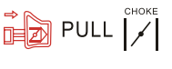 | Pull the pull start with the choke in this position. When you pull out the choke, the air flap closes. When you push in the choke, the air flap opens.
 | Press the fuel pump (primer) 6x
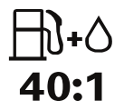 | Fuel tank; mixing ratio: 40 parts petrol to 1 part oil
 | Petrol: ROZ 95/ROZ 98
 | 2-stroke motor oil: ISO-L-EGD/JASO FD
 | Open flames and smoking in the vicinity of the appliance are strictly prohibited!
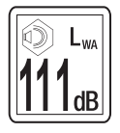 | Guaranteed sound power level of the appliance
 | Cutting device continues to rotate after the product is switched off. Wait until all components have completely stopped before touching the product.
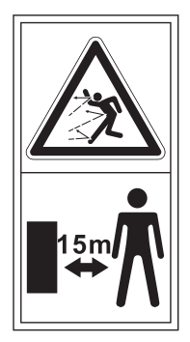 | Objects thrown by the product could hit the user or other bystanders.  Always ensure that other people and pets remain at a safe distance from the product when it is in operation. In general, children must not come near the area where the product is.
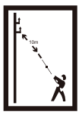 | Warning! Danger from overhead electric-power lines! Keep at least 10m distance.
 | Use metal blades with three teeth.
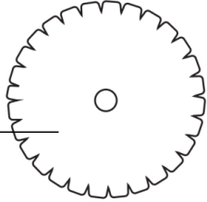 | Use metal blades with forty teeth.
 | Do not use saw blades.
 | Moving direction of saw chain
 | Beware of blade thrust!  Machines fitted with saw blades or cutter blades can be thrown violently to the side when the blade comes into contact with a fxed object. The blade is capable of amputating an arm or leg. Always keep people and animals at least 15 metres from the product.
 | Caution! Poisonous CO vapours (carbon monoxide vapours)!  Do not use the appliance in closed rooms!
 | WARNING!  Hair can be sucked into the appliance!
 | Caution – petrol is highly flammable!  Explosion hazard! Do not spill any fuel!
 | Turn the appliance off and remove the spark plug connector before performing any maintenance work!
 | Attention! Risk of suffocation!
 | Attention, hot parts. Maintain a safe distance!
 | Watch out for flung away parts!  Keep others away! Maintain a safe distance!
 | Do not fill up on E10!
 | Pour the gasoline mixture in here!
PART LIST
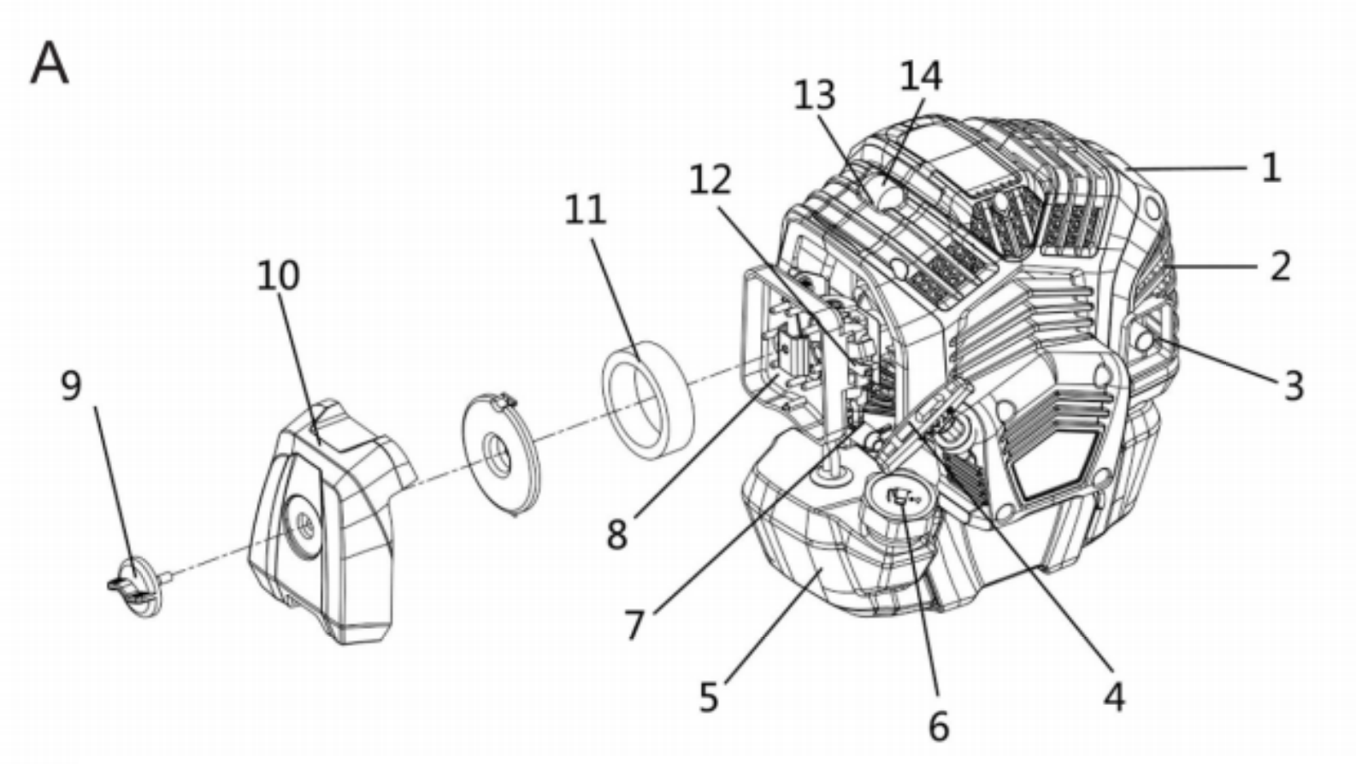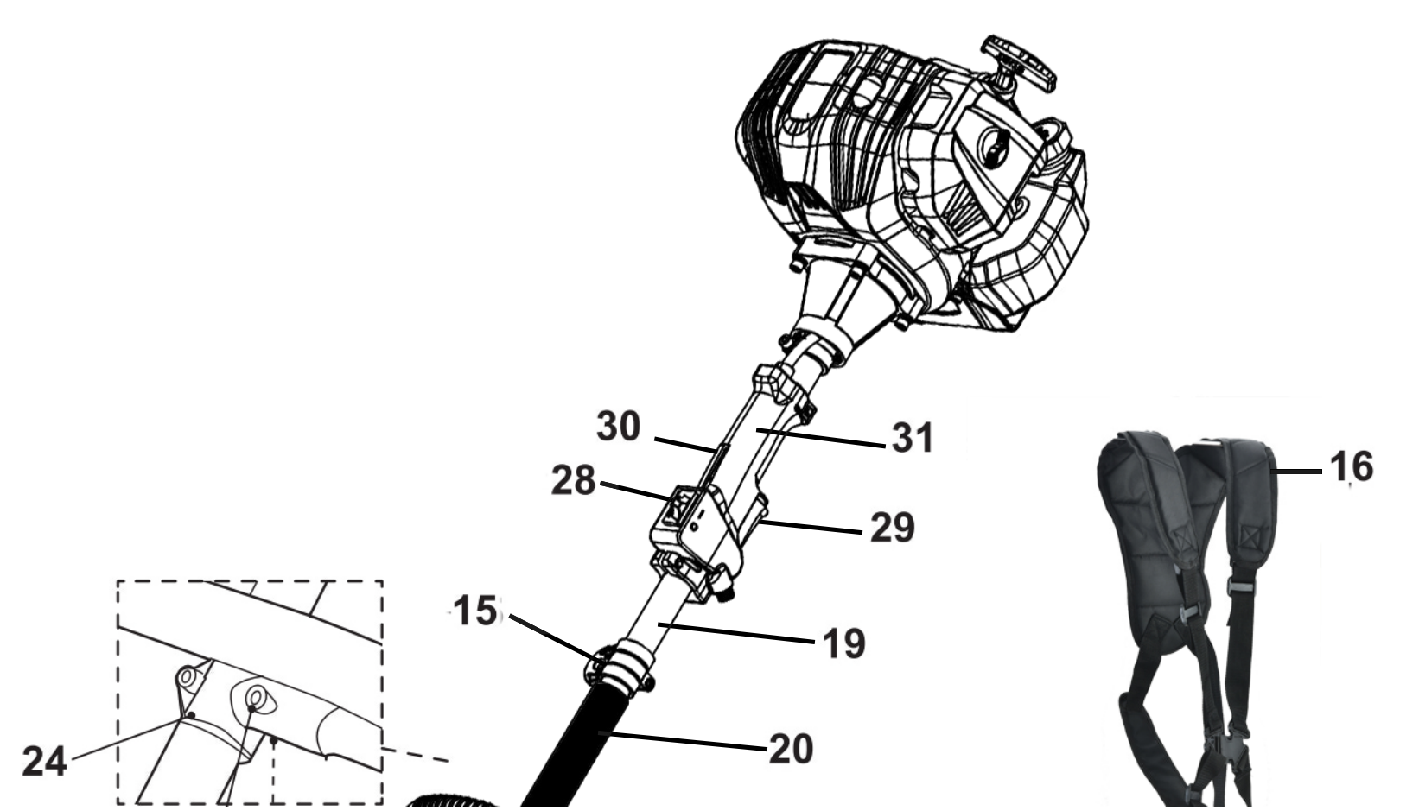

A |  | Main unit
1 | Engine | 17 | Rope
2 | Air vents | 18 | Securing clip
3 | Muffler | 19 | Upper pole
4 | Recoil starter handle | 20 | Suspense sleeve (x1)
5 | Fuel tank | 21 | Locking sleeve
6 | Fuel tank cap | 22 | Locking knob
7 | Primer | 23 | Spring bolt
8 | Air filter case | 24 | Bracket
9 | Fixation bolt | 25 | Bolt (x 2)
10 | Cover | 26 | Nut (x 2)
11 | Filter | 27 | Front handle
12 | Choke | 28 | Ignition switch I/STOP
13 | Spark plug connector | 29 | Throttle trigger
14 | Spark plug | 30 | Throttle interlock
15 | Harness loop | 31 | Main handle
16 | Harness
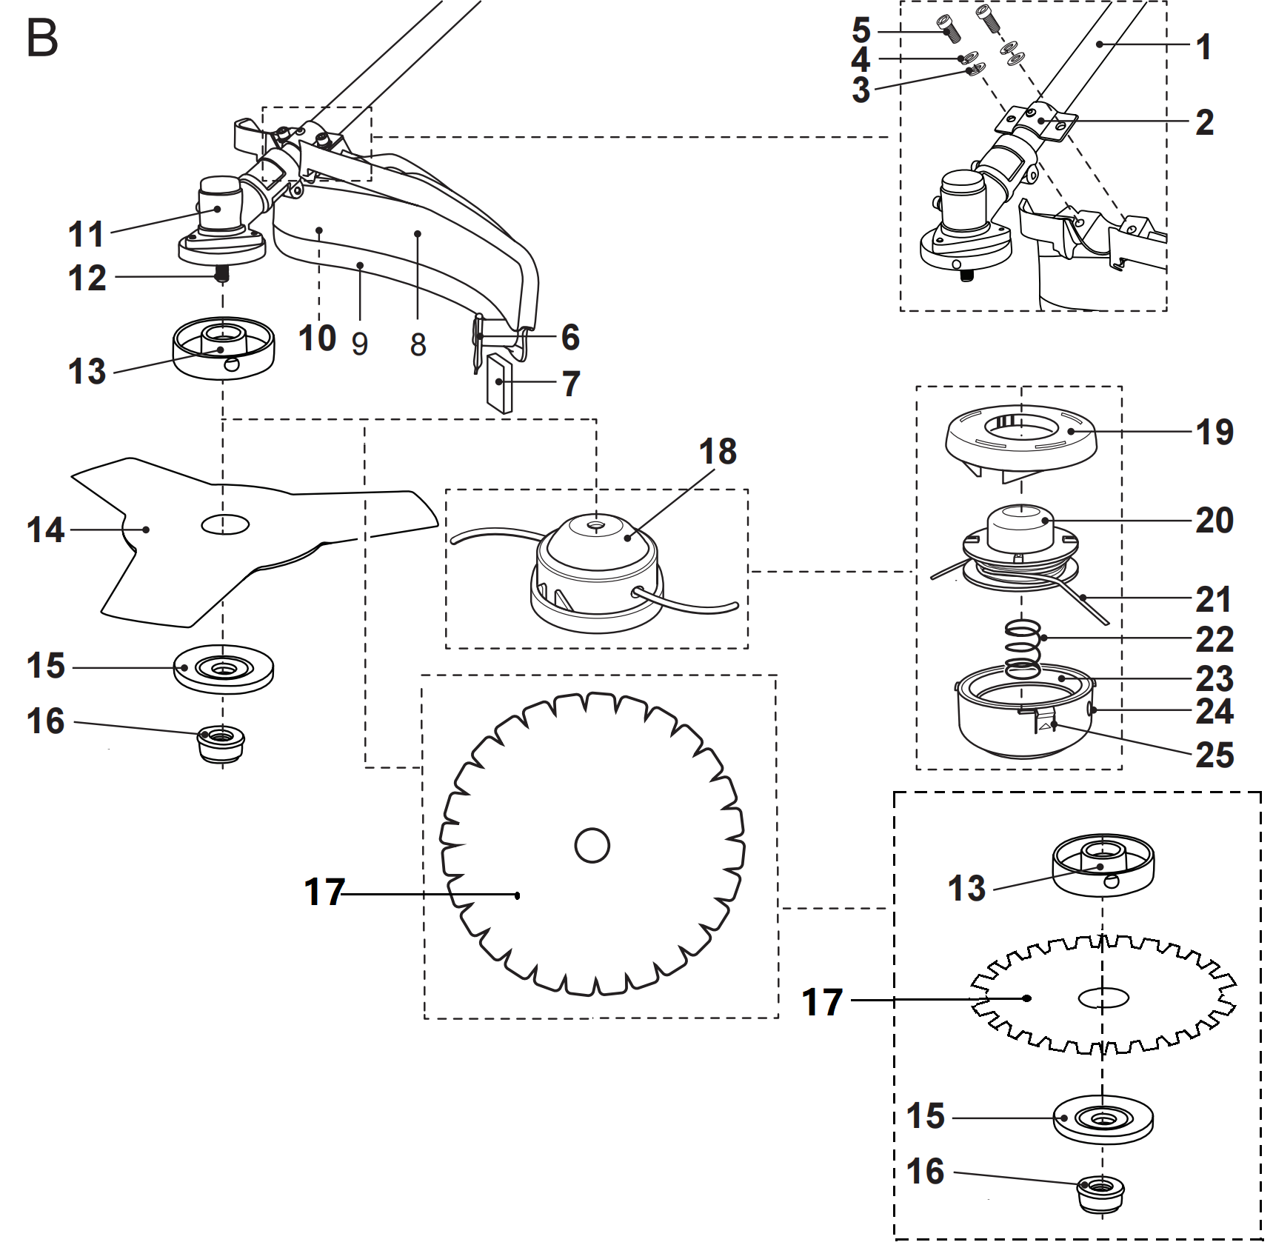
B |  | Brush cutter / grass trimmer
1 | Lower pole | 14 | Cutter blade (three teeth)
2 | Bracket | 15 | Locking flange
3 | Washer (x 2) | 16 | Nut
4 | Spring washer (x 2) | 17 | Cutter blade (forty teeth)
5 | Bolt (x 2) | 18 | Trimming head
6 | Knife | 19 | Cover
7 | Knife cover | 20 | Spool
8 | Guard | 21 | Trimming line
9 | Guard extension | 22 | Spring
10 | Latch (x 3) | 23 | Housing
11 | Gear head | 24 | Eyelet (x 2)
13 | Backing flange

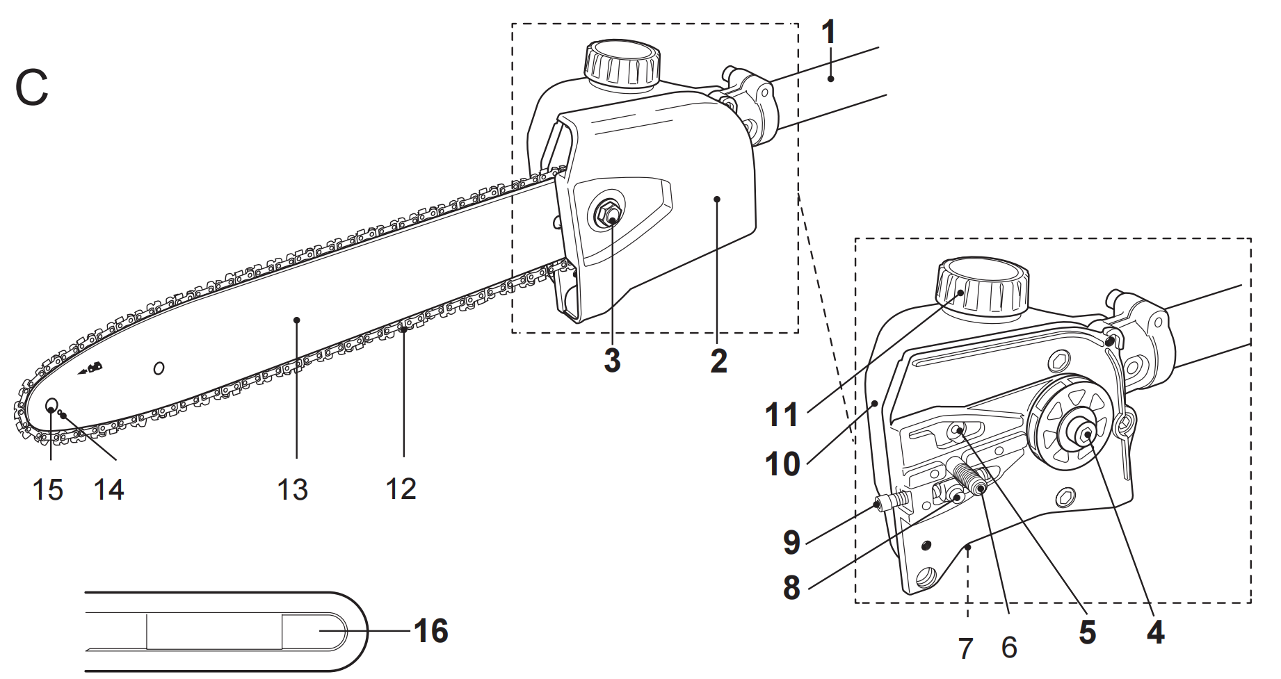

C |  | Pole saw
1 | Lower pole | 9 | Tension screw
2 | Cover | 10 | Oil tank
3 | Retaining nut | 11 | Oil tank cap
4 | Drive sprocket | 12 | Saw chain
5 | Oiling port | 13 | Guide bar
6 | Bolt | 14 | Lubrication hole
7 | Adjustment screw (chain oil  flow) | 15 | Sprocket wheel
8 | Tension pin | 16 | Guide bar cover
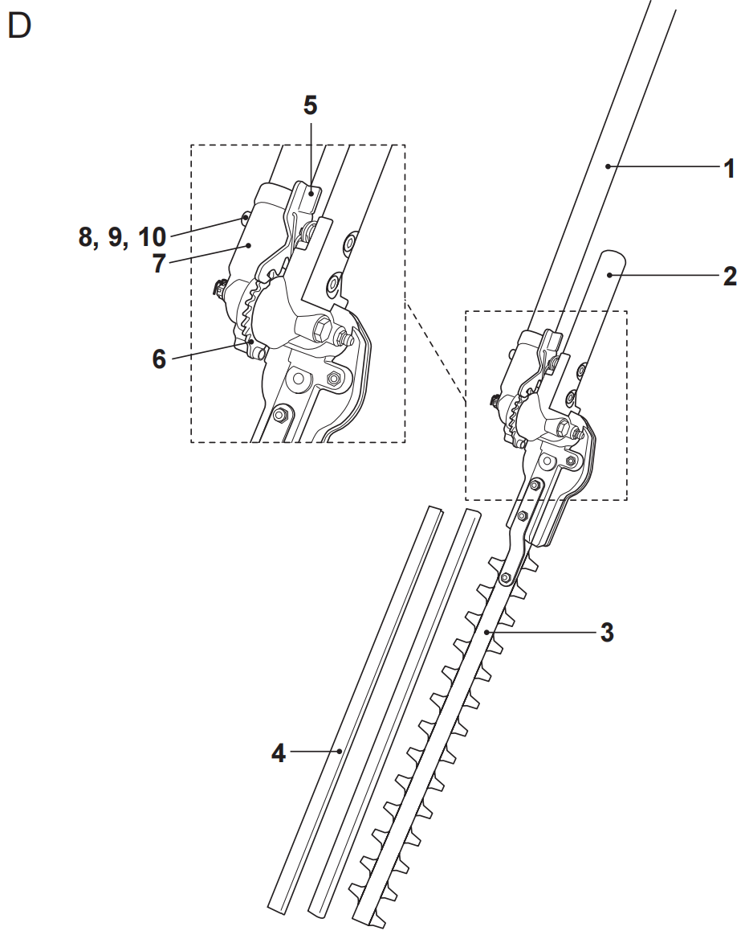

D |  | Pole hedge trimmer
1 | Lower pole | 6 | Teeth system
2 | Handle | 7 | Support
3 | Cutting blade | 8 | Bolt (x 2)
4 | Blade cover (x 2) | 9 | Spring washer (x 2)
5 | Unlock lever (x 2) | 10 | Washer (x 2)
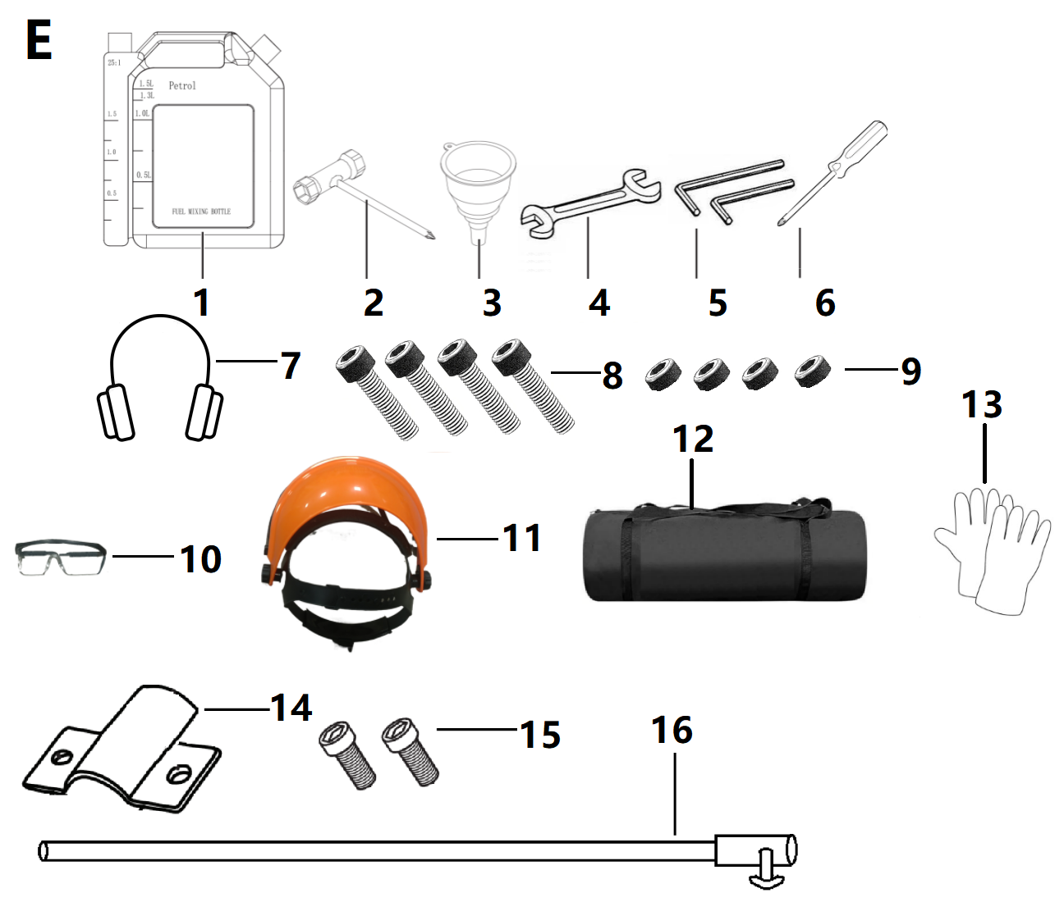
E |  | Tools
1 | Fuel mixing container | 4 | Assembly wrench
2 | Multi tool | 5 | Hex key (5 mm)
3 | Funnel | 6 | Hex key (4 mm)
7 | Protective earmuffs | 8 | Screw *4
9 | Nut*4 | 10 | goggles
11 | Face shields | 12 | Tote bag
13 | Glove | 14 | Sheet metal
15 | Screw *2 | 16 | Extension rods
Unpacking
1.Unpack all parts and lay them on a flat, stable surface.
2.Remove all packing materials and shipping devices if applicable.
3.Make sure the delivery contents are complete and free of any damage.
If you find that parts are missing or show damage do not use the product but contact your dealer. Using an incomplete or damaged product represents a hazard to people and property.
4.Ensure that you have all the accessories and tools needed for assembly and operation. This also includes suitable personal protective equipment.

WARNING! The product and the packaging are not children’s toys! Children must not play with plastic bags, sheets and small parts! There is a danger of choking and suffocation!

WARNING! The product must be fully assembled before operation! Do not use a product that is only partly assembled or assembled with damaged parts!

Follow the assembly instructions step-by-step and use the pictures provided as a visual guide to easily assemble the product!
Disconnect the spark plug connector (A13) from the spark plug! Reconnect it after assembly.

NOTE: Take care of small parts that are removed during assembly or when making adjustments. Keep them secure to avoid loss.

Assembly
Front handle
1. Remove the pre-assembled bolt (A25) and nut (A26) from the handle bracket (A24) and keep them handy (Fig. 1).
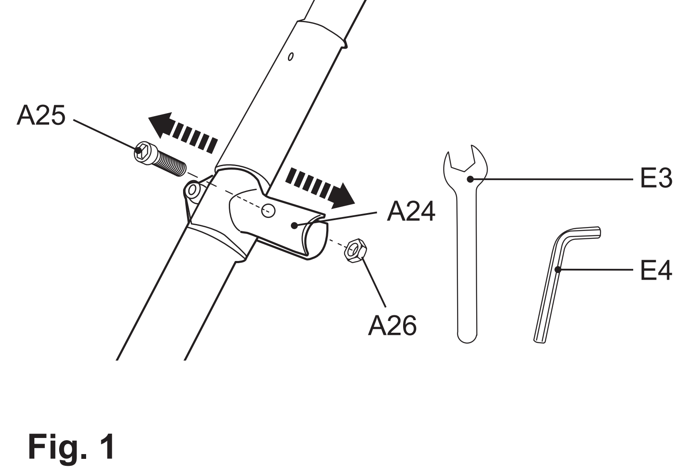

- Insert the shaft end of the front handle(A 27) into the bracket opening.Adjust the front handle with a twist motion to align the mounting holes.
- Secure the front handle in position with bolt(A 25) and nut t(A 26) (Fig. 2).
WARNING!
Make sure bolts (A25) ) and nuts (A 26) on the bracket(A 24) are properly tightened before using the product!
Pole assembly
- Choose the desired tool attachment according to the intended operation.
- Remove the pre-attached protection cap from the lower pole(B1/ C1/D1) (Fig.3,step 1) .
- Loosen the locking knob(A 22),but don’t fully remove e(Fig.3,step 2).
- Align and insert the lower pole(B 1/C 1/D 1) into the locking sleeve (A 21) ， while pulling the spring bolt(A 23) (Fig.3,step 3 and 4) .
- Slightly twist the lower pole to align the hole with the spring bolt (A23) . Release the spring bolt afterward to secure the lower pole in position.Ensure the spring bolt snaps in the hole(Fig.3, step 5) .
6. Tighten the locking knob(A 22) to secure the connection(Fig.3, step 6) .
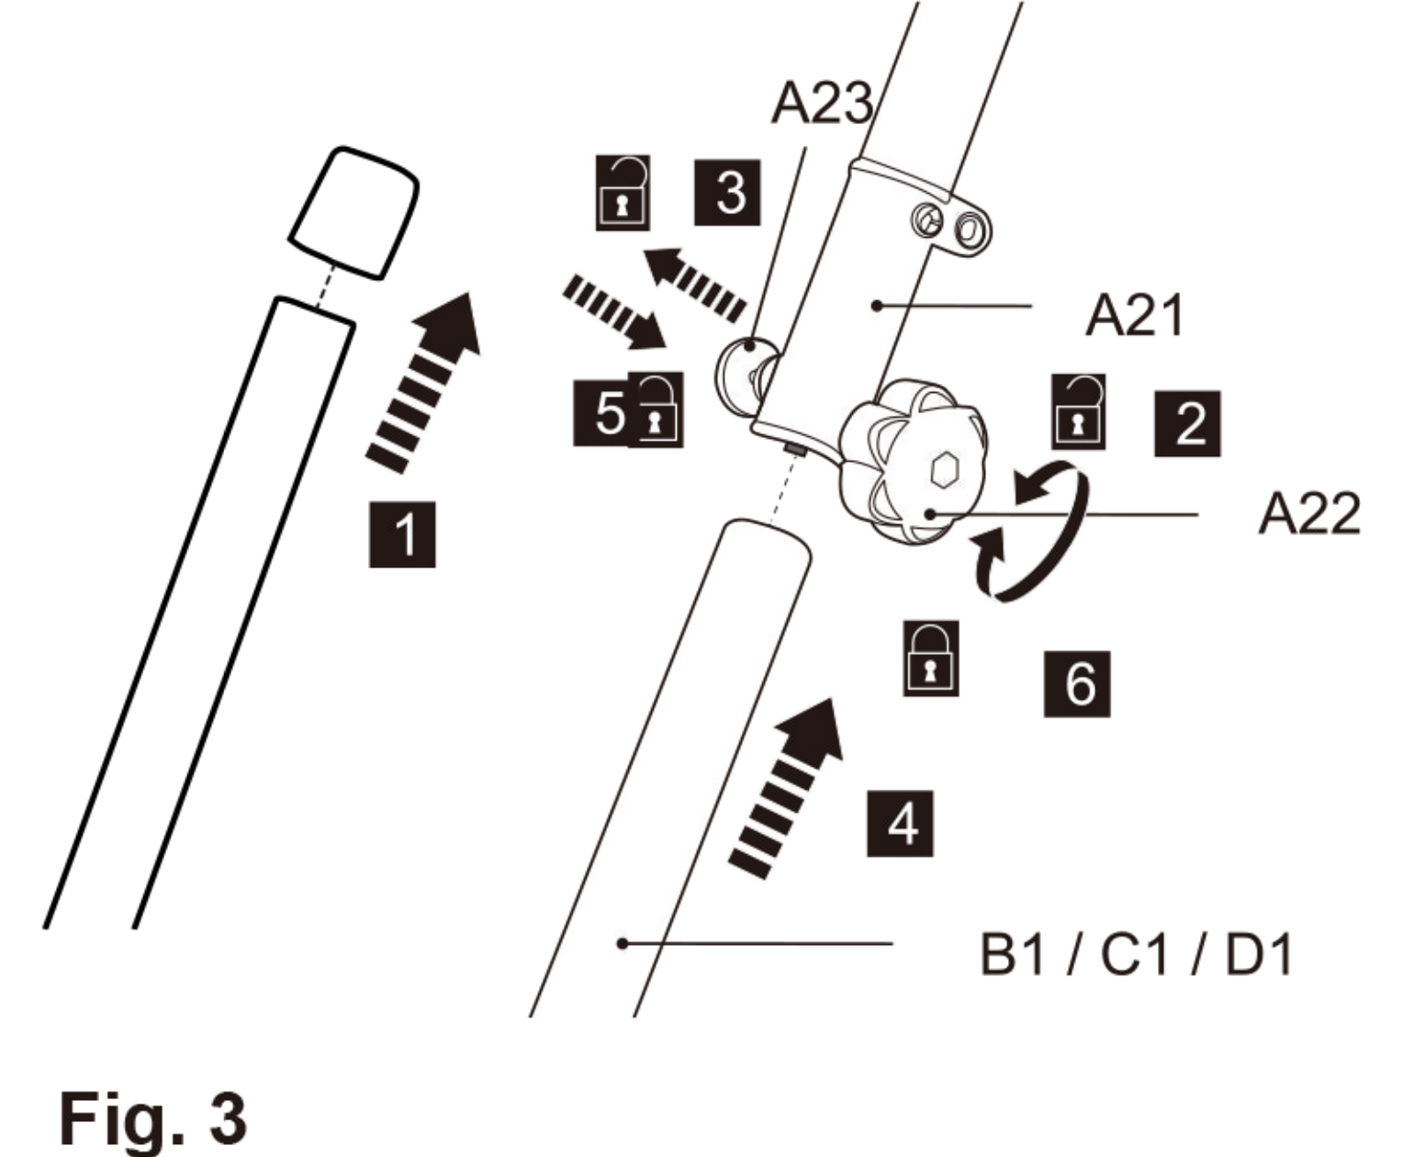

WARNING!
Make sure the locking knob(A 22) is properly tightened before using the product!

Brush cutter and grass trimmer
- Guard
The guard(B8) of the product consists of two pieces：the guard (B8) and guard extension (B9).
- Remove the pre-assembled bolts from the guard.
- Align the mounting a holes and assemble e the guard l(B 8) on to the bracket(B2) .
- Secure the connection with bolts (B5),spring washers rs( (B4) ) and washers (B3) ) using the tool(E4) .(Fig.4).
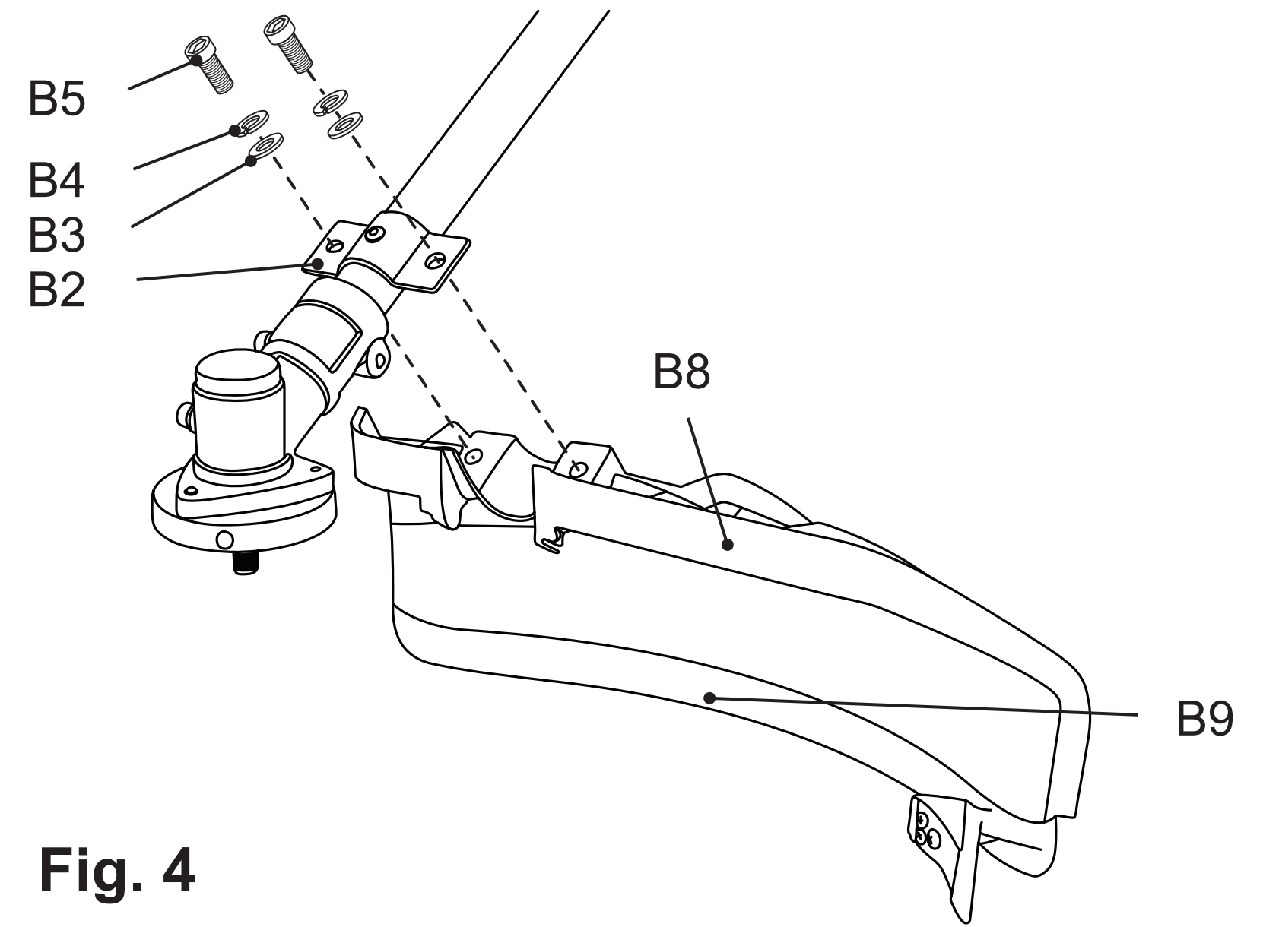

- Cutting options
Assemble the relevant cutting attachment to suit the intended operation.
NOTE：The thread on the spindle is left-hand.Turn clockwise to remove and turn anticlockwise to secure respective cutting attachment.

- Cutter blade
WARNING!Always wear gloves when handling the cutter blade.
Wear gloves while removing the blade cover(B 17) and take care not to come in contact with the cutter blade (B 14) while pulling the two halves apart.

1) Rotate the backing flange (B13) until its hole is aligned with the hole on the gear head (B11).
2) Insert the hex key (E4) into the holes to lock the spindle (B12).
3) Loosen the nut (B16) and remove it together with the locking flange (B15). Do not remove the backing flange (B13).
4) Remove the blade cover (B17) by separating the two halves.
5) Fit the cutter blade (B14) onto the spindle (B12). Ensure the cutter blade sits flush on the extruded ring on the backing flange (B13).
NOTE: Make sure the rotation in the cutter blade shall be same as the one marked on the guard (B8), the marking of the blade facing away.
6) Place the locking flange (B15) onto the cutter blade (B14).
7) Tighten the nut (B16) to secure the cutter blade counterclockwise while locking the spindle (B12) with the hex key (E5). Remove the hex key afterward (Fig. 5).
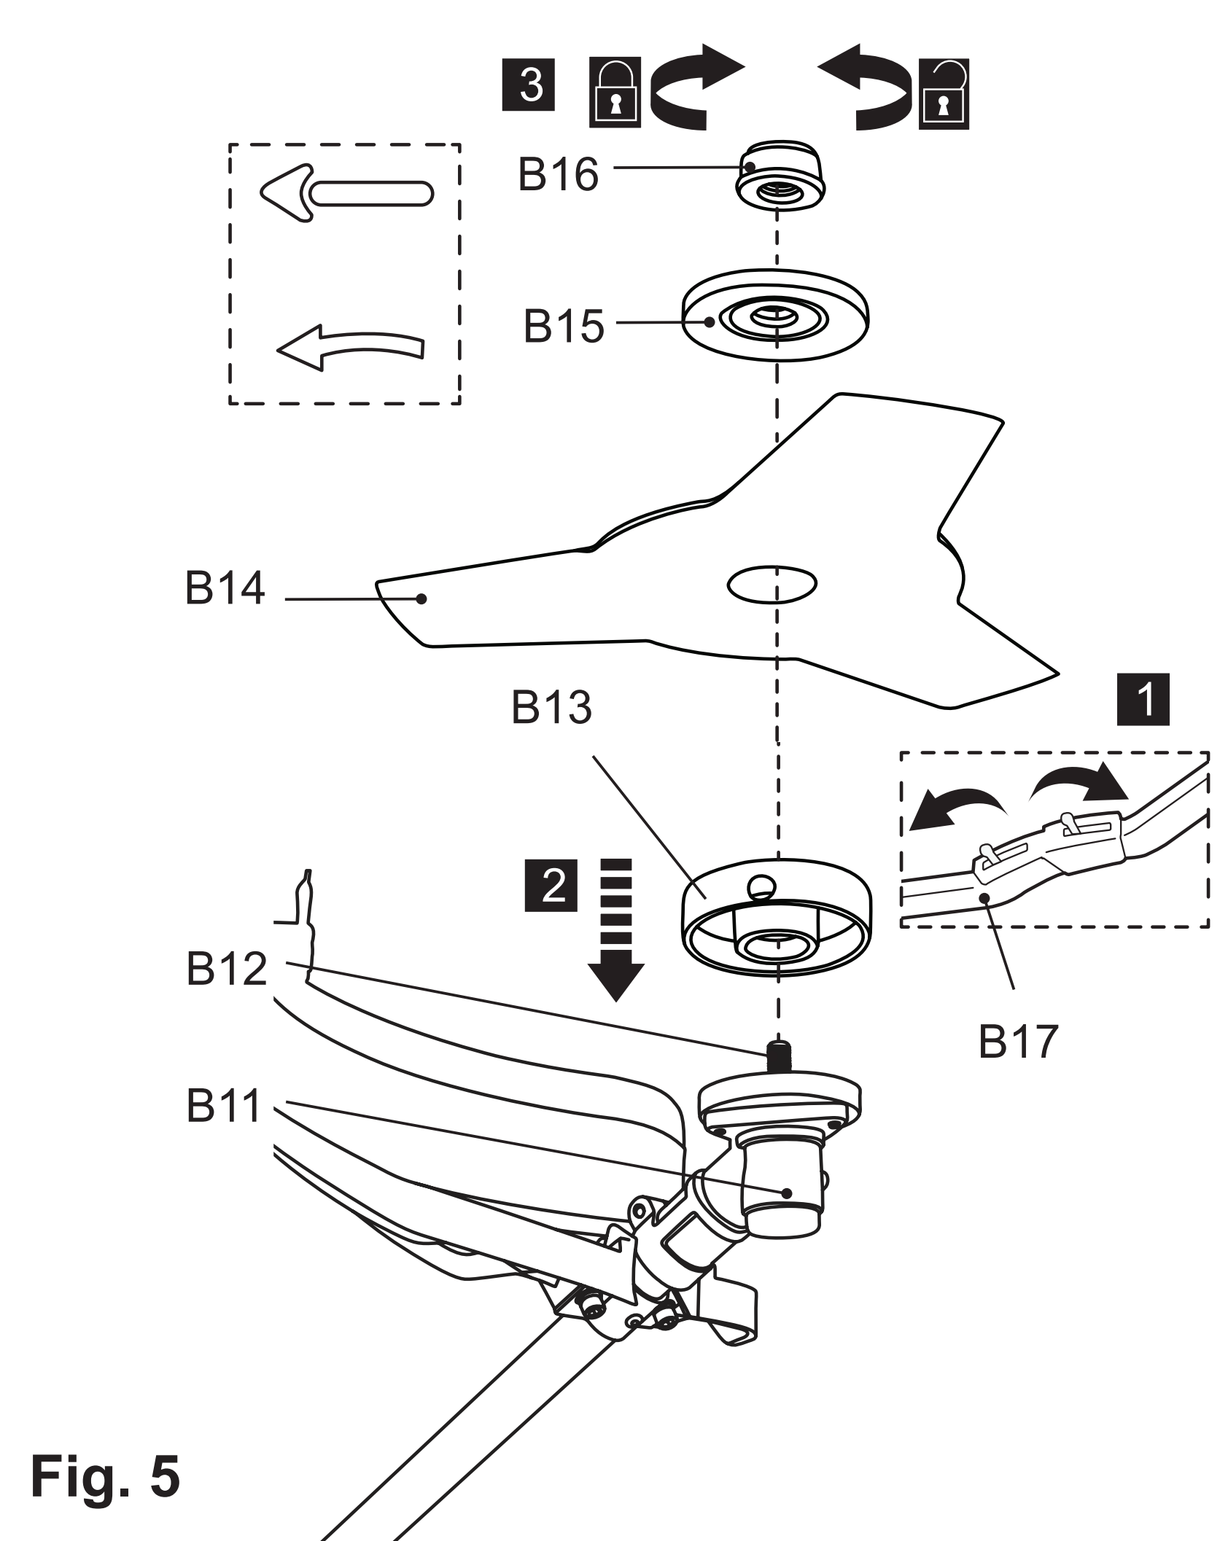
4.Trimming head
1) Rotate the backing flange (B13) until its hole is aligned with the hole on the gear head (B11).
2) Insert the hex key (E5) into the holes to lock the spindle (B12).
3) Loosen the nut (B16) clockwise and remove it together with the locking flange (B15). Do not remove the backing flange (B13).
4) Screw the trimming head (B18) counterclockwise onto the spindle (B12) and tighten it by hand while locking the spindle (B12) with the hex key (E5). Remove the hex key afterward (Fig. 6).
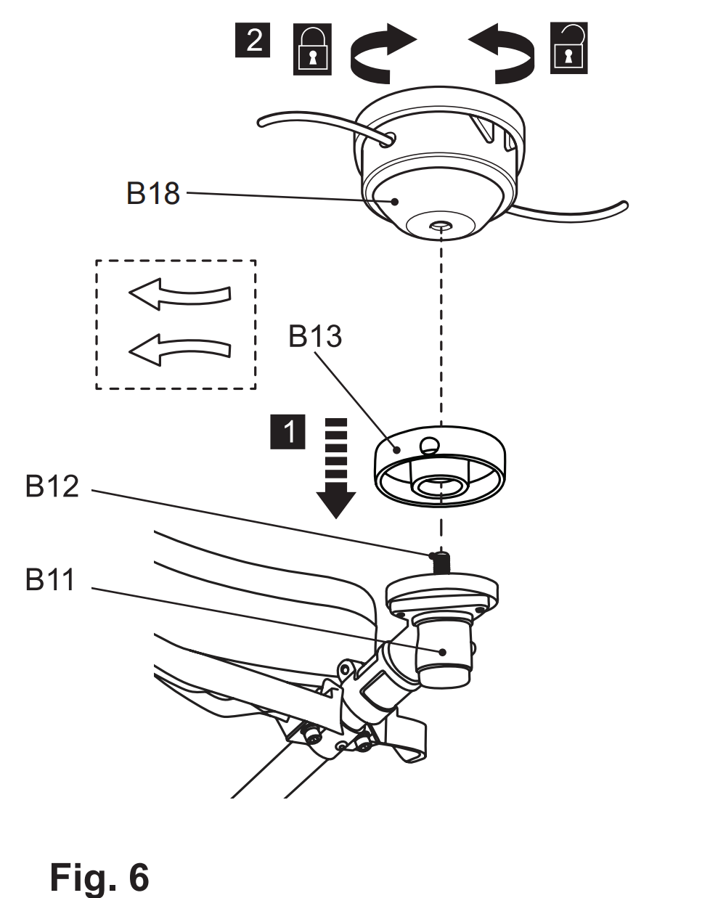

Pole saw
WARNING! Always wear gloves during assembly!

Assemble the guide bar (C13) and saw chain (C12) before operation.

1. Chain and guide bar assembly
1) Use only a guide bar (C13) and saw chain (C12) according to the technical data of the pole saw.
2) Place the product on a suitable flat surface with the side cover (C2) facing upwards.
3) Unscrew in counter-clockwise direction the retaining nut (C3) with the assembly wrench (E3) and then remove the side cover (C2). (Fig.7)
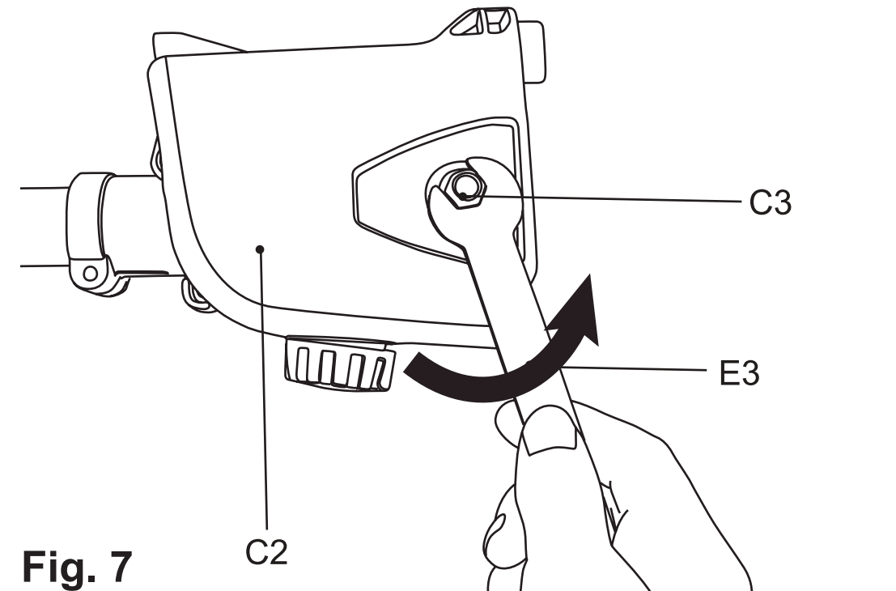

4) Spread the saw chain (C12) out with the cutting edges of the chain pointing in the direction of rotation.
Slide the saw chain (C12) into the groove around the guide bar (C13). Ensure saw chain (C12) is installed in correct direction of rotation. (Fig.8)
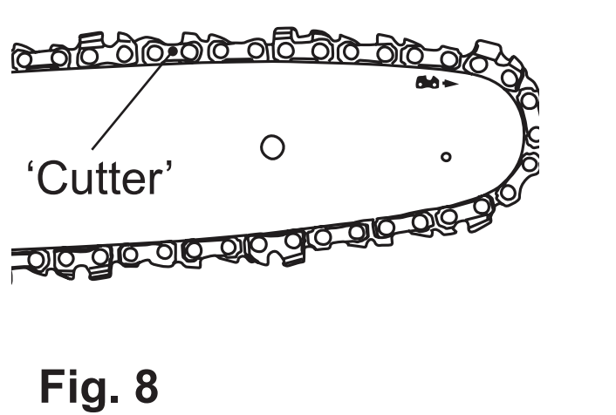
WARNING! The direction of the saw chain ‘cutters’ must be same as indicated by the symbol and arrow on the guide bar!

5) Use the screwdriver end of the multi tool (E2) to turn the chain tension screw (C9) in a counter-clockwise direction, then the tension pin (C8) is moved towards the left. If the chain tension screw (C9) is turned in a clockwise direction, then the tension pin (C8) is moved towards the right. (Fig.9)
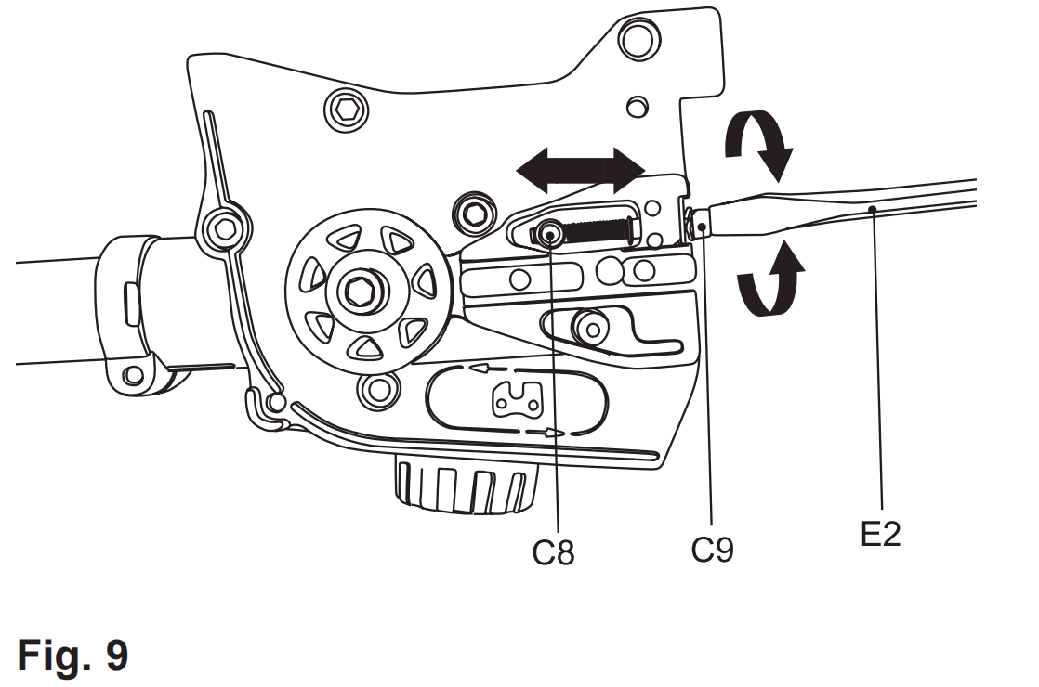
6) Align saw chain (C12) and the guide bar (C13) assembly with the drive sprocket (C4) and the mounting bolt (C6). Lay the saw chain (C12) around the drive sprocket (C4) and then lower the guide bar (C13) to install it to the mounting bolt (C6). Make sure the tension pin is inserted into the upper hole on the guide bar (C13). (Fig.10)
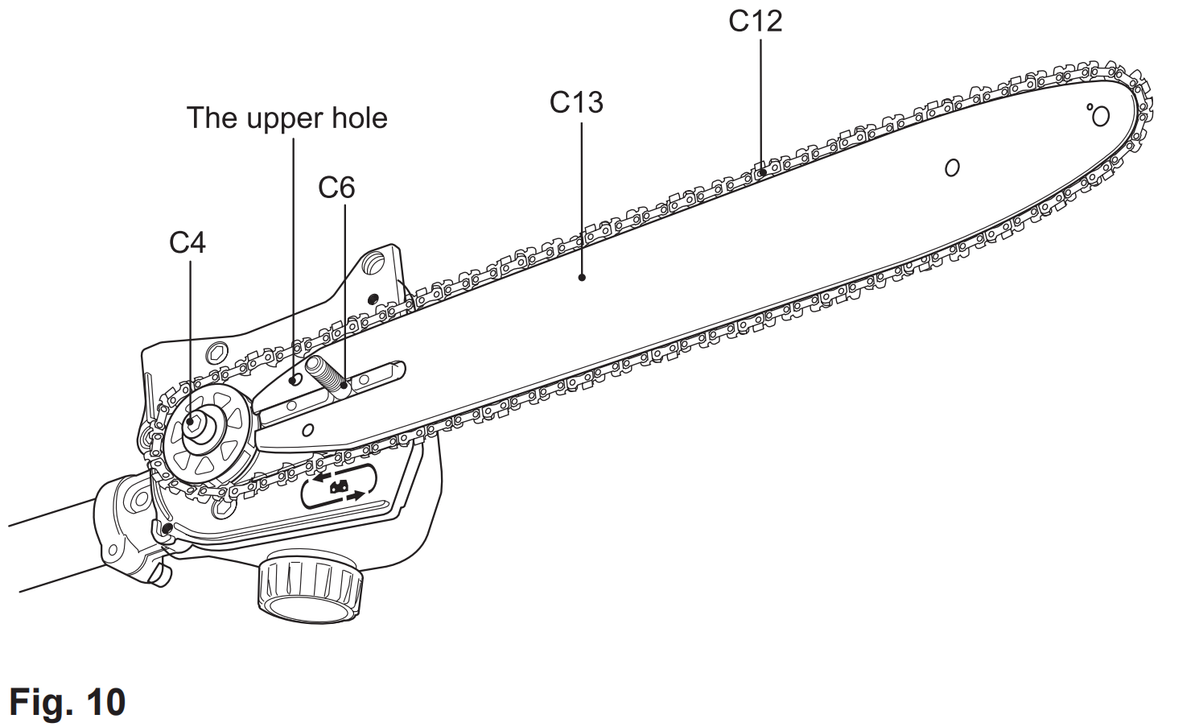

7) The saw chain movement is as indicated by the arrow (Fig. 11).
Make sure the saw chain (C12) is properly placed over the sprocket wheel (C15) of the guide bar (C13). (Fig.11)
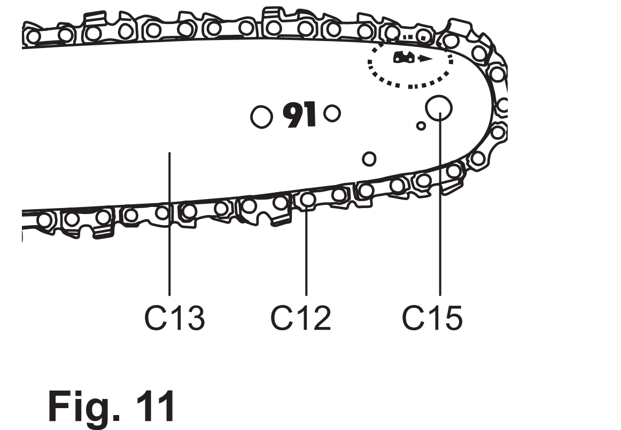
8) Refit the cover (C2), fit the rear of cover then front, ensure pin is located in position. Slightly tighten the remaining nut (C3) by using the assembly wrench (E3) (Fig. 12). Do not tighten the nuts completely as saw chain tensioning is required first.
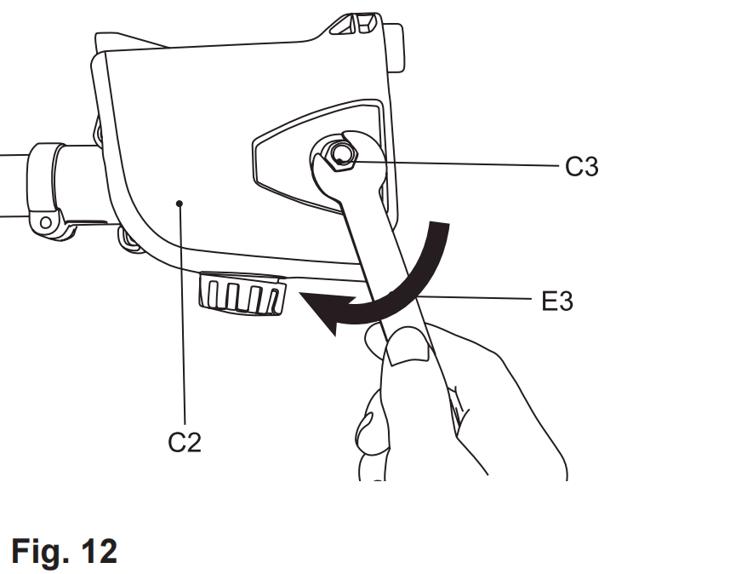
NOTE: The saw chain (C12) has not yet been tensioned. Tension the chain as described under “Saw chain tensioning”. After operating the product for approx. 1 hour, adjust the chain tension again.

2.Saw chain tensioning
Always check the saw chain tension before use, after first cuts and regularly during use, approx. every five cuts. After initial operation, new chains can lengthen considerably. This is normal during the break-in period and the interval between future adjustments will lengthen quickly.
WARNING! Disconnect the spark plug connector before adjusting saw chain tension!
The cutting edges of the saw chain are sharp! Always wear protective gloves when handling chain!
Always maintain proper chain tension! A loose chain increases the risk of kickback! A loose chain may jump out of the guide bar groove! This may injure the operator and damage the chain! A loose chain will cause rapid wear to the chain, guide bar and sprocket!
Tensioning the chain too tightly will overload the engine and cause damage, and insufficient tension can cause chain derailing, whereas a correctly tightened chain
provides the best cutting characteristics and prolonged working life! The chain life mainly depends upon sufficient lubrication and correct tensioning!

1) Place the product on a suitable flat surface.
2) Lift up the tip of the guide bar (C13) and keep it there as you adjust the tension (Fig. 13).
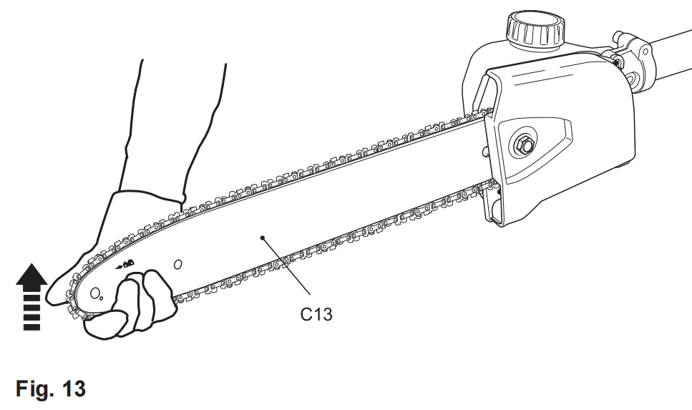
3) Screw the tension screw (C9) clockwise or unti-clockwise to adjust the tension pin (C8) / guide bar (C13) until the chain ‘tie straps’ are just touching the bottom edge of the guide bar (Fig. 14).
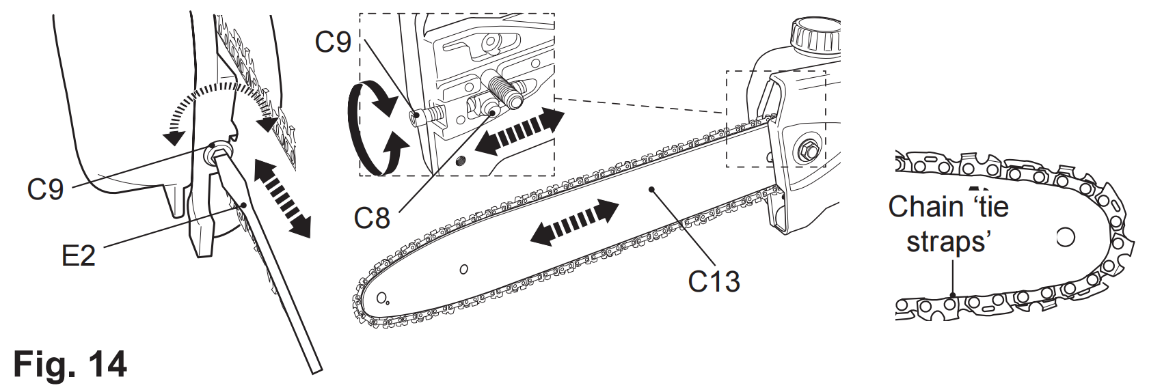
3.Tension test
1) Check the chain tension using one hand to lift the saw chain (C12) against the weight of the product. The correct chain tension is achieved when the saw chain can be lifted by approx. 2 - 4 mm from the guide bar (C13) in the centre (Fig. 15).
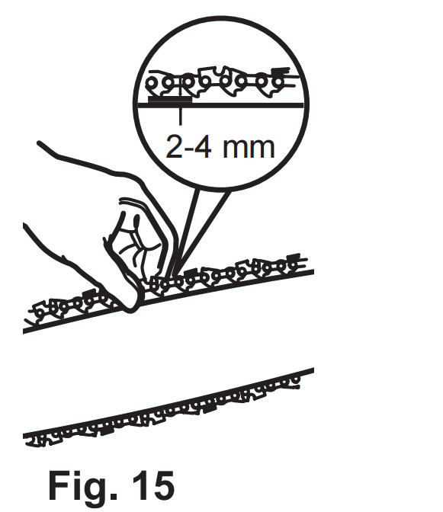
2) Adjust the tension if you find that the chain saw is too loose or tight.
3) Pull the saw chain (C12) along the top of the guide bar (C13) by
hand from one end to the other, several times. The chain should feel
tight but still move freely.

4.Chain lubrication
WARNING! The product is not filled with oil. It is essential to fill the product with oil before using it! Never operate the product without chain oil or with an empty oil tank, as this will result in extensive damage to the product!
Never operate the bar and chain without lubrication oil! Operating the product dry or with too little oil will decrease cutting efficiency, shorten the product life span and cause rapid wear to the chain and bar from overheating! Insufficient oil is evident by smoke or bar discoloration! Adequate lubrication of the saw chain during cutting operations is essential to minimise friction with the guide bar. Your product is equipped with an automatic oiling system! The oiling system
automatically delivers the proper amount of oil to the bar and chain!
1) Place the product on a stable, level surface with oil tank cap (C11) facing upward. We recommend laying a non-flammable sheet under the product.
2) Unscrew and remove the oil tank cap (C11) (Fig. 16), then add suitable lubricant into the tank. We recommend using environmentally-friendly chain oil specifically intended to be used with this product.
NOTE: Use a proper oil funnel with a filter to prevent debris entering the tank and to avoid splitting and overfilling the tank.

Use motor oil SAE#10W-30 all year round or SAE#30 in summer and SAE#10 in winter, or if the trees have excessive sap.

3) Do not overfill and leave approx. 5 mm of space to the lower edge to
allow the lubricant to expand (Fig. 17).
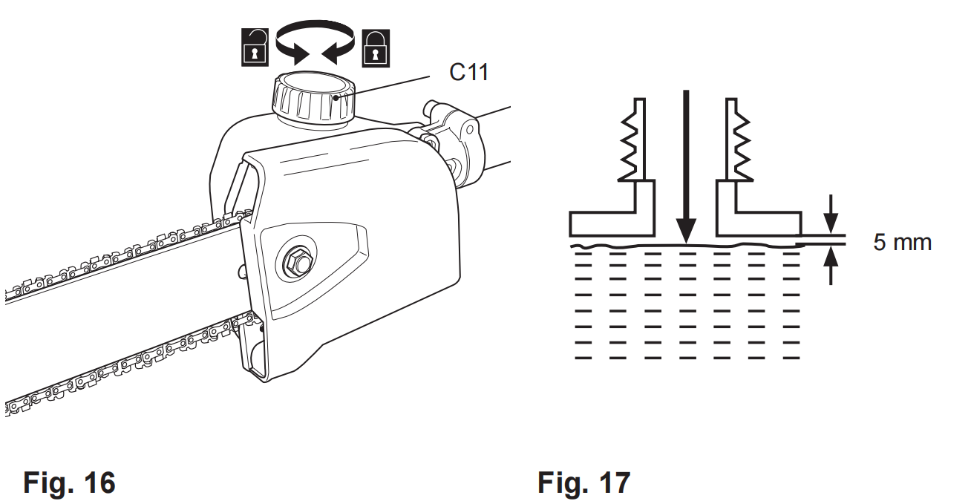
4) Wipe up spilled lubricant with a soft cloth and refit the oil tank cap (C11).
NOTE: Always dispose of lubricant, used oil and objects contaminated with them in accordance with local regulations.

5) Check the oil level prior to start-up and regularly during operation

5.Checking
NOTE: Perform the following test before operating your product.
This product is equipped with an automatic oiling system.
The oiling system automatically delivers the proper amount of oil to the bar and chain.
Checking the lubrication requires starting the product. Before checking, the product must be fully assembled and all instructions must have been read.

1) Check the chain lubrication before each use.
2) Make sure the guide bar (C13) and the saw chain (C12) are in place when you check the oil delivery.
3) Start the engine; keep it running and check if the chain oil is delivered as shown in the figure (Fig. 18).
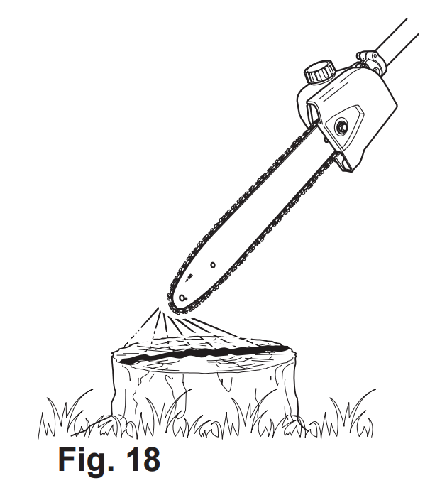

4) Turn the adjustment screw (C7) of the oiler on the bottom of the product to adjust the chain oil flow with the multi tool (E2) (Fig. 19).
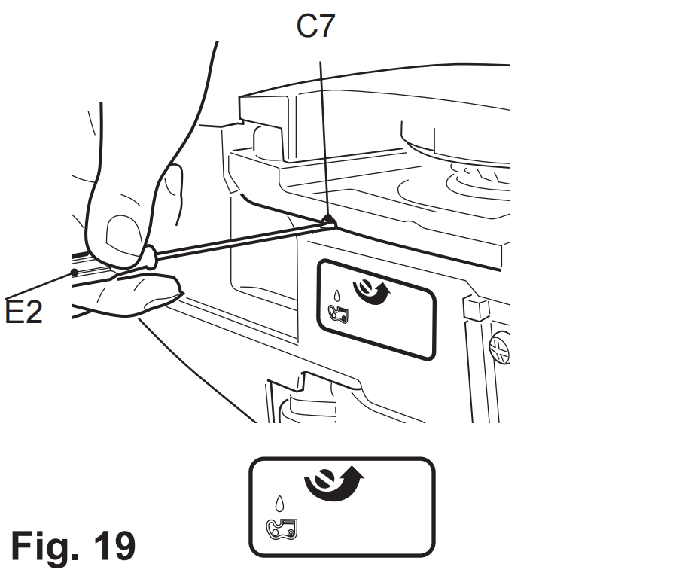

Pole hedge trimmer
1.Blade head
1) Loosen the bolts (D8) using tool (E5) until the lower pole (D1) can be inserted into the support (D7) (Fig. 20, step 1). Do not remove the bolts (D8), spring washers (D9) and washers (D10) from the support (D7).
2) Align and insert the lower pole (D1) into the support (D7) with a twist motion all the way to the stop until the mounting hole is aligned with the bolt. Use the arrow marking to help the alignment. (Fig. 20, step 2).
3) Tighten the bolts (D8) to secure the lower pole in position (Fig. 20, step 3).
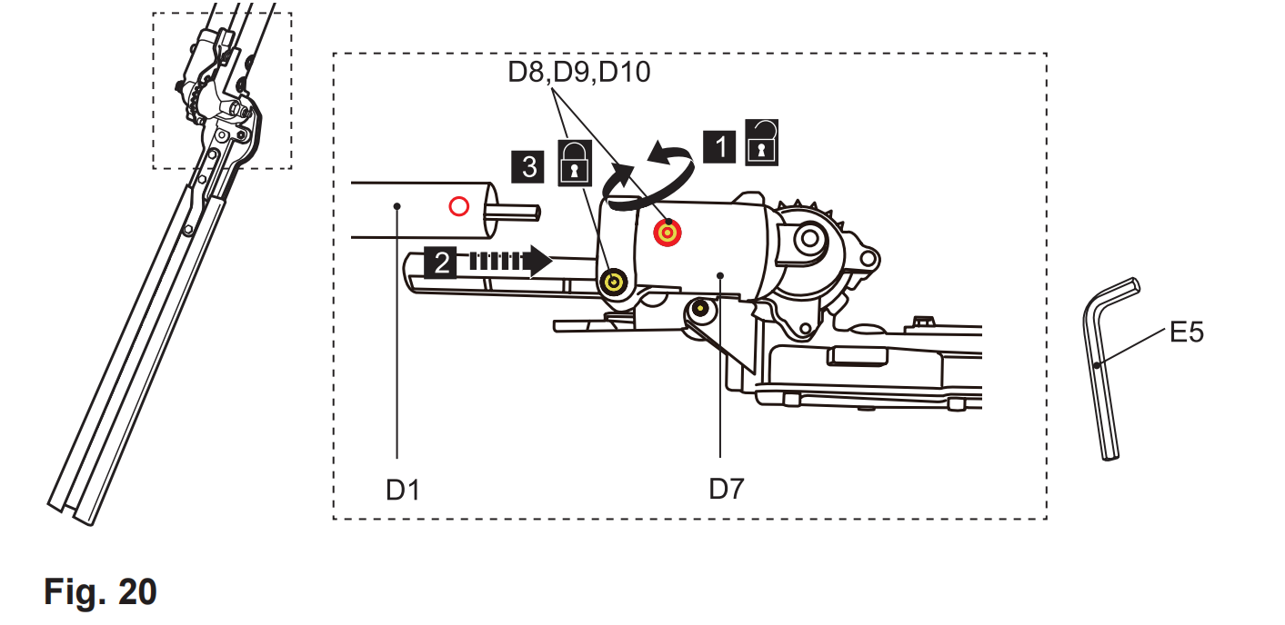

4) Hold the handle (D2) with left hand and the lower pole (D1) with the right hand.
5) Press the unlock levers (D5) to disengage the teeth system (D6) and adjust the blade head to the desired position (Fig. 21).
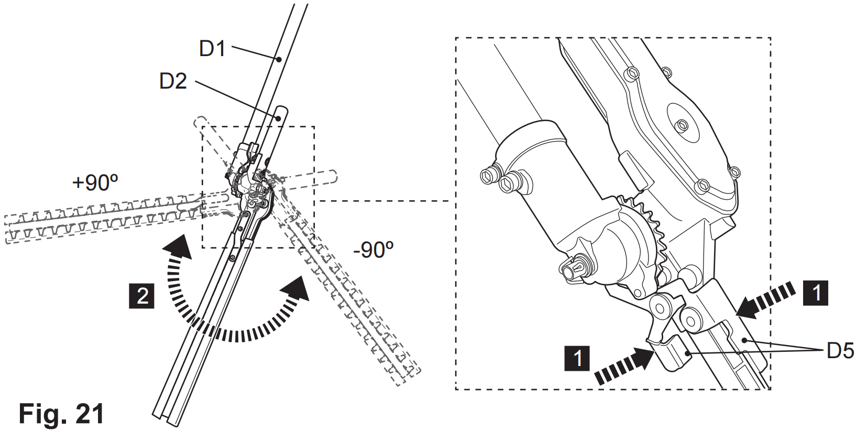

6) Release the unlock levers (D5) afterward. Ensure the teeth system (D6) is securely engaged (Fig. 22).
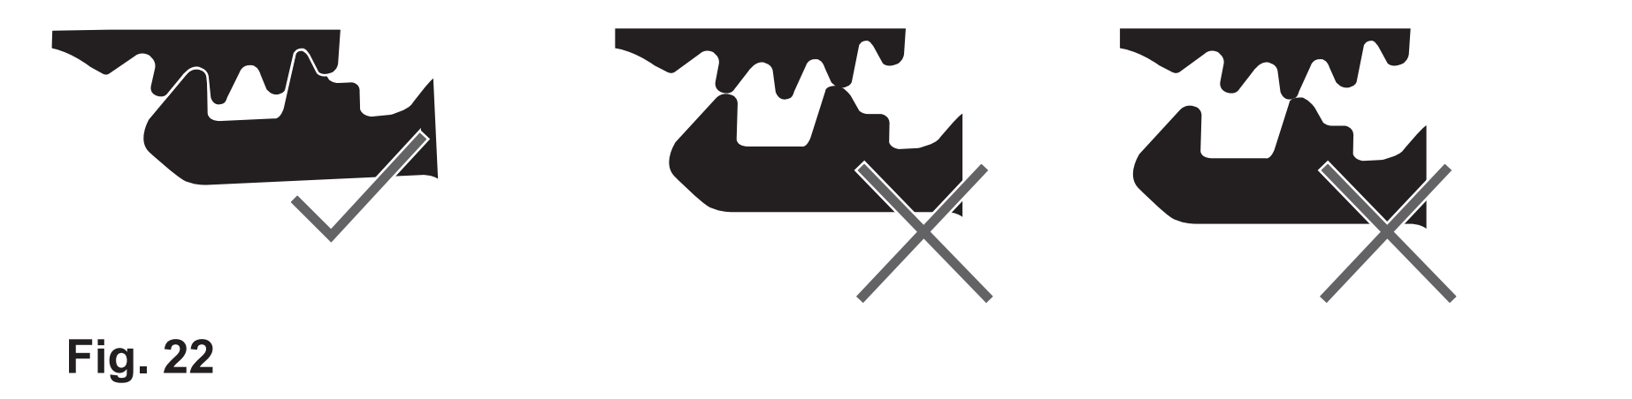
WARNING! The blade head can be adjusted in 12 different positions. Always ensure the teeth system is securely engaged! Do not attempt to use the product with the blade head in any intermediate position with the teeth system disengaged!

2.Blade cover
1) Remove the blade covers (D4) from the blade (D3) before operation (Fig. 23).
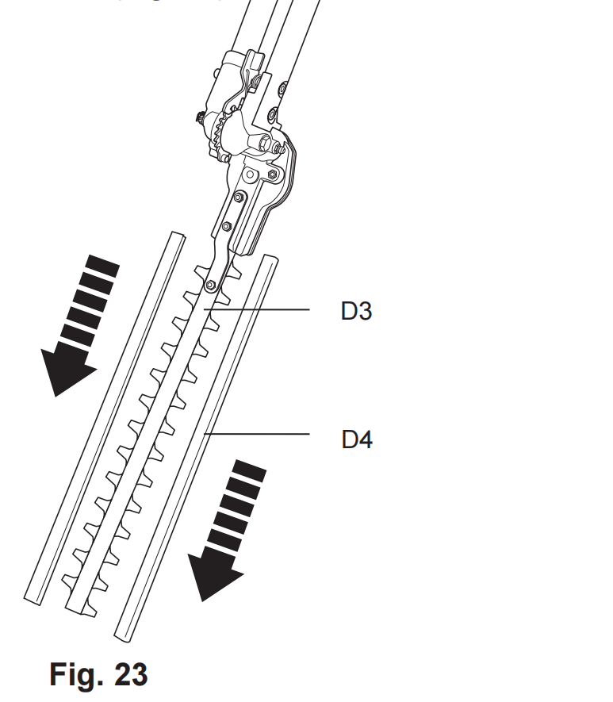

2) Refit the blade covers when the product is not in use, e.g. storage
and transportation.
Fuel and engine oil
This product is equipped with a 2-stroke engine, the fuel and oil tank
are combined and it is essential to fill a fuel-oil mixture before operating
this product. Observe the technical specifications for suitable fuel and
engine oil.
1. Place the product on a stable, level surface. We recommend laying a non-flammable sheet under the product.
2. Avoid spilling and overfilling the tanks.
WARNING! Fuel and oil are highly inflammable! Fumes will explode if lit! Ensure that there are no naked flames around the product! Do not smoke while filling fuel and oil!

3. Always dispose of fuel, used oil and soiled objects according to local regulations (see chapter “Recycling and disposal”).
Fuel
NOTE: This product is not supplied with fuel-oil mixture in the engine! Before operating this product it is essential to fill it with fuel-oil mixture!
1. Mix a regular-grade unleaded petrol and a quality engine oil for air cooled 2-stroke engines in the fuel mixing container (E1) (Fig. 24).
2. Petrol and oil have to be filled in respective sides accordingly to the scale marking on the container (E1). For example, fill petrol to scale marking “5” first, and then fill 2-stroke oil to scale marking “5”. This indicates a correct ratio of 40:1 when using the scale 40:1. By tilting the container, the oil falls into the petrol. Shake the container thoroughly to make the mixture.
3. Use an anti-oxidant-added quality oil expressly labeled for air cooled 2-stroke engine use (JASO FC GRADE OIL or ISO EGC GRADE). Do not use BIA or TWC (2-stroke water-cooling type) mixed oil.
4. The mixing ratio for petrol: oil is 40:1.
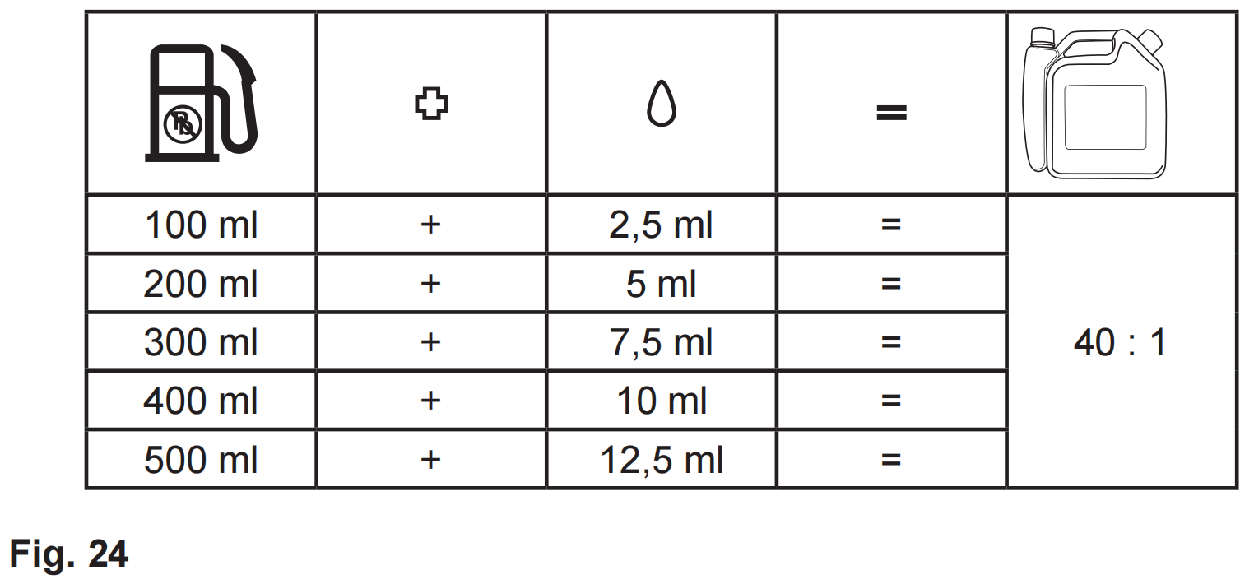
NOTE: Never mix fuel and oil directly in the tank of the product. Use a fuel mixing container that helps to ensure the correct mixing ratio. Shake gently to ensure a thorough mix of fuel and oil.

5. Always use clean, fresh unleaded petrol. Purchase fuel in quantities that can be used within 30 days.
6. Avoid getting dirt, dust or water in the fuel tank.
7. Unscrew and remove the fuel tank cap (A6) (Fig. 25).
8. Fill correctly mixed fuel / oil into the tank using a fuel funnel fitted with a filter to avoid debris entering the tank. Do not overfill. Leave a minimum 5 mm of space between the top of the fuel and the inside edge of the tank to allow for expansion (Fig. 26).
9. Wipe any spilled fuel with a soft cloth and reattach the fuel tank cap.
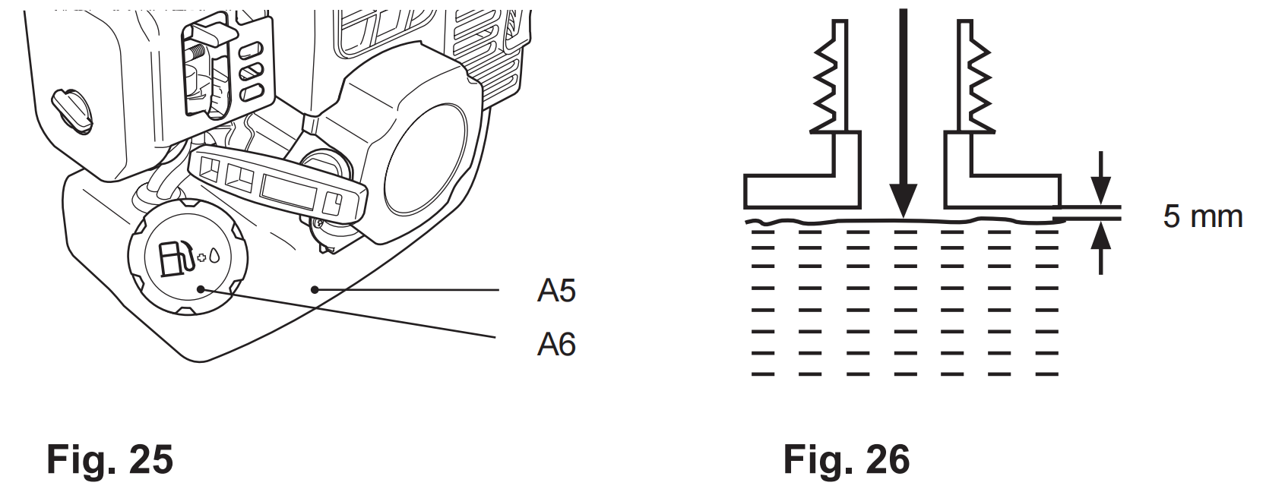

Operating controls
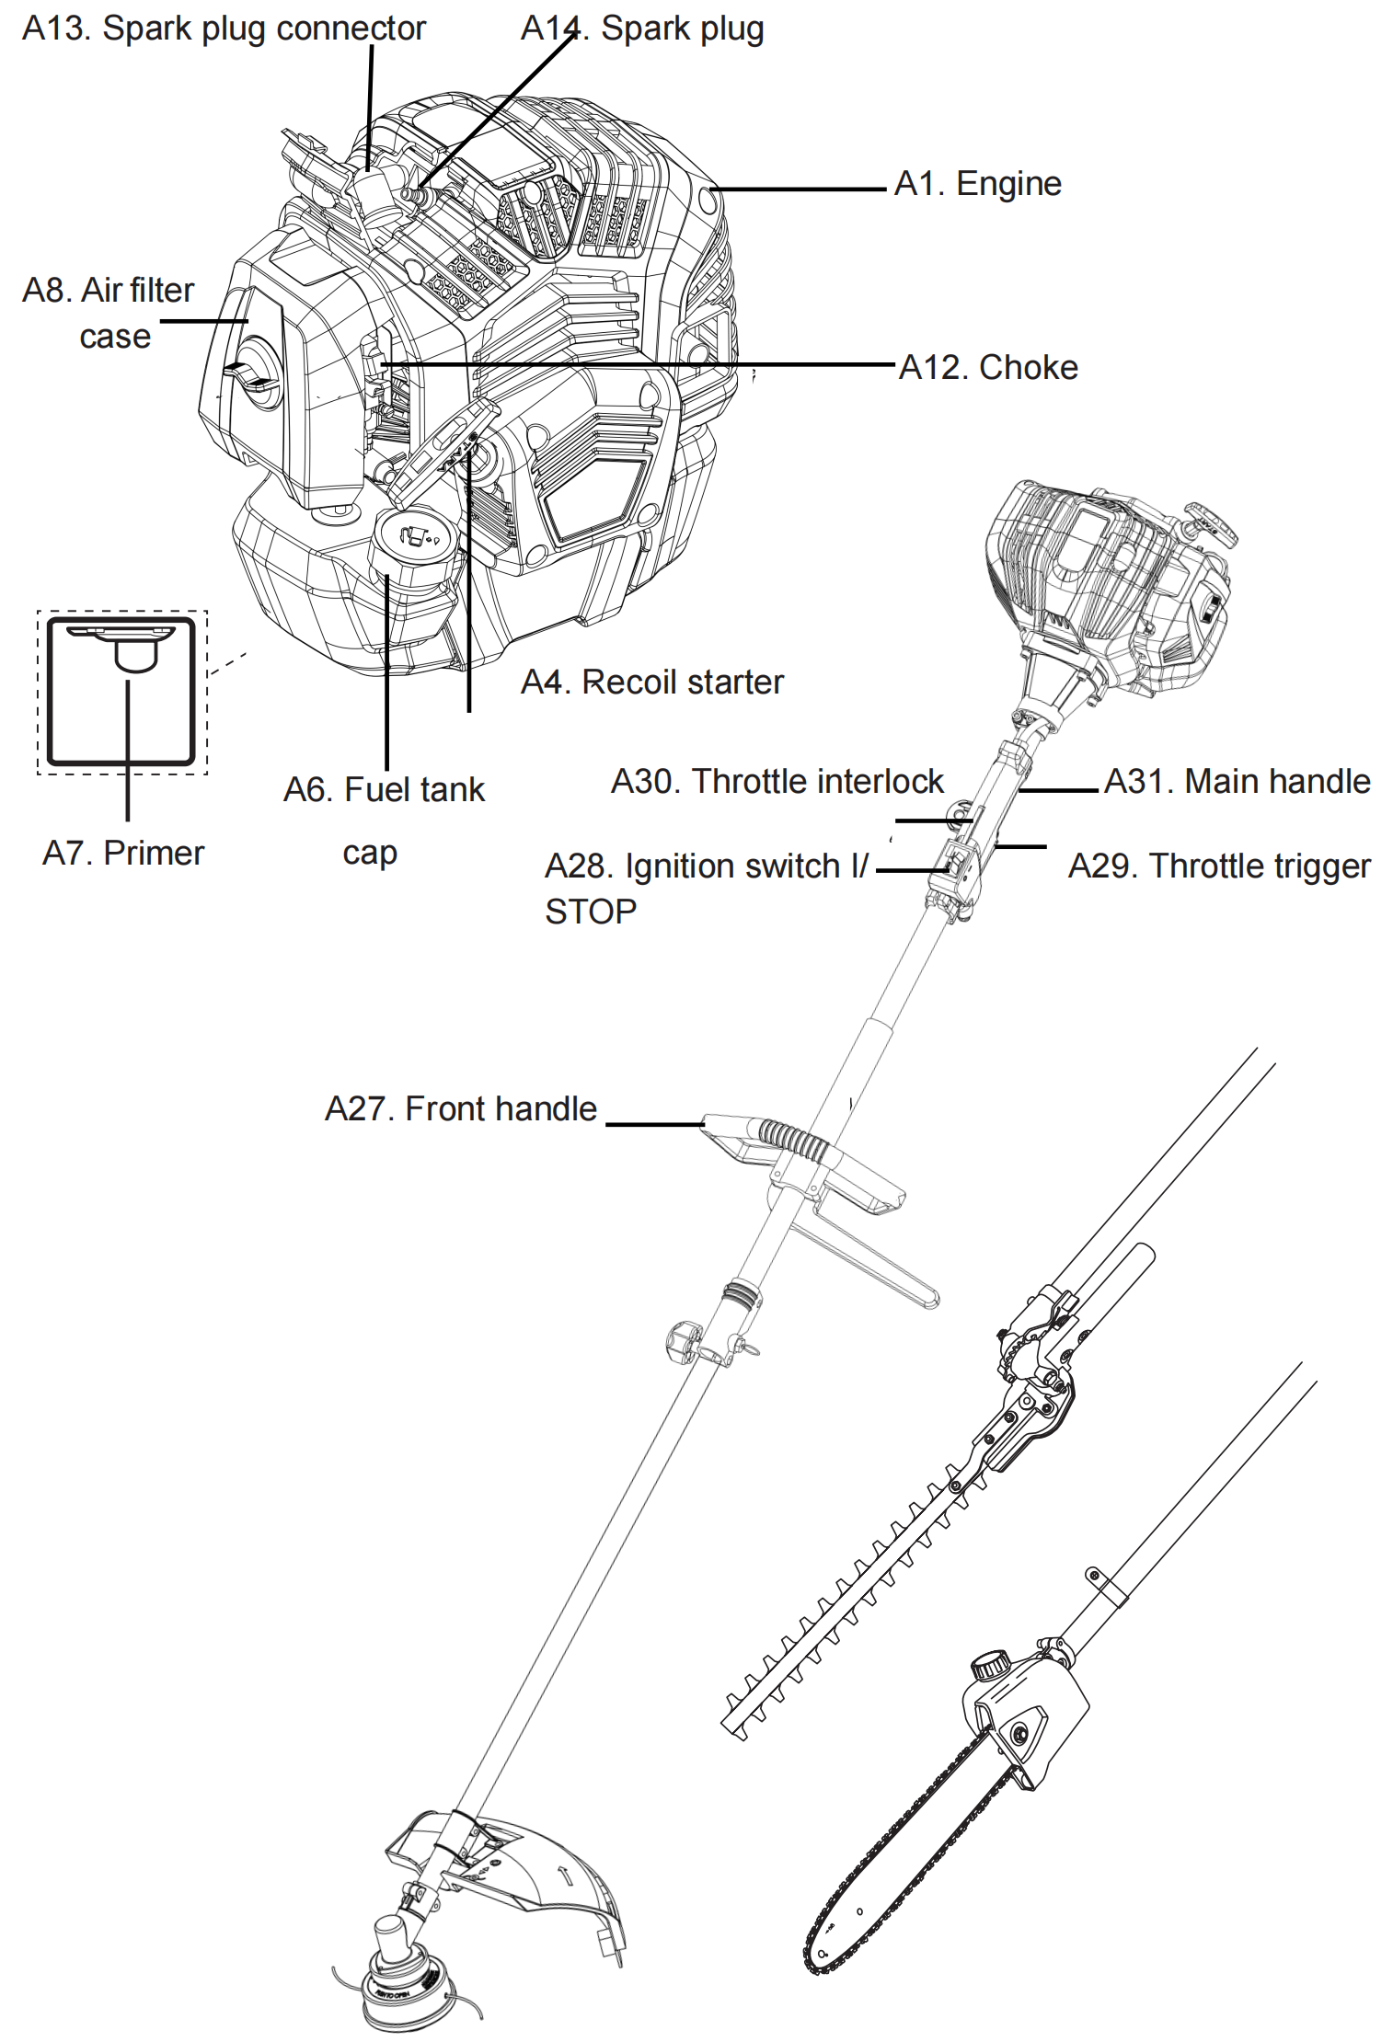
Cold start
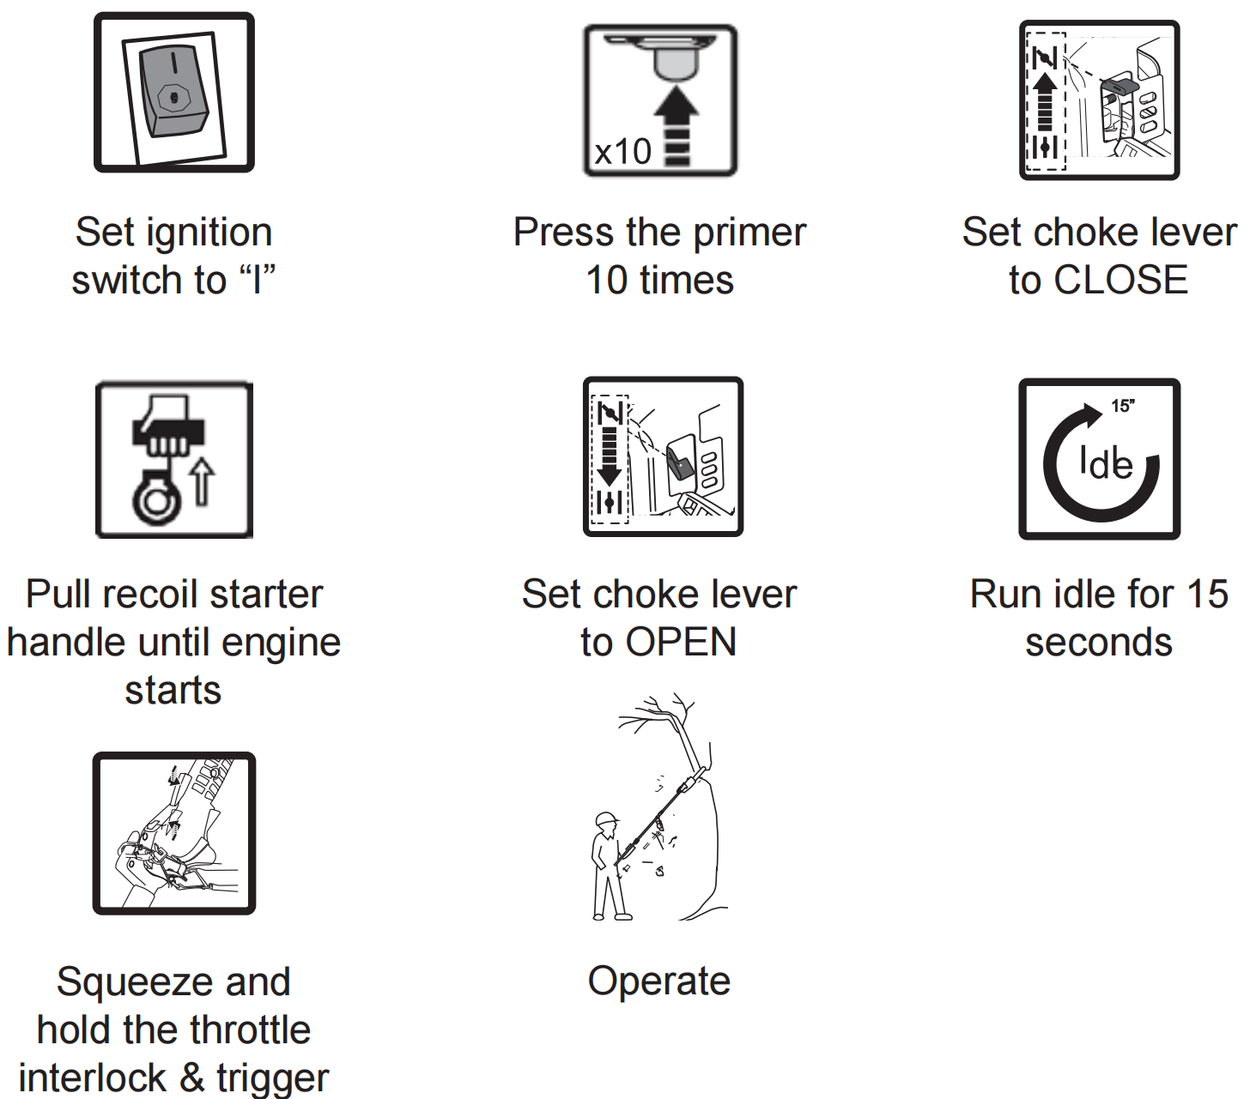
Warm start
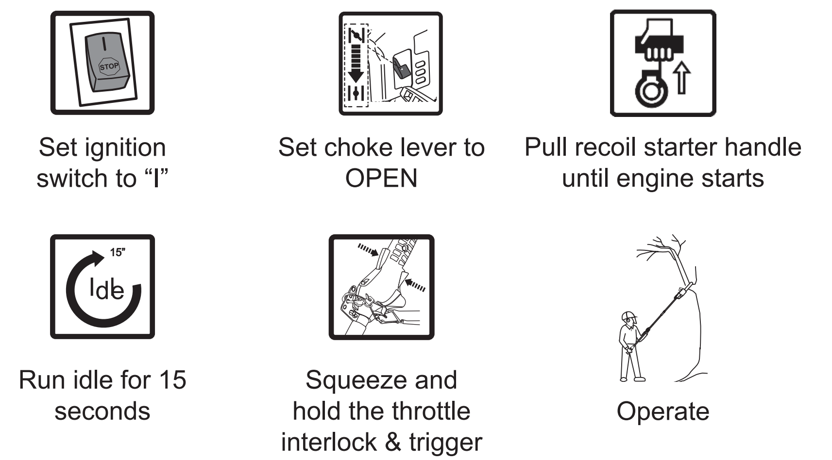
Stopping
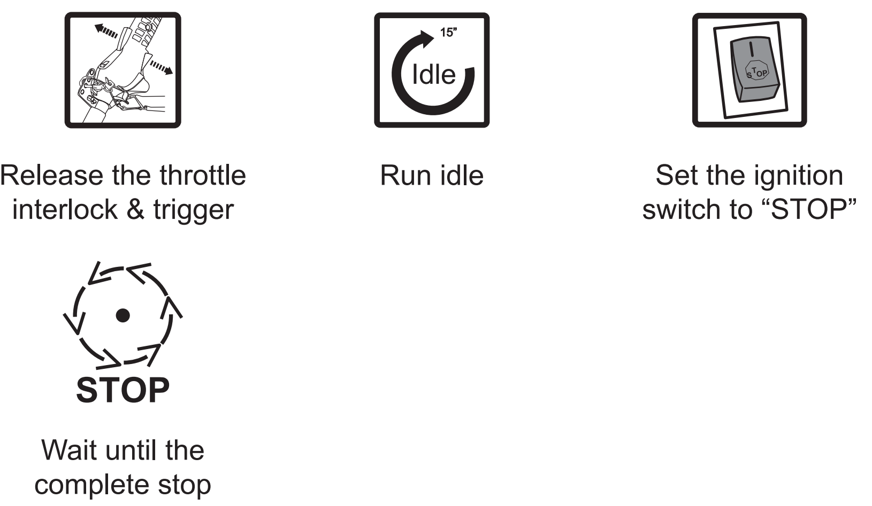
Storage

WARNING! This quick start provides only a short overview of how to start and stop the product! For safe use it is essential to read the entire instruction manual before first use!

Intended use
This petrol tool 4 in 1 FP4MTP33 is designated with a rated output of 1 kW. The product is multifunctional and can be used as brush cutter, grass trimmer, pole saw and pole hedge trimmer according to the intended operation with desired tool attachment.
Brush cutter: with the cutter blade attached, the product is intended to
cut heavier weeds, brush and similar vegetation.
Grass trimmer: with the trimming head attached, the product is intended to cut smaller types of weed, lawn grass or similar soft vegetation.
The product should not be used to cut unusually thick grass or vegetation, wet grass or to shred leaves etc.
Pole saw: with the saw chain / guide bar assembly attached, the product is intended for cutting limbs with a thickness of max. 200 mm.
It must not be used for cutting other materials, such as plastic, stone,
metal or wood that contains foreign objects. It may only be used with the
guide bar/saw chain combination stated in these instructions. It is not permitted to use other types or sizes.
Pole hedge trimmer: with the hedge trimmer blade, the product is
intended for cutting and trimming of high and wide hedges, bushes and
shrubs in domestic gardens. The maximum cutting capacity must be
observed. Do not cut branches exceeding the stated maximum capacity.
The use of this product in case of rain or humid environment is
prohibited.
For safety reasons it is essential to read the entire instruction manual
before first operation and to observe all the instructions therein.
This product is intended for private domestic use only, not for any
commercial trade use. It must not be used for any purposes other than
those described.

Product functions
Primer
The primer (A7) is positioned underneath the air filter case (A8). Use the
primer for cold start (Fig. 27).
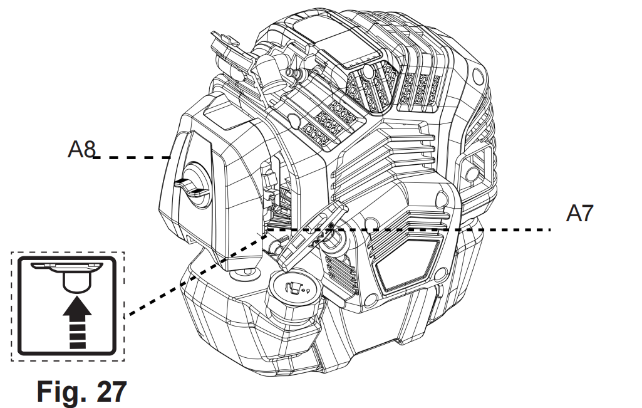
Recoil starter
1. The recoil starter handle (A4) is positioned at the rear side of the
engine.
2. Hold the product stable and pull the recoil starter handle lightly until
you feel resistance then pull it rapidly. Do it again until the engine starts (Fig. 28).
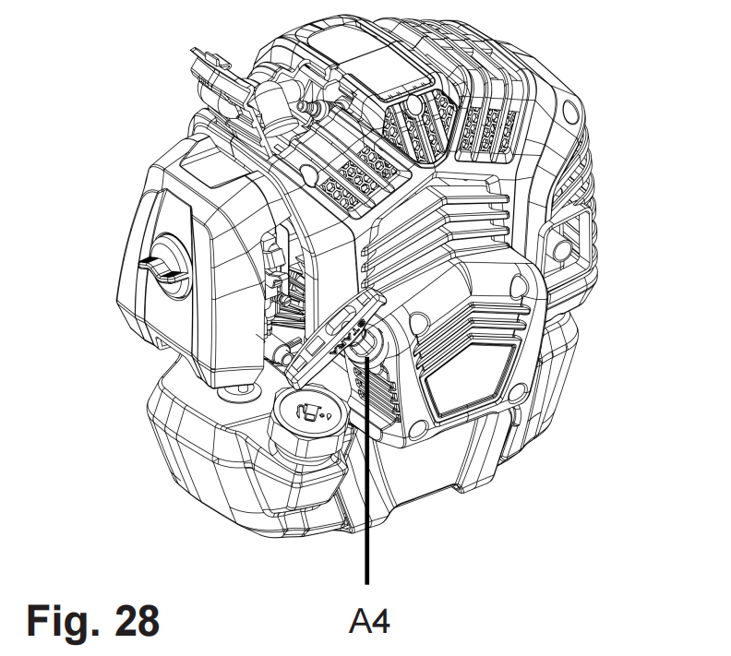
WARNING! Never twist the starter rope around your hand!
Only pull on the handle!
WARNING! Do not suddenly release the recoil starter handle! Allow the rope to return slowly and in a controlled manner each time it is pulled! Do not pull out the recoil starter beyond the red colour band at the end of the recoil starter! Pulling excessively will cause damage on the recoil starter cord.
Choke
1. Move the choke (A12) upward to CLOSE position  to close the choke (Fig. 29). Move the choke to CLOSE position for cold start.
2. Move the choke (A12) downward to OPEN position  to open the choke (Fig. 30). Move the choke to OPEN position for warm start and normal use.
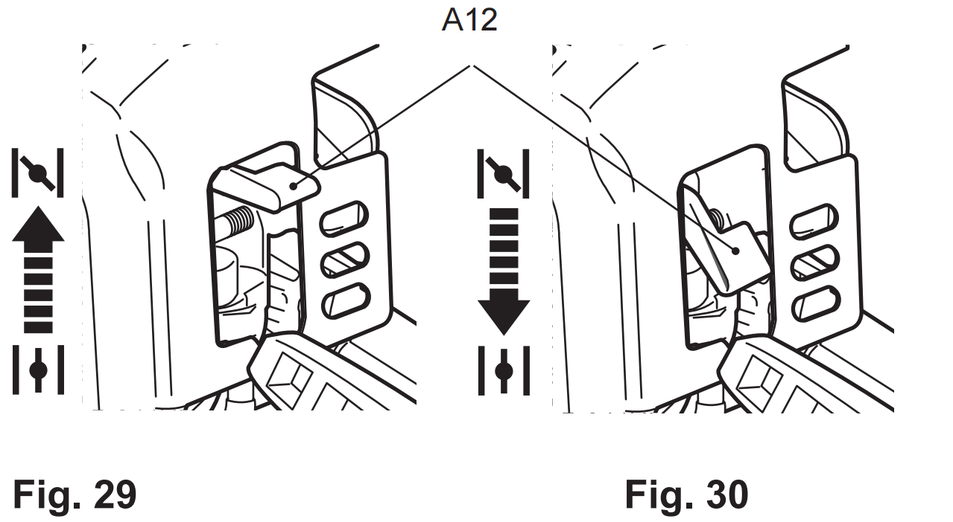
Control unit
There are three controls on the main handle (A31) with the following
functions (Fig. 31):

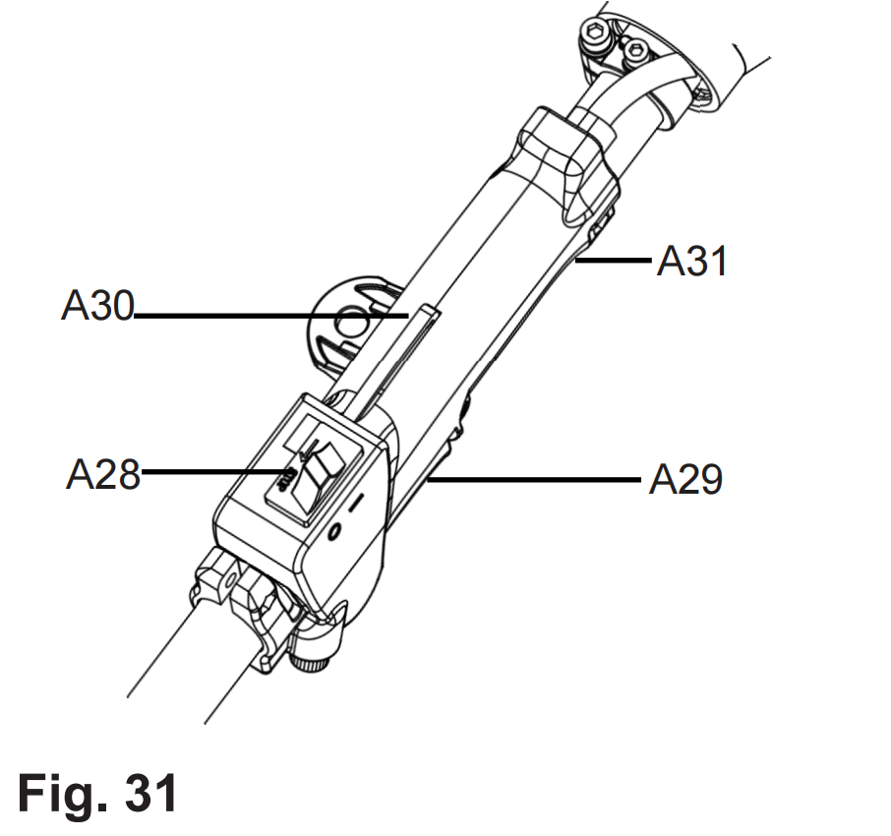
1. The throttle interlock (A30) prevents unintentional activation of the throttle trigger (A29).
2. The ignition switch (A28) electrically starts or stops the engine.
3. Adjust the engine speed with the throttle trigger (A29).

Harness
The harness (A16) helps the operator to carry the product.
1. Attach the securing clip (A18) to one of the four loops (A15) (Fig. 32).
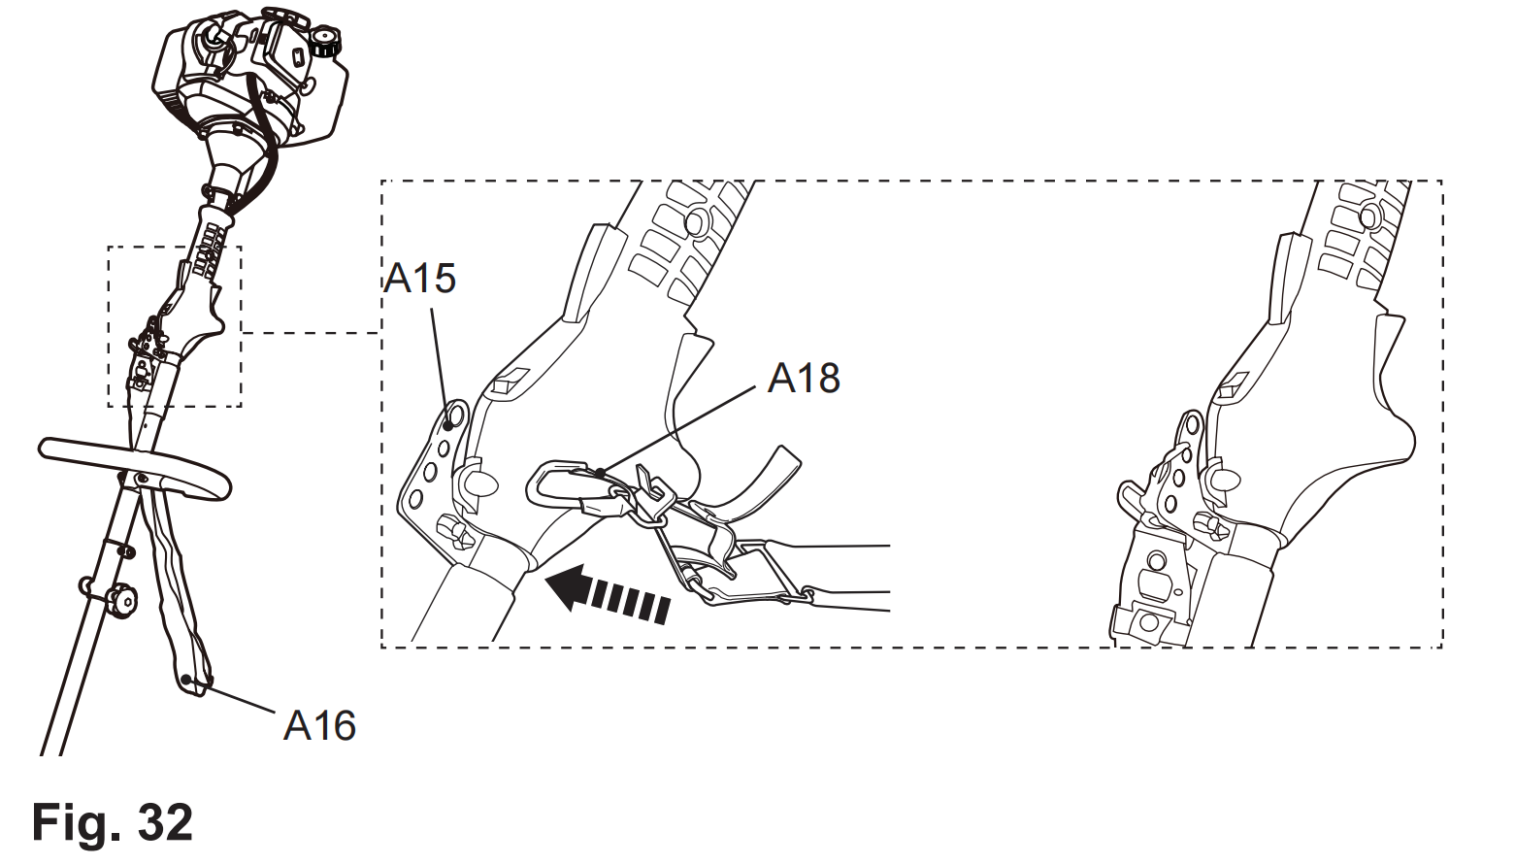
2. Place the harness (A16) so that it runs over the left shoulder, crossing the chest and back. The securing clip (A18) must be located at the right hip (Fig. 33).
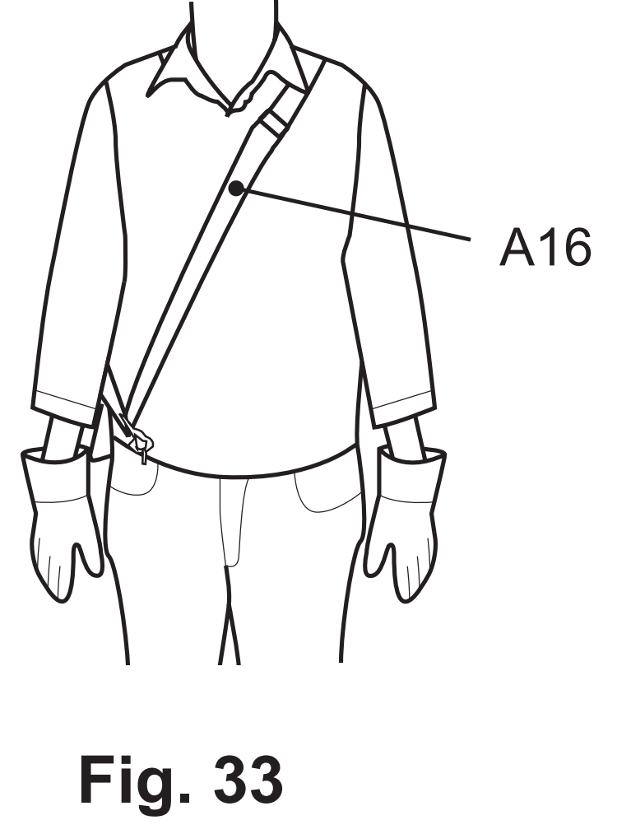
3. Ensure the position of the product is properly balanced.
4. Adjust the length of the harness (A16) so that the securing clip (A18) is approximately 15 cm below your waist.

WARNING!
Always attach the product to the harness. Do not carry it only with your hands!

5. In case of emergency, hold the front handle (A27) with the left hand, and use the right hand to pull the rope (A17) (Fig. 34). The metal locking bar will be released from the securing clip automatically because of the weight of the product.
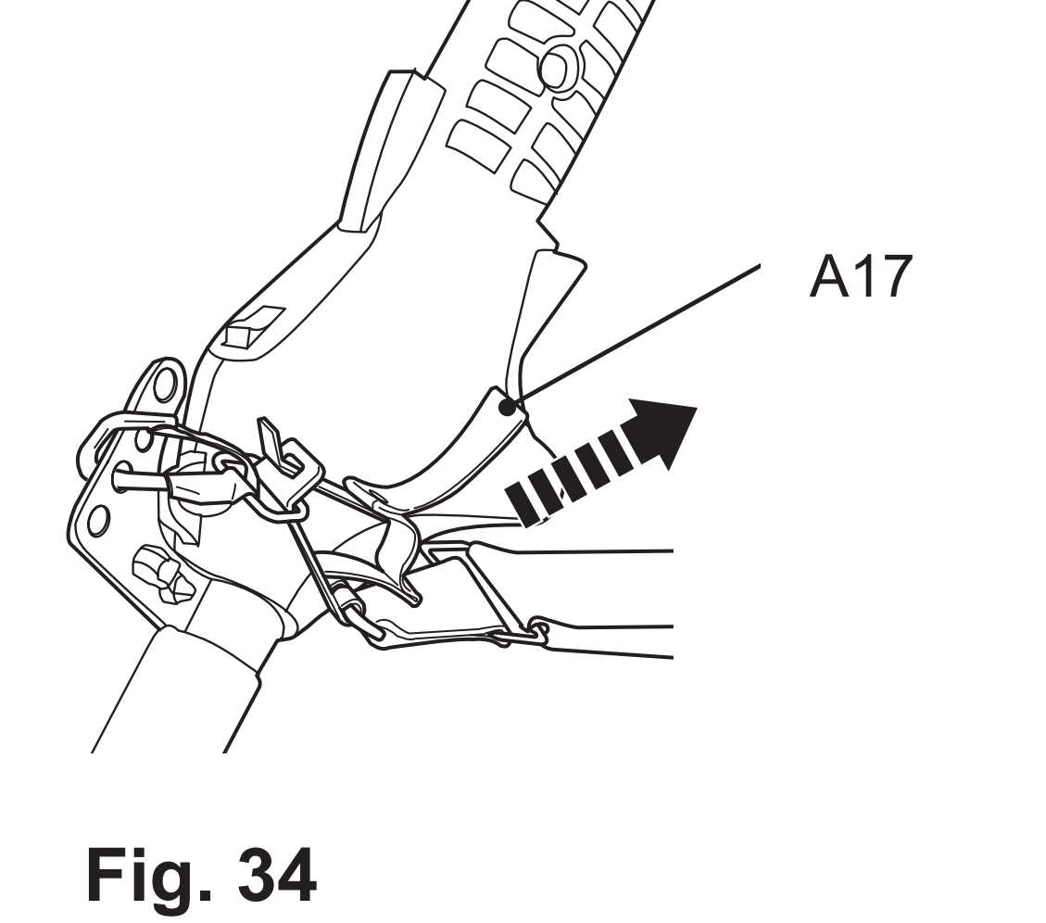
Handle adjustment
1. Loosen the bolts (A25) and nuts (A26). Do not remove the bolts and nuts from the bracket (A24).
2. Slide the bracket (A24) up or downward to one of the three positions until the mounting holes are aligned (Fig. 35).
3. Tighten the bolts (A25) and nuts (A26) afterward.

WARNING! Make sure the bolts (A25) and nuts (A26) on the bracket (A24) are properly tightened before using the product!

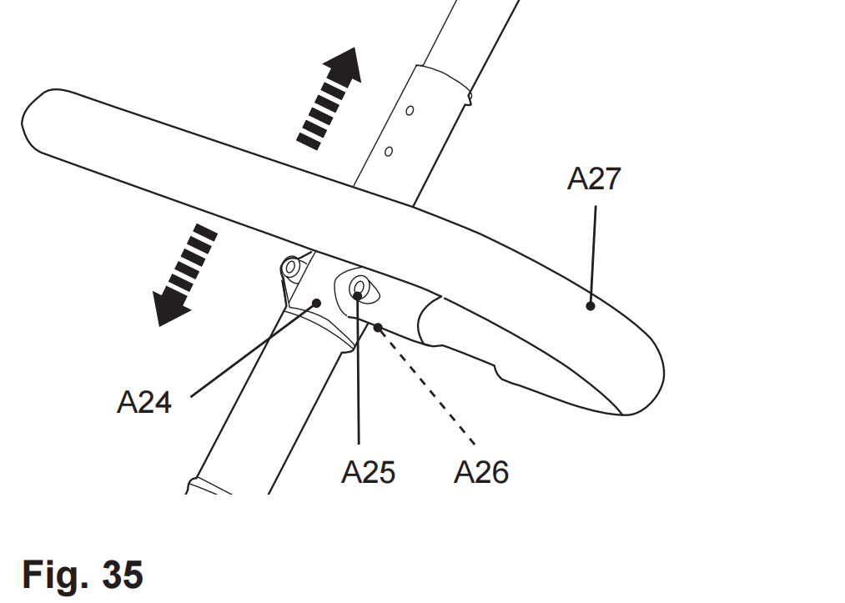

Cutting attachments (for brush cutter and grass trimmer)Cutter blade
Use the cutter blade (B14) to cut heavier weeds, brush and similar vegetation.

Trimming head
Use the trimming head (B18) to cut smaller types of weed, lawn grass or similar soft vegetation.
The trimming head is equipped with a bumper helping to cut the trimming line (B21) while operating. Simply tap the bumper on a firm surface and the spool (B20) will release fresh trimming line (Fig. 36).
A knife (B6) is integrated with the guard extension (B9) and this will cut the trimming line (B21) to the necessary length.
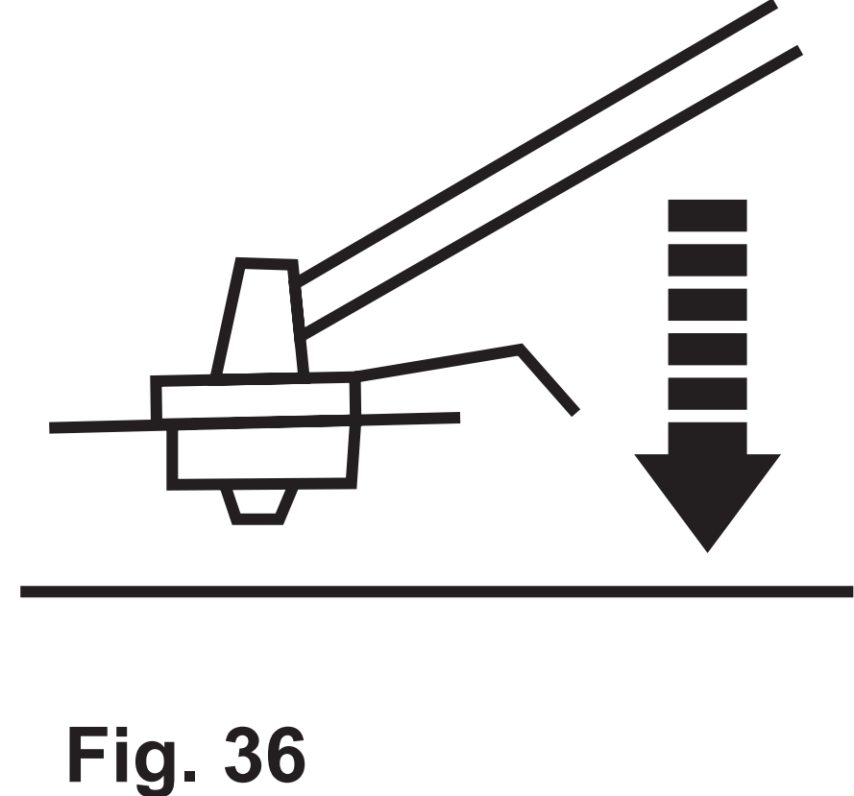
WARNING!
The cut line will be thrown out! Danger of injury especially for bystanders!

Guard extension (for brush cutter and grass trimmer)
The guard (B8) and guard extension (B9) protects the operator against thrown objects during operation. It is equipped with a knife (B6) that cuts the trimming line (B21) (Fig. 37).

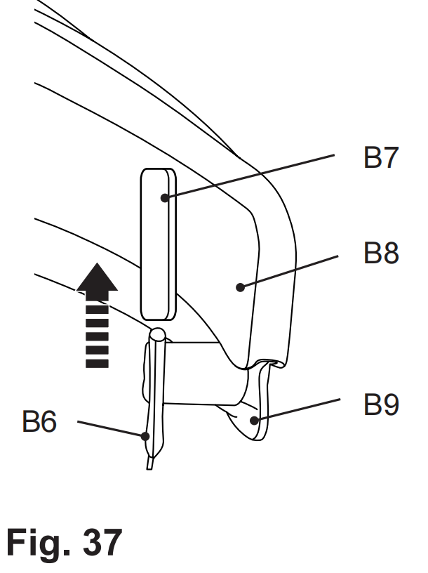

NOTE: Always remove the knife protection cover (B7) before use.

Operation instructions
General
1. Check the product as well as accessories for damage before each use. Do not use the product if it is damaged or shows wear.
2. Double check that the accessories and attachments are properly fixed.
3. Check the fuel level, refill if necessary.
4. Always hold the product by its handles. Keep the handles dry and free from lubricant to ensure safe support.
5. Ensure that the air vents are always unobstructed and clear. Clean them if necessary with a soft brush. Blocked air vents may lead to overheating and damage the product.
6. Switch the product off immediately if you are disturbed while working by other people entering the working area. Always let the product come to complete stop before putting it down.
7. Do not overwork yourself. Take regular breaks to ensure you can concentrate on the work and have full control over the product.
WARNING! In some countries regulations define at what time of the day and on what special days products are allowed to be used and what restrictions apply! Ask your community for detailed information and observe the regulations in order to preserve a peaceful neighborhood and avoid committing administrative offenses! (not applicable for UK)

Starting/Stopping
Cold start
1. Place the product on a flat, stable surface. Ensure the tool attachment in use does not touch the ground or any objects.
2. Set the ignition switch (A28) to position “I”.
3. Deeply press the primer (A7) 7 - 10 times until the fuel is visible.
4. Move the choke (A12) upward to CLOSE position .
5. Hold the product stable and pull the recoil starter handle (A4) slowly until you feel resistance then pull it rapidly. Move the choke slight downward to middle position if the engine does not start after trying up to 8 times. Do it again until the engine starts (Fig. 38).
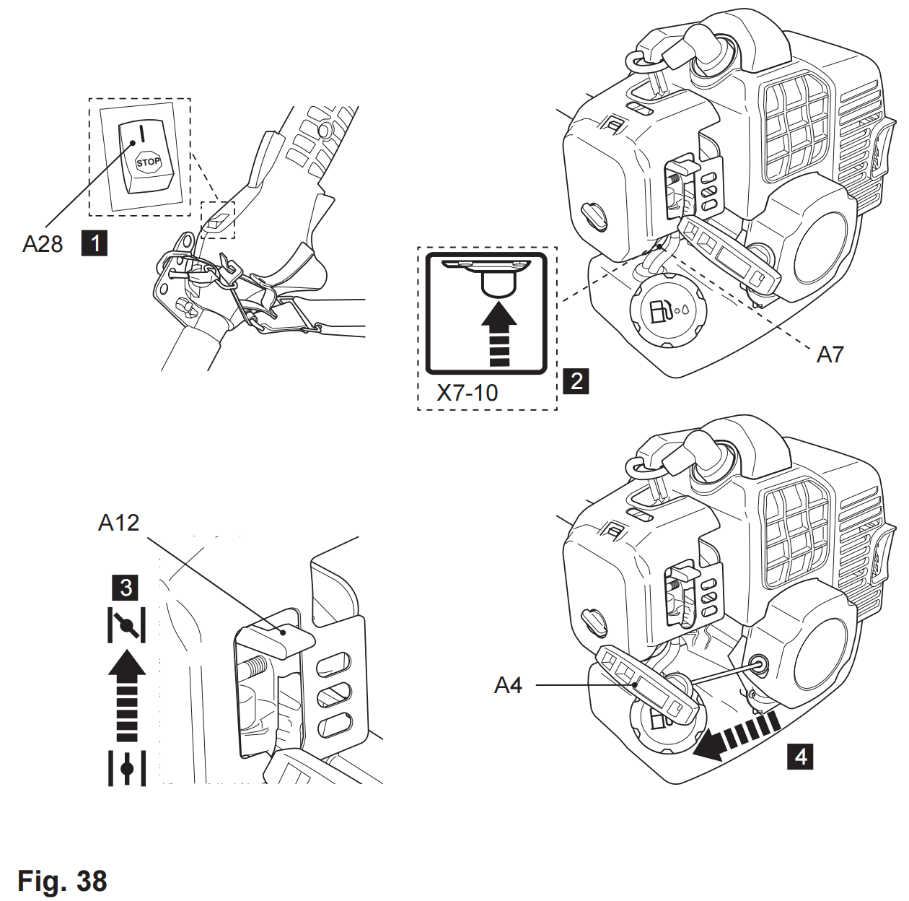
WARNING! Allow the rope to return slowly and in a controlled manner after each pull!
6. Move the choke (A12) downward to OPEN position once the engine starts.
7. Let the product run idle for a few seconds to warm it up.
WARNING! The cutting attachment should not move during idling speed! If you find that the cutting attachment is moving, stop using the product and have it inspected and adjusted by an authorised service centre or a similarly qualified person!
8. Once the engine is running smoothly, carefully lift the product and secure it to the harness (A16) by way of the securing clip (A18).
9. Firmly hold the product with left hand on front handle (A27) and right hand on main handle (A31).
10. Squeeze the throttle interlock (A30) and throttle trigger (A29) to operate the product (Fig. 39).
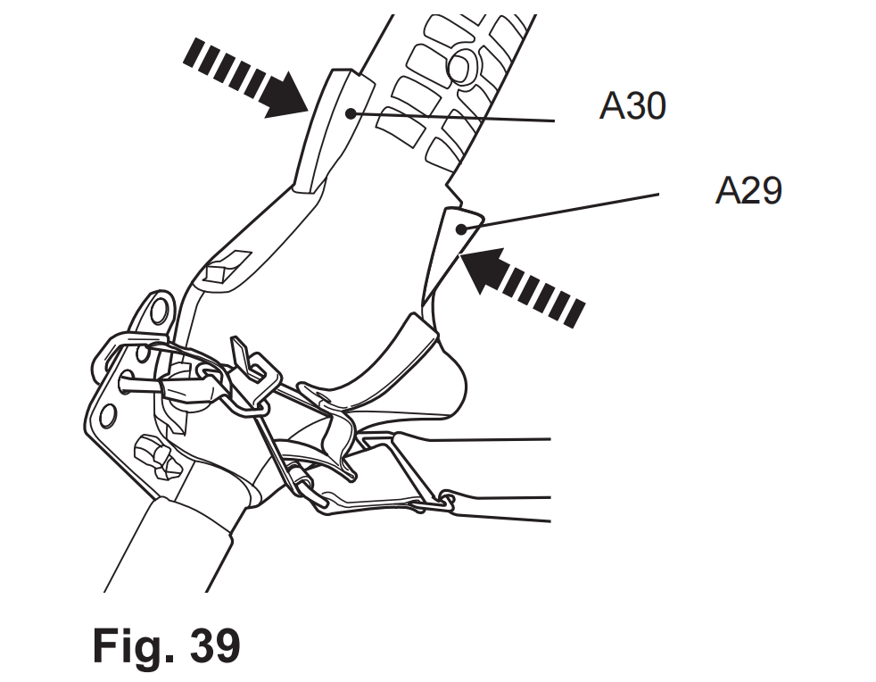
Warm start
1. Place the product on a flat, stable surface. Ensure the tool attachment in use does not touch the ground or any objects.
2. Set the ignition switch (A28) to position “I”.
3. Do not press the primer (A7).
4. Ensure the choke (A12) is at the OPEN position .
5. Pull the recoil starter handle (A4) lightly until you feel resistance then pull it rapidly. Do it again until the engine starts (Fig. 40).
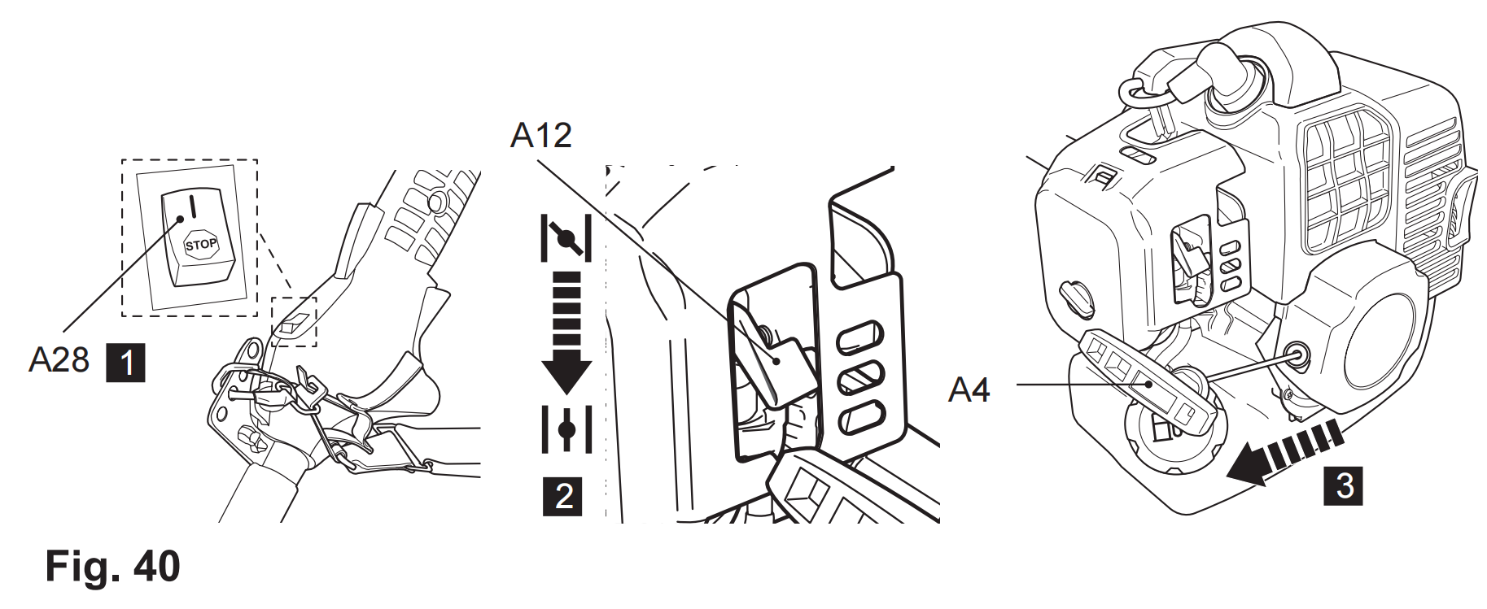
WARNING! Allow the rope to return slowly and in a controlled manner after each pull!
WARNING! The cutting attachment should not move during idling speed! If you find that the cutting attachment is moving, stop using the product and have it
inspected and adjusted by an authorised service centre or a similarly qualified person!

6. Once the engine is running smoothly, carefully lift the product and secure it to the harness (A16) by way of the securing clip (A18).
7. Firmly hold the product with left hand on front handle (A27) and right hand on main handle (A31).
8. Squeeze the throttle interlock (A30) and throttle trigger (A29) to operate the product (Fig. 41).
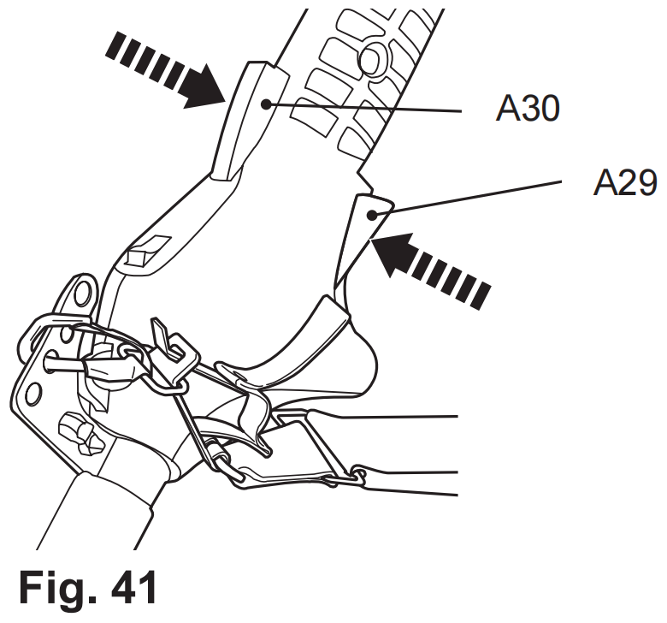
NOTE: If the engine does not start by the warm start procedure. Let the engine to cool down and try again to start the engine according to the cold start procedure.
NOTE: If the engine does not start, the engine may be flooded. Flooding is caused by too much fuel mixture applied at the wrong time and can prevent a product
from starting. Follow below procedure:
Remove the spark plug and dry it. Pull the recoil starter handle (A4) slowly for several times to drain the fuel from the combustion chamber.
If pull the recoil starter handle as normal, the fuel will not be released. There will be more & more fuel into the combustiion chamber.
Wait until fuel vapours and refit the spark plug. Clean up any spilled fuel and move the product at least 3 metres (10’) away before starting the engine to avoid any
accidental fire. Wait the engine to cool down then start the product as described in section “Cold start”.

Stopping
1. Release the throttle interlock (A30) and throttle trigger (A29) and let the product run at its idle speed for 10 – 15 seconds.
2. Set the ignition switch (A28) to position “STOP” (Fig. 42).
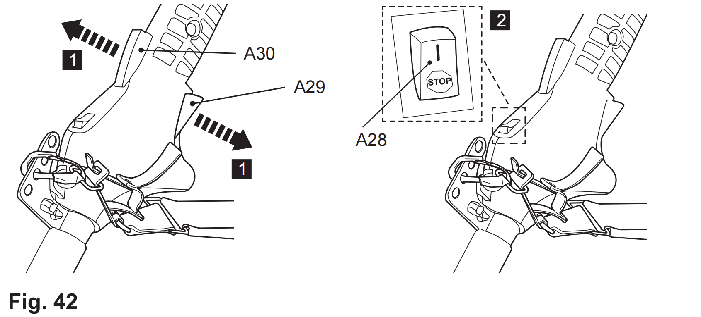

3. Carefully put down the product.

Cutting (brush cutter)
1. Attach the cutter blade (B14) to cut heavier weeds, brush and similar vegetation.
WARNING!
To avoid hazards never cut heavier weeds, brush and similar vegetation with a thickness exceeding the capacity stated in chapter “Technical specification”!
Avoid contact with stones, wire, glass etc. that may cause injury to the user! Inspect the blade regularly for damage, cracks or breaks! Always replace a damaged blade!
WARNING! Kickback (blade thrust): When working with the blade there is always a risk of kickback (blade thrust) if the cutting device comes into contact with a hard
object! Kickback (blade thrust) will cause the sudden stalling of the cutting device, which in turn results in the cutting device being forced in the opposite direction to
the rotation of the blade! Ensure that you retain a firm grip with both hands at any sign of such kickback (blade thrust), pay attention and retain a firm stance to avoid
injuries!

Kickback (blade thrust) is more likely to occur in areas where it is difficult to see the material to be cut!
Danger zone between 12 and 2 o’clock

2. Hold the product firmly so that it sits with a gap between the product and your right side.
3. Stand upright, do not lean forward and pay attention to posture. Keep both feet apart to help retain your balance.
4. Never hold the cutting head higher than your hip (Fig. 43); the higher you hold the cutting head will increase the risk of objects being thrown.
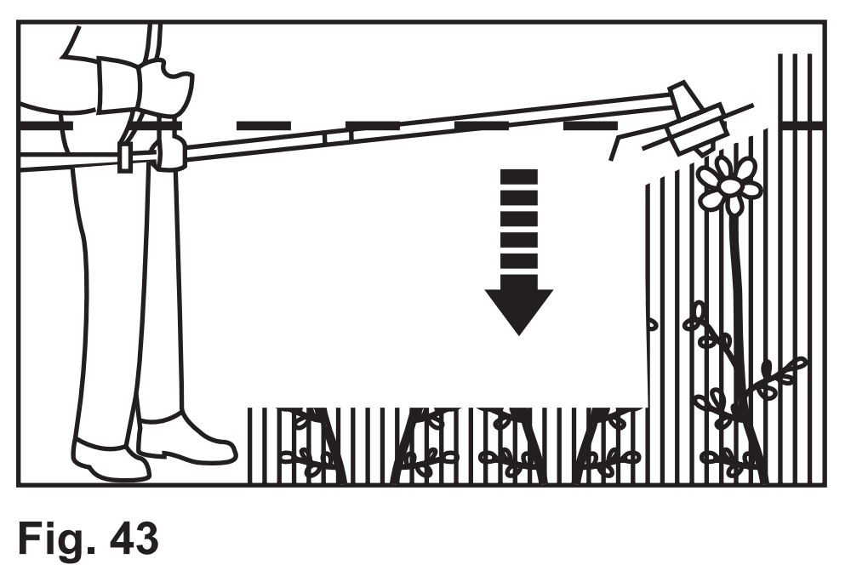

5. Carefully plunge the blade from above when cutting long undergrowth.

Trimming
1. Attach the trimming head (B18) to cut heavier weeds, brush and similar vegetation.
2. Hold the product firmly with a gap between the product and your right side.
3. Stand upright, do not lean forward and pay attention to posture. Keep both feet apart to help retain your balance.
4. Hold the trimmer head just above the ground at an angle of approximately 30° (Fig. 44).
5. Move the product with a slow regular arc from left to right before moving it back to the starting position before trimming the next area (Fig. 45).
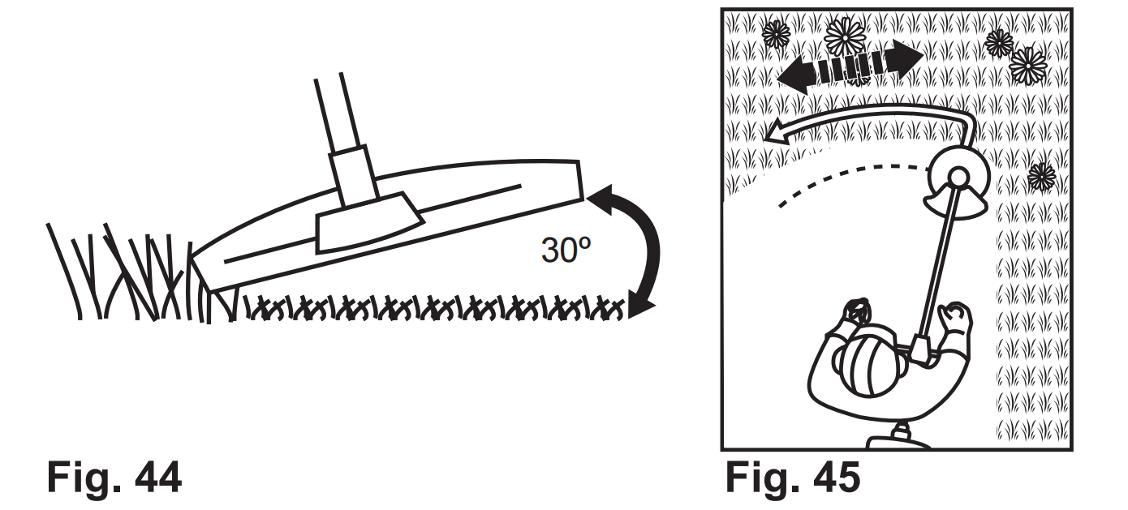
6. Ensure the cutting device remains clean and free from off-cuts that may cause it to jam. Check regularly. Stop the engine, set the ignition switch (A28) to “STOP” and remove the spark plug connector (A13) before checking.
7. Trim longer grass in stages; do not cut long grass in one cut (Fig. 46).
For the best results, cut longer grass in steps (Fig. 47).
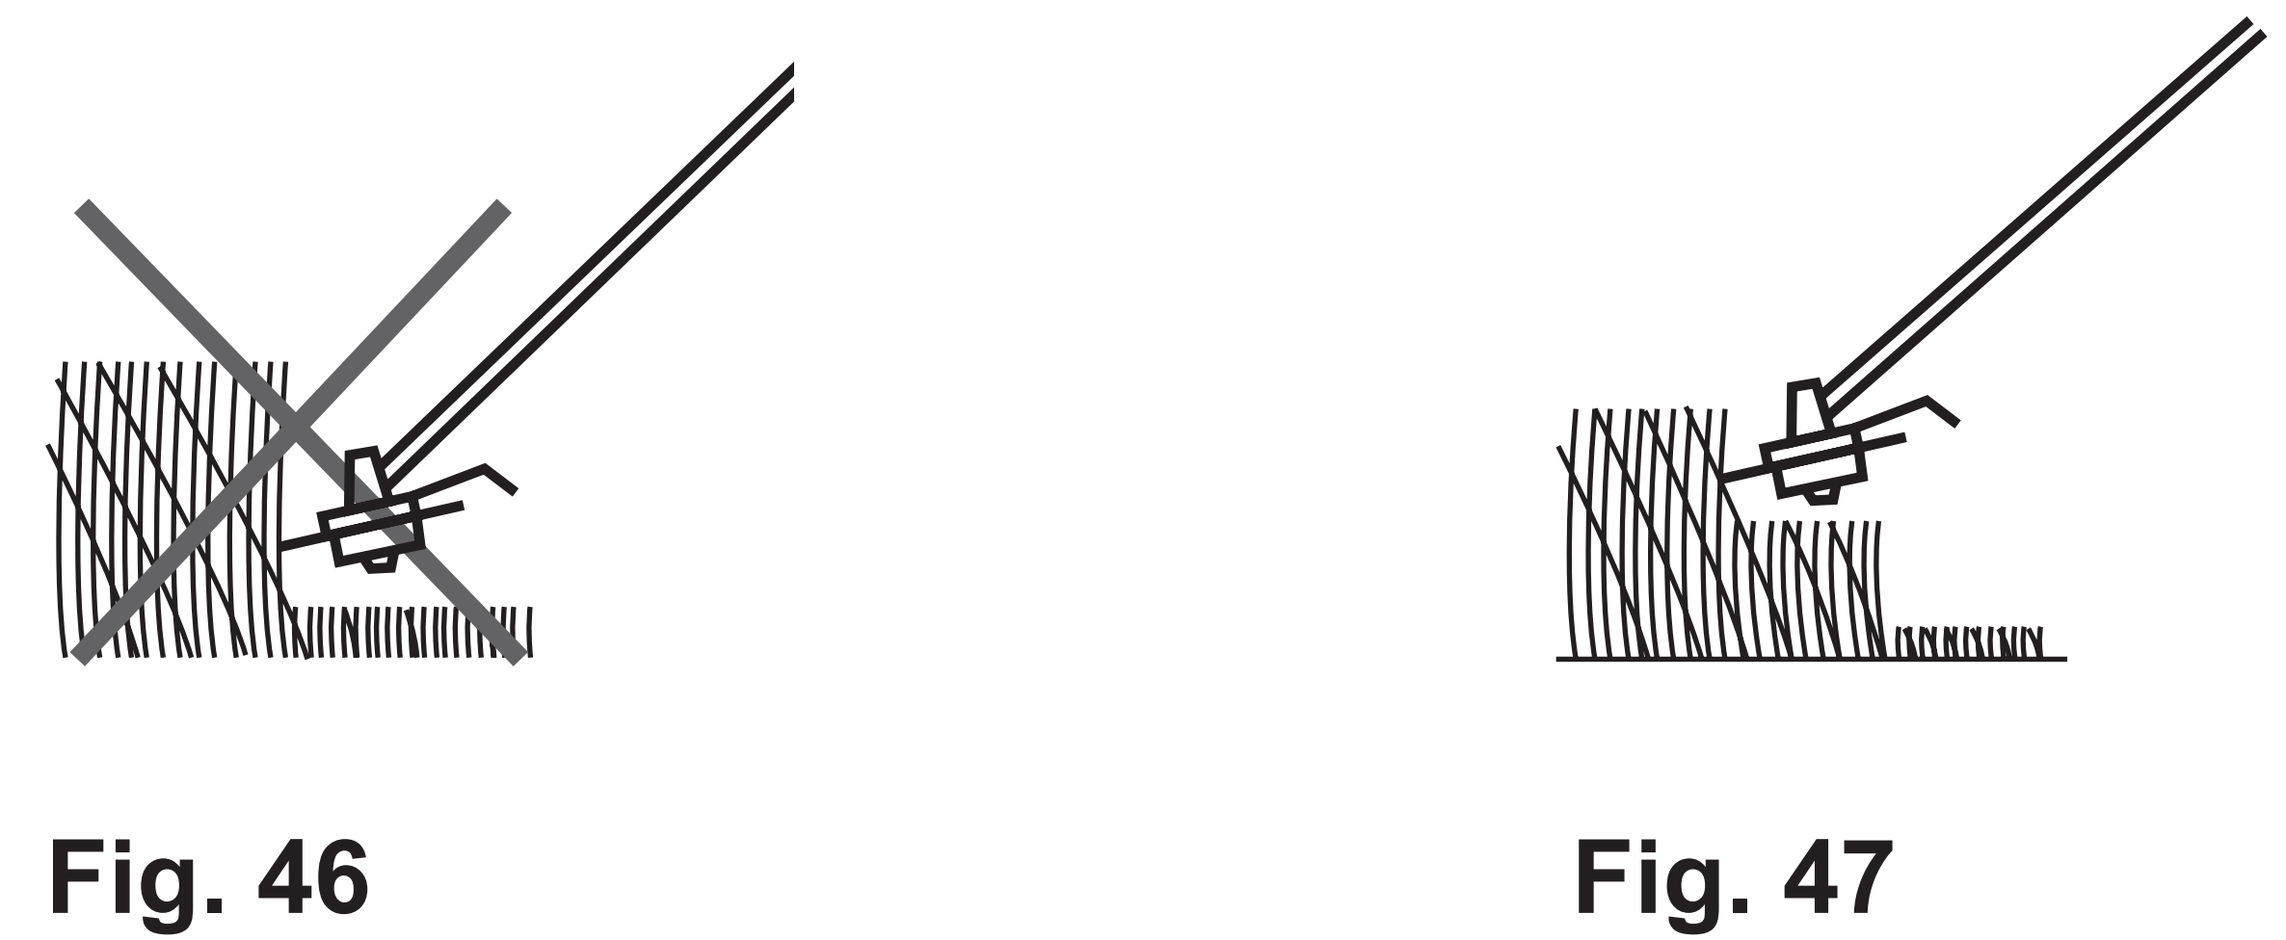

Tips
1. For best results, do not cut wet grass because it tends to stick to the cutting head and guard, prevents proper discharge of grass trimmings, and could cause you to slip and fall.
2. Pay special attention when performing the work close to trees and bushes. The cutting head could damage sensitive bark, and damage fence posts (Fig. 48).
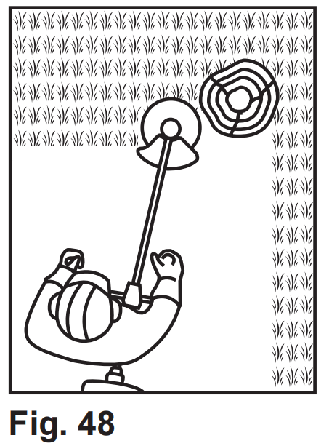
NOTE: The trimming line will wear faster and require more feeding if cutting is done along sidewalks or other abrasive surfaces or heavier weeds are being cut.
While trimming, the cutting device is possible to be blocked by grass or unevenly ground. Start it again with the warm starting procedure.

Pruning
Saw chain stop test
The product must always be held with two hands when switching it on.
1. Hold the front handle (A27) with the left hand and the main handle
(A31) with your right hand.
2. When switching on, the guide bar (C13) and the saw chain (C12)
must not be in contact with any object.
3. Switch the product off. The saw chain will come to stop in a few
seconds.
Kickback
WARNING! Beware of kickback! Kickback can lead to dangerous loss of control of the product and result in serious or fatal injury to the operator or anyone standing
close by! Always be alert because rotational kickback and pinch kickback are major product operational dangers and the leading cause of most accidents!
1. Kickback is the sudden backward/upward motion of the product, occurring when the chain (at the tip of the chain bar) comes in contact with a log or wood, or when the chain becomes jammed.
2. When kickback occurs the product reacts unpredictably and can cause severe injuries to the operator or bystanders.
3. With a basic understanding of “kickback”, the element of surprise can be reduced or eliminated. Sudden surprise contributes to the majority of accidents.
4. You should read all the safety warnings and user instructions carefully before attempting to operate this product.

To avoid kickback:
• Never work with a loose, widely stretched or heavily worn chain.
• Always use a low kickback chain.
• Ensure correct chain tension.
• Ensure the chain is sharpened correctly.
• Never work with the tip of the guide bar.
• Saw with the guide bar at a flat angle.
• Always hold the product firmly with both hands.

Pruning
1. Always hold the product firmly with both hands on the handles (A27, A31). Never operate this product using only one hand (Fig. 49).
2. Maintain a firm grip with your thumbs and fingers encircling the handles. A firm grip will help you reduce ‘kickback’ and maintain control of the product.
3. Always hold the product at an angle of not more than 60° from the horizontal level. Otherwise safe operation is not possible (Fig. 50).
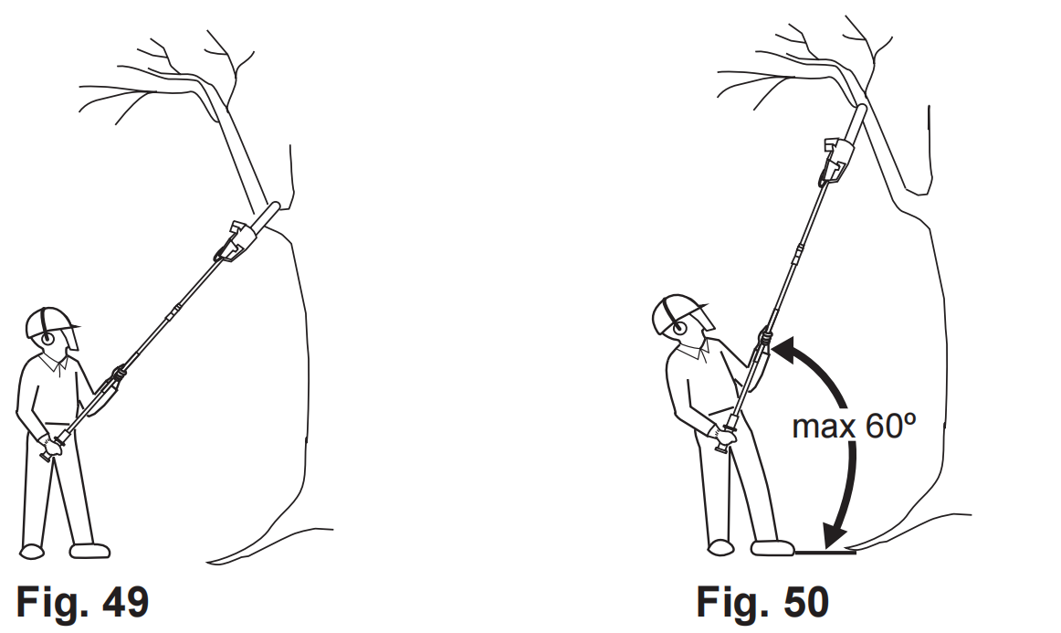

4. Never stand directly under the limb you are sawing. Objects may fall
different than expected. Always position yourself out of the path of falling limps (Fig. 51).
5.Keep other persons away from cutting end of product and at a safe distance from the work area. Maintain a minimum distance of 10 m to bystanders (Fig. 52).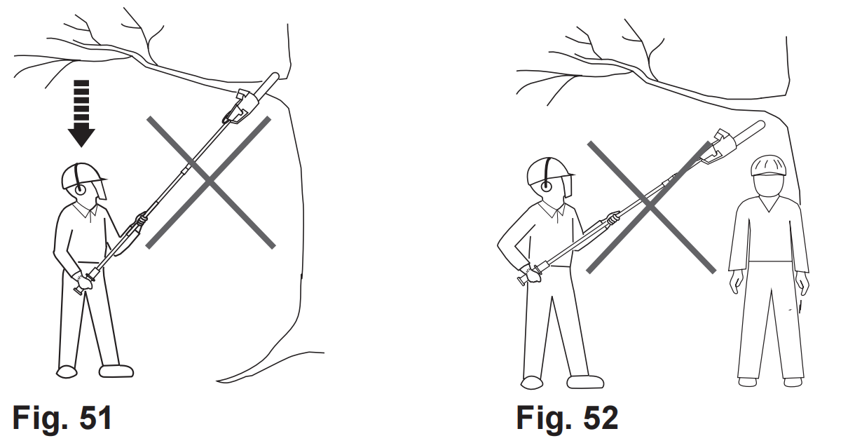
WARNING! Never climb into a tree to prune! Do not stand on ladders, platforms, logs, or in any position which may cause you to lose your balance or control of the
product! When pruning trees, it is important not to make the flush cut next to main limb or trunk until you have cut off the limb further out to reduce the weight! This
prevents stripping the bark from the main member!
6. Never stand on a ladder or other type of unstable support while
using the product. Insecure stand invites hazards (Fig. 53).

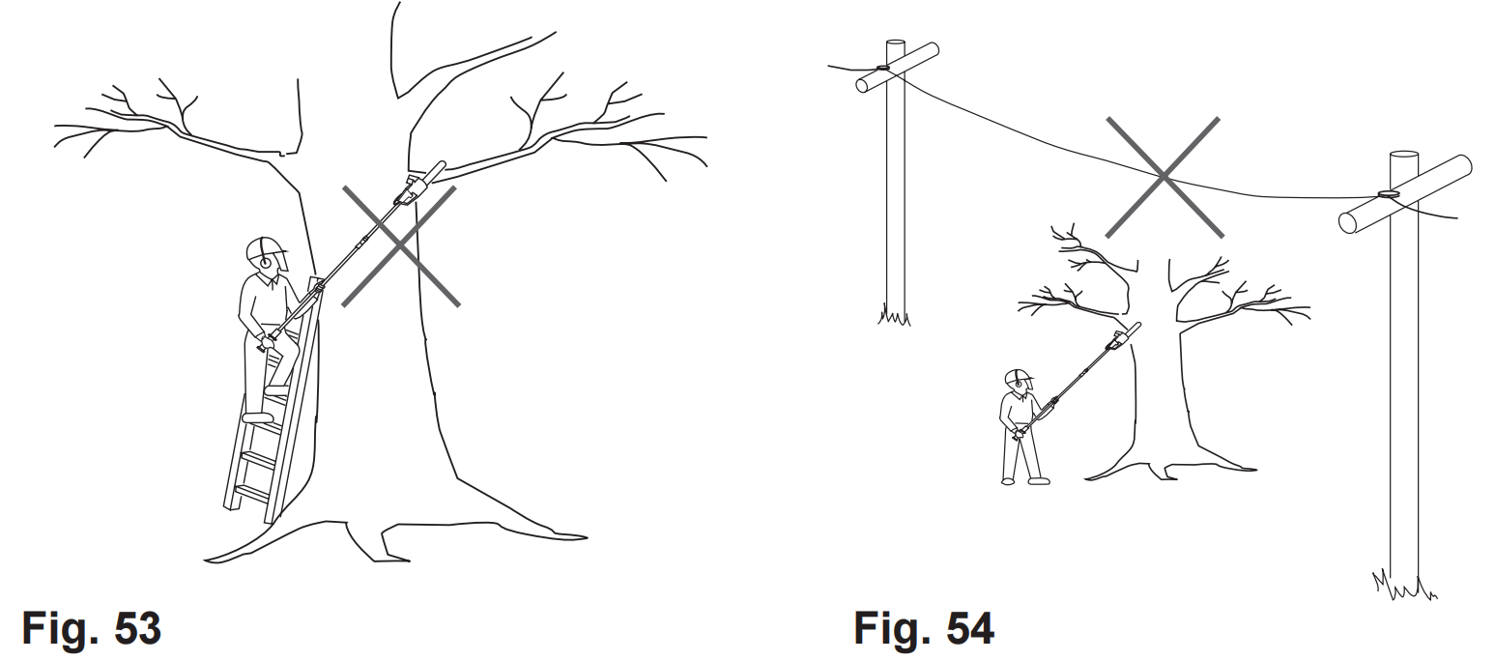
WARNING! This product has not been designed to provide protection from electric shock in the event of contact with overhead electric lines! Therefore do not use product near cable, electric power or telephone lines. Keep a minimum distance of 10 m to all electric lines (Fig. 54)!

7. Use the product only with secure footing. Hold the product at the right-hand side of your body. Regularly change the working position and include rest periods during operation.
8. Do not operate the product with arms fully extended or attempt to cut areas which are difficult to reach.
9. Keep a firm, steady pressure on the product while working with it. Do not try to force the product through the wood, let the cutting device do the work, using the gripping teeth to apply minimal leverage pressure.
10. Beware when reaching the end of the cut. The weight of the product may change unexpectedly as it cuts free from the wood. Accidents can occur to the legs and feet. Always remove the product from a wood cut while it is running.

NOTE: The chain must be running at full speed before it comes into contact with the wood.

Thin branches
Thin branches can be cut off with one single cut. To prevent the branch from slivering and buckling the branch should be cut off in several pieces (Fig. 55).
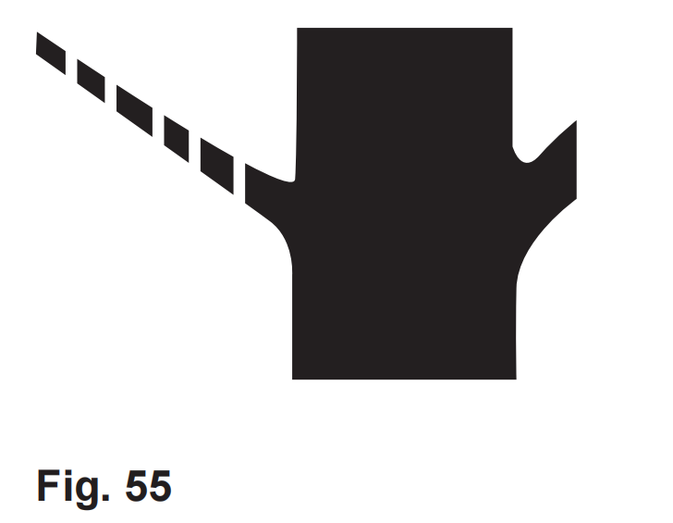
Thick branches
When cutting off larger branches three cuts are necessary.
1. First cut into the branch from below outside the place where you intend to cut off the branch. The cut should go from one third to halfway through the branch (Fig. 56).
2. Cut into the branch from the top outside at the same height the branch is sawn from top (Fig. 57).
3. Last, cut off the stump with one clean cut from top to bottom (Fig. 58).
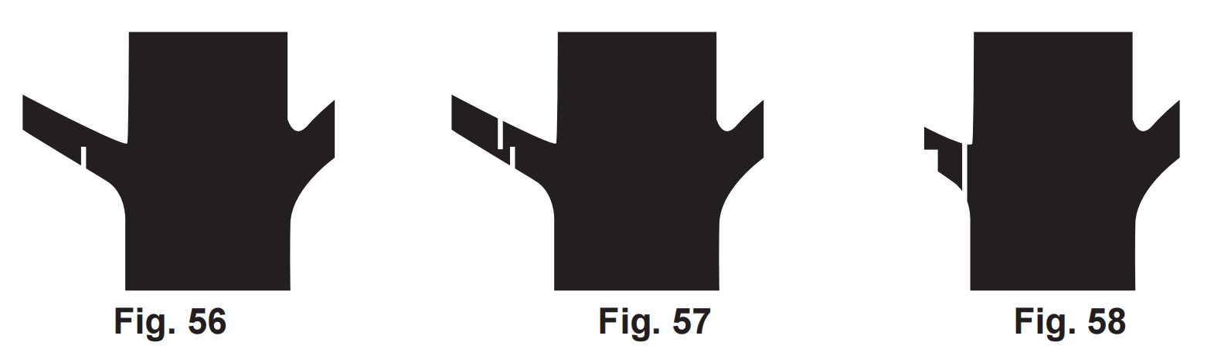
4. You might want to seal the cut with a suitable compound.
NOTE: Remove the branches lying on the floor regularly to avoid stumbling hazards. Check the oil level regularly and fill up if necessary. Switch the power off and disconnect from power source when leaving the product.
Trimming
Trimming times
green leaf hedges | June to October
evergreens | April and August
conifers and other fast growing shrubs | every 6 - 8 weeks

1. Adjust the blade head to the required position as described above.
2. Cut and remove branches exceeding the cutting capacity of this product using a proper pole saw before operation.
3. Always hold the product firmly with both hands on the handles (A27, A31). Never operate this product using only one hand.
NOTE: Try to keep the cutting device angled at approximately 15° to the cutting surface.
4. Cut both sides from the bottom cutting upwards to the top. This will prevent any of the cuttings falling into the path of the area still to be cut (Fig. 59).
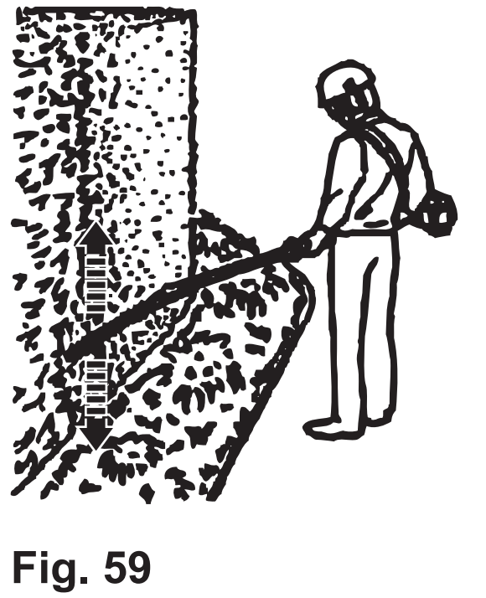

5. After cutting the sides proceed to the top.
6. When cutting wide hedges with the cutting area in sight move the cutting blade lightly through the cutting surface in a sweeping motion following the shape of the hedge or shrub. A slight tilt downwards of the cutting blade in the direction of motion is recommended for optimum cutting performance (Fig. 60).
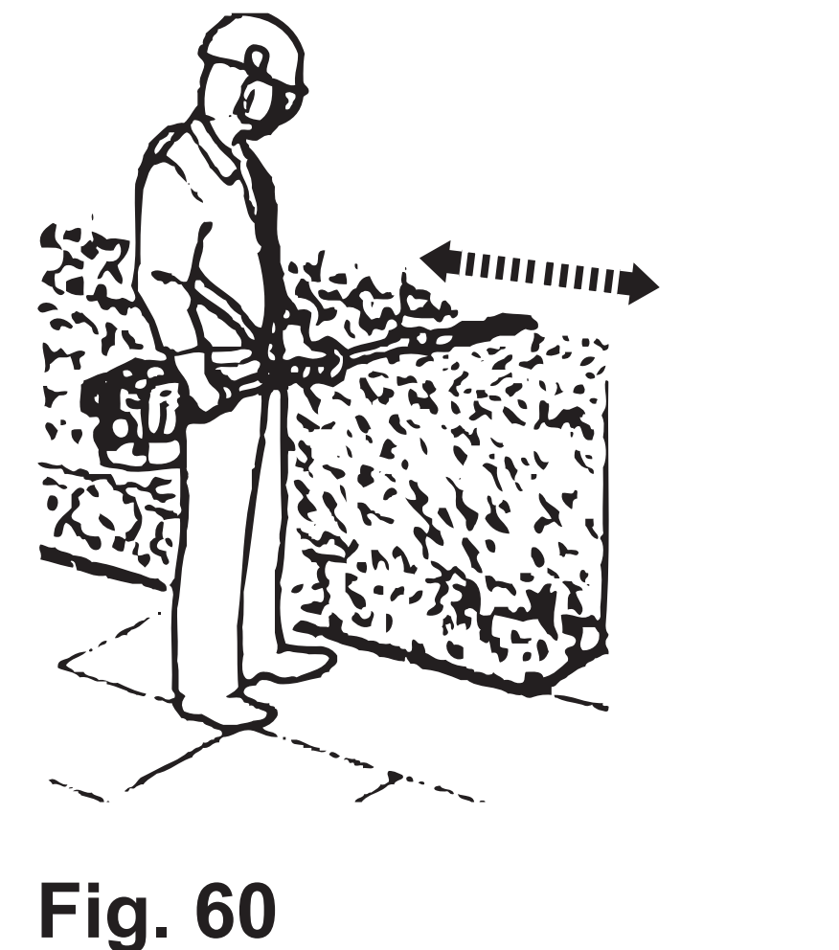

7. Move the product with slow motion forward when cutting higher hedge and the cutting area out of sight (Fig. 61).
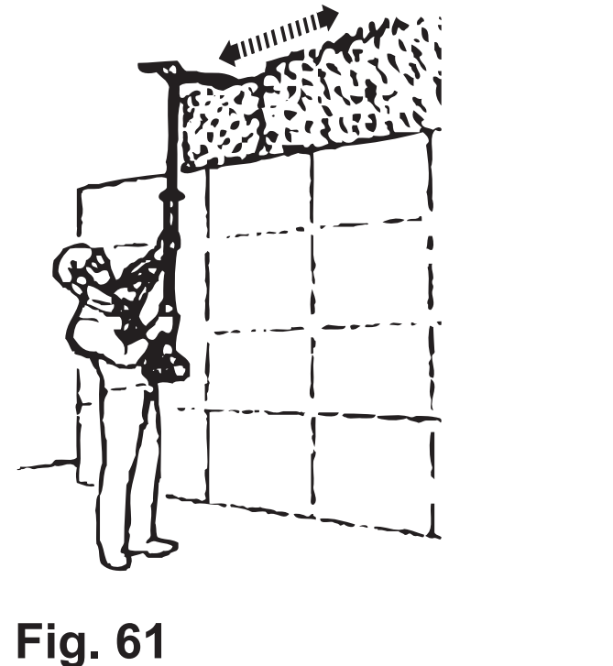

8. Do not rush and do not attempt to cut too much with one stroke of the cutting blade.
9. Cut in a number of stages if the area being cut is particularly long to achieve a better result; smaller cuttings will allow for easy composting.

NOTE: When shaping it is advisable to achieve a trapezoidal shape (Fig. 62). A trapezoidal cut corresponds to the natural growth of plants and results in optimal hedge growth, as it will expose more light to the lower end of the hedge.

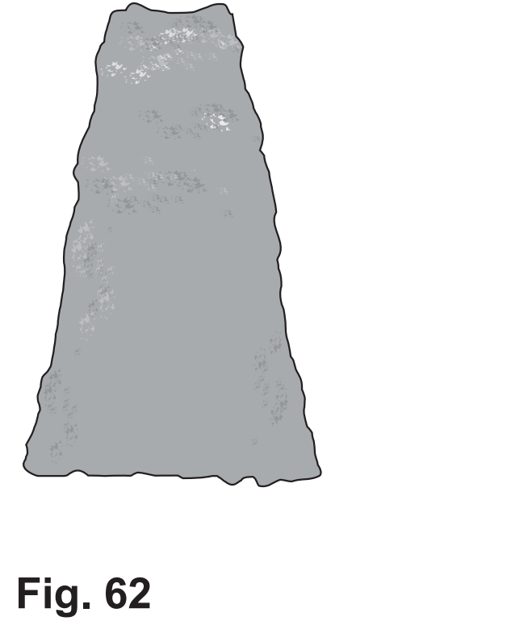
The golden rules for care
WARNING! Always switch the product off, disconnect the spark plug connector and let the product cool down before performing inspection, maintenance and cleaning work!

1. Keep the product clean. Remove debris from it after each use and before storage.
2. Regular and proper cleaning will help ensure safe use and prolong the life of the product.
3. Inspect the product before each use for worn and damaged parts. Do not operate it if you find broken and worn parts.

WARNING! Only perform repairs and maintenance work according to these instructions! All further works must be performed by a qualified specialist!

General cleaning
1. Clean the product with a slightly damp cloth and mild soap. Use a brush for areas that are hard to reach.
2. In particular clean the air vents (A2) after every use with a cloth and brush.
3. Remove stubborn dirt with high pressure air (max. 3 bar).
NOTE:Do not use chemical, alkaline, abrasive or other aggressive detergents or disinfectants to clean this product as they might be harmful to its surfaces.

4. Check for any damage and wear. Repair damages in accordance with this instruction manual or take it to an authorised service centre or a similarly qualified person before using the product again.
Maintenance
Before and after each use, check the product and accessories (such as attachments) for wear and damage. If required, exchange them for new ones as described in this instruction manual. Observe the technical requirements.

Maintenance table
Inspect and maintain this product regularly based on below maintenance table.
Part | To do | Before/  After each  use | First  month or  5 hours | Every 3  months  or 25  hours | Every 6  months  or 50  hours | Every  year or  100 hours | Every  2 years  or 250  hours
Air filter | check | x
Air filter | clean |  |  | x
Air filter | replace |  |  |  |  |  | x
Spark plug | check/  adjust |  |  |  |  | x
Spark plug | clean |  |  | x
Spark plug | replace |  |  |  |  |  | x
Spark  arrester | clean |  |  |  |  | x
Fuel tank | clean |  |  | x
Fuel tube | check | Every 2 years (replace if necessary)
Combustion  chamber | clean | Every 200 hours

Cutting attachment and guard
WARNING! Wear safety gloves when working on either cutting attachment. Use appropriate tools to remove debris e.g. a brush or wooden stick! Never use your bare hands!
Always use original spare parts for replacement. The cutting attachment must be replaced by an identification no. ref. xxxxxxx. Do not attach any other type of cutting attachment!
The replacement of the cutting attachment should be done by an experienced user! Rework or sharpening blades is not recommended unless it is done by an authorised service centre or a similarly qualified specialist!

1. Keep the cutting attachments and the safety guard clean and free of debris. Remove grass trimmings.
2. Keep the cutter blade (B14) sharp to retain a good cutting performance.
3. Replace worn or damaged cutter blades and refill the trimming line on the trimming head with new ones of the same type.

Spool
If the line is used up, replace it with a new spool, or replace new trimmer line to the spool.

WARNING! Only replace spool and/or trimming line according to the technical specifications.
Never use metal thread!
Always use cutting attachments in perfect condition, free of damage!

1. Lay the product on a flat stable surface with the trimming head facing upward.
2. Remove the trimming head (B18) from the product.
3. Press the release latches (B25) on the trimming head housing (B23) to open the cover (B19) (Fig. 63). The cover (B19) and spool (B20) will pop out.
4. Before put the new spool into the trimming head (B18), pass the trimming line (B21) through the holes on the housing.
5. Put the new spool into the trimming head housing (B23) and press it to the end, then pull the both lines (B21) out more than 10cm.
6. Align the notches on the cover to the noses of the housing, and then push the cover firmly onto the housing to close the trimming head.
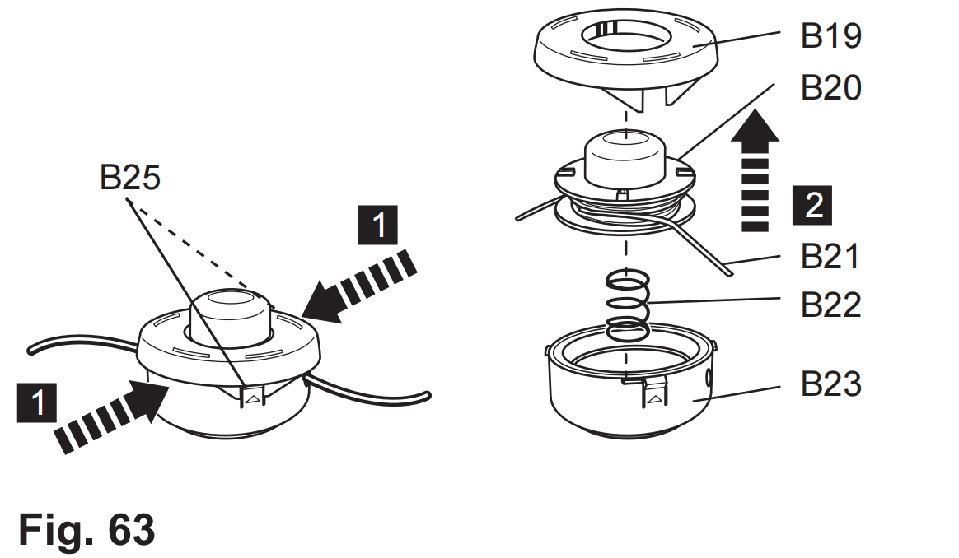

WARNING! The spool is fitted with a spring (B22)! Hold the casing away from you when opening to prevent injuries!

Replacing the spool
1. Remove the worn spool and replace with a new one of the same type and follow the above operation steps.
2. Align the notches on the cover to the noses of the housing, and then push the cover firmly onto the housing to close the trimming head.
WARNING! After changing the trimming line, run the product under no load for at least a minute to make sure that the line and the product are operating correctly!

Replacing trimmer line
1. Remove the worn trimmer line and replace with a new one of the same type. Take out the spool from trimmer head, pls follow the steps described in the above part <Spool>.
2. Cut two new 2m lines with a diameter of 2.5mm. Heat and flatten one end of these two lines, insert the other end of the lines into the locking holes and pull the lines all the way until the flatten end locking at position. (Fig.64, 65).
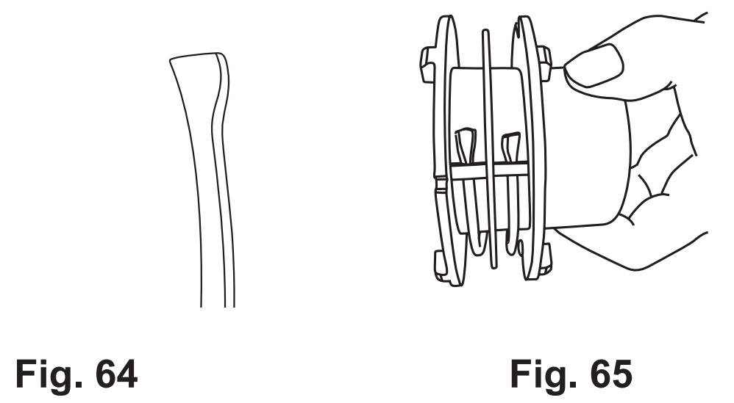
3. Wind the lines in clockwise direction firmly around the spool, ensure they are properly in the respective guide. (Fig.66)

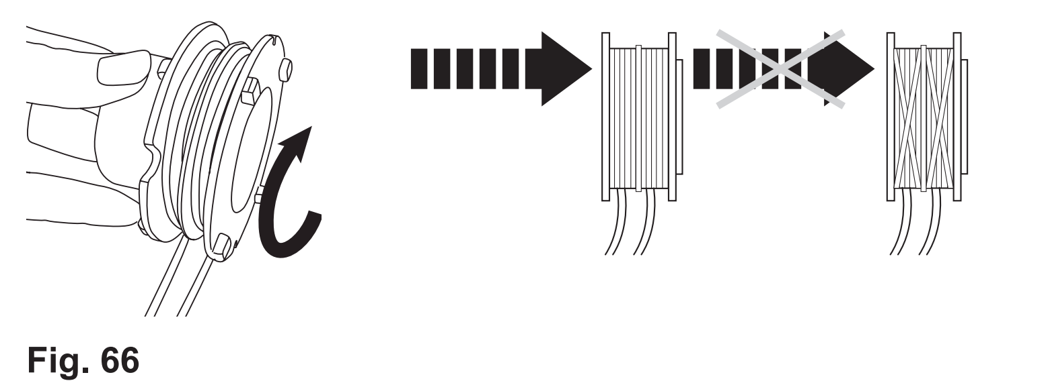
4. Leave about 200mm long at last, and stick the lines into the slots to keep them in place. (Fig.67)
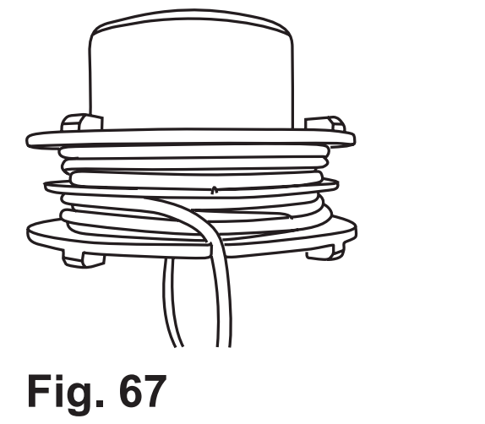
5. Put the spool back to trimmer head as above part <Spool>.

Bevel gear
The bevel gear is filled with grease. Regularly check the quantity and fill up using suitable lubricating grease such as a lithium based grease.
1. Loosen the screw with the hex key (E4) and remove it together with the washer.
2. Add suitable lubricant (Fig. 68).
3. Refit the washer and screw. Ensure the screw is properly tightened.
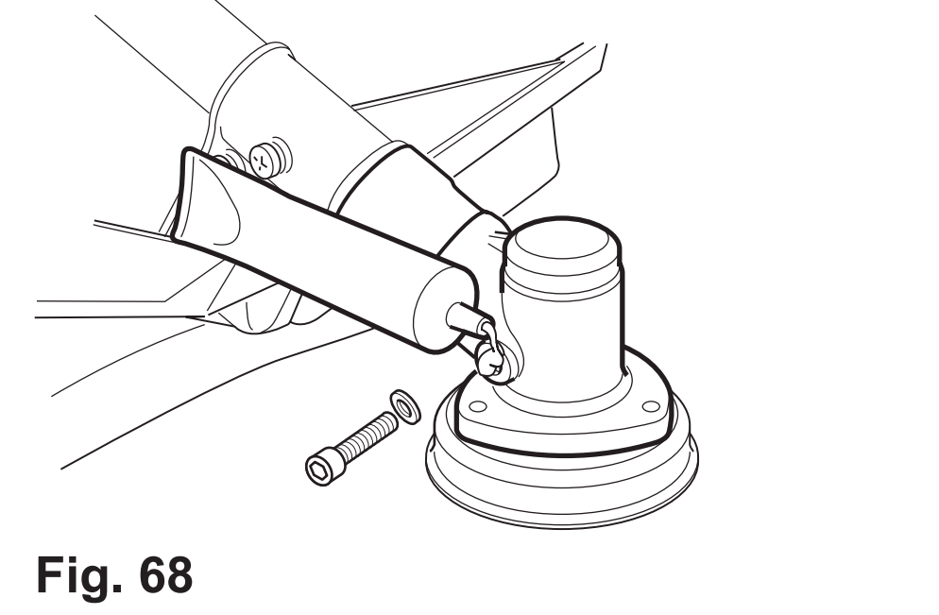

Saw chain and guide bar
Sprocket wheel
NOTE: It is not necessary to remove the saw chain (C12) to lubricate the sprocket wheel (C15). Lubrication can be done on the job.

1. Clean the sprocket wheel (C15).
2. Using a disposable lube gun, insert the needle nose into the lubrication hole (C14) and inject grease until it appears at the outside edge of the sprocket wheel (Fig. 69).
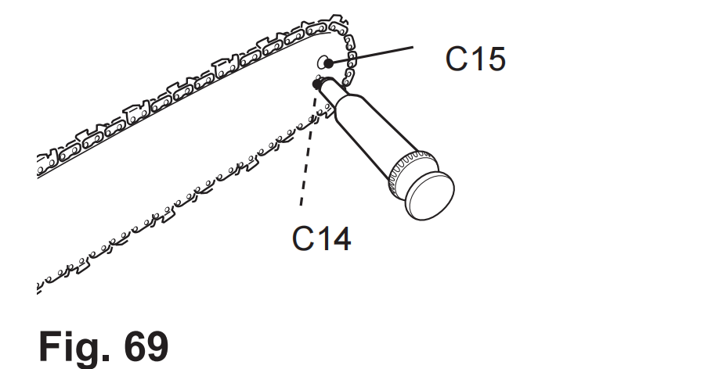
3. Rotate the saw chain (C12) by hand. Repeat the lubrication procedure until the entire sprocket wheel (C15) has been greased.
Guide bar and saw chain
Most guide bar problems can be prevented merely by keeping the product well maintained. Incorrect filling and non-standard cutter and depth gauge settings are the causes of most guide bar problems, primarily resulting in uneven bar wear. As the bar wears unevenly, the rails widen, which may cause the chain to clatter and make it difficult to complete straight cuts. If the guide bar is insufficiently lubricated
and the product is operated with a saw chain which is too tight, this will contribute to rapid bar wear. To help minimise bar wear, maintenance of the guide bar as well as the saw chain is recommended.
1. Disassemble the guide bar and saw chain in reversed order from assembly.
2. Check the oiling port (C5) for clogging and clean if necessary to ensure proper lubrication of the guide bar and saw chain during operation. Use a soft wire small enough to insert into the oil discharge hole (Fig. 70).
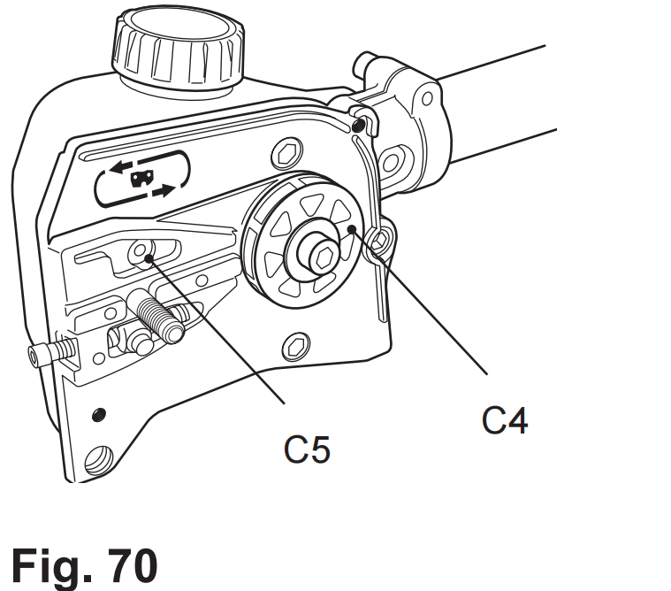
NOTE: The condition of the oil passages can be easily checked. If the passages are clear, the chain will automatically give off a spray of oil within seconds of
the product starting. Your product is equipped with an automatic oiling system.

3. Check the drive sprocket (C4). If it is worn or damaged due to strain, have it replaced by an authorised service centre or a similarly qualified person.
4. Clear residue from the rails on the guide bar (C13) using a screwdriver, putty knife, wire brush or other similar tool. This will keep the oil passages open to provide proper lubrication to the guide bar (C13) and saw chain (C12) (Fig. 71).
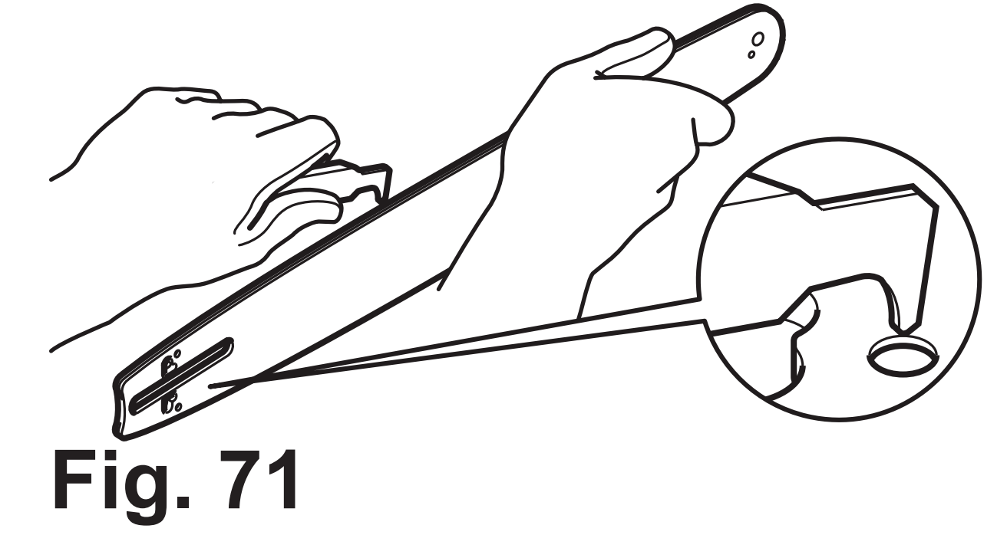
5. Check the guide bar ‘rail’ for wear: Hold a ruler (straight edge) against the side of the guide bar and ‘cutter side plates’. If there is a gap between the ruler and guide bar the guide bar ‘rail’ is normal.
If there is no gap (ruler flush against the side of the guide bar) the guide bar ‘rail’ is worn and needs to be replaced with a new one of the same type (Fig. 72).
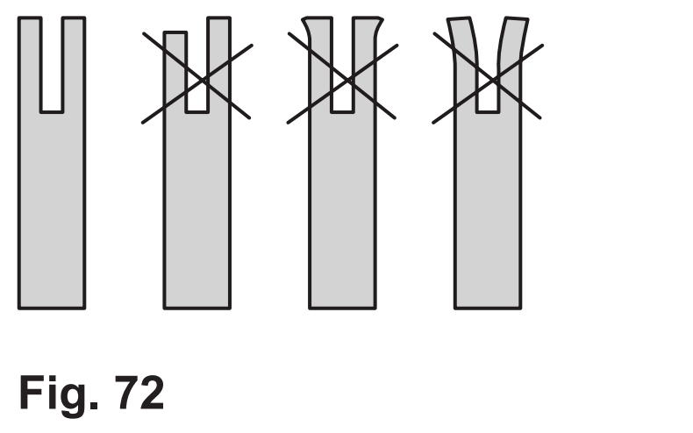
6. Check the saw chain for possible wear and damages. Replace it with a new one if required. Experienced users can sharpen a dull saw chain (see chapter “Saw chain sharpening”).
7. Refit the saw chain (C12) and the guide bar (C13) as described under “Assembly”.

Saw chain sharpening
NOTE: Saw chain sharpening may be required:
- after damp wood is cut (mealy sawdust),
- when handling the product becomes difficult (pulls to the left or right),
- when the saw chain is blunt (excessive force is required to penetrate the wood), or obviously damaged.
Never saw with a blunt chain. The saw chain is blunt if you have to push the product into the tree and the chips are very small.

1. Have your saw chain (C12) sharpened professionally at an authorised service centre or sharpen the chain yourself.
WARNING! Only sharpen the saw chain yourself if you are trained and have experience! Use proper tools to sharpen the saw chain!
2. The height difference between the tooth and the ridge is the cutting
depth. When sharpening the saw chain (C12) you have to consider
the following points (Fig. 73).
- File angle
- Cutting angle
- File position
- Diameter of round file
- File depth
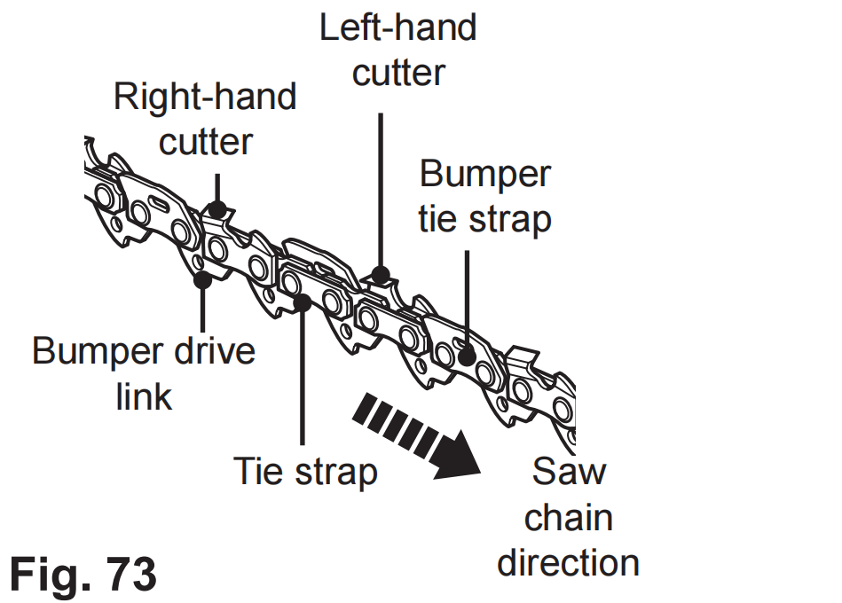
3. To sharpen the chain proceed as follows:
- Use protective gloves.
- Ensure the chain is correctly tensioned.
- Engage the chain brake to lock the chain on the bar.
- Use a chain file, whose diameter is 1.1 times the cutting tooth depth. Make sure 20% of the file diameter is above the cutter’s top plate.

NOTE: A file guide is available from most reputable tool merchants and is the easiest way to hold the file at the correct position.

5. File at an angle perpendicular to the bar, and at an angle of 25° to the direction of travel (Fig. 74).
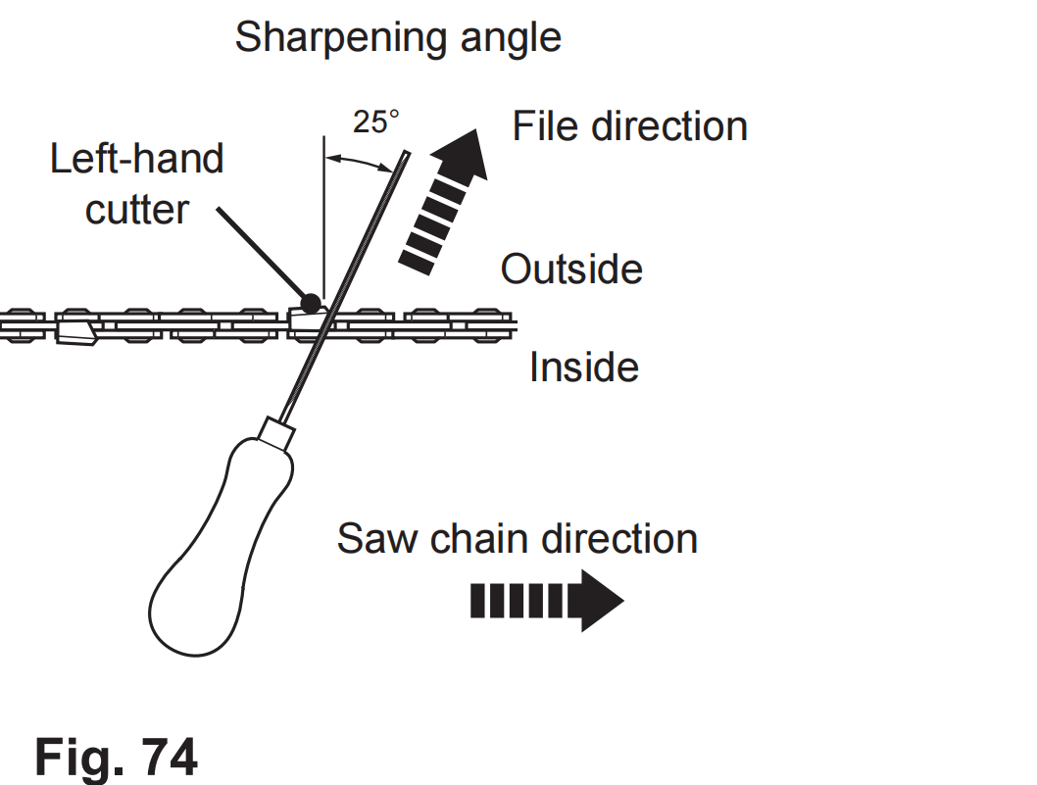
6. File each tooth from the inside towards outside only. File one side of the chain first than turn the saw around and repeat the process.
7. Sharpen each tooth equally by using the same number of strokes.
8. Keep all cutter lengths equal. Check the safety depth gauge height every 5 sharpenings. If the depth gauges are also trimmed it is essential that the original profile is restored.

9. Use a depth gauge measuring instrument to check the height of
the depth gauge. Depth gauge measuring jigs are available from
most reputable tool merchants (Fig. 75).
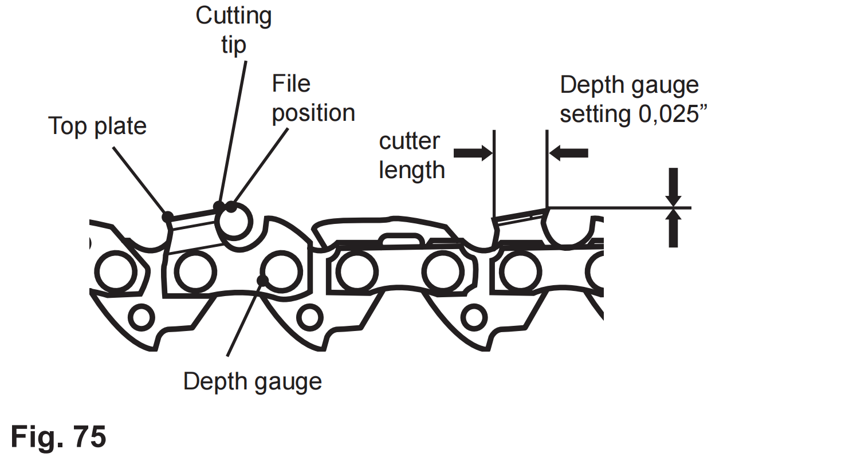
Pole hedge trimmer blade
WARNING! Wear safety gloves when working on the blade. Use appropriate tools to remove debris e.g. a brush or wooden stick! Never use your bare hands!
1. Keep the blade clean and free of debris. Remove trimmings.
2. Lubricate the cutting blade (D3) after each use to prolong the life span of the blade and product. Apply light machine oil along the edge of the cutting blade (Fig. 76).
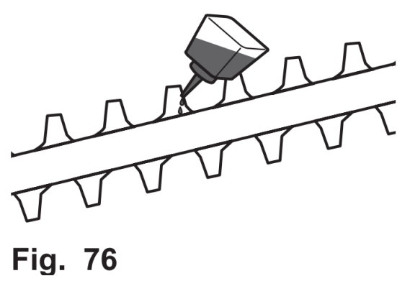
Air filter
Wash the air filter every 25 hours (if too dusty, every 10 hours) with clear water and dry it. Dip the air filter into clean machine oil if necessary. It can be used after superfluous oil is eliminated.
1. Inspect the air filter regularly. Replace it with a new one if necessary (Fig. 77).
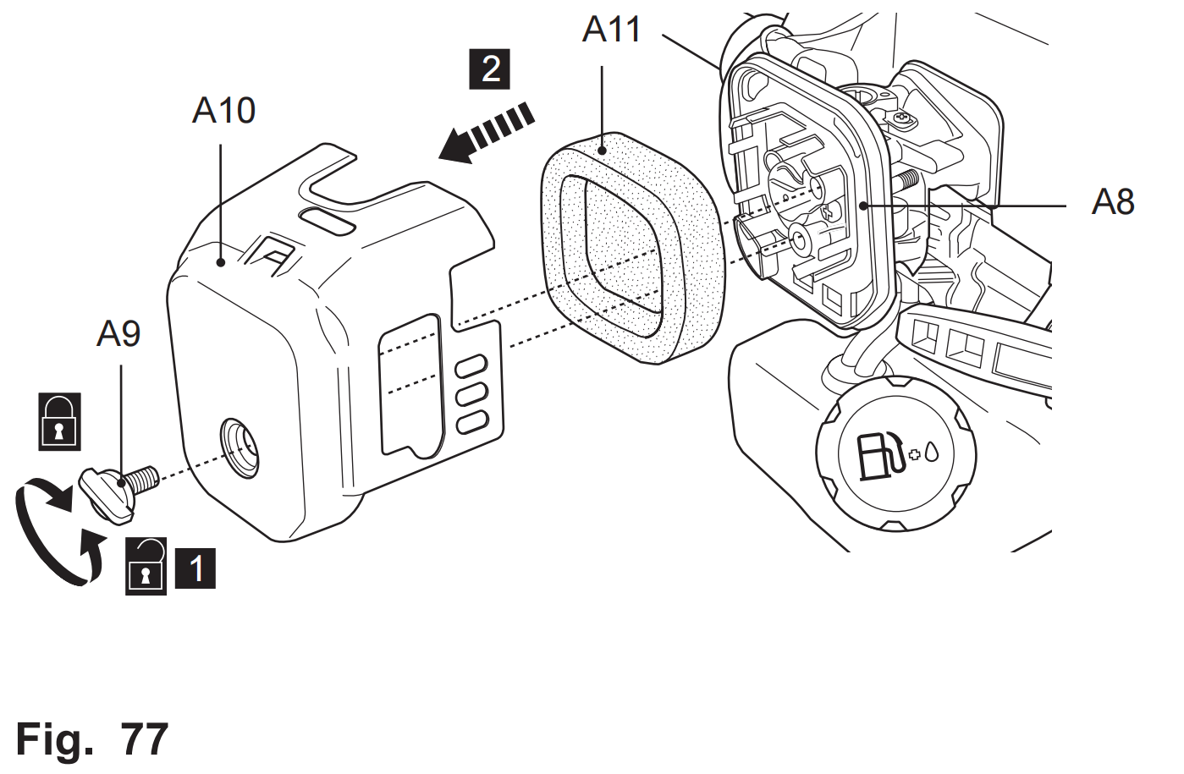
2. Loosen and remove the fixation bolt (A9) to open the air filter case (A8).
3. Remove the filter (A11) and tap it on a solid surface to remove dust.
4. Apply a small amount of air filter oil on the filter (A11) to increase the performance of the filter. Wring out surplus oil and put the filter back to the air filter case.
5. Re-attach the cover (A10) and secure it with the fixation bolt (A9).
Spark plug
Inspect the spark plug every 25 hours or prior to long-term storage over 30 days if the use has not been this high. Clean or replace with a new one if necessary.
1. Disconnect the spark plug connector (A13).
2. Loosen the spark plug (A14) anticlockwise using the multi tool (E2) and remove it carefully (Fig. 78).
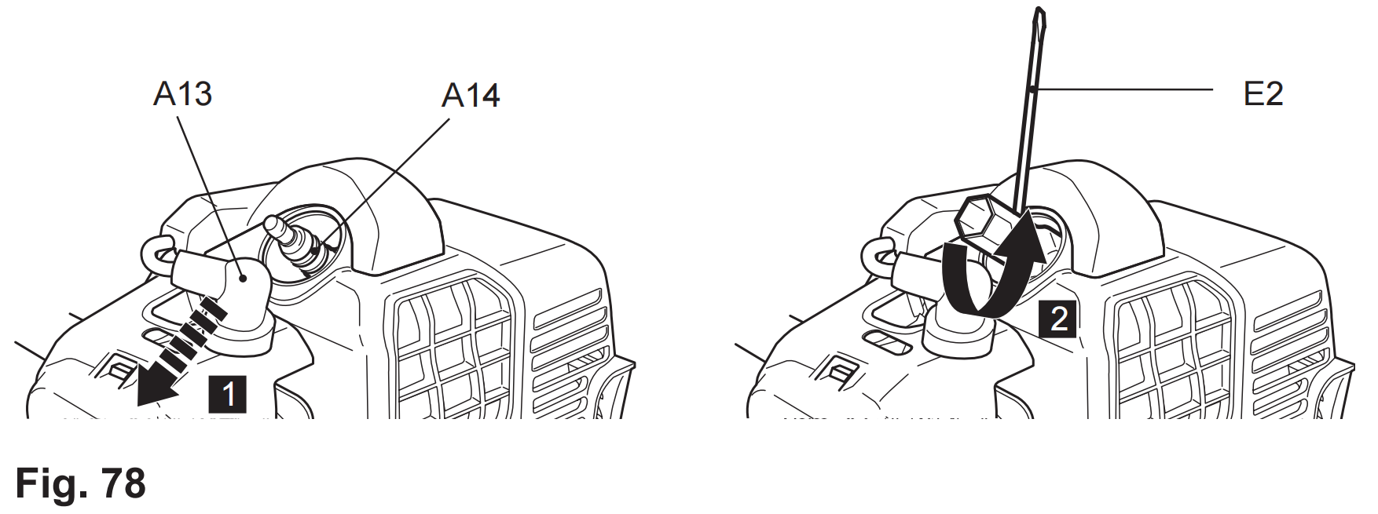
3. Check the spark plug (A14) for damage and wear. The colour of the electrode should be light-brown colored.
4. Remove debris from the electrode with a soft wired brush; avoid heavy cleaning of the electrode.
5. Dry the spark plug with a soft cloth, if it is wet from fuel.
6. Check the spark plug gap. It should be 0.7 – 0.8 mm (Fig. 79).
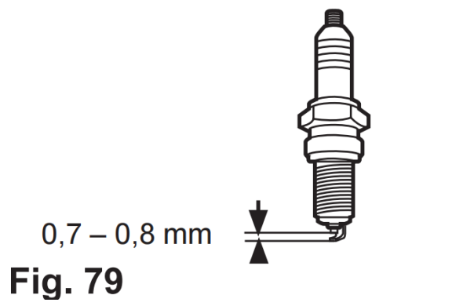
7. Replace with a new spark plug if either the electrode or the insulation is damaged.
8. When replacing the spark plug, first screw it in hand tight and then lightly tighten it with the multi tool (E2).
WARNING! Do not over tighten the spark plug to avoid
any damage!

Fuel
1. Empty the fuel tank (A5) when storing the product over 30 days to
prevent the fuel deteriorating.
2. Unscrew and remove the fuel tank cap (A6) to empty the fuel into
a suitable container.
WARNING! Do not store the fuel in the fuel mixing container (E1)!

Carburettor
The carburettor is pre-set by the manufacturer. Should it be necessary to make any changes, please contact an authorised service centre or a similarly qualified person. Do not attempt to make any adjustments by yourself.

Muffler
If it be necessary to modify or replace the muffler, please contact an authorised service centre or a similarly qualified person.

Spare parts/Replacement parts
The following parts of this product may be replaced by the consumer.
Spare parts are available at an authorised dealer or through our customer service.
Description | Specification
Blade | 3T
Chain | 12”
Guide bar | 12”
Spark plug | LD L8RTF
Starter assemble
Filter cover foam
Repair
This product does not contain any parts that can be repaired by the consumer. Contact an authorised service centre or a similarly qualified person to have it checked and repaired.
There are no spare parts available for this product. Contact an authorised dealer or through our customer service for more information.

Storage
1. Switch the product off and disconnect the spark plug connector.
2. Clean the product as described above.
3. Store the product and its accessories in a dry, frost-free place.
4. Always store the product in a place that is inaccessible to children. The ideal storage temperature is between 10°C and 30°C.
5. We recommend using the original package for storage or covering the product with a suitable cloth or enclosure to protect it against dust.
6. Empty the tank if you are not going to use the product for an extended period of time (more than 30 days) and before storing it for the winter.

Transportation
1. Switch the product off and disconnect the spark plug connector.
2. Attach transportation guards, if applicable.
3. Attach the blade cover (B17, C16, D4).
4. Always transport the product by its poles (A19, B1, C1, D1) and handles (D2, A27, A31).
5. Protect the product from any heavy impact or strong vibrations which may occur during transportation in vehicles.
6. Secure the product to prevent it from slipping or falling over, loss of fuel, damage and injury.
NOTE: Disassemble and remove the tool attachment for easy transportation if necessary.

Environmental protection
1. Old products are potentially recyclable and do not, therefore, belong in your household rubbish. You are requested to assist us and our contribution to saving resources and protecting the environment by handing in this appliance at an equipped collection centre (if there is one available).
2. Petrol, oil, used oil, mixtures of oil and petrol and objects contaminated with oil, e.g. cleaning cloths; do not belong with household waste. Dispose of oil-contaminated items in accordance with the local guidelines and hand them in at recycling centres.
3. The product comes in a package that protects it against damages during shipping. Keep the package until you are sure that all parts have been delivered and the product is function properly. Recycle the package afterwards.

Trouble shooting
Suspected malfunctions are often due to causes that the user can fix themselves. Therefore check the product using this section. In most cases the problem can be solved quickly.
WARNING! Only perform the steps described within these instructions! All further inspection, maintenance and repair work must be performed by an authorised service centre or a similarly qualified specialist if you cannot solve the problem yourself!
 | Problem | Possible cause | Solution
1 | Engine does  not start | 1.1. Not enough fuel in  fuel tank  1.2. Primer is not  pressed at cold start  1.3. Primer is pressed at  warm start  1.4. Spark plug is wet  1.5. Spark plug is damaged  1.6. Spark plug connector lose  1.7. Ignition switch not  set to “I”  1.8. Air filter is dirty  1.9. Spark plug loose  1.10.Spark plug gap is  incorrect  1.11. Carburettor is  flooded with fuel  1.12.Faulty ignition  module | 1.1. Add fuel  1.2. Press the primer and restart  1.3. Remove the spark plug and pull the recoil starter handle to  get excessive fuel out of engine.  1.4. Dry spark plug  1.5. Replace spark plug  1.6. Attach properly  1.7. Set ignition switch to “I”  1.8. Clean air filter  1.9. Tighten spark plug  1.10.Set gap between electrodes at 0.7 to 0.8 mm  1.11. Remove air filter and pull recoil starter handle continuously until carburettor clears itself and install air filter  1.12.Contact an authorised service centre or a similarly qualified person
2 | Engine stops | 2.1. Not enough fuel in  fuel tank  2.2. Tool attachment is  blocked | 2.1. Add fuel  2.2. Remove blockage
3 | Engine difficult  to start or loses  power | 3.1. Dirt, water or stale  fuel in the tank  3.2. Fuel tube clogged/  worn  3.3. Vent hole in fuel  tank cap is clogged  3.4. Air filter is dirty | 3.1. Drain fuel and clean tank. Fill tank with clean, fresh fuel  3.2. Contact an authorised  service centre or a similarly qualified person  3.3. Clean or replace fuel tank cap  3.4. Clean air filter
4 | Engine  operates  erratically | 4.1. Spark plug is defective  4.2. Spark plug gap is  incorrect  4.3. Air filter is dirty | 4.1. Install new, correctly  gapped plug  4.2. Set gap between  electrodes at 0.7 to 0.8 mm  4.3. Clean air filter
5 | Engine idles  poorly | 5.1. Air filter is dirty  5.2. Air vents are  clogged | 5.1. Clean air filter  5.2. Remove debris from vents
6 | Engine skips at high speed | 6.1. Gap between  electrodes of spark plug is too close | 6.1. Set gap between  electrodes at 0.7 to 0.8 mm
7 | Engine  overheats | 7.1. Air vents are  clogged  7.2. Incorrect spark plug  7.3. Tool attachment is  blocked | 7.1. Remove debris from  vents  7.2. Install correct spark plug and cylinder fins on engine  7.3. Remove blockage
8 | Engine runs  hot, smoke  comes off | 8.1. Chain oil tank empty  8.2. Chain tension too  tight | 8.1. Refill with the correct oil  8.2. Adjust the chain  tension
9 | Chain is not  rotating but  motor runs | 9.1. Chain tension too  loose  9.2. Guide bar or saw  chain damaged  9.3. Chain oil tank empty | 9.1. Adjust the chain tension  9.2. Replace with new parts  9.3. Refill with the correct oil
10 | Unsatisfactory  result | 10.1.Tool attachment is  worn/damaged  10.2.Saw chain is not  tensioned properly  10.3.Saw chain is blunt  10.4.Thickness of  branches exceeds  capacity of hedge  trimmer blade | 10.1.Replace with new one  10.2.Tension properly  10.3.Sharpen or replace  with new one  10.4.Only cut branches  complying with the  capacity
11 | Excessive  vibration/noise  or exhaust | 11.1.Tool attachment  is not properly assembled  11.2.Tool attachment is  worn/damaged  11.3.Bolts/nuts/flanges  are loosen  11.4.Fuel/oil is incorrect | 11.1.Check and reassemble  11.2.Replace with new one  11.3.Tighten bolts/nuts/  flanges  11.4.Empty out unused fuel/oil and refill with the correct fuel/oil
Technical specifications
1.General
Dimensions | approx. 2200 x 350 x 300 mm
Machine mass (without  fuel, cutting attachment and  harness) | approx. 11.5 kg
Net weight (include brush  cutter / grass trimmer /  pole saw / pole hedge  trimmer, harness and cutting  accessories) | approx. max. 12.6 kg
Fuel tank capacity | 1200 ml (cm³)
Petrol type | #95, unleaded
Engine oil type | 2-stroke engine oil
Mixture ratio petrol/oil | 40:1
Fuel consumption at max.  engine power | 750 g/h

2.Engine
Model no. | 1E40F-5
Engine type | air-cooled, 2-stroke
Engine displacement | 43cm³
Idle engine speed | 2800-3200 min-¹
Rated engine speed | 7500 min-¹
Maximum operating engine speed | 10000 min-¹
Maximum engine power | 1.25KW
Spark plug type | L8RTF
Spark plug gap | 0.7 – 0.8 mm
3.Brush cutter
Machine mass (without fuel) | approx. 6.8 kg
Cutter blade | 3 teeth metal blade, Ø 255 x 1.4  mm, max. 10000 min-¹
Cutting capacity | Ø 255mm
Max. rotational frequency of  the spindle | 9500 min-¹
Engine speed at max. spindle  speed | 10000 min-¹
Noise levelSound pressure level at  operator position LpARa | 96.2 dB(A)
Uncertainty KpA | 3 dB(A)
Sound power level LWARa  Uncertainty KWA | 105.4 dB(A) 3 dB(A)
Guaranteed sound power  level LWA | 111 dB(A)
Vibration level  Front handle ahv,eq | Idling 7.737m/s²  Racing 8.654m/s²
Main handle ahv,eq | Idling 7.811 m/s²  Racing 8.812m/s²
Uncertainty K | 1.5 m/s²

4.Grass trimmer
Machine mass (without fuel) | approx. 7.2 kg
Trimming line | nylon, Ø 2.4 x 250 mm ,  max. 10000 min-¹
Cutting capacity | Ø 430 mm
Max. rotational frequency of  the spindle | 9500 min-¹
Engine speed at max. spindle  speed | 10000 min-¹
Noise level  Sound pressure level at operator position LpARa | 96.2 dB(A)
Uncertainty KpA | 3 dB(A)
Sound power level LWARa  Uncertainty KWA | 107.7 dB(A)3dB(A)
Guaranteed sound power  level LWA Vibration level | 111 dB(A)
Front handle ahv,eq | Idling 7,737m/s² Racing 8,654m/s²
Main handle ahv,eq | Idling 7,811m/s² Racing 8,812m/s²
Uncertainty K | 1.5 m/s²

5.Pole saw
Machine mass (without fuel) | approx. 7.2 kg
Chain speed | 18.8 m/s
Chain oil tank capacity | 150 ml (cm³)
Chain type | 12”
Guide bar type | 12”
Guide bar length | 300 mm (12”)
Max. cutting length | 250 mm
Chain pitch | 9.525 mm (0.375”)
Chain gauge | 1.27 mm (0.050”)
Drive sprocket | 7 teeth x 9.525 mm
Noise level | 96,2 dB(A) 3 dB(A)
Sound pressure level LpA  Uncertainty KpA  Measured sound power level LWA  Uncertainty KWA | 105,4dB(A)3 dB(A)
Guaranteed sound power  level LWA | 111 dB(A)
Vibration level  Front handle ah | Idling 8,517m/s² Racing 8,551m/s²
Main handle ah | Idling 8,411m/s² Racing 8,512m/s²
Uncertainty K | 1.5 m/s²

6. Pole hedge trimmer
Machine mass (without fuel) | approx. 7.7kg
Cutting speed | 1600 r/min
Angle adjustment of cutting head | 12 positions (+/- 90°)
Max. cutting length | 390 mm
Max. cutting width | 24 mm
Noise level Sound pressure level LpA  Uncertainty KpA | 96,2 dB(A)  3 dB(A)
Measured sound power level LWA  Uncertainty KWA | 105,4 dB(A)  3 dB(A)
Guaranteed sound power level LWA | 111 dB(A)
Vibration level Front handle ah | Idling 8,137m/s² Racing 8,354m/s²
Main handle ah | Idling 8,103 m/s² Racing 8,212m/s²
Uncertainty K | 1.5 m/s²

The sound intensity level for the operator may exceed 80 dB(A) and ear protection measures are necessary.
The declared vibration value has been measured in accordance with a standard test method and may be used for comparing one product with another. The declared vibration value may also be used to evaluate the exposure for the user caused by vibration in advance

WARNING! Depending on the actual use of the product the vibration values can differ from the declared total!
Adopt proper measures to protect yourself against vibration exposures. Take the whole work process including times the product is running under no load or switched off into consideration.
Proper measures include among others regular maintenance and care of the product and tool attachments, keeping hands warm, periodical breaks and proper planning of work processes.



Address: Baoshanqu Shuangchenglu 803long 11hao 1602A-1609shi Shanghai
Imported to AUS: SIHAO PTY LTD,1 ROKEVA STREETEASTWOOD NSW 2122 Australia
Imported to USA: Sanven Technology Ltd., Suite 250,9166 Anaheim Place,Rancho Cucamonga,CA 91730
REP
UK
Pooledas Group Ltd
Unit 5 Albert Edward House, The Pavilions Preston, United Kingdom
REP
EC
SHUNSHUN GmbH
Römeräcker 9 Z2021, 76351 Linkenheim-Hochstetten, Germany
Made in China

Technical Support and E-Warranty Certificate
www.vevor.com/support
Made in China

